Guess Paper 2011
Class- XII
Subject - Mathematics
SECTION-A
Q1
Q2 If sin⁻¹ 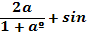⁻¹ 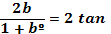⁻¹x, then find x.
Q3 If A is a square matrix such that A²=A, then find ²-3A.
Q4 If A=
Q5 Evaluate: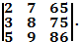
Q6 Find the value of 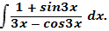
Q7 Write the value 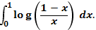
Q8 If is the angle between any two vectors
Q9 Find
Q10 Find a vector of magnitude 4 units which is parallel to the vector
SECTION-B
Q11 By using properties of determinants, show that
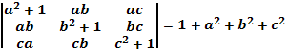
Q12 Evaluate:
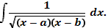
OR
Prove that :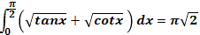

Q13 Verify the condition of mean value Theorem and find a point c in the interval as stated by the mean value theorem for the function given by.
= log_{e}x on [1,2]
OR
If x^{y}=e^{x-y}, show that 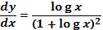
Q14 Show that the curves 2x=y² and 2xy =k cut each at right angles if k² =8.

Q15 Find the general solution of the differential equation:
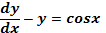
Q16 Show that the differential equation
Is homogenous and solve it.
Q17 If find the angle between .
Q18 By examining the chest X-ray, the probability that T.B. is detected when a person is actually suffering is 0.99. The probability of incorrect diagnoses is 0.001. In a certain city 1 in 1000 persons suffer from T.B. A person selected at random and is diagnosed to have T.B. what is the chance that he actually has T.B?
OR
A pair of dice is tossed twice. If the random variable X is defined as the number of doublets, find the probability distribution of X.
Q19 Find the distance of the point (3,8,2) from the line
Measured parallel to the plane 3x+2y-2z+15=0.
Q20 Show that the relation in the set A= {1,2,3,4,5} given by
R={(a,b): |a-b|is even}, is an equivalence relation.
Q21 find the intervals in which the function f(x) =(x+1)³ (x-3)³ is strictly increasing or decreasing.
OR
Find the equation of the tangent and the normal to the curve x=1 –cos , y=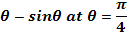
Q22 write the following function in the simplest from:
tan⁻¹ 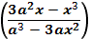
SECTION-C
If A= 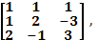find A⁻¹ and use it to solve the system of equation:
X+y+2z=0
X+2y-z=9
x-3y+3z=-14
OR
Let A=
Find a matrix D such that CD-AB=0.
Q24 A and B take turns in throwing to dice, the first two throw 9 being declared a winner. Show that the chances of A and B winning are in the ratio of 9:8, if A starts the game.
Q25 Prove that if a plane has the intercepts a,b,c and is at a distance of p units from the origin, then 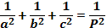 .
Q26 Find the point on the curve y²=2x which is at a minimum distance form the point (1,4).
Or
A right circular cylinder is inscribed in a right circular cone. Show that the curved surface area of the cylinder is maximum when the diameter of cylinder is equal to the radius of the base of the cone.
Q27Find the area of smaller region bounded by the ellipse 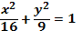 and the straight line .
Q28Evaluate: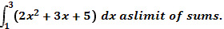
Q29 An oil company requires 13,000, 20,000 and 15,000 barrels of high grade, medium grade and low grade oil respectively. Refinery A produces 100, 300 and 200 barrels per day of high, medium and low grade oil respectively whereas the refinery B produces 200,400 and 100 barrels per day respectively. If A costs Rs. 400 per day an B costs Rs.300 per day to operate how many days should each be run to minimise the cost of requirement `
ANSWERS
Section-A
- (2) 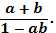 (3) (4) 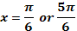. (5) 0. (6) `
(7) 0. (8) (9) (10)
Section-B
(11) .
(12) 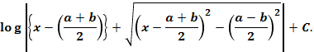 or
(13) or 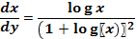. (14)
(15) 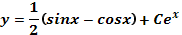. (16) .
(17) 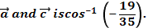 (18) . Or . (19) 7.
(20) is an equivalence relation.
(21) increasing in (1,) and decreasing(-,1) or eq of norma and eq of tangent
(22) 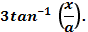
Section-D
(23) is the required solution. Or . (24) .
(25) 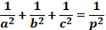. (26) point (2,2), point(1,4) or C is maximum for r=2x.
(27) 3( (28) . (29) 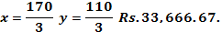

Prepared by:

Name Mukta Sawhney
Email sawhney_3@rediffmail.com
Phone No. 9212648772`

