Guess Paper 2011
Class- XII
Subject - Informatics Practices

Time : 3 Hours Marks : 70
General Instructions : 1. Answer the questions after carefully reading the Questions. 2. Marks are given against the respective questions.

SECTION A
1. Answer the following :
(a) What do mean by Network and explain its advantages? 2
(b) Explain bus and ring topologies? 2
(c) Differentiate between switch & hub? 2
(d) Write in brief the purpose of the following softwares: (i) Apache (ii) Tomcat 2
(e) Expand the following terms : (i) FLOSS (ii) OSS 2

2 Answer the following:.
(a) What is the use of method pow() and toLowerCase( )? 2
(b) What is the difference between String and StringBuffer class. 2
(c) Explain GUI? 1
(e) What is Firewall? 1
(f) What is the difference between abstract class and interface. 2
(g) What do you mean by List and combo box? 2
3. (a) What are the advantages of database over conventional file system. 3
(b) What is meant by “Data independence”? 2
( c) What is key? Explain primary and foreign key. 2
(d)Explain the architecture of client-server. 2
(e) What is Ogg Vorbis? 1
SECTION -B
4. HSBC is a bank. The Bank provides three types of loans- Car loan, House Loan, Education Loan.

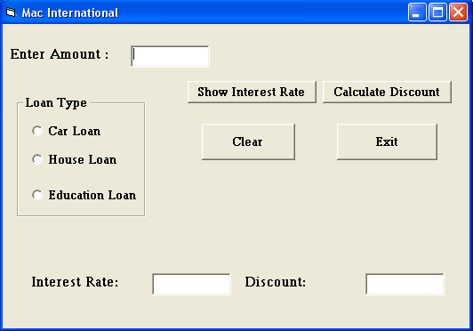

Read the following case study and answer the questions that follow:
Make a java swing frame as shown above and accept values through jTextFields. Perform according
to following questions:
  - Write the command to clear all the text boxes. 1
  - Write the command to set focus on Exit button and disable all other buttons. 2
  - Write the commands to show the interest rate according to the following criteria.: 2
Car loan – 10%
House Loan – 8.5%
Education Loan – 5%.
  - Write the code for Exit button to close the application. 1
  - Calculate the discount on the amount according to following criteria. 4
    - If amount > 10,000,00 and < 20,000,00 then 20% discount.
    - If amount > 20,000,00 then 25 % discount.

5 (a) Predict the output/error produced by the following code:
int I = 0;
outer :
while (true) {
I++;
inner:
for(int j=0;j<10;j++)
{
I+=j;
if(j==3)
Continue inner;
break outer;
}
continue outer;
}
System.println(I); 2

(b) Predict the output/error produced by the following code:

int I=0;
label :
if(I<2)
{
system.out.print(“I is “ +I);
I++;
continue label;
} 2

(c ) What will be the output the following code fragment if the value of ch is
(i) a (ii) c (iii) d (iv) b?
switch (ch)
{ case ‘a’: system.out.println(“It is a.”);
case ‘b’: system.out.println(“It is b.”);
case ‘c’: system.out.println(“It is c.”);
break;
case ‘d’: system.out.println(“It is d.”);
break;
default: system.out.println(“Not a ,b,c ,and d.”);
} 2

(d) During a special sale at a store, a 10% discount is taken on purchases over 1000/- .Write a program and design screenshot that asks for the amount of purchases, then calculate the discount price. The purchase amount will be input in Rs. :
Enter amount of purchases : 2000
Discount price : 1800 4

6. (a) Write a program to calculate factorial of a given number. 2
(b) Is Multiple inheritance is possible in java? If yes, How ? 2
(c ) Write the use of methods charAt() and substring() in java. 2
(d) Sketch the basic structure of an HTML program. 2 e) How the e-governance benefited the common man. 2
f) Define the front end in information system. 2
g) Define an entity. 1

7. Answer the following questions based on the table CLUB given below:
TABLE :CLUB
Column Name | Data Type | Size | Constraints | Description
Member_No  Member_Name  Address  Age  Type  Fees | Number  Varchar2  Varchar2  Number  Varchar2  Number | 5  40  30  2  10  6,2 | Primary Key  Not Null  >=18 | Member number  Name of the member  Address of he member  Age of the member  Type of membership  (Temp or Permanent)  Membership fees

(a) Write the SQL command to create the table CLUB including the constraints. 2
(b) Insert two tuples. 1
(c) Write the SQL command to display the details of all the members whose type is “Permanent” and fees is more than Rs. 5000. 1
(d) Write SQL query to add a new column called Phno. 1
(e) Change the fees rate by 10% if the membership is of type “Temp” 1
(f)Write The SQL command to display all the details of all the members whose age is grater than eighteen. 1
Thanks and All the best to you all
My web site is: http://hellodevendra.tripod.com

Prepared by:

Name devendra sharma
Email devendramgps@gmail.com
Phone No. 9425646162

