SAMPLE - PAPER
INFORMATION PRACTICES

Max Marks: 70 Time: 3 Hrs
General Instructions:
- The Question Paper is divided into three sections and all questions are compulsory.
- Section A consists of 30 marks.
- Section B and Section C consist of 20 marks each.

Section - A

Q1 a) Write code to artificially raise an error on entering value “BAD” in text box named
result. The code should be written on leaving the text box 2
b) Write (not explain) features of Visual Basic. 2

Q2 Difference between

SDI and MDI 2

Pass ByVal and Pass ByRef 2

Q3 Draw a diagram showing following relationship (not explain) 2
- One to One
- Many to Many

Q4 a) What are the Techniques used in Data Mining ? 2

b) What are four building blocks of Information System ? 2

c) Briefly explain System Analysis. 2
d) Briefly explain Two-Tier Model 2

Q5 a) How is serial execution of Transaction is different from concurrent execution ? 3
b) Briefly explain Row and Statement trigger type. 2
c) What are the attributes of Implicit Cursor 3
d) Define Transitive Dependency 2

Section - B

Q6 A Visual Basic Employee form’s some details are shown below 4
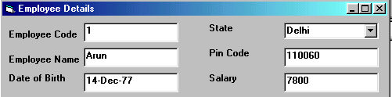

Create a function called Check() that returns Boolean value. This function should validate the following information for the fields on the form.
I The txtEmpCode text box cannot be empty
II The CboState Combo Box must have a state selected
III The txtPinCode text box must be filled
IV The txtBirthDate text box must be a valid date
V The txtSalary text box must be numeric
If all above are validations are satisfied then function should return true otherwise if any one of the validation is not satisfied function should return false

Q7 Create a Function named Factorial which returns factorial of the number passed as argument. 4

Q8 Write error free coding for the following four command buttons. Assume Adodc control is taken but visible property is made false. 5
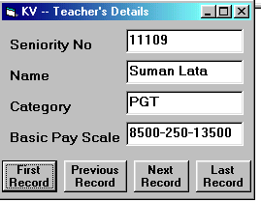

Q9 Suggest VB build in function name for the following tasks, also write the command to perform it.
- To extract “FORM” from the word “INFORMATION PRACTICES” 1
- Output both –16 and –17 form the number –16.7 (tell both functions) 1
- Print the current date in the format given below : 1
Thursday, December 2, 2004
- Add 7 days in the current date and store the result in variable ReturnDate 1
- Search (case insensitive) a string “HELLO” in the text box named txtMessage. 1

Q10 Write code to create the following message box. 2
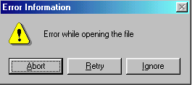

Section C

Q11 Write a PL/SQL program to print the following series. 4
1 4 7 10 ……………….40

Q12 Write a Cursor that calculates the Net Salary with specifications given below of each employee present in Emp table. Then insert the record in Emp_Sal_detail table having fields emoNo, NetSalay. 4
HRA 30% of Salary
DA 55% of Salary
PF 20% of Salary

Q13 Write a PL/SQL procedure which checks for employee number passed as argument whether exists ot not in the Emp table. If exists display its Name, Job, HireDate and Salary in following format.
Employee Name is :
Employee Job is :
Employee Date of Joining is :
Employee Basic Salary is :

If does not exists then display a message “Employee Number is Not Valid” 4

Q14 Create a trigger that inserts the whole record into Old_student table which is deleted from Student table having fields ( Roll_no, Name, Class, Section). 4

Q15 Write SQL Queries for the following problems.
- List name, job and department of all the employees who’s job is not same as in department no 10. (hint use subquery) 2
- Display Total no of employees per department in following format 2
DEPTNO TOTAL_EMPLOYEES
------------ ---------------
10 3
20 5
30 6

*-*-*-*-*-*-*-*-*-*-*-*-*-*-*-*

