Guess Paper 2011
Class- XII
Subject - Chemistry
Time : 3 Hrs M.M. 70
General Instructions :
(i) All questions are compulsory.
(ii) There are 30 questions in total. Questions 1 to 8 Carry one mark each, questions 9 to 18 carry two marks each, questions 19-27 carry three marks each and questions 28 to 30 carry five marks each.
1. How is ΔTf and ΔTb related to molecular mass of solute?
2. Write the names of monomers and equation for the preparation of Nylon-66.
3. Write IUPAC name of Na[Au(CN)2].
4. Write chemical equation to prepare Urotropine from Formaldehyde.
5. Define fibres. Give one example.
6. Give relation between average life period and half-life period.
7. How does electrical conductivity of semiconductors vary with temperature?
8. Write equation showing relation between standard free energy change and standard cell potential.
9. Which element of 13th group form the most stable +1 oxidation state?
Q10. (i) For a hypothetical reaction A2 + 3B2 → 2AB3. Write the rate equatiion in terms of rate of disappearance of B2.
(ii) A reaction is 50% complete in 2 hours and 75% complete in 4 hours. What is the order of reaction?
Q11. The value of ΔG°f for formation of Cr2O3 is –540 kJ mol–1 and that of Al2O3 is –827 kJ mol–1. Is the reduction of Cr2O3 possible with aluminium?
OR
Explain (i) Leaching (ii) Mond process.
12. Can a solution of 1M ZnSO4 be stored in a vessel made of Copper? Given E° Zn+2|Zn = –0.76V, E° Cu+2| Cu = 0.34V.
13. What is the difference between racemic and meso forms? Explain with two different examples.
14. If the rate constants of a reaction are 5 × 10–4 sec–1 and 2.0 × 10–3 sec–1 at 300K and 320K. Calculate the energy of activation. R = 8.314 J/K/mol.
15. Explain basic character and reducing character of hydrides of the 15th group elements.
16. What are enantiomers? How can they be identified?
17. What are the micro-alloys? Explain with two examples.
18. Half-life period of a radioactive element is 100 seconds. Calculate the disintegration constant and average life period. How much time will it take for 90% decay?
19. (a) Describe the structure and magnetic behaviour of [Ni(CN)4]2– ion on the basis of valence bond theory.
(Atomic No. of Ni = 28)
(b) Illustrate Carbylamine reaction.
20. Calculate the boiling point of a solution containing 0.456 gms of Camphor (mol. mass = 152) dissolved in 31.4 g of Acetone(b.p. = 56.30°C) if molal elevation constant per 100 g of acetone is 17.2°C.
21. Chromium erystallises in a body certred cubic lattice, whose density is 7.20 g/cm3. The length of the edge of unit cell is 288.4 p.m. Calculate Avogadro’s number. (Atomic mass of chromium = 52).
22. What do you mean by activity and selectivity of a catalyst? Explain with one example of each.
23. (a) Define coagulation or flocculation.
(b) What is the difference between Lyophilic and Lyophobic colloids?
24. What are proteins? Describe simple and conjugated protein with at least one example in each case.
25. (a) Amines have lower boiling points than corresponding alcohols and carboxylic acid. Explain.
(b) What happened, when:
(i) Aniline is diazotised and the product is coupled with phenol?
(ii) Ethylamine is treated with Nitrous acid?
26. (a) Write Zwittor ion structure of Glycine.
(b) What is denaturation of proteins?
(c) Why is ammonia used in ice factories and as a refrigerant?
27. (a) CO2 is a gas while SiO2 is a solid at room temperature, Explain.
(b) Write two difference between Thermosetting and Thermoplastic polymers.
OR
(a) How is phosphine prepared from:
(i) Calcium phosphide (ii) Aluminium phosphide (iii) Phosphrous acid?
Draw the structure of its molecule.
(b) SO2 can act as an oxidising as well as reducing agent, but SO3 can act as only oxidising agent. Explain.
28. (a) Why Sm+2, Eu+2 and Yb+2 ions in solution are good reducing agent, but an aqueous solution of Ce+4 is a good oxidising agent?
(b) Why Zr and Hf exhibit similar properties?
(c) The +3 oxidation state of Lanthanium (Z = 57), Gadolinium (Z = 64) and Luetium (Z = 71) are especially stable. Why?
OR
(a) Explain briefly the following terms :
(i) Quenching (ii) Temperature (iii) Annealing
(b) Discuss briefly the chemical reactions which take place in blast furnance during the extraction of iron from haematie.
29. (a) How will you convert -propanol to 2-propanol?
(b) How will you convert ethyl bromide to propanoic acid?
(c) Out of all he acid derivative acylchlorides are most reactive. Justify.
(d) Phenols are more acidic than alcohols. Explain.
OR
(a) Discuss briefly the following reactions :
(i) Gattermann Koch reaction (ii) Reimer Tiemann reaction (iii) Hofmann degradation reaction.
Q30. How will you bring about the following conversions?
(i) tert-Butyl bromide to isobutyl bromide.
(ii) Phenol to Anisole
(iii) Ethyl cyanide to Propiosphenone.
(iv) Acetic acid to Methylamine
(v) Aniline to Benzoic acid.
OR
- Identify A, B, C and D in the following reactions.
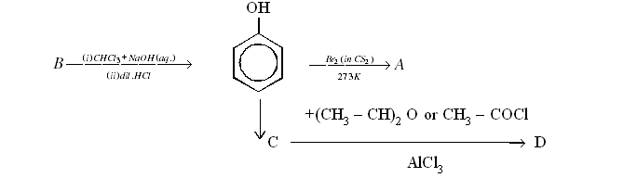
(ii) An aromatic compound ‘A’ on treatment with awqueous ammonia and heating forms compound ‘B’ which on heating with Br2 and KOH forms a compound ‘C’ of molecular formula C6H7N.
(iii) Give the structures of A and B in the following reaction : 1
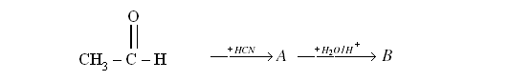

Sharma Chemistry Classes (A name in Chemistry)
By : Arvind Sharma, SIRSA
Mob. No. 098963-77903

