SAMPLE QUESTION PAPER
CHEMISTRY
CLASS - XII

Maximum Marks: 60 Time allowed: 2 hours

General Instructions:
- All questions are compulsory.
- Do the paper in a very neat and clearly readable handwriting.
- This paper consists of three sections. The individual section weight age is as follows:
Section A Q. No. 1 – 8 2 marks for each question
Section B Q. No. 9 – 16 4 Marks for each question
Section C Q No. 17 – 18 6 marks for each question
- Do all rough work in the fair copy itself. Please don’t ask for a separate sheet for calculations or any other rough work.

SECTION – (A)
Each question carries 2 marks

- Explain why dehydration of alcohols to form alkenes is always carried out with concentrated H₂SO₄ and not with concentrated HCl or HNO₃?

- Write the IUPAC names of the following compounds:
(a) 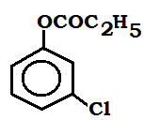 (b) 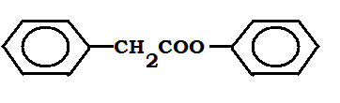

- Perform the following conversions:
- Toluene to benzyl chloride
- Aniline to iodo benzene

- Write the mechanism for the following reaction:

- Explain the following:
- Phenylamine is more soluble in HCl than in H2O.
- Aniline cannot be prepared by Gabriel Phthalamide synthesis.

- Write IUPAC names:
- 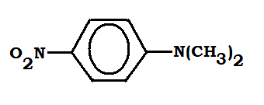(b) 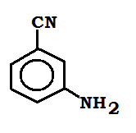

- Perform the following conversions:
- Benzene sulphonic acid to m – methoxy aniline
- Ethyl benzene to 2 – phenyl propanoic acid

- Write a plausible mechanism for the given reaction:
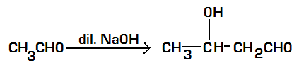

SECTION – (B)
Each question carries 4 marks

- Explain the following:
- Formic acid is stronger than acetic acid
- Carboxylic acids have higher boiling points than alcohols.
- Electrophilic substitution in benzoic acid takes place at m – position.
- and ions are ambidient nucleophiles.

- Perform the following conversions:

- 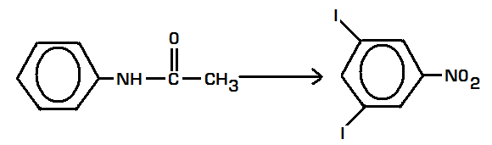
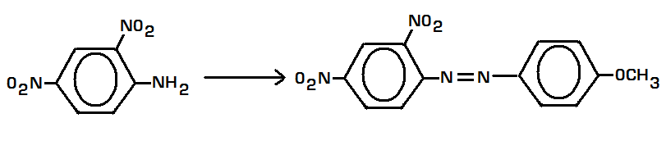

- Illustrate with examples:
- Sandmeyer’s Reaction
- Diazotization reaction
- Vapor phase nitration
- Cannizaro’s reaction

- Complete the following reactions:

- 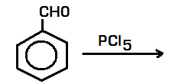
- 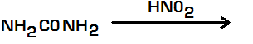
- 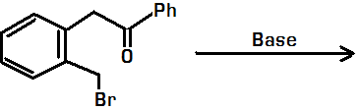
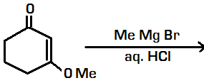

- Complete the following reaction:

- 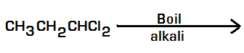
- 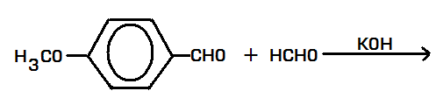
- 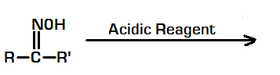
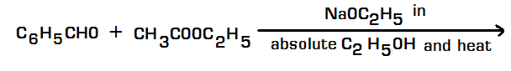

- Arrange the following as asked:
  - Aniline, ethyl amine, ethane, phenol (basic strength)
  - Et NH₂, Et₂ NH, Et₃ N, NH₃ (basic strength in gas phase)
  - C₃H₇CHO, CH₃COC₂H₅, C₂H₅COOCH₃, (CH₃CO)₂O (boiling points)

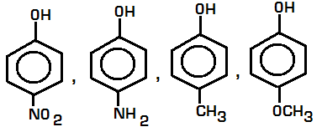(acidic strength)

- Explain the following:
  - Amine is a weaker base than cyclohexylamine
  - Amines have lower boiling points than those of the corresponding alcohols.
  - Amide is more acidic than amine
  - Aldehydes are more reactive than ketones towards nucleophilic reaction.

- How will you distinguish between:
  - ethyl amine and aniline
  - CH₃CHO and CH₃CH(OH)CH₃
  - 2 – pentanone and 3 – pentanone
  - acetone and formaldehyde

SECTION – (C)
Each question carries 6 marks

  - Distinguish between Wolf Kishner Reduction and clemmenson’s reduction.

  - Write the product of the following reaction –
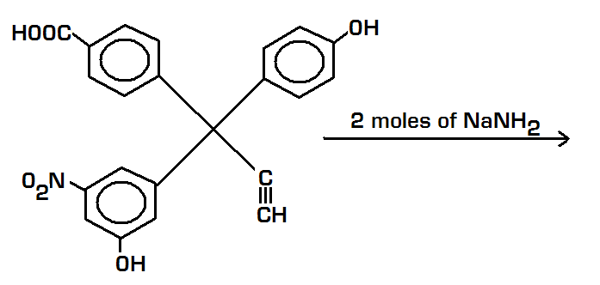
  - Identify A, B and C:

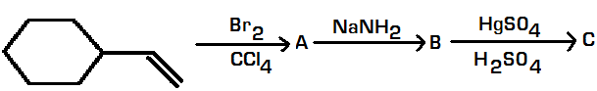

- Identify (A) – (F) in the following series of reactions:

  - 

   

