MATHEMATICS
CLASS X
Time allowed: 3¼ hours Maximum Marks: 100

Code number given on the right hand side of the question paper should be written on the title page of the answer- book by the candidate.

General Instructions:
- All questions are compulsory.
- The question paper consists of 25 questions divided into three sections A, B and C. Section A contains 10 questions of 2 marks each, Section B is of 10 questions of 3 marks each and section C is of 5 questions of 5 marks each.
- There is no overall choice. However, an internal choice has been provided in two questions of three marks each, two questions of four marks each and two questions of six mark each.
- In question on construction, the drawing should be neat and exactly as per the given measurements.
- Use of calculators is not permitted.

1. For what value of k the system will have no solution
3x+5y+4=0 ; 15x-ky-7=0

2. Find the sum of all the divisible of 7 between 100 and 300.

3. If the sum of first 8 and 19 terms of an AP are 64 and 361 respectively. Find the
common difference and sum of its nth term.

4. (x² - x - 6) is the GCD of the expression
(x + 2) (2x² + ax + 3) and (x - 3) (3x² + bx + 8). Find the value of a and b.

5. Neeru brought a washing machine at he down payment of Rs. 8000. the total cost of the machine is Rs. 27500. If the rest of the payment has to be given in three months at the rate of interest of 12%. Find the total amount given by him.

6. Find the probability of getting Monday or Tuesday in a leap year.
OR
If the probability of wining the game is twice than the loosing it. Find the probability of winning it?
7. Prove that the angle in a semi circle is a right angle.
OR

In the figure AB is a chord of a circle. Line QBS is a tangent to a circle at B. find angle APB and ABQ.

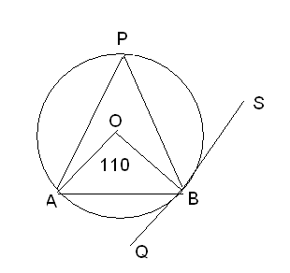
8. Find the least number of coins of diameter 2.5 cm and height 3 mm which are to be melted to form a solid cylinder of radius 3 cm and height 5 cm.
OR
The radii of two cylinders are in the ratio 2:3 and their heights are in 5:3. Calculate the ratio of their volume.

9. Construct a triangle who sides are 7,8,13 cm. Draw a triangle corresponding to it with the ratio of 0.6 times the original dimensions.

10. In the figure below angle B is 90° And P, Q are any points on the sides AB, BC respectively of ΔABC. Prove that
AQ²+CP²=AC² + PQ²

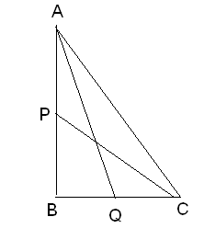

OR
State and prove Pythagoras theorem.

11. The coordinates of the mid point of the line joining the points (2p+2, 3) and (4, 2q+1) are (2p, 2q). Find the values of p and q.

12. If the points (x, y) is equidistant from the points (2, 1) and (1,-2), show that x+3y=0.

13. A man borrows Rs. 40,025 from a bank and has to repay it in a four equal half yearly installments. If the rate of interest is 15% per annum compounded quarterly. Find the amount of each installment.

14. If Tan A = n tan B and Sin A = m sin B, prove that cos²= m²-1/n²-1.

15. The mean of the following distribution is 23.4 and the total frequency is 40. Find the values of p and q

Class interval | Frequency
0-8 | 5
8-16 | 3
16-24 | P
25-32 | Q
33-40 | 4
41-48 | 2

16. Find the values of k so that the (x-3) is a factor of the polynomial k²x²-kx-2.

17. The sum of squares of three consecutive numbers is 194. Find the numbers.

18. 3Shikha works in a factory, in one week she earned Rs 707 for working 47
Hours, of which 7 hours was overtime. The next week she earned Rs 756 for working
50 hours, of which 8 hours was overtime. What is Shikha’s hourly income rate?
19. Simplify:
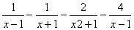

20. The pie-chart along-side shows the monthly expenditure of a family. Read the pie-chart carefully and answer the following question:
(i) What is the central angle for savings?
(ii) What is the ratio of expenditure on food to that on rent and rent to savings?
(iii) If the family spends Rs. 1945 on clothing, then what is the total monthly income?
(iv) What percentage of the total monthly income does the family save?
(v) What is the difference in rupees on amount spend on food and clothing?
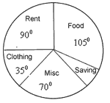

21. Water flows through a cylindrical pipe of the internal diameter 12 cm at 42 km/hr.
calculate the time taken to fill the cylindrical vessel of 45cm base and height of 3 m.
OR

22. Prove that the angle in the major segment is acute.
PQ and RS are two parallel chords of a circle and lines RP and SQ intersect each other
at O. prove that OP=OQ.

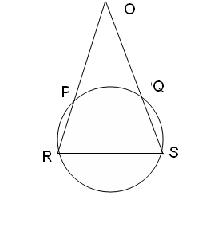
23 if PAB is a secant to a circle intersecting it at A and B, and Pt is a tangent then prove
that PA. PB= PT².
OR
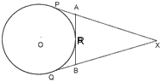
In figure. XP and XQ are two tangents to a circle with centre O from a point X out side the circle. ARB is a tangent to the circle at R. prove that XA + AR = XB + BR.

24. If the angle of elevation of a cloud from a point h metres above a lake is and the angle of depression of its reflection in the lake is . Prove that the height of the cloud is
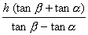

OR
From an aeroplane vertically above a straight horizontal plane, the angles of depression of tow consecutive kilometer stones on the opposite sides of the aeroplane are found to be and . Show that the height of the aeroplane is 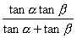.

25. The annual income of reema (age 45 years ) is Rs. 6,80,000 (exclusive of HRA). She contributes Rs.7,500 per month provident fund and pays annual premium of Rs. 12,000 towards her LIC policy. She pays Rs. 3,000 per month as income tax for the first 11 month. Also she contributes 50,000to Prime Minister fund. Calculate the income tax payable by her in the last month of the year.

For male persons (below 65 yrs) |  | For female (below 65 yrs) |  | For senior citizen
TAXABLE INCOME | INCOME TAX | TAXABLE INCOME | INCOME TAX | TAXABLE INCOME | INCOME TAX
Upto Rs. 100000 | NIL | Upto Rs. 135000 | NIL | Upto Rs. 185000 | NIL
Rs. 1lac to Rs. 1.5 lac | 10% of income exceeding Rs. 1 lac | Rs. 1.35 lac to Rs. 1.5 lac | 10% of income exceeding Rs. 1.35 lac | Rs. 1.85 lac to Rs. 2.5 lac | 20% of income exceeding Rs. 1.85 lac
Rs. 1.5 lac to Rs. 2.5 lac | Rs. 5000 + 20% of income exceeding Rs. 1.5 lac | Rs. 1.5 lac to Rs. 2.5 lac | Rs. 1500 + 20% of income exceeding Rs. 1.5 lac | More than 2.5 lac. | Rs. 13000+ 30% of income exceeding Rs. 2.5 lac.
More than 2.5 lac. | Rs. 25000+ 30% of income exceeding Rs. 2.5 lac. | More than 2.5 lac. | Rs. 21500+ 30% of income exceeding Rs. 2.5 lac.
- 10% of surcharge applicable if the taxable income exceed Rs. 10,00,000
- Educational cess of 2% on the tax payable including surcharge wherever applicable.

