Sample Paper – 2011
Class – X
Subject – Mathematics
INTRODUCTION TO TRIGONOMETRY

Trigonometric identities

- ,

 | 0 | 30 | 45 | 60 | 90
 | 0 |  |  | 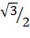 | 1
 | 1 |  |  |  | 0
 | 0 |  | 1 |  | ∞
 | ∞ |  | 1 |  | 0
 | 1 |  |  | 2 | ∞
 | ∞ | 2 |  |  | 1

Important Questions

- If

- In the adjoining figure, PQ = 24 cm, QR = 26 cm, ∠PAR =90°, PA = 6 cm and AR = 8 cm. find ∠QPR.
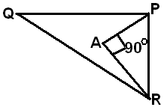

- In the adjoining figure, AD = 4 cm, BD = 3 cm and CB = 12 cm. find cot θ
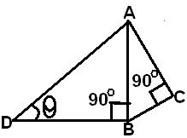

Prove each of the following

- 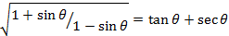s
- If

Evaluate each of the following
Solve each of the following equations for θ
- 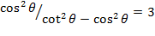
- If where 2A is an acute angle, find the value of A.
Without using trigonometric tables, evaluate
- If 7
Prove each of the following identities
- 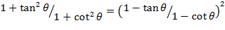
- 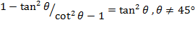
- 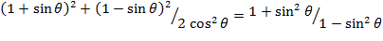
- 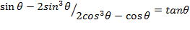
- If then show that
- 
Without using trigonometric tables, evaluate each of the following
Prove each of the following

Answers

- 17/12
- 90°
- 12/5
- 1
- 0
- 1
- 60°
- 30°
- 44°
- 5
- 1
- 2/3

Name: Sujeet Gaud
Email:Sujeet_Gaud@yahoo.com
Phone No.9928273041




