Sample Paper – 2012
Class – X
Subject – Mathematics

SECTION – A [1 mark each]
- If the least prime factors of p and q are 5 and 7 respectively, then the least prime factor of (p+q) is:
(a) 3 (b) 5 (c) 7 (d) 2
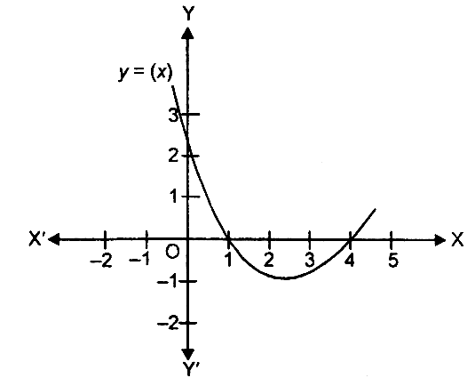
- The decimal expansion of the rational number $\frac{\text{99}}{2^{2}\text{.}\text{15}}$will terminate after:
(a) one decimal place (b) two decimal places
(c) three decimal places (d) more than three decimal places.
- In the given figure, the graph of a polynomial y = p(x) is given. The zeroes of the polynomial are
(a) 1, 4
(b) 0, 2.5
(c) 0,1
(d) 1,0
- The pair of linear equations a₁x + b₁y + c₁ = 0 and a₂x + b₂y + c₂ = 0, meet at a point, if
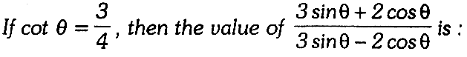
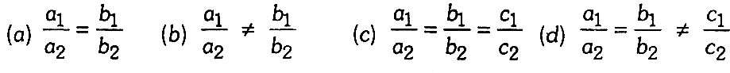

(a) 3 (b) 4 (c) 5 (d) 9
- The maximum value of $\frac{5}{\text{cos}\text{ec}θ}$is
(a)1 (b)5 (c)—1 (d) 0
- For a symmetric distribution, the relation between mean, median and mode is:
(a) Mean > Mode >Median (b) 2 Mode = Mean + Median
(c) Mean = Mode = Median (d) Mean <Mode <Median.
- For a given data with 70 observations the ‘less than ogive’ and the ‘more than ogive’ intersect at (20.5, 35). The median of the data is:
(a) 20 (b) 35 (c) 70 (d) 20.5
- If sec A =cosec B= $\frac{\text{15}}{7}$, then A + B is equal to:
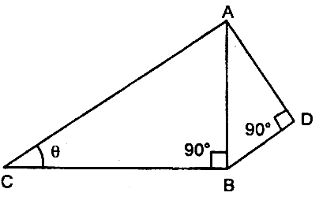
(a) zero (b) 90° (c) <90° (d) >90°
- If fig., AD = 4 cm, BD = 3 cm and CB = 12 cm, then cot θ equals:
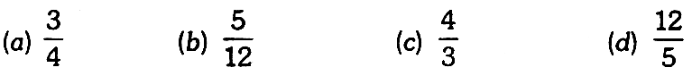

SECTION – B [2 mark each]

- Can (x — 2) be the remainder on division of a polynomial p(x) by (2x + 3) ? Justify your answer.
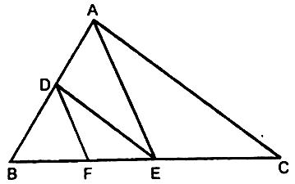
- If 7sin²θ +3cos²θ = 4, show that tanθ = 4, show that tanθ = $\frac{1}{\sqrt{3}}$
- In fig., DE||AC and DF||AE. Prove that $\frac{\text{EF}}{\text{BF}}=\frac{\text{EC}}{\text{BE}}$

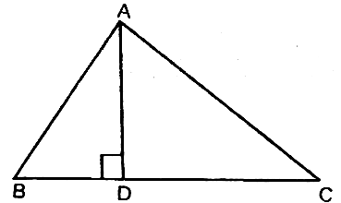
- In fig., AD ⊥ BC and BD = $\frac{1}{3}$CD. Prove that 2CA² = 2AB² + BC²

- a and $\frac{1}{a}$are the two zeroes of the polynomial p(y) = 4 — k — y + 2y². Find the value of k.
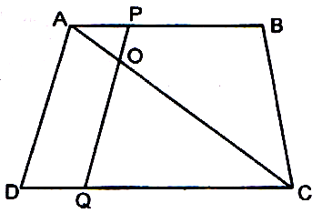
- (i) The values of remainder r, when a positive integer ‘a’ is divided by 3 are 0 and 1 only. Justify your answer.
(ii) In the given figure, if AB ||DC, AC and PQ intersect each other at the point O.
Prove that: OA.CQ = OC.AP

- In a retail market, fruit vendors were selling mangoes kept in packing boxes. These boxes contained varying number of mangoes. The following was the distribution of mangoes according to the number of boxes.
Write the above distribution as more than type cumulative frequency distribution.
- Calculate the mode of the following distribution:

SECTION – C [3 marks each]

- Find the HCF of 85 and 51 by using Euclid’s division algorithm and then express it in the form 85 x + 5ly, where x and y are integers.
- Prove that $\frac{5\sqrt{7}}{6}$ is irrational.
- A person rowing a boat at the rate of 5 km/hour in still water, take thrice as much time in going 40 km upstream as in going 40 km downstream. Find the speed of the stream.
- ΔABC and ΔDBC are on the same base BC and on opposite sides of BC and O is the point of intersection of AD and BC. Prove that $\frac{\text{area}(Δ\text{ABC})}{\text{area}(Δ\text{DBC})}$=$\frac{\text{AO}}{\text{DO}}$

- (i) The mean of the following frequency distribution is 25. Find the value of p.
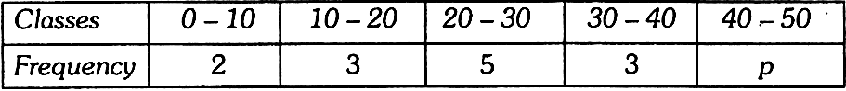
(ii) Find the median of the following data:

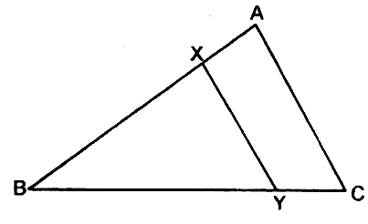
- In the given figure, the line segment XY is parallel to side AC of ΔABC and it divides the triangle into two parts of equal areas. Find the ratio $\frac{\text{AX}}{\text{AB}}$.

- A point O in the interior of a rectangle ABCD is joined with each of the vertices A, B, C and D. Prove that OA² + OC² = OB² + OD².
- If α and β are the zeroes of the polynomial p(x) = x² — 6x + 8, then form a quadratic polynomial whose zeroes are $\frac{1}{2α}$and$\frac{1}{2β}$.
- Prove that (1 + cotA + cosecA) (1 + tanA—secA)= 2
- If sin θ + cos θ = p and sec θ + cosec θ = q, show that q (p² —1) = 2p

SECTION – D [4 marks each]

- (i) Prove that $\frac{\text{sec}θ+\text{tan}θ−1}{\text{tan}θ−\text{sec}θ+1}=\frac{\text{cos}θ}{1−\text{sin}θ}$
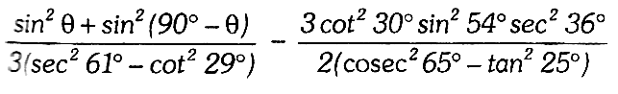
(ii)Evaluate :

- (i) If secθ + tan θ = p, prove that sin θ= $\frac{p^{2}−1}{p^{2}+1}$
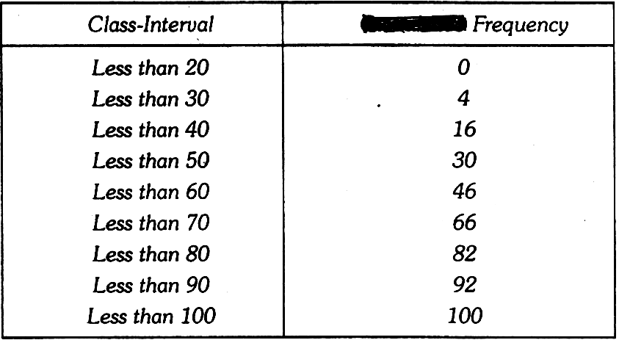
(ii) If $\frac{x}{a}$cosθ + $\frac{y}{b}$sin θ = 1 and $\frac{x}{a}$sin θ − $\frac{y}{b}$cos θ = 1, prove that $\frac{x^{2}}{a^{2}}+\frac{y^{2}}{b^{2}}$=2.

- (i) Prove that the ratio of the areas of two similar triangles is equal to the ratio of the square of their corresponding sides.
(ii) Compute the median for the following cumulative frequency
distribution.

- Find other zeroes of the polynomial p(x) = 2x⁴ — 21x³ + 49x² — 10x —20, if two of its zeroes are 5 ± $\sqrt{5}$ .

- (i) Prove that, if a line divides any two sides of a triangle in the same ratio, the line is parallel to the third side.
(ii) Prove that, in a right triangle, the square of the hypotenuse is equal to the sum of the squares of the other two sides.
- Draw the graphs of the pair of linear equations x—y +2 —0 and 4x—y—4 =0 (i) Find the solution of the equation from the graph. (ii) Shade the triangular region formed by the lines and the x-axis and find the area also.
OR
Draw the graphs of following equations 2x — y = 1, x + 2y = 13 (a) Find the solution of the equation
from the graph. (b) Shade the triangular region formed by the lines and the y-axis and find the area also.

MATHEMAGICS
VANDANA BANSAL M : 9855188797
VANDANA BANSAL # 3149, (T.F.), SECTOR 23−D, CHANDIGARH

