Sample Paper – 2012
Class – IX
Subject – Mathematics
M.M 60 Time: 2 ½ hrs

Syllabus: Rational Numbers;Polynomials;Co-ordinate Geometry;Lines and Angles;Euclid’s Geometry
------------------------------------------------------------------------------------------------------------
Instructions: 1.All questions are compulsory.
2.This question paper consists of 27 questions divided into four sections A,B,C and D as follows

Section | Section Type | Marks per question | Total Questions | Total Marks
A | MCQ | 1 | 10 | 10
B | SA-I | 2 | 6 | 12
C | SA-II | 3 | 6 | 18
D | LA | 4 | 5 | 20
TOTAL |  |  | 27 | 60

3.Internal Choices are provided in 1 question of 2 marks;1 questions of 3 marks and 2 questions of 4 marks each.You have to attempt only one alternative in such questions.
4.Use of CALCULATORS is STRICTLY PROHIBITED.
------------------------------------------------------------------------------------------------------------

SECTION-A
- Which of the following is not an irrational number?
a) √625 b)√3 c)√23 d)√29
2. The decimal representation of 8/3 is
a) 2.66…. b)2.6 c)2.67 d)2.7
3. The coefficient of y² in y+ πy²+8y³ is
a)1 b)π c)π/2 d)8
4. If p(y)=y³-3y²-7y+2 then p(1) =
a) 2 b)-7 c)1 d)None of These
5.It is known that if x+y=10 then x+y+z=10+z.The Euclid’s Axiom that illustrates this statement is
a)First Axiom b)Second Axiom c)Third Axiom d)Fourth Axiom
6. Boundary of Solids are
a) surfaces b)Points c)Lines d)Curves
7.The difference between two complementary angles is 40⁰. The Angles are-
a)25⁰,65⁰ b)20⁰,60⁰ c)40⁰,40⁰ d)None of These
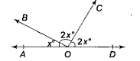
8.Value of x in the given figure
a)30⁰ b)180⁰ c)36⁰ d)45⁰
9.The co-ordinates of a point which is on left of y-axis and on x-axis at a distance of 4 units
a)(4,0) b)(-4,0) c)(0,-4) d(0,4)
10. The quadrant in which point (-3,3) lie
a)I b)II c)III d)IV
SECTION-B
11.Express 17.4848 as rational number.
12.Show that x=1 is the zero of f(x)=2x³-3x²+7x-6.
OR
Verify r=-1,2 are the zeros of p(r)=(r+1)(r-2).
13.Prove that every line segment has one and only one mid point.
14.Look in the following figure and write the following

i) Coordinate of A 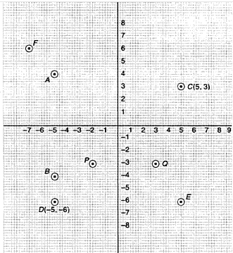
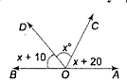
ii)Coordinate of B iii)Points identified by the coordinates (-2,-3) and (3,-3) iv)Abscissa of C v)Ordinate of D vi)Coordinates of E.
15.In the given figure, OA and OB are two opposite rays.Find the value of x and also angles BOD,COD and AOC.
16.Represent √3 on number line.
SECTION-C
17.Prove that √7 is irrational.
18.Find the remainder when x³-ax²+6x-a is divided by x-a.
OR
Use Factor Theorem to determine whether (x+5) is a factor x³+x²+3x+175.
19.Look at the figure and show that length AH>sum of lengths of AB+BC+CD.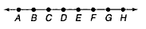
20.Plot the following ordered pairs of numbers(x,y) as points in the cartesian plane.Use the scale 1 cm=1 unit on the axes.
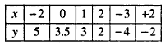
21.If two parallel lines are intersected by a transversal,Show that the bisectors of any pair of alternate interior angles are parallel.
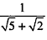
22.Rationalize the denominator of the following

SECTION-D

23.Simplify The following Expression
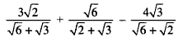
OR
Find the values of a and b
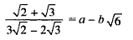
24.Find the area of the figure enclosed by the points (-2,2),(2,-2),(2,2) and (-2,2) Using Graph.
25.Evaluate 103 x 107 and factorize 1-p⁶.
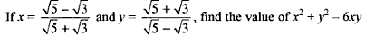
26.

OR
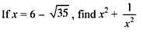
27

Paper By: Siddharth Gupta Mob-9981501755

