Sample Paper – 2012
Class – X
Subject – Mathematics
SECTION – A [1 mark each]
- The decimal expansion of the rational number $\frac{\text{23}}{2^{3}5^{2}}$, will terminate after how many places of decimal?
(a) 1 (b) 3 (c) 4 (d) 5
- The value of k for which 6x—3y + 10 = 0 and 2x + ky + 9 =0 has no solution is
(a) —1 (b) —2 (c)1 (d)3
- Let ΔABC - ΔPQR, area of ΔABC = 81 cm², area of ΔPQR = 144 cm² and QR = 6 cm, then length of BC is
(a) 4cm (b) 4.5 cm (c) 9 cm (d) 12 cm
- The value of $\frac{\text{cos}({\text{90}}^{0}−θ)\text{cos}θ}{\text{tan}θ}$ − 1 is
(a) —sin² θ (b) —cosec²θ (c) —cos²θ (d) —cot θ
- If tan θ + $\frac{1}{\text{tan}θ}$=2, then the value of tan² θ + $\frac{1}{{\text{tan}}^{2}θ}$is
(a) 3 (b) 4 (c) 2 (d) —4
- If sec 4A = cosec (A — 20°), where 4A is an acute angle, then the value of A is
(a) 21° (b) 22° (c) 23° (d) 24°
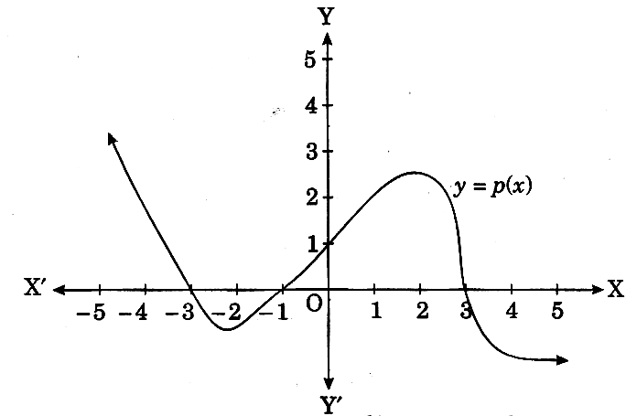
- In figure, the graph of some polynomial p(x) is given. The zeroes of the polynomial p(x) are
(a) 1, 3 and —1
(b) 1, −3 and −1
(c) —1, —3 and 3
(d) — 3, 1 and 3
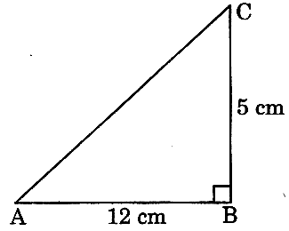
- In figure, ABC is a right angle triangle, right angled at B, AB = 12 cm and BC = 5 cm, then the value of tan A + cot C is
(a) $\frac{6}{5}$ (b) $\frac{5}{6}$
(c) $\frac{\text{12}}{5}$ (d) $\frac{\text{13}}{6}$

- The prime factorization of a natural number n is 2³ x 3² x 5² x 7, then the number of consecutive zeroes in n are
(a) 2 (b) 3 (c) 4 (d) 5
- The median and mean of a unimodal statistical data are 42.4 and 40.6 respectively, then its mode is
(a) 45.8 (b) 46 (c) 46.3 (d) 45.3

SECTION – B [2 mark each]
- If 2 is a zero of both the polynomials 3x² + ax— 14 and 2x³ + bx²+x-2, find the value of a − 2b.
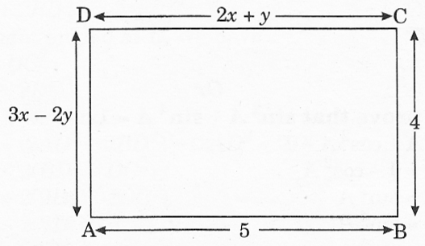
- In figure, ABCD is a rectangle. Find the values of x and y.

- If A and B are acute angles such that tan A = $\frac{1}{2}$ and tan B =$\frac{1}{3}$ and tan (A+B) = $\frac{\text{tan}A+\text{tan}B}{1−\text{tan}A\text{tan}B}$, find A + B.

(ii) If cos A + cos² A = 1, prove that sin²A + sin⁴ A = 1
- If the polynomial x⁴ + 2x³ + 8x² + 12x + 18 is divided by another polynomial x² +5, the remainder comes out to be px + q. Find the values of p and q.
- Solve the following system of equations: $\frac{1}{2x}−\frac{1}{y}$=− 1; $\frac{1}{x}+\frac{1}{2y}$= 8, where x ≠ 0, y ≠ 0.
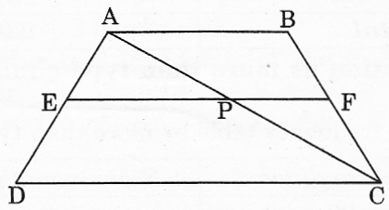
- Prove that in the figure if ABCD is a trapezium with AB ||DC || EF, then
$\frac{\text{AE}}{\text{ED}}=\frac{\text{BF}}{\text{FC}}$

- In ΔABC, ∠A = 90° and AD ⊥ BC. Prove that AB² + CD² = BD² + AC².

- For the following grouped frequency distribution find the mode:

SECTION – C [3 marks each]
- Show that any positive odd integer is of the form 6q + 1 or 6q + 3 or 6q + 5, where q is a positive integer.
- Find the value of sin 30⁰ geometrically (ii)Prove that $\sqrt{2}+\sqrt{5}$ is irrational.
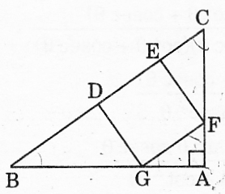
- If α and β are the zeroes of the quadratic polynomial f(x) = 2x² − 5x +7, find the quadratic polynomial whose zeroes are 2$α+3β$ and 3$α+2β$
- Prove that $\frac{\text{sin}θ}{\text{cot}θ+\text{cos}\text{ec}θ}=2+\frac{\text{sin}θ}{\text{cot}θ−\text{cos}\text{ec}θ}$
- In figure, DEFG is a square and ∠BAC = 90°. Show that DE² = BD x EC.

- Find the mean of the following distribution, using step-deviation method:
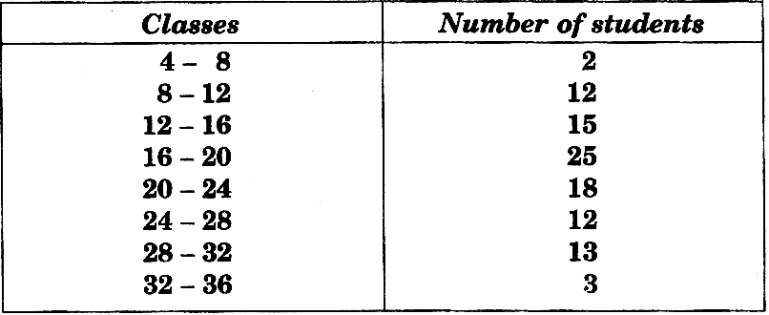
- Find the median of the following distribution:
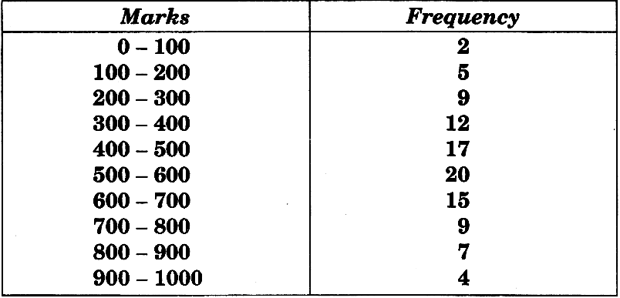
- If two zeroes of the polynomial x⁴ + 3x³ — 20x² — 6x + 36 are $\sqrt{2}$ and —$\sqrt{2}$, find the other zeroes of the polynomial.
- If x = tanA + sinA and y = tanA − sinA, show that x² − y² = 4$\sqrt{\text{xy}}$
- The sum of a two-digit number and the number obtained by reversing the order of its digits is 165. If the digits differ by 3, find the number.

SECTION – D [4 marks each]
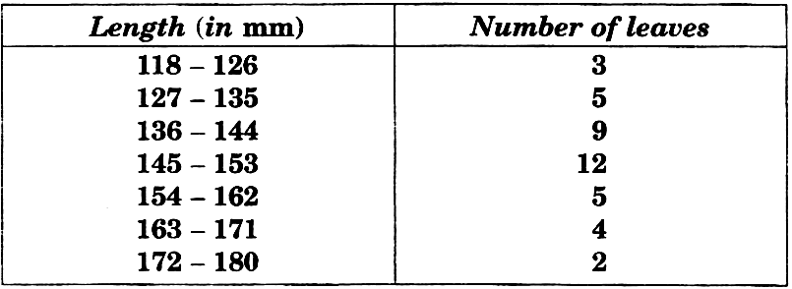
- The lengths of 40 leaves of a plant are measured correct to the nearest millimetre, and the data obtained is represented in the following table: Draw a more than type ogive for the given data. Hence, obtain the median length of the leaves from the graph and verify the result by using the formula.

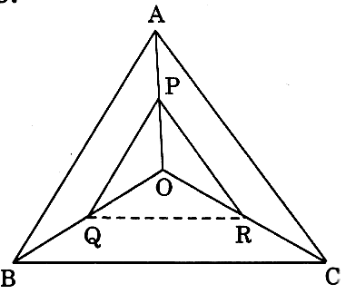
- State and prove B.P.T. Also ,In figure, PQ ||AB and PR || AC. Prove that
QR ||BC.

- (i) Find the zeroes of the polynomial p(x) = x³ — 5x² — 2x + 24, if it is given that the product of its two zeroes is 12.
(ii)If two zeroes of the polynomial x⁴ — 6x³ — 26x² + 138x -35 are 2 ± $\sqrt{3}$, find other zeroes.
- Form a pair of linear equations in two variables using the following information and solve it graphically : Aftab tells his daughter, “Seven years ago, I was seven times as old as you were then. Also three years from now, I shall be three times as old as you will be”. Find their present ages. What was the age of Aftab when his daughter was born ?
- The mean of the following data is 46.2. Find the missing frequencies f${}_{1}$ and f${}_{2}$:

(ii) The following cumulative frequency distribution is given:
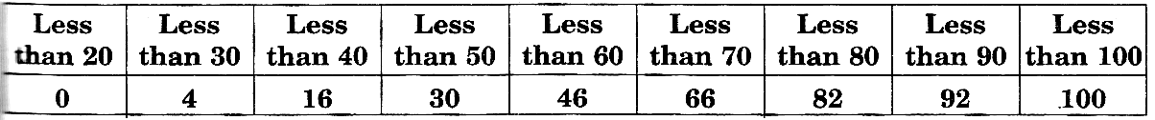
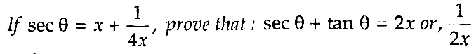
Write the ordinary frequency distribution.
- (i)

(ii) Evaluate : $\frac{\text{cos}\text{ec}θ\text{sec}θ({\text{90}}^{0}−θ)−\text{cot}θ\text{tan}({\text{90}}^{0}−θ)+{\text{sin}}^{2}\text{37}+{\text{sin}}^{2}{\text{53}}^{0}}{\text{tan}5^{0}\text{tan}{\text{25}}^{0}\text{tan}{\text{45}}^{0}\text{tan}{\text{65}}^{0}\text{tan}{\text{85}}^{0}}$

MATHEMAGICS
VANDANA BANSAL M : 9855188797
VANDANA BANSAL # 3149, (T.F.), SECTOR 23−D, CHANDIGARH

