Sample Paper – 2012
Class – X
Subject – Mathematics

Section – A 1x10 = 10

Q1. Which of the following is terminating decimal expansion.
a. 91/21000 b. 343/2³x5³x7⁴
c. 11/7000 d. None of these
Q.2 Euclids division lemma states that for any two positive integers a and b, there exist unique integers q and r such that a = bq+r, where r must satisfy.
a. r > b b. 0 < r < b c. 0 < r b d. 0 r < b
Q.3 Which one is not polynomial
a. 2x³-x²+x-1 b.
c. d. b and c are not polynomial
Q.4 Two rails can be represented by one of the following.
a. x+2y=4, 2x+4y-12=0 b. 5x-6y=3, 3x+2y=9
c. 7x-2y=1, 14x-4y=2 d. None
Q.5 If D and E are points on AB and AC of triangle ABC such that DE BC if AD=6cm, BD=9cm and AE=8cm then EC
a. 10cm b. 12cm c. 14cm d. 18cm
Q.6 Read the given statements carefully (A) SecA = CosecB=15/7 for A+B = 90 (B) CotA is not defined for A=0 (C) the value of Cos increases as increases (D) Cos A is the abbreviation for Cosine of angle A
Chose the most satisfactory conclusion.
a. A,B are True, C, D are false ` b. A B C D are false
c. A, D, B are true, C is false d. All the given statements are correct
Q.7 Sin²A + Cos²A = 1 is true only for
a. 0 < A< 90 b. A = 0 or 90 c. 0 A 90 d. 0 A<60
Q.8 If SinA = CosB then A+B is equal to
a. 0 b. 45 c. 90 d. 60
Q.9 If a Cos + bsin = 4 and asin-bcos = 3 then a²+b² is
a. 7 b. 25 c. 12 d. -1
Q.10 The curves for more than and less than ogives meet at (54,96) If mode of the data is 60 then mean is
a. 50 b. 52.5 c. 48 d. 51

Section – B 2x8 = 16

Q11. Which one is irrational no. or justify it.
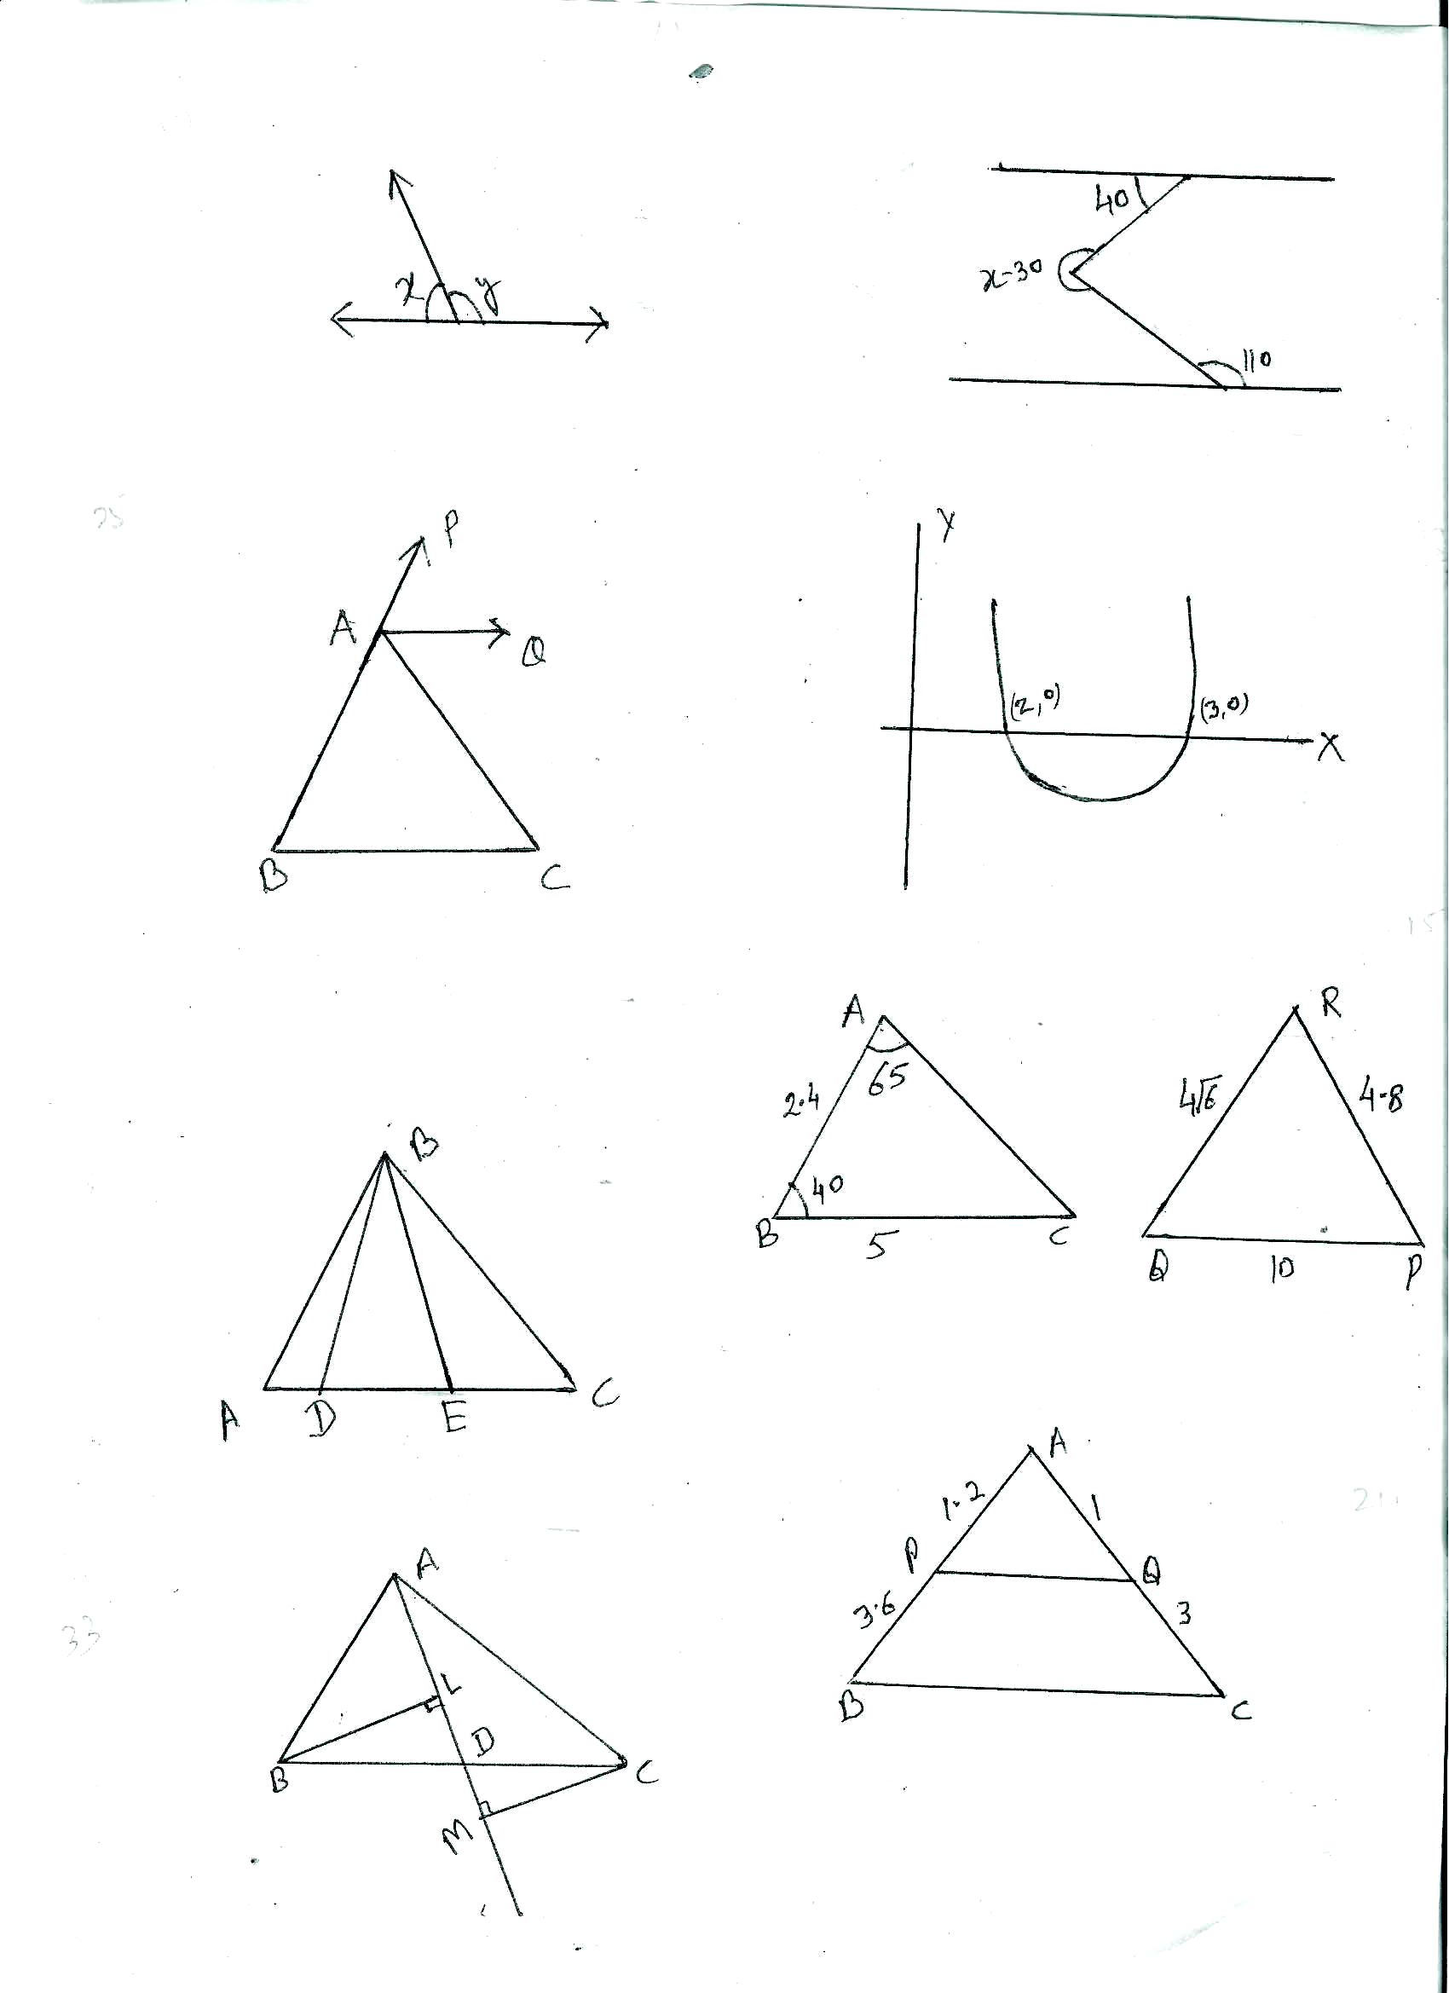
Q.12 Solve 4x+6/y = 15 and 6x-8/y = 14 and hence find p if y = px-2
Q.13 Observe the graph and form the polynomial

Q.14 Prove that the sum of the squares of the sides of rhombus is equal to the sum of squares of its diagonals.
Q.15 Are the given triangle similar or not, if yes then
justify the criterion of similarity.
Q.16 Evaluate Sin²5⁰ + Sin²10⁰ + Sin²15⁰ + ------------------ Sin²85⁰
Q.17 Mode of the following is 36 find its missing frequency.
0-10 10-20 20-30 30-40 40-50 50-60 60-70
8 10 P 16 12 6 7
Q.18 Prepare less than ogive and obtain median.
0-10 10-20 20-30 30-40 40-50 50-60 60-70 70-80
2 3 4 11 15 7 2 3

Section – C 3x10 = 30

Q19. Determine the minimum no. of chocolates to distribute among the students of saffron house, white house and green house in school on the occasion of republic day if the no. of students are 192, 180 and 144 respectively.
Q.20 State the fundamental theorem of arthematic and using it prove that 6^{n} can not end with 0 for any natural no. n

OR
Complete the important fact “If p is prime no. and a is positive integer. If p divides ----------------------------” using it prove the irrationality of
Q.21 If α and β are Zeroes of polynomial x²+7x+10 them form polynomial whose zeroes are (α+β) and (α-β).
Q.22 The ratio of the income of to persons is 9:7 and ratio of their expenditure is 4:3 it each of them save Rs. 200 per month find their monthly income
OR
A boat covers 32 km. up stream and 36km down stream in 7 hrs. Also it covers 40km. up stream and 48km. down stream in 9 Hrs. Find the speed of boat and stream in still water.
Q.23 In triangle ABC D, and E are points on AB such that AD = BE if DP BC and EQ AC then prove that PQ AB (P and Q are point on AC and BC).
Q.24 In a given figure ABC is triangle in which
AP = 1.2cm, PB=3.6cm and AQ = 1cm.
QC = 3cm prove that area of triangle APQ =1/16 of triangle ABC.
Q.25 Prove that
Q.26 Prove that
Q.27 Calculate the mean using step deviation method.
0-10 10-20 20-30 30-40 40-50 50-60
12 18 27 20 17 6
Q.28 Mean of the following 25 find the value of P
0-10 10-20 20-30 30-40 40-50
2 3 5 3 p
Section – D 4x6 = 24

Q.29 Solve the following equation graphically x-y = 1, 2x+y=8
Shade the area bonded by two lines and y axis also find the area of triangle form.
Q.30 Find the all zeroes of polynomial if 2x³+x²-6x-3 if two of its zeroes are
OR
Find the values of a and b if lines of given equation are coincide
2x+3y-9=0
(a+b)x + (2a-b)y = 3 (a+b+1)
Q.31 State and prove the Pythagoras Theorem. Using this theorem and its converse solve the following problems.
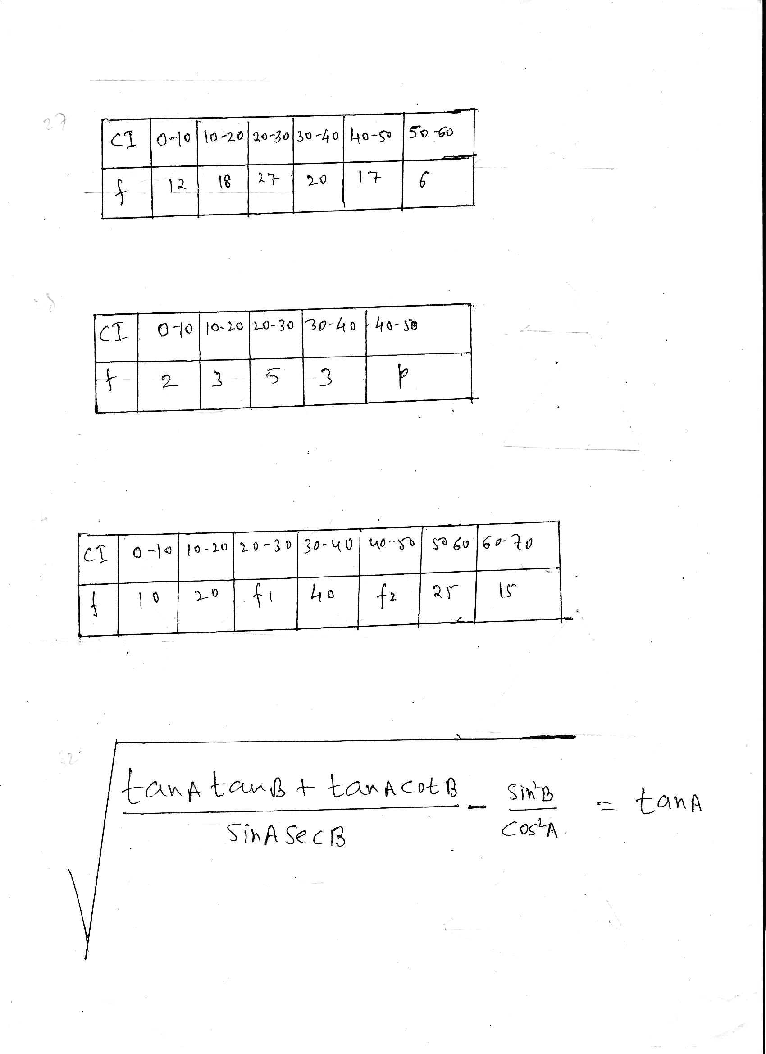
In a quadrilateral ABCD angle B = 90 If AD²=AB²+BC²+CD² prove that angle ACD = 90
Q.32 Prove that

If A+B=90
OR
Prove that
(1-Sins+Cos)² = 2(1+Cos) (1-Sin)
Q.33 Prove that x²+y²=1 If x Sin³+ y Cos³ = Sin Cos and xSin = y Cos
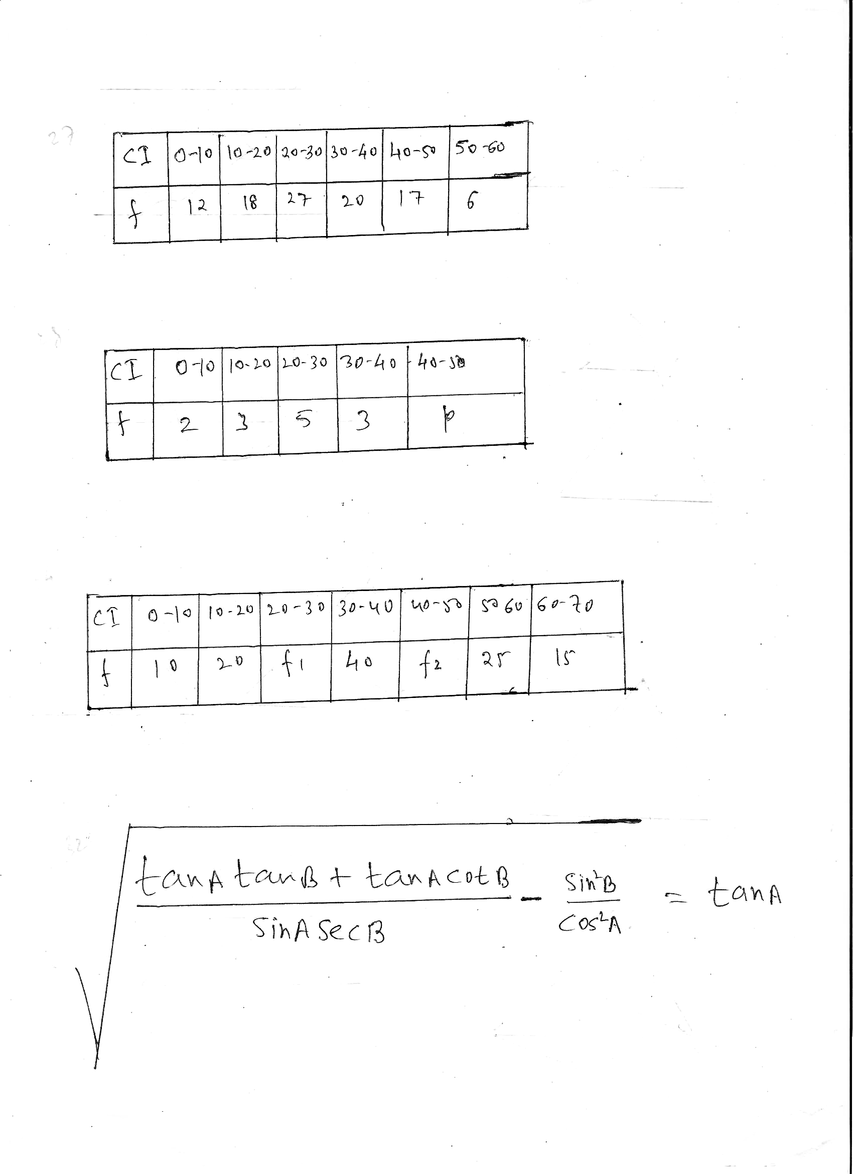
Q.34 If the median of following data is 35 and the sum of frequencies is 170 then find f1 and f2

Paper Submitted By:
Pradeep Sahajwani Classes (BASE MAKER)

IX – X CBSE (Maths / Science)
S-20, Vivekanand Colony, Bhopal, Phone : 0755-2751377, 9893213700

