Sample Paper – 2012
Class – XII
Subject – Chemistry

1. In the following pairs of halogen compounds, which compound undergoes faster S_{N}1 reaction?
(i)
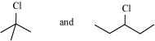
(ii)
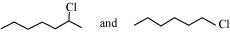
2. Identify A, B, C, D, E, R and R¹ in the following:
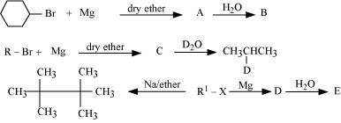
3. Which alkyl halide from the following pairs would you expect to react more rapidly by an S_{N}2 mechanism? Explain your answer.
(i)
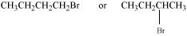
(ii)
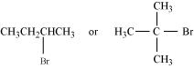
(iii)
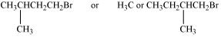
3. Explain why
(i) the dipole moment of chlorobenzene is lower than that of cyclohexyl chloride?
(ii) alkyl halides, though polar, are immiscible with water?
(iii) Grignard reagents should be prepared under anhydrous conditions?
4. Write the structure of the major organic product in each of the following reactions:
(i)
(ii)
(iii)
(iv)
(v)
(vi)
(vii)
(viii)
5. Show how are the following alcohols prepared by the reaction of a suitable
Grignard reagent on methanal?
(i)
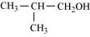
(ii)
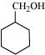
6. Write the equation of the reaction of hydrogen iodide with:
(i) 1-propoxypropane
(ii) Methoxybenzene and
(iii) Benzyl ethyl ether
7. Explain the fact that in aryl alkyl ethers
(i) The alkoxy group activates the benzene ring towards electrophilic substitution and
(ii) It directs the incoming substituents to ortho and para positions in benzene ring
8. Write the names of reagents and equations for the preparation of the following ethers by Williamson’s synthesis:
(i) 1-Propoxypropane
(ii) Ethoxybenzene
(iii) 2-Methoxy-2-methylpropane
(iv) 1-Methoxyethane
9. Explain how does the −OH group attached to a carbon of benzene ring activate it towards electrophilic substitution?

10. How are the following conversions carried out?
(i) Propene → Propan-2-ol
(ii) Benzyl chloride → Benzyl alcohol
(iii) Ethyl magnesium chloride → Propan-1-ol.
(iv) Methyl magnesium bromide → 2-Methylpropan-2-ol.
11. Write the structures of products of the following reactions;
(i)
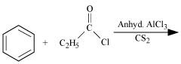
(ii)
(iii)
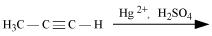
(iv)
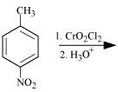
12. Arrange the following compounds in increasing order of their reactivity in nucleophilic addition reactions.
(i)Ethanal, Propanal, Propanone, Butanone.
(ii)Benzaldehyde, p-Tolualdehyde, p-Nitrobenzaldehyde, Acetophenone.
Hint:Consider steric effect and electronic effect.
13. Which acid of each pair shown here would you expect to be stronger?
(i) CH₃CO₂H or CH₂FCO₂H
(ii)CH₂FCO₂H or CH₂ClCO₂H
(iii) CH₂FCH₂CH₂CO₂H or CH₃CHFCH₂CO₂H
(iv)
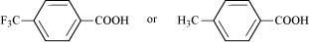
14. Predict the products formed when cyclohexanecarbaldehyde reacts with following reagents.
(i) PhMgBr and then H₃O⁺
(ii)Tollens’ reagent
(iii) Semicarbazide and weak acid
(iv)Excess ethanol and acid
(v) Zinc amalgam and dilute hydrochloric acid
15. Give plausible explanation for each of the following:
(i) Cyclohexanone forms cyanohydrin in good yield but 2, 2, 6 trimethylcyclohexanone does not.
(ii) There are two −NH₂ groups in semicarbazide. However, only one is involved in the formation of semicarbazones.
(iii) During the preparation of esters from a carboxylic acid and an alcohol in the presence of an acid catalyst, the water or the ester should be removed as soon as it is formed.
16 An organic compound contains 69.77% carbon, 11.63% hydrogen and rest oxygen. The molecular mass of the compound is 86. It does not reduce Tollens’ reagent but forms an addition compound with sodium hydrogensulphite and give positive iodoform test. On vigorous oxidation it gives ethanoic and propanoic acid. Write the possible structure of the compound.

17 How will you convert?
(i) Benzene into aniline
(ii) Benzene into N, N-dimethylaniline
(iii) Cl−(CH₂)₄−Cl into hexan-1, 6-diamine?
18 Give one chemical test to distinguish between the following pairs of compounds.
(i) Methylamine and dimethylamine
(ii) Secondary and tertiary amines
(iii) Ethylamine and aniline
(iv) Aniline and benzylamine
(v) Aniline and N-methylaniline
19 Arrange the following:
(i) In decreasing order of the pK_{b}values:
C₂H₅NH₂, C₆H₅NHCH₃, (C₂H₅)₂NH and C₆H₅NH₂
(ii) In increasing order of basic strength:
C₆H₅NH₂, C₆H₅N(CH₃)₂, (C₂H₅)₂NH and CH₃NH₂
(iii) In increasing order of basic strength:
(a) Aniline, p-nitroaniline and p-toluidine
(b) C₆H₅NH₂, C₆H₅NHCH₃, C₆H₅CH₂NH₂.
(iv) In decreasing order of basic strength in gas phase:
C₂H₅NH₂, (C₂H₅)₂NH, (C₂H₅)₃N and NH₃
(v) In increasing order of boiling point:
C₂H₅OH, (CH₃)₂NH, C₂H₅NH₂
(vi) In increasing order of solubility in water:
C₆H₅NH₂, (C₂H₅)₂NH, C₂H₅NH₂.
20 How will you convert:
(i) Ethanoic acid into methanamine
(ii) Hexanenitrile into 1-aminopentane
(iii) Methanol to ethanoic acid
(iv) Ethanamine into methanamine
(v) Ethanoic acid into propanoic acid
(vi) Methanamine into ethanamine
(vii) Nitromethane into dimethylamine
(viii) Propanoic acid into ethanoic acid
21 What are the hydrolysis products of (i) sucrose and (ii) lactose?
22 What happens when D-glucose is treated with the following reagents?
(i) HI (ii) Bromine water (iii) HNO₃
23 Differentiate between globular and fibrous proteins.

24 Write the names of monomers of the following polymers:
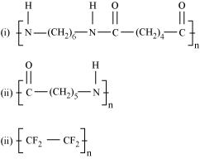
25 Write the monomers used for getting the following polymers.
(i) Polyvinyl chloride (ii) Teflon (iii) Bakelite
26 What are the monomeric repeating units of Nylon-6 and Nylon-6, 6?

27 How is dacron obtained from ethylene glycol and terephthalic acid?

28 What are the main constituents of dettol?

29 Explain the following terms with suitable examples
(i) Cationic detergents
(ii) Anionic detergents and
(iii) Non-ionic detergents
30 How do antiseptics differ from disinfectants? Give one example of each.

Paper Submitted By:

Name MANISH TULI
Email saimanishtuli@rediffmail.com
Phone No. 9425809658

