SAMPLE PAPER YEAR - 2012
Class – XII
MATHEMATICS (CODE – 041)
Time Allowed : 3 hours Maximum Marks : 100
General Instructions :
- All questions are compulsary.
- The question paper consist of 29 questions divided into three sections A, B and C. Section A comprises of 10 questions of one mark each, Section B comprises of 12 questions of four marks each and section C comprises of 07 questions of six marks each.
- All questions in Section A are to be answered in one word, one sentence or as per the exact requirement of the question.
- There is no overall choice. However, internal choices have been provided in 04 questions of four marks each and 02 or 03 questions of six marks each. You have to attempt only one of the alternatives in all such questions.
- Use of Calculator is not permitted. However, you may ask for logarithmic and statistical table, if required.
SECTION A
- If : R→R be given by then find
- Evaluate
- If A = 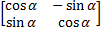 then A + A’ = I , find the value of
- Find the projection of on if
- If A is square matrix such that A² = A then find the value of (I + A)³ – 7A
- If where A is 3x3 matrix, find
- Find the direction of vector joining the points A(1,2,-3) and B(-1,2,-1) directed from A to B
- If and. Find a unit vector parallel to
- Differentiate
- Evaluate

SECTION B
- Consider given by show that is invertible with the inverse of given by , where in set of all non-negative real numbers.
- Prove that 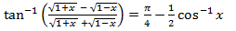
- Show that 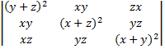 =
- If 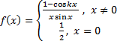 is continuous at find
- If 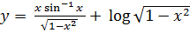 then prove that 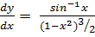
OR
If Prove that 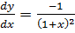
- Express the vector as the sum of two vectors such that one is parallel to the vector and other is perpendicular to
OR
If the vector are such that and Find the
angle between and
- Find the shotest distance between the pairs of line
̂
- Evaluate:
OR
- Solve the differential equation
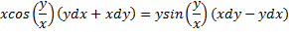
- A and B throw a die alternatively till one of them gets a 6 and win the game, find their respective probabilities of winning, if A starts first.
- Find the equation of the tangent and the normal to the curve at the point, where it cuts x-axis.
OR
Find the intervals in which the following function is increasing or decreasing
- Form the differential equation of the family of circle in the first quadrant which touch the coordinate axes.
SECTION C
- Find the area of the region enclosed between two circle and
OR
Using Integration. Find the area of region bounded by the triangle whose vertices are (1, 0), (2,2) and (3,1)
- Using Matrices, solve the following equation
OR
Using elementary transformations, find the inverse of the following matrix
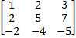
- Show that the volume of greatest right circular cylinder that can be inscribed in a right circular cone of height ‘h’ and semivertical angle ‘ is.
- From the point P (1, 2, 4) a perpendicular segment is drawn on the plane Find its equation and its length. Also find the coordinates of the foot of the perpendicular.
- A dietician has to develop a special diet using two foods P and Q. Each packet of Food P contains 12 units of Calcium, 4 units of Iron, 6 units of Cholesterol and 6 units of Vitamin A. Each packet of the same quantity of Food Q contains 3 units of Calcium, 20 units of Iron, 4 units of Cholesterol and 3 units of Vitamin A. The diet requires atleast 240 units of Calcium, atleast 460 units of Iron and atmost 300 units of Cholesterol. How many packets of each food should be used to minimize the amount of Vitamin A. In the diet what is minimum amount of Vitamin A.
- If a fair coin is tossed 10 times. Find the Probability of
- Exactly six heads
- At least six heads
- At most six heads
- Evaluate :
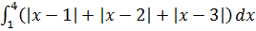
OR
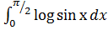

Paper Submitted By:
Name: LOVEKUSH GOEL
Email: lovekushgoel@gmail.com
MOBILE: 09358021550

