Sample Paper – 2012
Class – XII
Subject – Mathematics
- If Show that 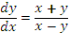
- If Find
- If Show that 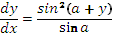
- If Show that 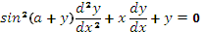
- Find , if
- If Prove that 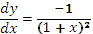
- If and Find
- Find
- If 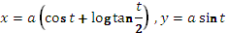 . Find
- Find
- Find
- 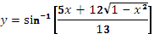 Find
- 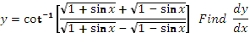
- 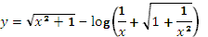Find
- Prove that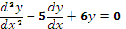
- Prove that 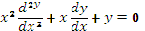
- 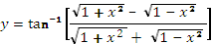 Find
- Prove that 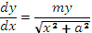
- 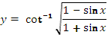 Find
- 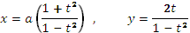 Find
- Show that 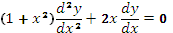
- Prove that 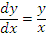
- Prove that 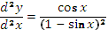
- 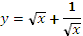 Show that 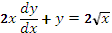
- Find , if
- 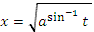 and 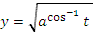 Show that 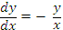
- If Prove that 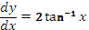
- Show that 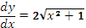
- Show that 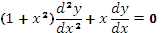
- 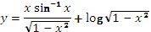 Show that 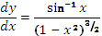
- If Show that 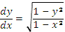
- If 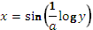 Show that
- If Prove that 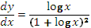
- Show that 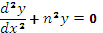
- Show that
Paper Submitted By:
Name: LOVEKUSH GOEL
Email: lovekushgoel@gmail.com
MOBILE: 09358021550

