Guess Paper – 2012
Class – XII
Subject –Informatics Practices
TIME : 3Hrs. M.M. 60
General Instructions: -
1). This Question paper is divided into three sections. Section- A, Section- B, and Section- C
2). Section – A consist of 10 Marks, Section – B consist of 25 marks and Section – C consist of 25
marks
3). Don’t write un-necessary answer in your answer sheet.
Q1. Write in brief the purpose of the following software: (1 x 4=4)
a). MySQL
b). LINUX
c). Mozilla
d). Apache Server
Q2. Distinguish between : (2)
Open Source Software and Propriety Software
Q3. Write the full forms of the following : (0.5 x 4=2)
a). OSS b). GNU c). W3C d). FOSS
Q4. The Omnipresent organization has set up its new center at New Nagar for its office and web
based activities. It has four blocks of buildings as shown in the diagram below: (0.5 x 4=2)
BLOCK
A
BLOCK
C

BLOCK
D

BLOCK
B

A to B | 40 m
B to C | 120 m
C to D | 60 m
A to D | 170 m
B to D | 150 m
A to C | 70 m

Distance between the various blocks is as follows :
Nubers of Computers
Block A | 25
Block B | 50
Block C | 125
Block D | 10
(i). Suggest a cable layout of connections between the blocks and topology.
(ii). Suggest the most suitable place (the block) to house the server of this organization with a
suitable reason.
(iii). Suggest the placement of the following device with justification.
a). Repeater
b). Hub/Switch
(iv). The Organization is planning to link its front office suited in the city in hilly region where cable connection
is not feasible, suggest an economy way to connect it with reasonably high speed.
Section – B
5) a). i). Define a class Book with the following specifications : [3]
Data Members of the class Book are :
BOOK_NO INTEGER
BOOK_TOTLE STRING
NO_OF_BOOKS INTEGER
PRICE FLOAT ( Price per copy)
TOTAL_COST() A Function to be calculate the total cost for number of copies.
Member method of the class book are :
INPUT() Function to read NO_OF_BOOKS, BOOK_TITLE, PRICE.
The following is the screen used to declare class to calculate total cost :
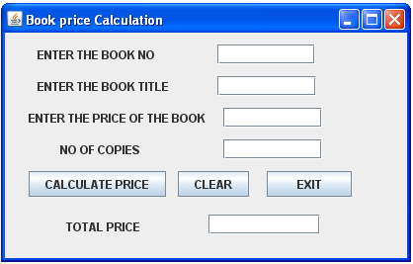
The list of the controls for the above form is as follows :
Control Type | Control Name | Property Title | Property Value
JTextField | JTextField1  JTextField2  JTextField3  JTextField4  JTextField5 | Variable Name  Variable Name  Variable Name  Variable Name  Variable Name | txtBno  txtBName  txtPrice  txtNo  txtTotal
JButton | JButton1  JButton2 | Variable Name  Variable Name | btnPrice  btnExit

a). Define a Java Class Book with required specification.
b). Write the code for calculation price buttons click event procedure to operate the class
Book’s Method.
c). Write the code for EXIT button to exit application.
ii). Define a Java class ‘Tour’ with the following specification: [3]
Data Members
TCode INTEGER
No_of_Adults INTEGER
No_of_Kids INTEGER
kilometers INTEGER
Total_Fare Float
A function AssignFare() which calculates and assigns the value of the data member Total_Fare
as follows :
FARE FOR KILOMETERS
500 >=1000
300 <1000 & >=500
200 <500
For each Kid the above fare will be 50% of the Fare mentioned in the above table.
For example:
if Kilometers is 850, No_of_Adults =2 and No_of_Kids =3
then Total_Fare should be calculated as :
No_of_Adults*300 + No_of_Kids*150
i.e. 2*300 + 3*150 = 1050
a). A function EnterTour() to input the values of the data members TCode, No_of_Adults,
No_of_Kids, and Kilometers, and invoke the AssignFare() Function.
b). A function ShowFare() which displays the total fare for the tour.
The following is the screen used to declare class to calculate Fare :
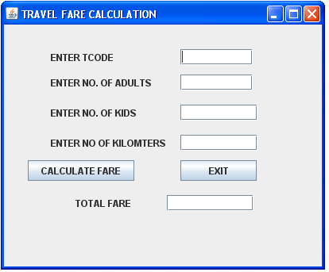
Control Type | Control Name | Property Title | Property Value
JTextField | JTextField1  JTextField2  JTextField3  JTextField4  JTextField5 | Variable Name  Variable Name  Variable Name  Variable Name  Variable Name | txtCode  txtA  txtK  txtKL  txtP
JButton | JButton1  JButton2 | Variable Name  Variable Name | btnF  btnExit

Define a class Tour with required specification.
b). write the code for Calculate Fare buttons click event procedure to operate the class Tour’
Method.
c). Write the code for EXIT button to exit application.
iii). Read the following case study and answer the questions that follow : [3]
AVON Tools has computerized its billing. The following is the data entry screen in NetBeans IDE used by them :
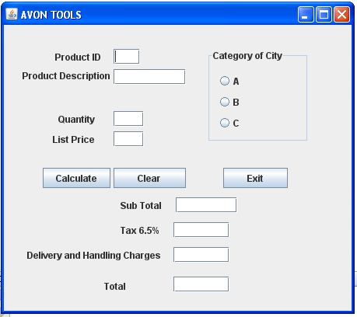
The list of controls for the above form is as follows :
Control Type | Control Name | Property Title | Property Value
JTextField | JTextField1  JTextField2  JTextField3  JTextField4  JTextField5  JTextField6  JTextField7  JTextField8 | Variable Name  Variable Name  Variable Name  Variable Name  Variable Name  Variable Name  Variable Name  Variable Name | txtPID  txtDesc  txtQty  txtPrice  txtSub  txtTax  txtCharge  txtTotal
JRadioButton | JRadioButton1  JRadioButton2  JRadioButton3 | Variable Name  Variable Name Variable Name | optA  optB  optC
JButton | JButton1  JButton2 | Variable Name  Variable Name | btnCalc  btnExit

When the user clicks Clear Button, all the values stored in the text boxes and option button should be cleared and set the category of the city as A.
When the command button with caption “Calculate” (cmdCalculate) is clicked, subtotal, tax (6.50% of subtotal), delivery and handling charges and Total Amount are computed and displayed.
The criterion of calculation of Delivery and handling charges is as given below:
Category of City | Charges
A  B  C | Rs. 2,000  Rs. 3,000  Rs. 3,500
Sub total is calculated by multiplying Quantity price.
Tax is calculated as 6.50% of Sub Total.
Total is calculated as the sum of sub total, tax, delivery and handling charges.
c). write the code for Exit Button to close the application.
6) . i). Write a program to implement Fibonacci Series (i.e. sum of previous number is the next [2]
number). e.g. ( 1 1 2 3 5 8 13 ……… )
store the resulted series in the JTextArea1. The following is the screen used to find Fibonacci Series.
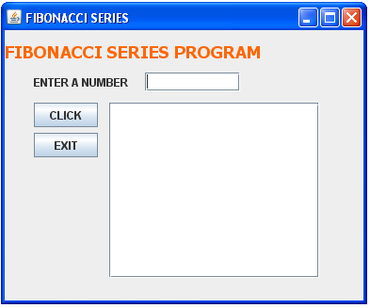
ii). Write a program to input any number and print them in reverse order using while statement. [2]
Whereas the input number must be positive. The following is the screen used to print the reverse of
a number.
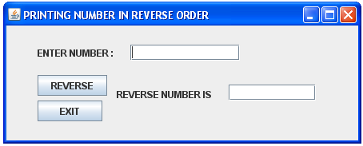
iii). Write a program to find out the Armstrong number : (for e.g. 153 = 13 + 5 + 3) [2]
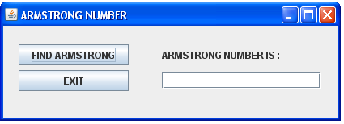
7). i). Find out errors, if any and rewrite the code in yours answer sheet with underline the errors: [2]
m=1;
n=0;
for ( ; m + n < 19 ; ++n)
System.out.println(“Hello \n”);
m = m + 10 ;
ii). While (ctr ! = 10) ; { [2]
ctr = 1 ;
sum = sum + a ;
ctr = ctr + 1;
}
8). i). What will be the output of the following program code : [1^{1/2}]
public class Num {
int x;
double y;
void init()
{
x=0;
y=0;
}
void read( int i, double j)
{
x = i;
y = j;
}
void display()
{
System.out.println(“x = > “ + x + “\n”);
System.out.println(“y = > “ + y + “\n”);
}
public static void main(String[] args[]) {
Num obj1=new Num();
Num obj2=new Num();
obj1.init();
obj2.init();
obj1.read(15, 11.21);
obj1.display();
obj2.display();
}
}
ii). What will be the output of the following program code : [1^{1/2}]
class Patt {
int Calc (int U)
{
if ( U%2 ==0)
return u+10;
else
return U*2;
}
void Pattern ( char M, int B)
{
for ( int CNT =0; CNT<B; CNT++)
System.out.println ( Calc (CNT) + M );
System.out.println();
}
}
public class Hello
public static void main ( String[] args ) {
Patt pt=new Patt();
pt.Pattern(‘*’,0);
pt.Pattern(‘#’, 4);
pt.Pattern(‘@’,3);
}
}
9). i). Rewrite the following ‘if-else ‘ segment using ‘switch-case’ statement : [1^{1/2}]
char code = ‘A’
if ( code = = ‘A’)
System.out.println(“Accountant”);
if ( ( code ==’C’ ) || (code = = ‘G’))
System.out.println(“Grade IV”);
if ( code = = ‘F’)
System.out.println(“Financial Advisor.”);
ii). Rewrite the Corrected code for the following program, underline each correction (if any) : [1^{1/2}]
void sum(int a, int b)
{
System.out.println(a + b);
}
private void jButton1ActionPeformed(java.awt.Event.actionEvent evt)
{
int a, b;
String str = JOptionPane.showInputDialog(“Enter the value of N”);
String a = Integer.parseInt(str);
str= JOptionPane.showInputDialog(“Enter the value of N”);
b=Integer.parseInt(str);
int s = sum(a, b);
System.out.println(s);
}
Section : C
Q10. Write the answer of the following questions:
a). What is the difference between Primary Key and Unique Constraints? [2]
b). Name any for data types in SQL. [1.5]
c). What is ‘ACID’ property in MySQL? [2]
d).Name two DDL and DML Commands. [2]
e). What is Foreign Key. Give Example. [2]
f). Define the term Degree. [1]
g). Define the term Tuple. [1]

Q11. a). Write a SQL Command to create table ‘MEMBER’ with following details : [1]
Column Name | Data Type | Size | Constraint
Mem_id  Mem_Name  Address  Mdate  Mem_Fee | INT  VARCHAR  VARCHAR  DATE  Double | 4  20  30  6,2 | Primary Key  NOT NULL  NOT NULL  CHECK ( Price greater than zero)

b). Write a Command to describe the structure of the above table. [1]
c). Add one more column in the above table as PHONE_NO of type INT and Size 10 [1]
d). Modify the column Address as char 25. [1]
e). Drop the Column Address. [1]
f). Change of the name of the column Mem_id to M_ID. [1]
g). Insert the record in the above table. [1]
h). Change the Address ‘Kolkatta’ as ‘Bangalore’ from Record 2 . [1]
i). Delete any one Record of the above table. [1]
j). Delete the Above table. [1]
1 | Mr. Arjesk Kumar | Mumbai | 21/11/2010 | 1550.50
2 | Mr. Rakesh Kumar | Kolkata | 28/2/2011 | 1875.80
Q12. Write the resulting output of the following: [1 x 0.5 = 3.5]
a). SELECT FLOOR (344.98)+CEIL(9876.89)
b). SELECT SUBSTR(‘ABS Public School’, 1,3);
c). SELECT UPPER(‘ABS Public School’);
d). SELECT 200+SQRT(144);|
e). SELECT MOD(ROUND(125.60, 1), 5);
f). SELECT MID(‘INFORMATICS PRACTICES’, 3, 8);
g). SELECT LENGTH (‘RAMESH SHARMA’);
-------------------------------------------------------- ------------------------------------------------------

Paper Submitted By:
Name: Gagan Kumar Agarwal
Email: gagan_agarwal2006@hotmail.com
Phone No. 09758777202

