Guess Paper – 2012
Class – XII
Subject – Informatics Practices

Section A
Q1.
- Write one advantage and one disadvantage of Bus Topology. 1
- What are the advantages of database over conventional file system? 1
- Differentiate between Hackers and Crackers. 1
- What are the various e-commerce categories? 2
- Explain the architecture of client-server. 2
- “Kanganalay Cosmetics” is planning to start their offices in four major cities in Uttar Pradesh to provide cosmetic product support in its retail fields. The company has planned to set up their offices in Lucknow at three different locations and have named them as “Head office”, “Sales office”, & “Prod office”. The company’s regional offices are located at Varanasi, Kanpur & Saharanpur. A rough layout of the same is as
follows:
An approximate distance between these offices as per network survey team is as follows:
Place from | Place to | Distance
Head office | Sales office | - M
Head office | Prod office | - KM
Head office | Varanasi office | - KM
Head office | Kanpur office | - KM
Head office | Saharanpur office | 408 KM
Number of computers:
Head office | 156
Sales office | 25
Prod office | 56
Varanasi office | 85
Kanpur office | 107
Saharanpur office | 105

- Suggest the placement of the repeater with justification. 1
- Out of the following devices suggest the device to be procured by the company for connecting all the computers in each of its offices 1
Modem
Switch/Hub
- The company is planning to link its head office situated in Lucknow with the office at Saharanpur. Suggest an economic way to connect it; the company is ready to compromise on the speed of connectivity. Justify your answer. 1
Q2.
- Swati needs to remove all the rows from SALES table to release storage space. But she does not want to remove the table structure. Which statement should she use? 1
- Compare DDL and DML statements of SQL. 1
- What is the importance of primary key in a table? Explain with example. 1
- Which command has to be given to start using the database created by you? 1
- What is meant by “Data independence”? 1
- What is key? Explain primary key and foreign key. 1
- Explain Cartesian product of two relations with an example. 2
- Explain Candidate key and Relation. 2
Q3.
- What is the use of default statement in switch case? 1
- Which is the parent class of JCheckBox and JRadioButton? 1
- What is javax.swing.JFrame? 1
- Explain the method of showInputDialog. 1
- What is type conversion and type casting? 1
- What is a container? Name three top-level containers. 1
- What is block statement? How are block statements used in java programme? 2
- What does it mean to prime a loop? 2

Section B
Q1.
- Write the output of the following java code. 2
int I = 0;
outer :
while (true)
{
I++;
inner:
for(int j=0;j<10;j++)
{
I+=j;
if(j==3)
break outer;
}
continue outer;

}
System.out.println(I);

- What will be the value of a and b after execution of following code: 2
int a=1,b=2;
while(++b<5)
{
a*=b;
}
System.out.print(""+a+","+b);
- What will be the output the following code fragment if the value of ch is 2
(i) a (ii) c (iii) d (iv) b
switch (ch)
{
case 'a':
System.out.println("It is a.");
case 'b':
System.out.println("It is b.");
case 'c':
System.out.println("It is c.");
break;
case 'd':
System.out.println("It is d.");
break;
default:
System.out.println("Not a ,b,c ,and d.");
}

- Write a java code to get the output as shown below by using loops. 3
A
B A
C B A
D C B A
E D C B A

- Write a java code to find the GCD (HCF) of the two numbers entered by the user: 3
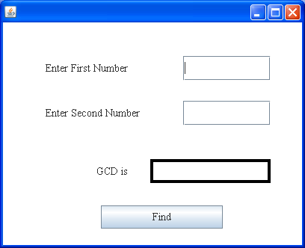
- Write a java method to find the sum of all digits of a number and return it in a label: 3
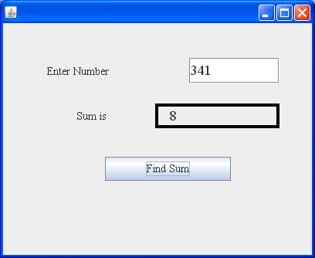
- Write a java code to generate the series given below: 3
1, 3, 6, 10, 11, 13, 16, 20 ………………………………………………
- Write a java code to generate the series given below: 2
100, 81, 64, 49, 36, ……………………………………………… 0
Section C
Q1.
- The Title and Price columns of table “Library” are given below: 2
TITLE | PRICE
Mastering C++ | 495
Guide Network | 500
Mastering SQL | 650
Dos GUIDE | 400
Basic for beginners | 399
Mastering Window
Based on this information ,find the output of the following queries:
- SELECT MIN(Price)from library where price>400;
- SELECT COUNT(price) from library;
- Select AVG(price) from library WHERE title like ‘%e%’;
- Select title from library where price = (select max(price) from library);
- Write an SQL command to creating a table, named ‘student’ whose structure is given below: 2
FIELD NAME | DATATYPE | SIZE | CONSTRAINT
Rno | Number | 3 | Primary Key
Class | Varchar | 5 | Primary Key
Percentage | Number | 5,2 | >0 and <=100
Projno | Number | 6 | FK –Project(pno)
Address | Varchar | 30 | Default Hyderabad

- Create a table MEMBER with the following details . 7
Field name | Field type | Size
Mem_code | Character | 3
Mem_name | Character | 30
Mem_phone | Character | 10
Mem_add | Character | 50
- Add the constraint - mem_code as primary key in the existing table MEMBER.
- Add a new record in the table.
- Show the structure of the table.
- Drop the Primary key constraint.
- Delete the column mem_add.
- Rename the field name Mem_phone as Mem_mobile.
- Copy only structure of member table to member1 without copying the data.
- Consider the following tables Client and Bill. Write SQL commands for the statements (i) to (iv) and give outputs for SQL queries (v) to (viii) 6

Table : Client
Cust_Id | Cust_Name | Address | Phone_no | City
C007 | Pritam Sharma | 12,M.G Road | 71274250 | Bangalore
C008 | Sutopa | 14/1 Pritam Pura | 41206819 | Delhi
C010 | Anurag Basu | 15A, Park Road | 61281921 | Kolkata
C012 | Hrithik | 7/2 Vasant Kunj | 26121949 | Delhi
C013 | Firoz Shah | 2, Servamali road | 25014192 | Bangalore
C025 | Vinod Nagpal | 46-a Navi Mumbai | 64104944 | Mumbai
C027 | Sameer | 41,Dwarka | 42101619 | Delhi
C002 | Pasunjit Bose | 16/A K.G Marg | 27220012 | Bangalore
C035 | Aamina Begum | 13/A Versova | 41612181 | Mumbai
Table : BILL
Ord_id | Cust_id | Item | Ord_date | Qty | Price
7002 | C007 | Pizza | 20-11-07 | 1 | 249.50
7003 | C013 | Garlic Bread | 24-10-05 | 3 | 75.75
7004 | C012 | Pasta | 03-03-07 | 4 | 173.00
7005 | C010 | Ice Cream | 01-01-08 | 30 | 195.75
7006 | C035 | Pizza | 02-03-06 | 4 | 249.50
7009 | C035 | Garlic Bread | 02-03-08 | 2 | 75.75
7010 | C013 | Brownie | 04-05-07 | 4 | 40.50
7011 | C014 | Ice Cream | 02-06-08 | 5 | 195.75
7012 | C002 | Pizza | 01-02-08 | 7 | 249.50

- Display a report containing cust_id, cust_name, Item,qty,price and bill amount. Bill amount is calculated as the sum of qty*price
- Display how many customers have ordered Pizza in the month of March.
- Count the number of customers who have ordered items worth more than 1700. Total amount = sum of qty* price
- Display the name of customer along with the city in alphabetical order of city
- select A.Cust_name , A.City, B.ord_date from Client A, Bill b Where A.Cust_id =b.Cust_id;
- select Cust_name from Client where Cust_id=( Select Cust_id from Bill where Year(ord_date) =2008);
- select count(*) from Client group by City;
- select Distinct (Item) from Bill;
- Write the output of the following queries. 3
- SELECT POW(2,-4) ;
- SELECT ROUND(1204.34, -3);
- SELECT TRIM( LEADING ‘san’ FROM ‘sansanjay is an IP teacher’);
- SELECT TRIM( Both ‘###’ FROM ‘####IP IS JAVA #####‘)
Nair Computer Classes Bhopal.
Mobile : 09826092456
- Select DAYOFYEAR(‘2008-10-31’)
- Select substr(right('School name is Sharda Vidya Mandir', length('School')+length('name')+length('practices')), 14);

