Sample Paper – 2012
Class – XII
Subject –Physics

Note: - Questions 1 to 8 carry one mark each, questions 9 to 18 carry two marks each, questions 19-27 carry three marks each and questions 28-30 carry five marks each.
Q1. Calculate Work done in moving a unit charge through a distance of x meter on an equipotential surface.
Q2. An electron beam projected along +X-axis, experiences a force due to a magnetic field along the +Y-axis. What is the direction of magnetic field?
Q3. Why does a metallic piece become very hot when it is surrounded by a coil carrying high frequency alternating current?
Q4. What features of electromagnetic waves led Maxwell to conclude that light itself is electromagnetic wave?
Q5. An object is placed between two plane mirrors inclined at 30⁰ to each other. How many images do you expect to see?
Q6. Two metals X and Y have work functions 2eV and 5eV respectively. Which metal will emit electrons, when irradiated with light of wavelength 400nm and why?
Q7. Define Doping & Dopant.
Q8. In a common emitter circuit, if V_{CE} is changed by 0.2V, collector current changes by 0.004 mA. Calculate the output resistance.
Q9. Two conductors A and B have capacities in ratio 2:3. A is given some charge, which it shares with B. Compare the total energy of A and B with initial energy of A.
Q10. If the current flowing in the copper wire be allowed to flow in another copper wire of double the radius, then what will be the effect on the drift velocity of the electrons? If the same current is allowed to flow in an iron wire of the same thickness, then?
Q11. Prove that when a current is divided between two resistances in accordance with Kirchhoff’s laws, the heat produced is minimum.
Q12. (a). A loop of irregular shape carrying current is located in an external magnetic field. If the wire is flexible, why does it change to circular shape?
(b). What is the main function of a soft iron core used in moving coil galvanometer?
Q13. Show that in the free oscillations of an LC circuit, the sum of energies stored in the capacitor and the inductor is constant in time.
Q14. Define reactance X and impedance Z. Can these be negative? If yes, when and what does it imply?
Q15. What is displacement current? Why did Maxwell introduce the concept of displacement current? Explain.
Q16. Explain why
(a). A diamond glitters in a brightly lit room, but not in dark room.
(b). The bubbles of air rising up in water tank appear silvery when viewed from top.
Q17. (a). Why Si and GaAs are preferred materials for solar cells?
(b). Can two p-n junction diodes placed back to back as p-n-p transistor?
Q18. Long distance radio broadcasts use short wave bands. Why?
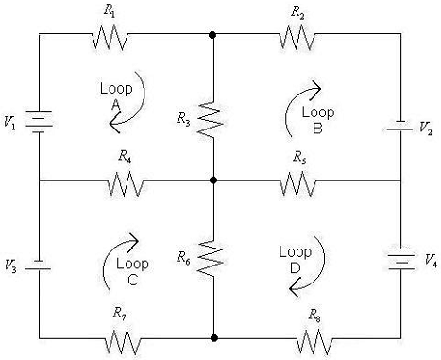
Q19. For the following circuit, set up appropriate number of current/node equations and voltage/loop equations and Calculate current in each arm of the give circuit. (V₁= 4V, V₂=V₃= 2V, V₄=6V, R1=R8=8Ω, R2=R7=6Ω, R4=R5=4Ω and R6=R3=2Ω).
Q20. When a circuit element X is connected across an a.c. source, a current of √2 A flows through it and this current is in phase with applied voltage. When another element Y is connected across same a.c. source, the same current flows in the circuit, but it leads voltage by π/2. Name the circuit elements X and Y. Find the current that flows in the circuit when series combination of X and Y is connected across same a.c. voltage. Plot graph showing variation of net impedance of series combination of X and Y as a function of angular frequency of applied voltage.
Q21. (a). Why there is do dispersion of light refracted through a glass slab?
(b). A ray of light is incident at an angle of 60⁰ on one face of 30⁰ prism. The emergent ray from the prism makes an angle of 30⁰ with the incident ray. Show that the emergent ray is normal to the surface from which it emerges. Calculate the refractive index of the material of the prism.
Q22. Draw a labeled ray diagram of a compound microscope. Write an expression for its magnifying power. How can the magnifying power be increased?
Q23. Explain de Broglie dualistic nature of matter and derive relationship for wavelength of matter waves.
Q24. Using Bohr’s formula for energy quantization, determine
(a). The longest wavelength in Lyman series of hydrogen atom spectrum.
(b). The excitation energy of the n=3 level of He⁺ atom.
(c). The ionization potential of the ground state of Li⁺⁺ atom.
Q25. State and explain the laws of radioactive disintegration. Hence define disintegration constant and half-life period. Establish relation between them.
Q26. Explain the working of n-p-n transistor as an amplifier and determine its voltage gain.
Q27. (a). How does the following be affected in the absence of atmosphere around earth?
(1). Surface temperature of earth. (2). Range of radio waves transmission.
(b). A T.V. tower has a height 100m. By how much the height of tower is increased to triple its coverage range.
Q28. Derive an expression for potential at a point due to electric dipole. Hence deduce values for potential at a point on :- (a). Dipole Axis (b). Equatorial Plane
Q29. (a). State Ampere’s Circuital Law.
(b). Using Ampere’s Circuital Law, Derive an expression for magnetic field due to current through a very long circular cylinder at point P :- (1). Lying outside the cylinder (2). Lying inside the cylinder. Also show the variation of magnetic field with the distance from the axis of cylinder in form of graph.
Q30. Define wave-front. What is meant by interference of light? Describe briefly Young’s Double slit experiment to demonstrate interference of light. Obtain the conditions for constructive and destructive interference of light.
Paper Submitted By:
Name: Naman Kareer
Email: naman_kareer@yahoo.in
Phone No. 9501998800

