Guess Paper – 2012
Class – XII
Subject – Chemistry
ALCOHOLS AND PHENOLS

Question 11.1:
Classify the following as primary, secondary and tertiary alcohols:
(i)
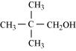
(ii)
(iii)
(iv)
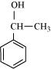
(v)
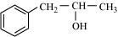
(vi)
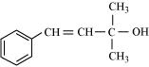
- Answer
Primary alcohol → (i), (ii), (iii)
Secondary alcohol → (iv), (v)
Tertiary alcohol → (vi)
Question 11.2:
Identify allylic alcohols in the above examples.
- Answer
The alcohols given in (ii) and (vi) are allylic alcohols
Question 11.3:
Name the following compounds according to IUPAC system.
(i)
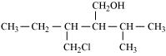
(ii)
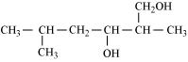
(iii)
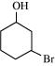
(iv)
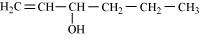
(v)
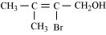
- Answer
(i) 3-Chloromethyl-2-isopropylpentan-1-ol
(ii) 2, 5-Dimethylhexane-1, 3-diol
(iii) 3-Bromocyclohexanol
(iv) Hex-1-en-3-ol
(v) 2-Bromo-3-methylbut-2-en-1-ol
Question 11.4:
Show how are the following alcohols prepared by the reaction of a suitable
Grignard reagent on methanal?
(i)
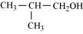
(ii)
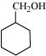
- Answer
(i)
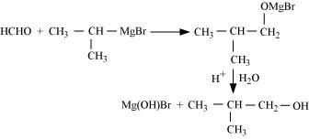
(ii)
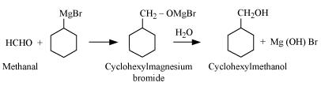
Question 11.5:
Write structures of the products of the following reactions:
(i)
(ii)
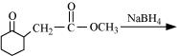
(iii)
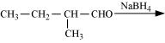
- Answer
(i)
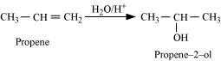
(ii)
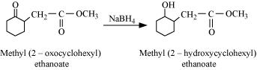
(iii)
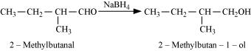
Question 11.6:
Give structures of the products you would expect when each of the following alcohol reacts with (a) HCl-ZnCl₂ (b) HBr and (c) SOCl₂.
(i) Butan-1-ol
(ii) 2-Methylbutan-2-ol
- Answer
(a)
(i)
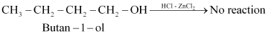
Primary alcohols do not react appreciably with Lucas’ reagent (HCl-ZnCl₂) at room temperature.
(ii)
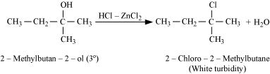
Tertiary alcohols react immediately with Lucas’ reagent.
(b)
(i)
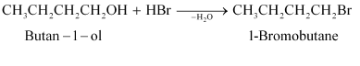
(ii)
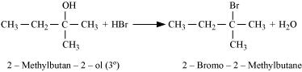
(c)
(i)
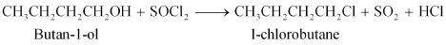
(ii)
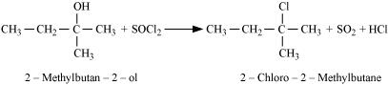
Question 11.7:
Predict the major product of acid catalysed dehydration of
(i) 1-methylcyclohexanol and
(ii) butan-1-ol
- Answer

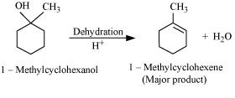
(ii)
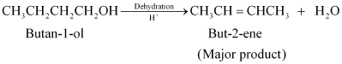
Question 11.8:
Ortho and para nitrophenols are more acidic than phenol. Draw the resonance structures of the corresponding phenoxide ions.
Answer 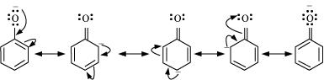
Resonance structure of the phenoxide ion
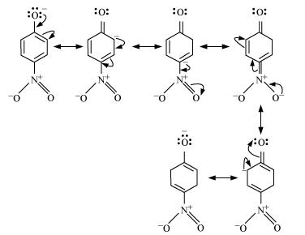
Resonance structures of p-nitrophenoxide ion
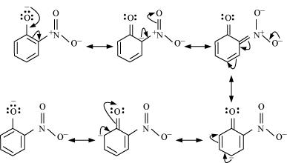
Resonance structures of m-nitrophenoxide ion
It can be observed that the presence of nitro groups increases the stability of phenoxide ion
Question 11.9:
Write the equations involved in the following reactions:
(i) Reimer-Tiemann reaction
(ii) Kolbe’s reaction
- Answer
- Reimer-Tiemann reaction
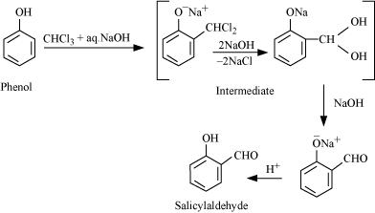
- Kolbe’s reaction
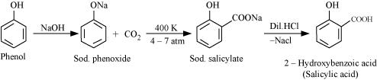
Question 11.10:
Write the reactions of Williamson synthesis of 2-ethoxy-3-methylpentane starting from ethanol and 3-methylpentan-2-ol.
- Answer
In Williamson synthesis, an alkyl halide reacts with an alkoxide ion. Also, it is an S_{N}2 reaction. In the reaction, alkyl halides should be primary having the least steric hindrance. Hence, an alkyl halide is obtained from ethanol and alkoxide ion from 3-methylpentan-2-ol.
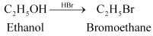
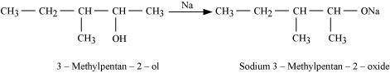
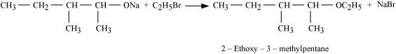
Question 11.11:
Which of the following is an appropriate set of reactants for the preparation of 1-methoxy-4-nitrobenzene and why?
(i)
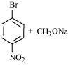
(ii)
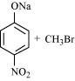
- Answer
Set (ii) is an appropriate set of reactants for the preparation of 1-methoxy-4-nitrobenzene.
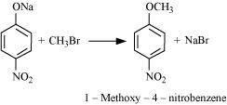
In set (i), sodium methoxide (CH₃ONa) is a strong nucleophile as well as a strong base. Hence, an elimination reaction predominates over a substitution reaction
Question 11.12:
Predict the products of the following reactions:
(i)
(ii)
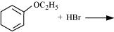
(iii)
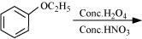
(iv)
- Answer
- (i)
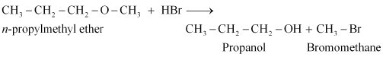
(ii)
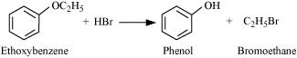
(iii)
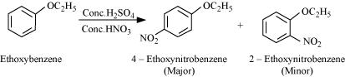
(iv)
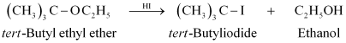
Question 11.1:
Write IUPAC names of the following compounds:
(i)
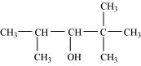
(ii)
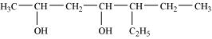
(iii)
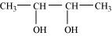
(iv)
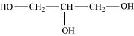
(v)
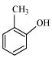
(vi)
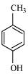
(vii)
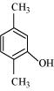
(viii)
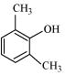
(ix)
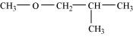
(x)
(xi)
(xii)
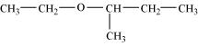
- Answer
(i) 2, 2, 4-Trimethylpentan-3-ol
(ii) 5-Ethylheptane-2, 4-diol
(iii) Butane-2, 3-diol
(iv) Propane-1, 2, 3-triol
(v) 2-Methylphenol
(vi) 4-Methylphenol
(vii) 2, 5-Dimethylphenol
(viii) 2, 6-Dimethylphenol
(ix) 1-Methoxy-2-methylpropane
(x) Ethoxybenzene
(xi) 1-Phenoxyheptane
(xii) 2-Ethoxybutane
Question 11.2:
Write structures of the compounds whose IUPAC names are as follows:
(i) 2-Methylbutan-2-ol
(ii) 1-Phenylpropan-2-ol
(iii) 3,5-Dimethylhexane −1, 3, 5-triol
(iv) 2,3 − Diethylphenol
(v) 1 − Ethoxypropane
(vi) 2-Ethoxy-3-methylpentane
(vii) Cyclohexylmethanol
(viii) 3-Cyclohexylpentan-3-ol
(ix) Cyclopent-3-en-1-ol
(x) 3-Chloromethylpentan-1-ol.
- Answer
(i)
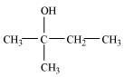
(ii)
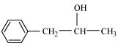
(iii)
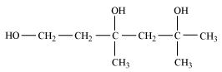
(iv)
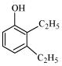
(v)
(vi)
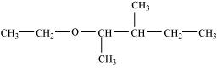
(vii)
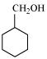
(viii)
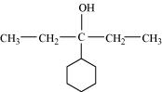
(ix)
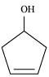
(x)
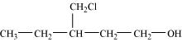
Question 11.3:
(i) Draw the structures of all isomeric alcohols of molecular formula C₅H₁₂O and give their IUPAC names.
(ii) Classify the isomers of alcohols in question 11.3 (i) as primary, secondary and tertiary alcohols.
- Answer
(i) The structures of all isomeric alcohols of molecular formula, C₅H₁₂O are shown below:
(a)
Pentan-1-ol (1°)
(b)
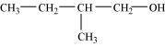
2-Methylbutan-1-ol (1°)
(c)
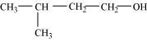
3-Methylbutan-1-ol (1°)
(d)
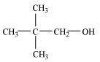
2, 2-Dimethylpropan-1-ol (1°)
(e)
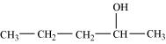
Pentan-2-ol (2°)
(f)
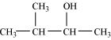
3-Methylbutan-2-ol (2°)
(g)
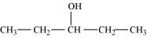
Pentan-3-ol (2°)
(h)
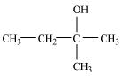
2-Methylbutan-2-ol (3°)
(ii) Primary alcohol: Pentan-1-ol; 2-Methylbutan-1-ol;
3-Methylbutan-1-ol; 2, 2−Dimethylpropan-1-ol
Secondary alcohol: Pentan-2-ol; 3-Methylbutan-2-ol;
Pentan-3-ol
Tertiary alcohol: 2-methylbutan-2-ol
Question 11.4:
Explain why propanol has higher boiling point than that of the hydrocarbon, butane?
- Answer
Propanol undergoes intermolecular H-bonding because of the presence of −OH group. On the other hand, butane does not
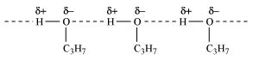
Therefore, extra energy is required to break hydrogen bonds. For this reason, propanol has a higher boiling point than hydrocarbon butane
Question 11.5:
Alcohols are comparatively more soluble in water than hydrocarbons of comparable molecular masses. Explain this fact.
- Answer
Alcohols form H-bonds with water due to the presence of −OH group. However, hydrocarbons cannot form H-bonds with water.
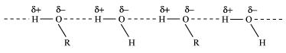
As a result, alcohols are comparatively more soluble in water than hydrocarbons of comparable molecular masses.
Question 11.6:
What is meant by hydroboration-oxidation reaction? Illustrate it with an example.
- Answer
The addition of borane followed by oxidation is known as the hydroboration-oxidation reaction. For example, propan-1-ol is produced by the hydroboration-oxidation reaction of propene. In this reaction, propene reacts with diborane (BH₃)₂ to form trialkyl borane as an addition product. This addition product is oxidized to alcohol by hydrogen peroxide in the presence of aqueous sodium hydroxide.
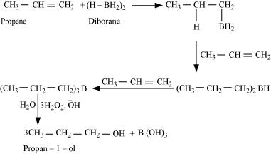
Question 11.7:
Give the structures and IUPAC names of monohydric phenols of molecular formula, C₇H₈O.
Answer 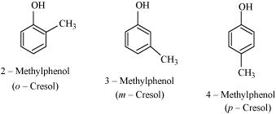
Question 11.8:
While separating a mixture of ortho and para nitrophenols by steam distillation, name the isomer which will be steam volatile. Give reason.
- Answer
Intramolecular H-bonding is present in o-nitrophenol. In p-nitrophenol, the molecules are strongly associated due to the presence of intermolecular bonding. Hence, o-nitrophenol is steam volatile.
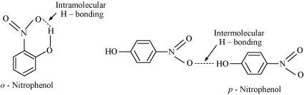
Question 11.9:
Give the equations of reactions for the preparation of phenol from cumene.
- Answer
To prepare phenol, cumene is first oxidized in the presence of air of cumene hydro-peroxide.
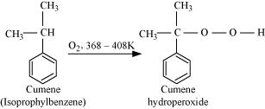
Then, cumene hydroxide is treated with dilute acid to prepare phenol and acetone as by-products.
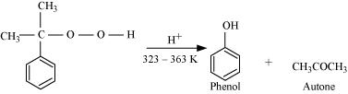
Question 11.10:
Write chemical reaction for the preparation of phenol from chlorobenzene.
- Answer
Chlorobenzene is fused with NaOH (at 623 K and 320 atm pressure) to produce sodium phenoxide, which gives phenol on acidification.
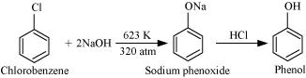
Question 11.11:
Write the mechanism of hydration of ethene to yield ethanol.
- Answer
The mechanism of hydration of ethene to form ethanol involves three steps.
Step 1:
Protonation of ethene to form carbocation by electrophilic attack of H₃O⁺:
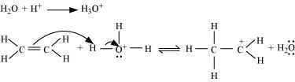
Step 2:
Nucleophilic attack of water on carbocation:
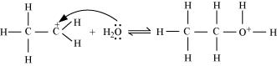
Step 3:
Deprotonation to form ethanol:
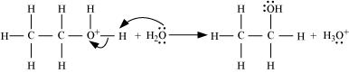
Question 11.12:
You are given benzene, conc. H₂SO₄ and NaOH. Write the equations for the preparation of phenol using these reagents.
Answer 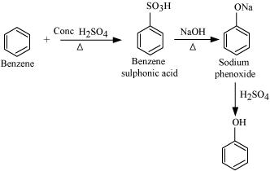
Question 11.13:
Show how will you synthesize:
(i) 1-phenylethanol from a suitable alkene.
(ii) cyclohexylmethanol using an alkyl halide by an S_{N}2 reaction.
(iii) pentan-1-ol using a suitable alkyl halide?
- Answer
(i) By acid-catalyzed hydration of ethylbenzene (styrene), 1-phenylethanol can be synthesized.
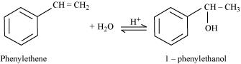
(ii) When chloromethylcyclohexane is treated with sodium hydroxide, cyclohexylmethanol is obtained.
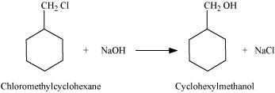
(iii) When 1-chloropentane is treated with NaOH, pentan-1-ol is produced.
Question 11.14:
Give two reactions that show the acidic nature of phenol. Compare acidity of phenol with that of ethanol.
- Answer
The acidic nature of phenol can be represented by the following two reactions:
(i) Phenol reacts with sodium to give sodium phenoxide, liberating H₂.
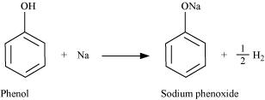
(ii) Phenol reacts with sodium hydroxide to give sodium phenoxide and water as by-products.
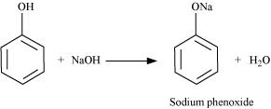
The acidity of phenol is more than that of ethanol. This is because after losing a proton, the phenoxide ion undergoes resonance and gets stabilized whereas ethoxide ion does not.
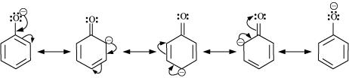
Question 11.15:
Explain why is ortho nitrophenol more acidic than ortho methoxyphenol?
Answer 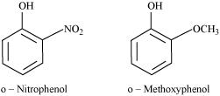
The nitro-group is an electron-withdrawing group. The presence of this group in the ortho position decreases the electron density in the O−H bond. As a result, it is easier to lose a proton. Also, the o-nitrophenoxide ion formed after the loss of protons is stabilized by resonance. Hence, ortho nitrophenol is a stronger acid.
On the other hand, methoxy group is an electron-releasing group. Thus, it increases the electron density in the O−H bond and hence, the proton cannot be given out easily.
For this reason, ortho-nitrophenol is more acidic than ortho-methoxyphenol
Question 11.16:
Explain how does the −OH group attached to a carbon of benzene ring activate it towards electrophilic substitution?
- Answer
The −OH group is an electron-donating group. Thus, it increases the electron density in the benzene ring as shown in the given resonance structure of phenol.
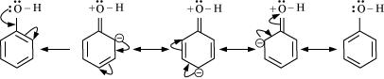
As a result, the benzene ring is activated towards electrophilic substitution
Question 11.17:
Give equations of the following reactions:
(i) Oxidation of propan-1-ol with alkaline KMnO₄ solution.
(ii) Bromine in CS₂ with phenol.
(iii) Dilute HNO₃ with phenol.
(iv) Treating phenol with chloroform in presence of aqueous NaOH.
- Answer
(i) 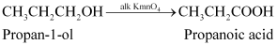
(ii)
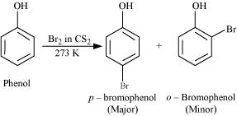
(iii)
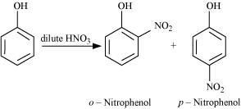
(iv)
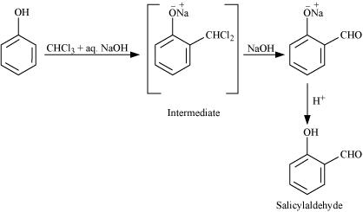
Question 11.18:
Explain the following with an example.
(i) Kolbe’s reaction.
(ii) Reimer-Tiemann reaction.
(iii) Williamson ether synthesis.
(iv) Unsymmetrical ether.
- Answer
(i) Kolbe’s reaction:
When phenol is treated with sodium hydroxide, sodium phenoxide is produced. This sodium phenoxide when treated with carbon dioxide, followed by acidification, undergoes electrophilic substitution to give ortho-hydroxybenzoic acid as the main product. This reaction is known as Kolbe’s reaction.
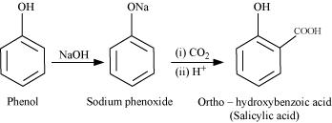
(ii) Reimer-Tiemann reaction:
When phenol is treated with chloroform (CHCl₃) in the presence of sodium hydroxide, a −CHO group is introduced at the ortho position of the benzene ring.
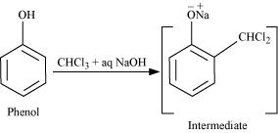
This reaction is known as the Reimer-Tiemann reaction.
The intermediate is hydrolyzed in the presence of alkalis to produce salicyclaldehyde.
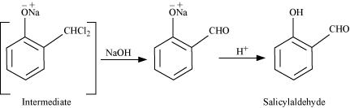
(iii) Williamson ether synthesis:
Williamson ether synthesis is a laboratory method to prepare symmetrical and unsymmetrical ethers by allowing alkyl halides to react with sodium alkoxides.
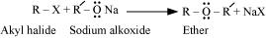
This reaction involves S_{N}2 attack of the alkoxide ion on the alkyl halide. Better results are obtained in case of primary alkyl halides.
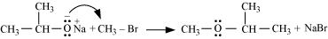
If the alkyl halide is secondary or tertiary, then elimination competes over substitution.
(iv) Unsymmetrical ether:
An unsymmetrical ether is an ether where two groups on the two sides of an oxygen atom differ (i.e., have an unequal number of carbon atoms). For example: ethyl methyl ether (CH₃−O−CH₂CH₃).
Question 11.20:
How are the following conversions carried out?
(i) Propene → Propan-2-ol
(ii) Benzyl chloride → Benzyl alcohol
(iii) Ethyl magnesium chloride → Propan-1-ol.
(iv) Methyl magnesium bromide → 2-Methylpropan-2-ol.
- Answer
(i) If propene is allowed to react with water in the presence of an acid as a catalyst, then propan-2-ol is obtained.
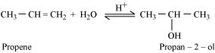
(ii) If benzyl chloride is treated with NaOH (followed by acidification) then benzyl alcohol is produced.
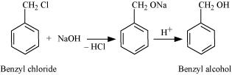
(iii) When ethyl magnesium chloride is treated with methanal, an adduct is the produced which gives propan-1-ol on hydrolysis.
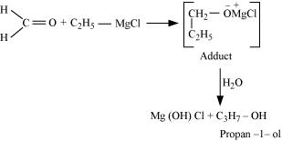
(iv) When methyl magnesium bromide is treated with propane, an adduct is the product which gives 2-methylpropane-2-ol on hydrolysis.
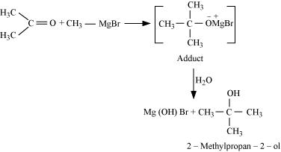
Question 11.21:
Name the reagents used in the following reactions:
(i) Oxidation of a primary alcohol to carboxylic acid.
(ii) Oxidation of a primary alcohol to aldehyde.
(iii) Bromination of phenol to 2,4,6-tribromophenol.
(iv) Benzyl alcohol to benzoic acid.
(v) Dehydration of propan-2-ol to propene.
(vi) Butan-2-one to butan-2-ol.
- Answer
(i) Acidified potassium permanganate
(ii) Pyridinium chlorochromate (PCC)
(iii) Bromine water
(iv) Acidified potassium permanganate
(v) 85% phosphoric acid
(vi) NaBH₄ or LiAlH₄
Question 11.22:
Give reason for the higher boiling point of ethanol in comparison to methoxymethane.
- Answer
Ethanol undergoes intermolecular H-bonding due to the presence of −OH group, resulting in the association of molecules. Extra energy is required to break these hydrogen bonds. On the other hand, methoxymethane does not undergo H-bonding. Hence, the boiling point of ethanol is higher than that of methoxymethane.
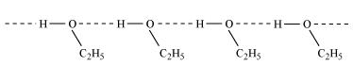
Question 11.23:
Give IUPAC names of the following ethers:
(i)
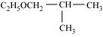
(ii)
(iii)
(iv)
(v)
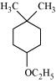
(vi)
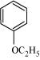
- Answer
(i) 1-Ethoxy-2-methylpropane
(ii) 2-Chloro-1-methoxyethane
(iii) 4-Nitroanisole
(iv) 1-Methoxypropane
(v) 1-Ethoxy-4, 4-dimethylcyclohexane
(vi) Ethoxybenzene
Question 11.24:
Write the names of reagents and equations for the preparation of the following ethers by Williamson’s synthesis:
(i) 1-Propoxypropane
(ii) Ethoxybenzene
(iii) 2-Methoxy-2-methylpropane
(iv) 1-Methoxyethane
- Answer
(i)
(ii)
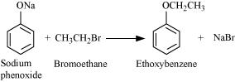
(iii)
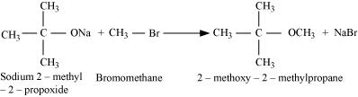
(iv)
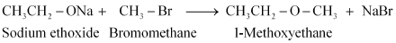

Question 11.25:
Illustrate with examples the limitations of Williamson synthesis for the preparation of certain types of ethers.
- Answer
The reaction of Williamson synthesis involves S_{N}2 attack of an alkoxide ion on a primary alkyl halide.
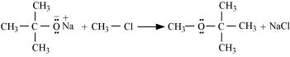
But if secondary or tertiary alkyl halides are taken in place of primary alkyl halides, then elimination would compete over substitution. As a result, alkenes would be produced. This is because alkoxides are nucleophiles as well as strong bases. Hence, they react with alkyl halides, which results in an elimination reaction.
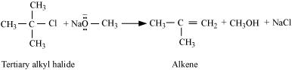
Question 11.26:
How is 1-propoxypropane synthesised from propan-1-ol? Write mechanism of this reaction.
- Answer
1-propoxypropane can be synthesized from propan-1-ol by dehydration.
Propan-1-ol undergoes dehydration in the presence of protic acids (such as H₂SO₄, H₃PO₄) to give 1-propoxypropane.
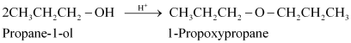
The mechanism of this reaction involves the following three steps:
Step 1: Protonation
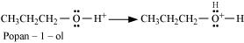
Step 2: Nucleophilic attack
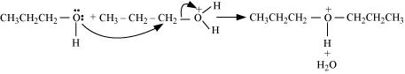
Step 3: Deprotonation
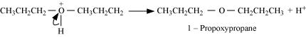
Question 11.27:
Preparation of ethers by acid dehydration of secondary or tertiary alcohols is not a suitable method. Give reason.
- Answer
The formation of ethers by dehydration of alcohol is a bimolecular reaction (S_{N}2) involving the attack of an alcohol molecule on a protonated alcohol molecule. In the method, the alkyl group should be unhindered. In case of secondary or tertiary alcohols, the alkyl group is hindered. As a result, elimination dominates substitution. Hence, in place of ethers, alkenes are formed.
Question 11.28:
Write the equation of the reaction of hydrogen iodide with:
(i) 1-propoxypropane
(ii) Methoxybenzene and
(iii) Benzyl ethyl ether
- Answer
(i)
(ii)
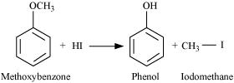
(iii)
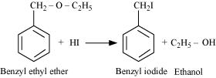
Question 11.29:
Explain the fact that in aryl alkyl ethers
(i) The alkoxy group activates the benzene ring towards electrophilic substitution and
(ii) It directs the incoming substituents to ortho and para positions in benzene ring.
- Answer (i)
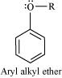
In aryl alkyl ethers, due to the +R effect of the alkoxy group, the electron density in the benzene ring increases as shown in the following resonance structure.
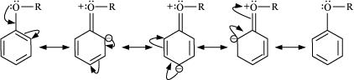
Thus, benzene is activated towards electrophilic substitution by the alkoxy group.
(ii) It can also be observed from the resonance structures that the electron density increases more at the ortho and para positions than at the meta position. As a result, the incoming substituents are directed to the ortho and para positions in the benzene ring
Question 11.30:
Write the mechanism of the reaction of HI with methoxymethane.
- Answer
The mechanism of the reaction of HI with methoxymethane involves the following steps:
Step1: Protonation of methoxymethane:
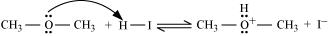
Step2: Nucleophilic attack of I^{−:}
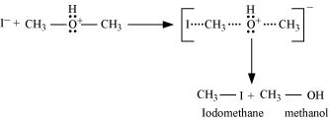
Step3:
When HI is in excess and the reaction is carried out at a high temperature, the methanol formed in the second step reacts with another HI molecule and gets converted to methyl iodide
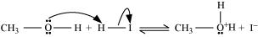
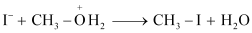
Question 11.31:
Write equations of the following reactions:
(i) Friedel-Crafts reaction−alkylation of anisole.
(ii) Nitration of anisole.
(iii) Bromination of anisole in ethanoic acid medium.
(iv) Friedel-Craft’s acetylation of anisole.
- Answer
(i)
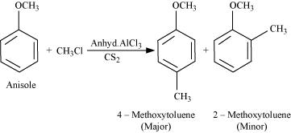
(ii)
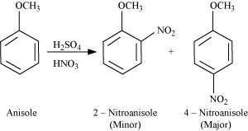
(iii)
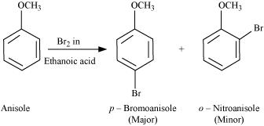
(iv)
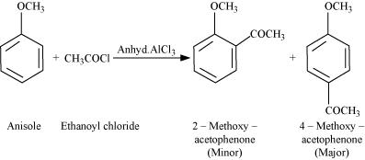
Question 11.32:
Show how would you synthesise the following alcohols from appropriate alkenes?
(i)
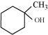
(ii)
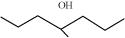
(iii)
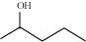
(iv)
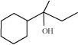
- Answer
The given alcohols can be synthesized by applying Markovnikov’s rule of acid-catalyzed hydration of appropriate alkenes.
(i)
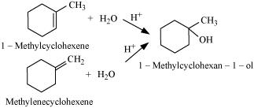
(ii)
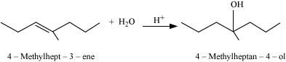
(iii)
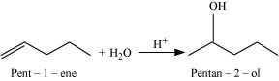
Acid-catalyzed hydration of pent-2-ene also produces pentan-2-ol but along with pentan-3-ol.
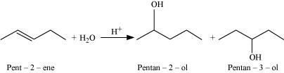
Thus, the first reaction is preferred over the second one to get pentan-2-ol.
(iv)
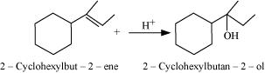
Question 11.33:
When 3-methylbutan-2-ol is treated with HBr, the following reaction takes
place:
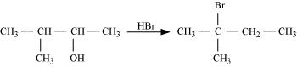
Give a mechanism for this reaction.
(Hint : The secondary carbocation formed in step II rearranges to a more
stable tertiary carbocation by a hydride ion shift from 3rd carbon atom.
- Answer
The mechanism of the given reaction involves the following steps:
Step 1: Protonation
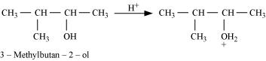
Step 2: Formation of 2° carbocation by the elimination of a water molecule
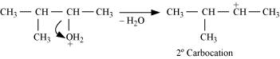
Step 3: Re-arrangement by the hydride-ion shift
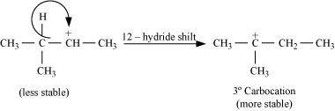
Step 4: Nucleophilic attack
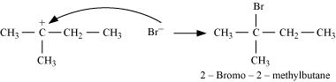

Paper Submitted By:
Name MANISH TULI
Email saimanishtuli@rediffmail.com
Phone No. 9425809658

