Sample Paper – 2012
Class – XII
Subject – Physics
Electrostat,& EMI
Q 1—two copper spheres of the same radii ,one hollow & other solid are charged to the same potential. Which of these two will hold more charge. (1) mark
Q 2—can similarly charge bodies ever attract each other explain? (1) mark
Q 3—two equally charged identical metal spheres A & B repel each other with a force 2×N . Another identical uncharged spheres C is touched to B and then placed at the mid point between A & B. what is the net electric force on C. (2)mark ans- 2 N along .
Q 4- the belt of vandegraff generator is 50cm wide.the belt is moving with a speed of 30 cm//sec. if thisbelt is desposing charge on a sphere at rate of ampere then calculate the surface density of ncharge on belt. Ans 6.67c/. (2) marks.
Q 5—two charges of values 2µC & -50µC are placed at a distance 80 cm apart .calculate the distance of the point from the smaller charge where the iintensity will be zero. (2) marks ans – 20 cm from smaller charge.
Q 6-- two charges of values -4µC &+16µC are placed at a distance 60 cm apart .calculate the distance of the point from the smaller charge where the potential will be zero. (2) marks ans --- 12 cm inside or 20 cm outside .
Q7-- an electric dipole consist of two opposite charge of strength 2µc separated by a distance of .02 m calculate the maximum torque which can be exerted on dipole if it is kept in uniform field of strength N/colmb. (2) marks ans 4N/col.
Q8 – for a flash pictures a photographer uses a capacitor of 30µf and a charger that supplies 3volt. Calculate the heat &charge generated (2) marks ans -135joule , .09 coulomb
Q9—a parallel plate condenser condenser consist of two plates of area 100 sq.cm each and their separation is 1cm .A square glass slab of thickness 1 cm and 5 cm is placed between the plates . calculate the capacity if the dielectric constant of glass is 10 . (3) marks ans - 2.87F.
Q10- calculate the capacity between the points M & N. in the given figure
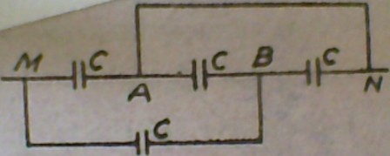
Ans -5c/3 (2) marks
Q11-- a coil of area 4 square m has 400 turns it is placed with its plane perpendicular to a uniform field of strength wb/m2 calculate the change in flux if the coil is rotated through (1) 60˚ (2) 90˚ (3) 180˚ (3) marks ans – 8, 16 , 32 weber respectively
Q12-- a conducting rod of length 1 metre makes contact with the metal rail CM & DN . the whole system is kept in a uniform magnetic fiwld induction .4 wb/m2 .calculate indued emf in the rod if it moves with a velocity of 10 m/sec as shown in the figure
Ans - 4 ( 3) marks 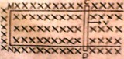
Q13-- a coil of inductance 20 henery & resistance 40 Ω is connected to 22 volt supply .calculate the current after .5 sec. when the switch is cut off. (2) marks
Ans- .2023 ampere
Email-dcdilipkumar@gmail.com dilip kumar choudhary

