Sample Paper – 2012
Class – X
Subject –MATHEMATICS

Arithmetic progressions
Time – 1 hr M.M.
All questions are compulsory and carrying 4 marks each:
- If the general term of A.P. is an = - 4n + 15. Find its 15th term.
- Is 184 is the term of the series 3, 7, 11…………..
- Find the 10th term of the A.P 1, 4, 7, 10……..
- The sum of three numbers in A.P. is -3 and product is 8. Find the numbers.
- If the m^{th} term of A.P. is 1/n and n^{th} term is 1/m, show that the sum of mn term is ½(mn +1).
- How many terms of the series 54, 51, 48 --------- be taken so that their sum 513.
- The sum of three terms of an A.P. is 21 and the product of the first and the third term exceed the second term by 6. Find the terms.
- In an A.P. if the 5th and 12th terms are 30 and 65 respectively, what is the sum of first 20 terms.
- The sum of n, 2n, 3n terms of an A.P. are s₁, s₂, and s₃ respectively. Prove that
S₃ = 3(s₂ – s₁)
- Find the sum of the all three digit natural numbers, which are divisible by 3.
- Two APs have the same common difference. The difference between their 100th term is 100, what is the difference between their 1000th terms?
- In a potato race, a bucket is placed at the starting point, which is 5 m from the first potato,and the other potatoes are placed 3 m apart in a straight line. There are ten potatoes in the line
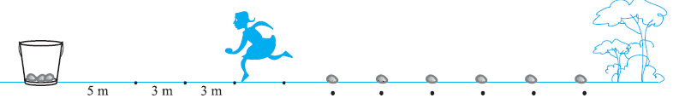

Time 1hr M.M. 35
Answer the following questions:

(Carrying two marks each)

- Find the distance b/t the points (a, b) and (-a, -b).
- Is 184 is the term of the series 3, 7, 11…………..
- Find the ratio in which the line segment joining the points (-3, 10) and (6, -8) divided by (-1, 6).
- Find the value of a if the distance b/w the points (3, a) and (4,1) is √10.
- Find the sum of n natural numbers.
(Carrying three marks each)

- Check whether (5, -2), (6, 4) and (7, -2) are the vertices of isosceles triangle.
- How many terms of the series 54, 51, 48 --------- be taken so that their sum 513.
- if (1, 2), (4, y), (x, 6) and (3, 5) are the vertices of the parallelogram taken as order . Find the value of x and y.
- For what value ‘a’ these points are collinear
(7, -2), (5, 1), (3, a)
- If five times the fifth term of an A.P. is equal to 8 times of its 8 term. Show that its 13th term is zero.
(Carrying five marks)

- Find the area of the quadrilateral with vertices (-4, -2), (-3, -5), (3, -2) and (2, 3).
- A spiral make up a successive semicircles, with centers alternately at A and B, starting with center at A of radii .5 cm, 1.0 cm, 1.5 cm ……. . What is the total length such a spiral making up in thirteen consecutive semicircles?
(Takeπ = 22/7)

VANDANA TUTORIAL
Mapping your future…
sanjeev_29nov@rediffmail.com
9897632688, 99997121333

