Sample Paper – 2012
Class – XII
Subject –MULTIMEDIA AND WEB TECHNOLOGY
Sample paper 3

Time allowed : 3 hours Maximum Marks: 70
________________________________________________
- Candidates must write the Code on the title page of the answer-book.
- Underline the keyword and start answer with punch line.
- Must write supporting answer for all descriptive questions.
- Please check that this question paper contains 7 questions.
_____________________________________________________________
- (a) What is the significance of database? 1
(b) Define the following database terminology 1
1. Degree
2. Cardinality
( c) What is the difference between Number and date data types ? 1
(d) What is the length of text type field ? 1
(e) How is the Alternate key is different from Foreign key ? 1
(f)Study the following data and answer the questions given below :
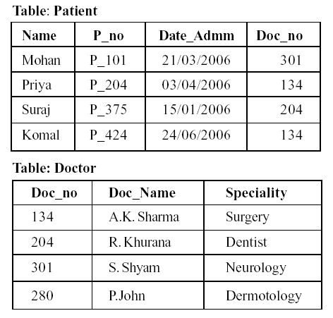
i. Name the field, which can act as the primary key for the table Patient and the table Doctor respectively. 1
ii. Name the field, which can act as the foreign key for the table Patient.1
iii. What type of relationship exists between the table Patient and the table Doctor ? 1
(f) What is the full form of MIDI ? 1
(g) Differentiate between JPEG and GIF file formats. 1
(h) Give extension of any two sound file formats. 1

2. . Questions given below are based on Macromedia Flash:
a) Write steps to include flash file into a HTML file? 1
b) Define the term layer. What are the different properties of layer that can be set using layer property dialog box? 2
c) Explain the concepts of Frame, Frame Buffer and Frame Rate. 1.5
d) How character kerning is different from character tracking? 1
e) What do you mean by publishing a flash movie ?Name different formats in which flash movie can be published . 2
f) Observe the figure given bellow and do as directed : 4
- The image on the left hand side shows the position and size of the image for frame1.
- The image on the right hand side shows the position and size of the image for frame 40.
Write the procedure and property settings for animating the above scenario.

3 . Question given below are based on HTML:
- What is URL ? Explain different Types of URL. 2
b) How can you include background sound in HTML page ? 2
or
(b) Explain the importance of font tag ? How font is different from base font tag?
(c) Define <DL> tag . 1
(d) explain the importance of NOFRAME tag . 1
c) Write the HTML code to generate a Web Page in the format given below : 4
Consider the following while writing the HTML code
1. Background colour of the page should be “Pink”, text color should be “Maroon” and link colour should be “Green”.
2. Title of the page is “DehraDun”.
3. Text colour of main heading on the page should be “Red”.
4. Font face of text in the page should be “Arial”.
5. Picture used in the page is the file “forest.jpg ,village.jpg , morning.jpg”.
6. Use the concept of list to display the given list.
7. Pages linked to :
- Mussorrie - m.html
- Sahastradhara- s.html
- IIT roorkee – iit.html
- Dobhri – Dobhri.html
- Haridwar – h.html
- Rishikesh – r.html
8. The table should have a caption “Travel”, a border of 2 pixels and the background color of the first row should be “Aqua”.

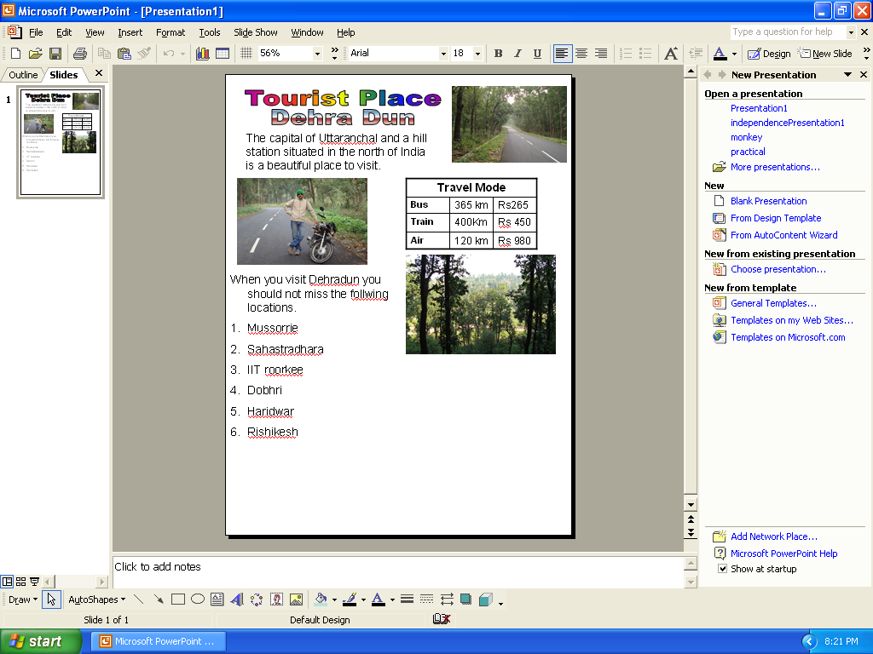

4.
- What do understand by the cursortype of a recordset? What are the different values that a user can specify for the cursortype? 2
- Explain with example the difference between implicit and explicit declaration of variables. 1
- What do you mean by trimming ? How can you implement the trimming concept in ASP program? 1 1 1
- How IF ..ELSE…END IF is different from SELECT CASE….END SELECT statement ? explain with syntax . 1
- Write the difference between Sub Procedure and Function. 1
- Differentiate between Response Object and Request Object with the help of an example ? 1
- Differentiate between flush method and end method of response object .1
- Find output 3
- Response.write(ucase(mid(“ congratulations!”,2,abs(13 mod 5))
- Response.write(instr(“mistrust or DISTRUST” , “ST”)
- Response.write( Right (“ CLASS XII , hour(#4:30:10 AM#)

5. a. Convert the following coding in to for ………..next loop 2
a=1,b=20,c=3,d=4,e=5
do while b>=10
sum=a+b+c+d+e
a=a+3
b=b-7
c=c+3+d+e/2
loop %>
b. Find the errors in the following ASP code 2
<mtnl>
<body>
<%
s=” Dynamic Array”
do while (i<7)
if mod(len(s),2)
document.write (n)
next %>
</body>
</html>
c. Find the output of the following ASP coding 2
<%
i=4
atx=array(10,20,30,40,50,60)
min=1
do while(i>=min)
atx(i)= atx(i)\3
i=i-1
response.write(atx(i))
loop %>
</body>
</html>
d) write a program in ASP to count the number of space in a paragraph stored in “d:/wwwroot/localhost/astronaut.txt” 3

6. a) Differentiate between Local and Global scope of a variable in VbScript.1
b) Change the following script using Do while …….. loop without affecting the output: 2
<script language="VBScript">
sub result()
dim i,r,rev,k
k=000004320100
for i = 5 to 12 step 5
r=k mod 10
rev=rev*10+r
k=k\10
next
end sub
</script>
c) Give the output for the following script code: 2
<script Language="VBScript">
sub result()
Name = “Web Tech”
startword = true
For i = 1 to Len (Name)
if (startword) Then
Document.Write (Mid (Name, i, 1) )
if (Mid (Name, i, 1) = ‘W’ Then
startword = false
else
startWord = true
End if
End If
Next
end sub
</Script>

d)Rewrite the following code after correcting the errors: 2
<”script language” =vbscript>
sub result()
dim N1,N2,sum,i
N1=messagebox(“enter number”)
N2 =messagebox(“enter number”)
Do while i<=N2
sum=N1+N2
if sum=100
exit do
next
end sub
end sub
</script>
e ) Write the HTML code for creating the form given below and also write the embedded VBScript code for the click event of the submit button, such that it displays a message with the name entered by the user and amount of his bill. The costs are given below : 3
Regular Pizza : Rs. 200
Pan Pizza : Rs. 250

The toppings cost extra :

Cheese Topping : Rs. 80
Capsicum Topping : Rs. 95
Peperoni Topping : Rs. 70

If the user enters name as “Umang” and selects “Pan” and topping as “Cheese” then it should display the message “Dear Umang ! Your bill amount is Rs. 330” in a message box.
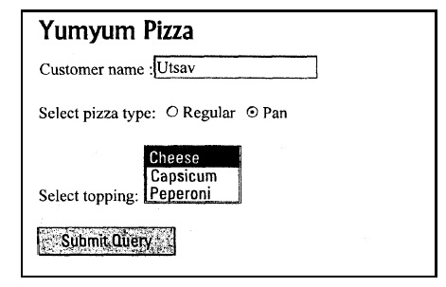

7.
(a). Write a short note on 1
1) Interspace 2) Intranet
(b).Define the following network devices : 1
bridge, router
(c).Write short notes on the following communication protocols: 1
TCP/IP , FTP
(d) Explain the following network security concepts. 1
firewall ,Crackers.

(e)Infoedge is a Noida based big organisation and has 5 Wings(Wing1 – Nokri.Com, Wing2- Geevansathi.Com , Wing3- 99 Acres.Com, Wing4 – Brijj.Com, Wing5-Siksha.Com) where it runs its operations (shown below): 4

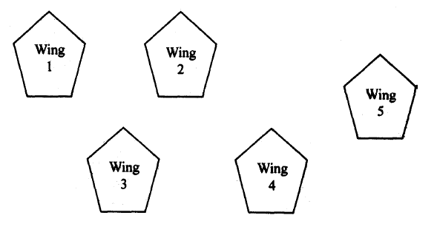

The distances between the different wings are given below :

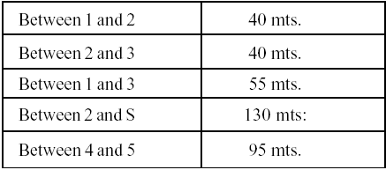
Each wing contains following number of computers :
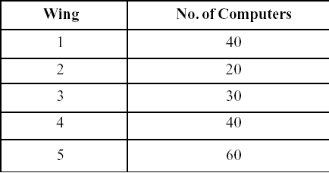

Answer the following questions based on the above given information :
(i) Suggest suitable cable layout(s) for connecting the wings.
(ii) Where do you think the server should be placed and explain why ?
(iii) Suggest the type of cable must should be used if the organization wants
the most economical option.
(iv) Where and why should repeaters be used ?

******************

Solution –sample paper 3
Q1 a. significance of database
- to reduced data redundancy
- to share the data among all other users
- inconsistency can be avoided
- integrity can be maintained

b. degree: total number of attribute (coloumn)
cardinality: total number of rows(tuple)
c.
Number | Date
User can calculate or update and end enter numeric value | Not more than 8 digit
It can be in decimal | Can enter system date, contains date and time information.
d. 255 text data type store number as well as character and default is 50.
e.
Alternate key | Foreign key
A key not selected for primary | Used to link related table
One out of two candidate key | Always primary key for first table
A key that could also be used as a unique identifier for an entity. | Does not uniquely identify rows in that table
f. i) patient P_no
doctor Doc_no
ii) Doc_no
iii) between patient and doctor
many – to – one
MIDI Musical instrument digital interface

g.
JPEG | GIF
High resolution can take 24 byte(bits) color combination means millions of color | Low in resolution can take 8 byte(bits) color combination means 255 colors
Joint photographic engineering group | Graphics interface format

h. .mp3
.mva
.WMA

Q2. a. to include flash file into a HTML file use following command
<EMBED SRC = “Filename.swf”>

b. layer: it is a transparent sheet of plain glass placed on the top of others.
* properties of layer:
i. layer name
ii. show and lock
iii. type
iv. outline color
- layer height
- layer as outline (check view) etc.

c. frame: it is a segment of movie
mainly used for creating and storing object.

- frame buffer: before displaying where movie stored called frame buffer.
- Frame rate: number of frame per second. It actually used to control the speed of movie.

d.
Character kerning | Character tracking
When there are unequal space between the character it is called kerning. It controls the spacing between pairs of characters. | When there are equal uniform space between characters it is called tracking.

e. publishing means delivering a complete movie to the audience.

Formats
- html
- swf
- gif
- jpeg
- png
- exe
- hax
- mov
- smil

f. following are the steps to shape tweening:-
i. draw a sun shape on the first frame.
ii. place the playhead at the 40th frame and insert a keyframe
(insert – timeline – keyframe)
iii. drag the object by selecting the selection tool, select both stroke and the fill. Place it on the right hand side of the stage as shown in the figure.
iv. at the 40th frame, delete the sun shape and draw a different shape lets say cloud with a different fill colour.
v. place the playhead at the first frame and right click over it. Chose panels > frame.
Frame dialog will appear. In tween option select “shape” and in the blend option select “Distributive”.
Q3 a. URL (universal resource locator)
WWW uses an addressing scheme known as URL to indicate the location of such items.
In the WWW a unique location of a web site is required to view that web page / site in the browser. This unique address of the web element is reffered to as a URL.
Types of URL
- absolute URL: it uses a complete internet address to give the location of a resource. For example http:\www.yahoo.com\index
- relative URL: it only designates the file name.
- fragment URL: using the name attribute of an <A> element creates an anchor, the fragment URL is created.
b. to include background sound in html page use following coding
<bgsound src=”music.wav” loop=3>
here
loop = -1 is infinite

or

font tag
font is a container tag and always written inside body tag. With the halp of font tag we can change size (1 to 7) color (in ---- code, or simple text like “red”) and face (arial etc)
Font tag | Basefont tag
Container tag | Empty tag
Can used many times in a document | Only one time used
Attributes are face, size,color | Attributes are face, size , color

Q3 c
<dl> tag (definition list)
there are two type of list order and unorder list. <dl> tag is used to define the heading of a topic and the description.
Other sub tag of <dl> are
i). <DD> (definition description)
ii) <DT> ( definition term)

d. importance of NOFRAME tag.
<NONFRAME>
all browser do not support frame, due to this if <NONFRAME> tag is not used browser shows errors on display.
So <NONFRAME> is used to ignore the error and if browser do not support the frame it will not display errors.

Example:
<html>
<head> <title> nonframe</title>
</head>
<NoFrame>
<Frame set ……………………
…………………………..
…………………………..
……………………
</Frame set>
</NoFrame>
</html>

e. <html>
<head>
<title> behradun</title>
</head>
<body bgcolor =”pink” text = “maroom” ling =”green”>
<font color = “red”> <h1> tourist place <br> dehradun </h1> </font>
<br>
<basefont face = “arial”>
<imag src = “forest.jpg” align = right” height=30 width =40>
<p> the capital of uttarnachal and a hill<br>
station situated in the north of India<br>
is a beautiful place to visit<br></p>
<ing src =”village.jpg” align = :left” height =”30” width =”40”>
<table align = right border =1 cellspacing = 1 cellpadding =3>
<caption> travel </caption>
<tr> <th colspan =3 bgcolor=”aqua”> travel mode </tr>
<tr> <th> bus</th>
<td>365 Km </td>
<td> Rs 265</td>
</tr>
<tr> <th> train</th>
<td> 400Km</td>
<td>Rs450</td>
</tr>
<tr> <th> Air</th>
<td> 120Km</td>
<td>Rs980</td>
</table>
<br>
<img src = “mprning.jpg” heigt = 30 width=40 align=right>
<p> when you visit dehradun you<br>
should not miss the following<br>
locations<br> </p>
<ol type = “1” start = ‘1’>
<LI> < a herf = m.html> Mussorie </a> </LI>
<LI> < a herf = m.html> sahastradhara </a> </LI>
<LI> < a herf = m.html> IIT roorkee </a> </LI>
<LI> < a herf = m.html> dobhri </a> </LI>
<LI> < a herf = m.html> haridwar </a> </LI>
<LI> < a herf = m.html> rishikesh </a> </LI>
</ol>
</body>
</html>

Q4.a. Curror type of a record set.
It is an optional parameter and specifics what sort of curror the recordset will have on opening.
Different values that a user can specify for the cursortype.

i) adopenforwardonly: i) default
ii) user can only scroll forward
ii) adopenkeyset; i) data changed by other user are visible
ii) data added by other username not visible etc.
iii) adopen dynamic: i) all type of movement allowed
ii) add, change, delete are visible
iv) adopensetatic: i) addition, change , deletion are not visible.

b) six objects of ASP
i) server: it provides methods and properties that cnables your ASP’S to communicate with server.
ii) request: to retrive information from the client.
iii) response: to send information , including html, to the client.
iv) application: used to store information about your web.
v) session: used to store information about a particular client’s browsing session.
vi) asperror: used to obtain information about an error condition that has occurred in an ASP.

c. trimming: if remove space from left, right, both side

to implement the trimming we use three reserve function:
- LTRIM() : to remove the blank space from the left side of a string.
- RTRIM(): to remove the blank space from the right side of a string.
- TRIM(): to remove the blank space from both side of the string.

d.
If …else…endif | Select case ….. end select
It can called a single selection structure because it selects or ignores a single action | This structure works with a single test expression that is evaluated once, at the top of the structure.

Syntax:
if (condition) then
…. Statement if condition is true…
else
… statement if condition is false…
end if
select case (variable)
case:
…statement 1..
case:
…statement 2..
case else
…. Statement 3..

end select

e. record set:
a record set is collection of records retrieved from a database.
In ADO, a record set us represented using a recordset

Syntax
<% Recordset.open source, connection, cursor type, lock type%>

f.
Request object | Response object
Used to send data from the browser  Example. I) query string  ii) form  iii) cookies | Used to send information from the server to the browser  Example i) write method  ii) flush method  iii) end method

g.
Flush method | End method
- sends any previously buffered output to the client.  - Continue processing the script.  - <% response. Flush %> | - send the buffered output.  - Causes the server to stop processing the script  iii. <% response.end%>

h. a) ONG

b) 15
c) #X||

# ; indicates space

Q5 a.
<% a = 1, c=3, d=4, e=5

for b = 20 to 10 step -7
sum = a+b+c+d+e
a=a+3
c=c+3+d+e/2
Next %>

b. <mtnl> i) <html>
<body>
<% s=”dynamic arrary”
do while (i<7>
if mod(len(s), 2) then
document.write (n) iii)response.write(n)
….. iv)end if
….. v)loop %>
next %>
<body>
</html>

c. 1613106
d. <% dim myfile, fileobj, k
set fileobj = Server.createobject(“sending.filesystemobject”)
set myfile = fileobj. Opentextfile (“d:/wwwroot/localhost/astronaut.txt”)
while not myfile.atendofstream
k= myfile.read(1)
if k = “ “ then
count = count + 1
end if
wend
response.write(“total number of space=” , count)
myfile.close
myfile.nothing %>

Q 6 a.
Local variable | Global
- declared inside a procedure  - only access to a particular procedure | - declare outside a procedure  - valid for all the procedure function etc.

b. change into Do while ……. Loop

<script language = “VBScript”>
sub result()
dim I, r, rev, k
k=000004320100
i=5
do while(i<=12)
i=5
do while (i<=12)
r=k mod 10
rev = rev * 10 +r
k=k/10
i=i+5
loop
end sub
</script>

c. Wb Tech

d. <script language = “Vbscript”>
sub result()
dim N1, N2, sum, i
N1= inputbox (“enter number”)
N2= inputbox (“enter number”)
Do while(i<=N2)
Sum = N1+N2
If sum = 100 then
Exit do
End if
Loop
End sub
</script>

e. VBscript code

<html>
<head><title> yumyum pizza</title>
<script language = “VBscript”>
sub result()
Dim name, itemnum
name = document.form1.txt1.value
itemnum = document.form1.select1.selectedindex

If form1.op(0).checked and itemnum = o then
total = 200 + 80
Endif
If form1.op(0).checked and itemnum = 1 then
total = 200 + 95
Endif
If form1.op(0).checked and itemnum = 2 then
total = 200 + 70
Endif
If form1.op(0).checked and itemnum = o then
total = 250 + 80
Endif
If form1.op(1).checked and itemnum = 1 then
total = 250 + 95
Endif
Endif
If form1.op(1).checked and itemnum = 2 then
total = 250 + 70
endif
Msgbox(“”dear “ & name &”! you bill amount is RS.” & total)
End sub
</head>
</script>
<body>
<form name=:form1” method = “post”>
customer name. < input type =”text” name=”text 1” > <br>
select pizza type <input tyoe = “radio” value = “regular” name=”op”>
<input tyoe = “radio” value = “pan” name=”op”>
<br>
<select name = “select 1” size = 3>
<option> cheese
<option> capsicum
<option> peproni
</select>
<input type= “button” name = “btn” value = “submit quary” onclick= “result()”>
</form>
</body>
</html>

Q7 a.
  - interspace: it is a vision of what the internet will become, where users cross correlate information in multiple ways from multiple sources
  - intranet: it is a local collection of interconnected network, govern by the local authority.
A private owned network is termed as intranet.
b. bridge: it is used to connect two same types which are physically reparated but logical same network.
Router : it connect two computer network that is physically same and that use same communication architecture and protocols.

c. tcp/ip : it is a software that control the movement of messages across the internet. It is transmission control protocol/ internet protocol.

ftp. File transfer protocol used for uploading file on server.

d. firewall: used to filter the messages to allow only those that are wanted . it is an electronic blocking mechanism that will not allow unauthorized intruders.

Crackers: are the people who break and enter computer network without authorized access with malicions intenl.

E. II) Wing 5
Reason: i) number of computer is more than any other wing.
ii) more computer will get good communication speed.
III) co axiala cable: though the most economic is twisted paired but the number of computer is more so it is not suitable to use twisted pair.
Coaxial is more suited for five wing having above 300 computer.
- repeater is used to boost the speed of signal and only used if the cable length (if coaxial) is more than 60m.
repeater should be used between
- wing 4 and wing 5
- wing 2 and wing 4

Paper Submitted By:
Name : Sudhir Kumar Dwivedi
Email : sudhirryanfbd@gmail.com
Phone No. 9873690129

