Sample Paper – 2012
Class – X
Subject – Mathematics
Topic – Area of Circle, Sector and Segment
- A steel wire, when bent in the form of a square, encloses an area of 121 sq cm. the same wire is bent in the form of a circle. Find the area of the circle.
- A wire is looped in the form of a circle of radius 28 cm. it is rebent into a square form. Determine the length of the side of the square.
- A road which is 7 m wide surrounds a circular park whose circumference is 352 m. find the area of the road.
- If the perimeter of a semicircular protractor is 36 cm, find its diameter.
- A bicycle wheel makes 5000 revolution in moving 11 km. find the diameter of the wheel.
- The area of the sector of a circle of radius 10.5 m is 69.3 cm². Find the central angle of the sector.
- A pendulum swings through an angle of 30° and describes an arc 8.8 cm in length. Find the length of the pendulum.
- The short and long hands of a clock are 4 cm and 6 cm long respectively. Find the sum of distances travelled by their tips in 2 days. Take π = 3.14.
- Find the area of a right – angle triangle, if the radius of its circumcircle is 2.5 cm and the altitude drawn to the hypotenuses is 2 cm long.
- Two circle touch externally. The sum of their area is 130 π sq cm and the distance between their centres is 14 cm. find the radii of the circles.

- In the given figure, OABC is rhombus whose three vertices A, B, C lie on a circle of radius 10 cm. find the area of the rhombus. Take
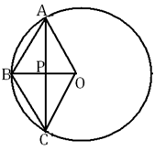

- Three horses are lethered with 7 meter long ropes at the three corners of a triangular field having sides 20 m, 34 m and 42 m. find the area of the plot which can be grazed by the horses. Also, find the area of the plot which remains ungrazed.
- The circumference of a circle exceeds its diameter by 16.8 cm. find the circumference of the circle.
- The inner circumference of a circular track is 440 m, and the tract is 14 m wide. Calculate the cost of leveling the track at 25 paisa/m² also find the cost of fencing the outer boundary of the tract at Rs 5 per metre.

- PQRS is diameter of a circle of radius 6 cm. the lengths PQ, QR and RS are equal semicircles are drawn with PQ and FQSS as diameters, as shown in the given figure. If PS = 12 cm, find the perimeter and area of the shaded regions. Take π = 3.14.
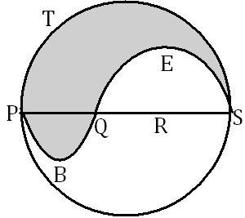

- In the given figure, OPQR is a rhombus, three of whose vertices les on a circle with centre O. if the area of the rhombus is 32 cm² find the radius of the circle.
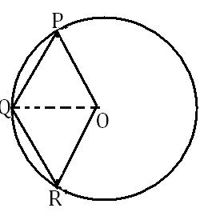




Paper Submitted By:

Name: Sujeet gaud
Email: sujeet_gaud@yahoo.com
Phone No. 9928273041

