MATHEMATICS
CLASS X
Time allowed: 3¼ hours Maximum Marks: 80

Code number given on the right hand side of the question paper should be written on the title page of the answer- book by the candidate.

General Instructions:
- All questions are compulsory.
- The question paper consists of 25 questions divided into three sections A, B and C. Section A contains 7 questions of 2 marks each, Section B is of 12 questions of 3 marks each and section C is of 6 questions of 5 marks each.
- There is no overall choice. However, an internal choice has been provided in two questions of three marks each, two questions of three marks each and two questions of six mark each.
- In question on construction, the drawing should be neat and exactly as per the given measurements.
- Use of calculators is not permitted.

SECTION - A
- What is the probability of sure event and impossible event?

- Find the sum of the first 10 terms of an AP whose first term is 3 and the last term is 102.

- simplify
(x⁶-y⁶) ÷ (x⁸-y⁸)

- A scooter is sold for Rs.22800 cash or for Rs.11200 cash down payment followed by 4 equal monthly installments of Rs.2750 each. Compute the rate of interest under the installment scheme.

- If A= c+1/c, express A+1/A² as a rational expression in c.

- Determine the value of ‘a’ for which the quadratic equation 3x²-5ax+11=0 has equal and real roots.
OR
The sum and reciprocal of two numbers in 10/3. Find the numbers.

- If two chords of a circle bisect each other. prove that these are diameters of the circle
OR
The ladder 13 m long reaches a window of a house 12 m above the ground. Determine the distance of the foot of the ladder from the house.

SECTION - B

- The sum of first six terms of an AP is 42. The ratio of 10th term to 30th term is 1/3. Find its 15 term.
OR
Find the sum of the numbers divisible by 4 but not by 5 ,between 1 to 100.

- Draw the graph of following equations:-
2x+3y+8=0, 3x+8y-12=0
OR
If (x² + x – 12) divides (x³ +ax²+bx-84) completely, find the values of ‘a’ and ‘b’.

- find the LCM and GCD of the following polynomials
(2x²-3a²) y+ (2a²-3y²) x and (2a²+3y²) x + (2x²+3a²) y

- A rectangular garden has dimensions 10mX16m is to be surrounded by a concrete walk of uniform width. If the area of walk is 120m², find the width of the walk.

- Derive the relation to find the centroid of a triangle.

- If the two vertices of equilateral triangle are (0, 0) and (3, 0). Find the third one.

- If the probability of Chandni to select non medical is 0.2, medical is 0.3 and the probability to choose commerce and arts is equal in eleventh. Find its probability of choosing commerce.

- Two circles of radii 5 cm and 2.8 cm touch each other. Find the distance between their centers if they touch a) externally b) internally

OR

A circle is touching the sides BC of a triangle ABC at P and is touching AB and Ac when produced at Q and R respectively. Prove that

2AQ= perimeter of triangle ABC.

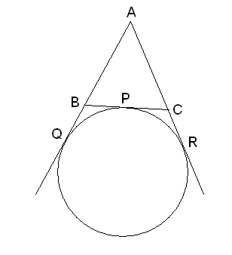

- The largest sphere is carved out of side 14cm. find the volume of the sphere.
OR
The radius and height of the cylinder are in the ratio of 2:7. If the volume of the cylinder is 704 cu cm. find the total surface area of the cylinder.

- A housing society charges for a flat Rs. 16, 00,000 or Rs. 5, 85,999 cash down payment and three equal half yearly installments. If the society charged 16% p.a. compounded half yearly, calculate the value of each installment and the total interest charged.

- Draw a circle of radius 5 cm. from a point P, 6 cm away from centre; draw a pair of tangents to the circle without using its centre.

- Evaluate

- prove that the angle subtended by an arc at a centre is double than the angle subtended by its at any point on the remaining part of the circle
OR

State and prove the basic proportionality theorem.
- Prove that the quadrilateral formed by angle bisector of a cyclic quadrilateral is also cyclic. Using this find the angle of x and y.
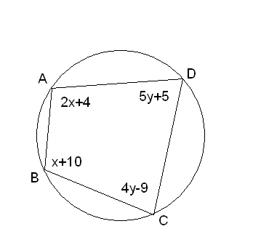
- The radii of circular ends of frustum of a cone are 33 cm and 27 cm. and the slant height is 8 cm. find its total surface area.
OR
A toy is the union of a right circular cone and a hemisphere that has the same (circular) base as the cone. Find the CSA of the toy if the height of the cone is 12 cm and the radius of its base is 3 cm.
- In the adjoining figure, ABCD is a trapezium in which AB || CD. Line segments RS and LM are drawn parallel to AB such that AJ = JK = KP. If AB = O.5m and AP = BQ = 1.8m, find the length of
AP, BD, RS and LM. 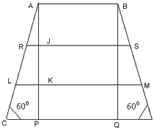
OR

A man standing on the deck of a ship, which is 10m above water level, observes the angle of elevation of the top of a hill as 60⁰ and angle of depression of the base of the hill is 30⁰. Find the distance of the hill from the ship and height of the hill.
- The total number of marks scored by class in test is given below. find the mean by step deviation method:-

Below 20 | 4
Below 40 | 12
Below 60 | 30
Below 80 | 44
Below 100 | 50

- . The annual income of RAM is Rs. 4, 80,000 (exclusive of HRA) He contributes Rs. 8,000 per month towards his provident fund and pays an annual premium of Rs. 28,000 for his LIC policy. If he pays Rs.7, 000 per month towards income tax liability for the last month of the year.
For male persons (below 65 yrs) |  | For female (below 65 yrs) |  | For senior citizen
TAXABLE INCOME | INCOME TAX | TAXABLE INCOME | INCOME TAX | TAXABLE INCOME | INCOME TAX
Upto Rs. 100000 | NIL | Upto Rs. 135000 | NIL | Upto Rs. 185000 | NIL
Rs. 1lac to Rs. 1.5 lac | 10% of income exceeding Rs. 1 lac | Rs. 1.35 lac to Rs. 1.5 lac | 10% of income exceeding Rs. 1.35 lac | Rs. 1.85 lac to Rs. 2.5 lac | 20% of income exceeding Rs. 1.85 lac
Rs. 1.5 lac to Rs. 2.5 lac | Rs. 5000 + 20% of income exceeding Rs. 1.5 lac | Rs. 1.5 lac to Rs. 2.5 lac | Rs. 1500 + 20% of income exceeding Rs. 1.5 lac | More than 2.5 lac. | Rs. 13000+ 30% of income exceeding Rs. 2.5 lac.
More than 2.5 lac. | Rs. 25000+ 30% of income exceeding Rs. 2.5 lac. | More than 2.5 lac. | Rs. 21500+ 30% of income exceeding Rs. 2.5 lac.
- 10% of surcharge applicable if the taxable income exceed Rs. 10,00,000
- Educational cess of 2% on the tax payable including surcharge wherever applicable.

