Guess Paper – 2012
Class – XI
Subject – Informatics Practices
- Decide what controls are required on your own.

Time : 1 Hr. M.M. 20
Q1. Define the followings: [ 1 x 3 = 3 ]
i). Data Types.
ii). Literal.
iii). Constants
Q2. Develop an application to prepare students results on the basis of marks entered. A sample screen shot is being shown
below : [5]
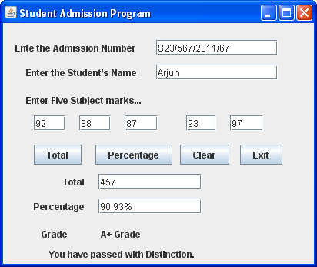
Q3. WAP in java to print week day name as shown in given box when user entered a number between (1 to 7). If
user entered another number print an error message in jLabel2 control. [2^{1/2}]
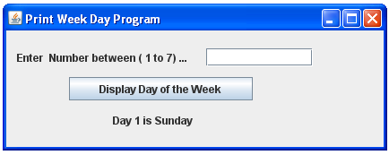
Q4. WAP in java to obtain age of a person and then display person is eligible for voting or Not if person age is less
than 18 years. [2^{1/2}]
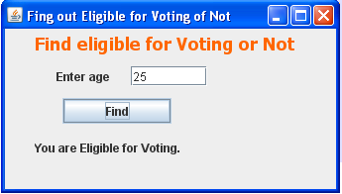
[ P.T.O. ]
Q5. ABC bank has launched is Fixed Deposit Promotional scheme. As per this, for amounts more than Rs. 25000. It offers
following rates of Interest for its fixed deposit accounts : [5]
Time ( in years) | Rate of Interest (% per annum)
7 | 7.0
10 | 8.5
15 | 9.5
20 | 12.5
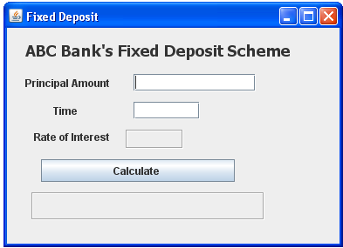
For principal amount less than Rs. 25000. It offers rate of interest as 6.0% per annum. For time other than specified ones , the rate of Interest is 6.75%.
As per bank’s FD scheme, create an application that obtains principal amount and time from the user and then determine how much final amount user will be receiving at the end of the time, Total amount is calculated with compound Interest amount as per following formula :
Total amount= Principal amount(I + Rate %/100)^{time}
Q6. WAP in Java to print a table, when user click on “Click here” jButton control. [2]
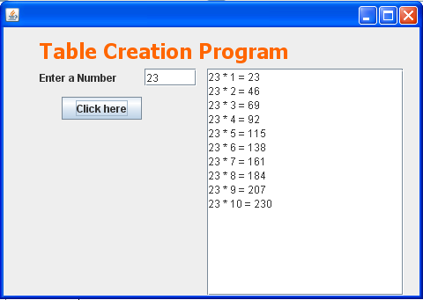

----------------------------------------------------- -----------------------------------------------------
Paper Submitted By:
Name Gagan Kumar Aggarwal
Email gagan_agarwal2006@hotmail.com
Phone No. 09758777202

