INFORMATICS PRACTICES (Theory)
CLASS XI E & F

Time allowed: 3 hours Maximum Marks: 70

Instructions:
(i) All questions are compulsory.
(ii) Programming language: Visual Basic

Section –A
- Answer the following questions
- Briefly explain the basic architecture of a computer. 3
- What is the difference between compiler and interpreter? 2
- Distinguish between Primary memory and Secondary memory 3
- Explain CPU and its components? What is Microprocessor ?
Write any two examples? 4
- Answer the following questions
- What do you understand by various computer generations? How they differ from each other? 4
- Define optical Disk with two examples? 3
- Define nonimpact Printer? 2
- Write short note on the following: 3
- Barcode Rader (ii) Biometric Sensor (iii) Web Camera
- Answer the following questions.
- What does DTP stands for? 2
- What is Antivirus? List any four antivirus software? 3
- Explain the difference between packages and utilities? 2
- What are Hard disks? Explain Track, Sector and RPM 4
Section B
4. Answer the following questions.
- Discuss the different types of operating systems with one
example each. 4
- Expand the following programming languages
- BASIC (ii) COBOL (iii) FORTRAN 3
- Write any four examples of fourth generation languages 2
- What is the difference between a nibble and a word? 1
Section C
5. Answer the following questions:
(a) What do you understand by the term event driven programming?
Explain. 2
(b) What do you understand by the term IDE? 3
Why visual basic is called an IDE?
(c) Write names of any two properties which are common to textbox, label and command button object. 3
(d) What is RAD? 2

6. Answer the following questions:
(a) What is the use of Form Layout window and project explorer? 2
(b) What are container controls? Explain it with example. 2
(c) What is the function of following controls in visual basic. 3

(i) Picture Box (ii) Timer (ii) Combo Box

(d) How do label and text box differ from each other? 2

7. Ms. Ganga, a student of informatics practices designed an arithmetic 6
calculator, its interface is given below. She forgot to do the coding; you should help her to complete the program. The name of each control is given below.
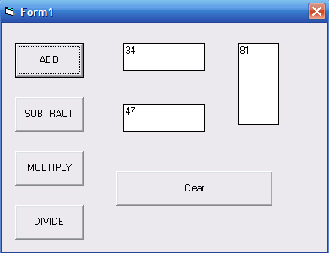



Text Boxes | Firsttxt  Secondtxt  anstxt
Command Button | Cmdadd  Cmdsub  Cmdmult  Cmddivide  cmdclear



