Guess Paper – 2012
Class – XII
Subject – CHEMISTRY(THEORY)
Note:
- Question 1-8 carry 1 mark each.
- Question 9-18 carry 2 mark each.
- Question 19-27 carry 3 mark each
- Question 28, 29, 30 carry 5 mark each
1. Can The Order Of Reaction Be Negative ? Explain. (1)
2. What happens when phosphorus is heated with concentrated NaOH solution in and inert atmosphere of CO2 .
3. Write The IUPAC name of K3[ Fe(C2O4)3] .(1)
4. Why Bond Length in phenol is slightly Less than in methanol.(1)
5. Write Two Properties of Amylose .(1)
6.Give Reaction of Aldehydes To Form Acetals .(1)
7. Why Do Tertiary Amines Do Not React with HINSBERG’S reagent whereas primary and secondary do react.
OR
Why cannot primary amines be prepared by GABRIEL PTHALIMIDE REACTION.(1)
8. DEFINE ZETA POTENTIAL .(1)
9.Draw A plot between ln[conc] and t for a first order reaction . Also Find The Slope.Assume Initial Conc.=[ Conc1].
(2)
10.A First Order Reaction takes 40 min for 30% decomposition . Calculate t3/4 . (2)
11 . Give reasons :
i)Why are halogens coloured
ii)Why do noble gases have comparatively large atomic sizes ?
12. What is Valence Bond Theory . Explain [C0(NH3)6 ] 3+ is an inner orbital complex whereas [Ni(NH3)6]2+ is Outer .
13.What is Wurtz- Fittig And Fittig Reaction . Give Equation.
14. Convert
i) 2- Bromopropane to 1- Bromopropane
ii)but-1-ene to n-butyliodide
15.Differentiate Between Frenkel Defect and Schottky Defect . (2 )
16.Copper Crystallises into a fcc lattice with edge length 3.61 x 10 ⁻⁸ cm . Show That The Calculated Density is in agreement with its measured value of 8.92 g cm-3 .(2) .
17.Predict The Products of electrolysis ofan aqeous solution of AgNO3 in
i) Silver Electrodes
ii) Platinum Electrodes (2)
18.What are Interhalogen Compounds . Write Their Properties. (2)
19. Define Corrosion. State Its Effects in Everyday Life. What is Cathodic protection
OR

DefineChemical EquiValent .
A Solution of CuSO4 is Electrolysed for 10 minutes with a current of 1.5 Ampere. What is The Mass Of Copper Deposited At the cathode . (3)
20. What is Electrophoresis and Peptization. State One Application of Each of them.
How Colloids Are protected ? (3)

21. Explain Liquation and Vapour Phase Refining Giving necessary chemical equations . what is the role of froth stabilisers and collectors .in froth flotation . (3)

22.Write the balanced chemical equations of :
i) Reaction of thermal decomposition of sodium azide .
ii)Equation involved in contact process. Name the catalysts .
iii)Amphoteric nature of Al2o3 .
OR
Give Reasons
- Nitrogen exists as diatomic molecule and phosphorous as P4 .
- Nitrogen shows less catenation properties than phosphorous
- When HCL reacts with finely powdered iron , it form ferrous chloride and not ferric chloride . why
(3)

23.Give Structures And IUPAC names of The products :
i) Hydroboration-Oxidation of propene.
ii) Phenol with Conc. HNO3 .
iii)Anisole with Br2 in Ethanoic Acid .(Major and Minor) (3)

24.An aromatic compound A on treatment with aqeous ammonia and heating forms compoundB which on heatin with Br2 and KOH forms a compound C of mollceular formula C6H7N. write the structures and IUPAC names of compounds of A B C. (3)

25.
i)Draw The structure of alpha D Glucose.
ii)Two Strands in DNA are NOT identical but complementary.
iii)What Are Reducing Sugars (3)

26. What is Vulcanisation of Rubber. What is The need . Write properties f vulcanised rubber.
OR
Differentiate between Condensation and Addition Polymers.
Draw Structures of Melamine-FormaldeHyde Polymer and Buna-N Rubber. (3)

27. Define the Following :i
i) Tranquilizers
ii) Antibiotics
Give Reason Why Aspartame is not used for cooking (3)

28.Suggest The Most Important type of intermolecular attractive interaction in the following pairs and explain the type .
i) n-hexane and n-octane
ii) methanol and acetone
Define Osmotic Pressure .Give Its S.I Units. What is the role of Van’t Hoff factor in determining osmotic pressure ? (5)

OR

Why dO Scuba divers use concentrations of helium in tanks ?
45 g of ethylene glycol (c2h6o2) is mixed with 600 g of water. Calculate
- Depression in freezing point and
- B) freezing point of solution
- Vant hoff factor (5)
29..
i) Perform A test to distinguish between
a) AcetoPhenone and Benzoic Acid
b) Ethanal and Propanal

ii) Complete The Synthesis
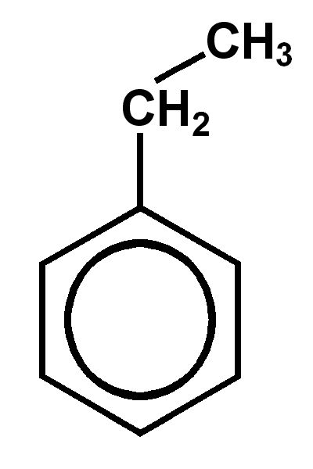 reacts with KMNO4 and KOH and heat

iii)During The preparation of esters from a carboxylic acid and an alcohol in the presence of an acid catalyst . the water or the ester should be removed as asoon as it is formed.
- What is the effect of electron withdrawing and electron donating groups on acidity of carboxylic acids and aromatic acids . Explain

OR

i)Carry out the following Conversion
a) Benzoic Acid to m- Nitro Benzyl Alcohol
b) benzoic acid to benzaldehyde
ii) Explain
- Cross Aldol Condensation
b) Hell Vohlard Zelinsky Reaction
iii) Why Thionyl Chloride is preferred for replacement of carboxylic group with Chlorides instead of PCl5 or PCl3.. (5)

30.Give Reasons :
i)Why are Mn2+ compounds more stable than Fe2+ compounds towards oxidation reaction
ii)Chromium is typically a hard metal while mercury is liquid
iii)The atomic radii of metals of the third (5d ) series of transitions elements are same as these of 4d series
iv)Transition metals exhibit higher enthalpies of atomisation
v)Actinoid Contraction is greater from element to element than the lanthanoid contraction

OR

- Explain Preparation of Potassium Permanganate . with chemical reaction .
- Give The Consequences of Lanthanoid Contraction
- Find magnetic moment of a divalent ion in aqeous solution if its atomic number is 25 .

Name: Sahil ManchanDA
Email: sahil_m1992@yahoo.co.in
Phone No. 9654040804

