SAMPLE QUESTION MATHEMATICS
Class: X

Time : 3 1/4 hrs Marks :80

General Instructions

1. All questions are compulsory
2. The question paper consists of 25 questions divided in to three sections A, B and C .Section A
contains 7 questions of 2 marks each .Section B is of 12 Questions of 3 marks each and section
C of 6 Questions of 5 marks each
3. There is no overall choice .However ,internal choice has been provided in two questions of two marks each, two questions of three marks each, two questions of five marks each
4. In question on construction ,drawing should be neat exactly as per the given measurements.
5. Use of calculators is not permitted.

- Solve for x and y
99x+101y=499xy
101x+99y=501xy
OR
Solve for x and y:- x/a - y/b = 0, ax + by + a² + b²
- Find sum of all the digits between 2 to 300 which are divisible by 11.
- The 8th term of an AP is zero. Find the ratio of its 38th term and 18th term.
- In an equilateral triangle ABC, D is point on BC such that BD= 1/3 BC. Prove that 9 AD ² = 7 AB²
OR
Prove that cyclic parallelogram is a rectangle.
- Find the value of a and b so that the polynomial x³ + ax² + bx + 15 is divisible by x² + 2x - 15.
- A card is drawn at random from well shuffled pack. What is probability that the card is not of red color and not an even number.
- A watch is available for Rs.1560 cash or for Rs. 780 cash down payment and two equal monthly installments of Rs. 745 each. Calculate the rate of interest charged under the installment plan.
- The largest cube is carved out of a cube of radius 7 cm. find the volume of the sphere.
- Find the probability that that the month of February has 5 Wednesdays in a non leap year.
OR
Find the mean of following
Interval | 0-8 | 8-16 | 16-24 | 24-32 | 32-40
frequency | 10 | 18 | 10 | 20 | 4

- Prove that tan 7° tan 16° tan 60° tan 74° tan 83° = √3
OR
Prove sec²A+cosec²A=sec²A cosec²As

- If the roots of the equation (a - b) x² + (b - c) x + (c - a) = 0 are equal, prove that 2a = b + c. Find the value of P for which the following equations has real roots:
- If 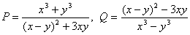and 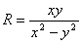, find the value of
- Prove that the sum of the squares of the diagonals of a parallelogram is equal to sum of squares of its sides.

- Construct triangle ABC in which AB=6.5 cm, BC=7 cm and angle C=60 . draw circle which passes through its three vertices.

- A farmer wishes to grow a 100m² rectangular vegetable garden. Since he has with him only 30m barbed wire, he fences three sides of the rectangular garden letting compound wall of his hones act as the fourth side-fence. Find the dimensions of his garden.

- A housing society charges for a flat Rs. 26,00,000 or Rs. 15,85,999 cash down payment and three equal half yearly installments. If the society charged 16% p.a. compounded half yearly, calculate the value of each installment and the total interest charged.

- Determine graphically the CD- ordinates of the vertices of a triangle, the equation of whose sides are given:
x + y = 5; x - y = 5; x = 0
- Plot the points P (-4,0), Q(3,0) and R(3,7) in a rectangular coordinate system.
Find the coordinates of the fourth point S such that PQRS is a square.

- The line joining the points (2,1) and (5,-8) is trisected at points P and Q. if the
point P lies on the line 2x-y+k=0.

- a) prove that the angle in a semi circle is a right angle.
b) in the fig. below find the value of a,b,c,d

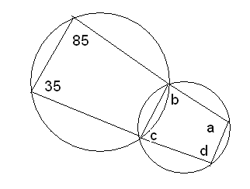

- AD is median of triangle ABC and AE perpen. BC. If BC = a, CA=b,AB=c,AD=p and ED=x, prove that
  - b²=p²+ax+a²/4
  - c²=p²-ax+ a²/2
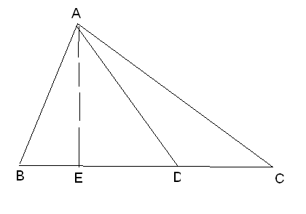

- From the top of a church spire 96 m high the angles of depression of two vehicles on a road, at the same level as the base of the spire and on the same side of it are x° and y°, where tan x° = 1/4 and tan y° = 1/7. Calculate the distance between the vehicles.
OR
From the deck of a ship the elevation of the top of a cliff is ° and from the top of a mast 50 m above the deck the elevation is °. If tan ° = 1·2 and tan° = 0·7 and the height of the cliff above the deck. BY:- VIKRANT, LUDHAIAN, 09915089502)
- A circus that is in the shape of a cylinder surmounted by a cone. The diameter of the cylindrical part is 24m and its height is 11m. If the vertex of the tent is 16m above the ground, find the area of canvas required to make the tent.
OR
An iron pillar has some part in the form of a right circular cylinder and remaining in the form of a right circular cone. The radius of the base of each of cone and cylinder is 8cm. The cylindrical is 240cm high and the conical part is 36cm. Find the weight of the pillar if one cu,cm of iron weight 7.8 grams.
- The given pie-chart represents the number of valid votes obtained by 4 students who contested for school leadership. The total number of valid votes polled was 720. Read the pie-chart and answer the following questions;
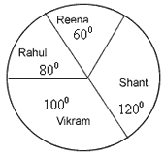
(i) Who has won the election
(ii) What is the minimum number of votes obtained by any candidate?
(iii) By how many votes did the winner defeat the nearest constestant?
(iv) What percentage of valid voles polled was obtained by the winning candidate
(v) if each candidate get more 80 votes. draw new pie chart.
- Gopal has an annual income of Rs. 3,60,000 (exclusive of HRA). He contributes Rs. 6,000 per month towards his GPF and pays an LIC premium of Rs. 15,000. He has invested Rs. 10,000 in NSC’S. He pays Rs. 5,500 as income Tax per month for the first 11 months. Find his income tax liability for the last month of the financial year.
Rate of Income Tax.
) Upto Rs. 50,000 Nil
ii) From Rs.50,001 to Rs.60,000 10% of the amount exceeding Rs. 50,000
iii) From Rs. 60,001 to Rs. 1,50,000 Rs.1000+ 20% of the amt. exceeding Rs.60,000.
iv) Above Rs. 1,50,000 Rs. 19,000 + 30% of the amount exceeding Rs1,50,000
Rebate : 20% of the amount of saving subject to maximum Rs.14,000 if taxable income is upto Rs.1,50,000

15% of the amount of saving subject to a maximum of Rs.10,500 if taxable income is above Rs. 1,50,000.

Surcharge : 5% of the net income tax paid.

