Guess Paper – 2012
Class – XII
Subject – Physics

Time allowed : Three Hours Max. Marks: 70
General Instructions:
- All questions are compulsory.
- There are 30 questions in total. Questions 1 to 8 carry one mark each, questions 9 to 18 carry two marks each, questions 19 to 27 carry three marks each and questions 28 to 30 carry five marks each.
- There is no overall choice. However, an internal choice has been provided in one question of one marks and each question of five marks each. You have to attempt only one of the given choices in such questions.
- Use of calculators is not permitted.
Draw neat labelled diagram wherever necessary to explain your answer
Note:- 1. Attempt all the questions in neat and beautiful handwriting with proper presentation.
2. Avoid overwriting and scribbling.
========================================================================
One Marks Question

- A force F is acting between two charges q₁ and q₂ are placed at a distance L apart in vacuum. If a brass rod of length L is placed between these two charges, how does the force between these forces change?

- A (hypothetical) bar magnet (AB) is cut into two equal parts.
One part is now kept over the other, so that pole C2 is above C1. A C₁ C₂ B
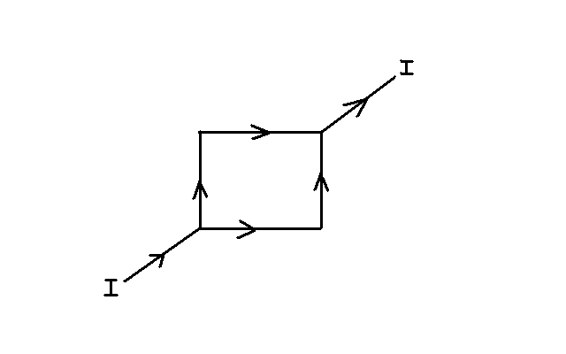
If M is the magnetic moment of the original magnet, what
would be the magnetic moment of the combination so formed?

- Following figure shows a square loop made from a uniform wire. A B
If a battery is connected between the point Dand B, what will be
the magnetic field at the center of the square loop ABCD ?
D C

- Maxwell showed experimentally that Ampere’s circuital law for calculating magnetic field B along any current carrying closed loop is inconsistence. What modification made by Maxwell in this law?

- A polarizer and an analyzer are so oriented that intensity of light so transmitted light is maximum. If the analyzer is rotated through 60˚, what fraction of the maximum light is transmitted?

- Zener diodes have higher dopant densities as compared to ordinary p-n junction diodes. How does it affect the (i) Width of the depletion layer? (ii) Junction field?

- Four nuclei of an element fuse together to form a heavier nucleus. If the process is accompanied by release of energy, which of the two - the parent or the daughter nucleus would have a higher binding energy/nucleon?
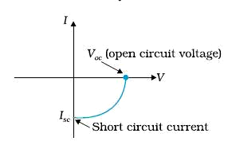

- The above fig. is a V-I graph for a device. Identify the device.
Mention any one material from which itis prepared.

Two Marks Question

- A battery of emf 10V and internal resistance 3Ω is connected to a resistor. If the current in the circuit is 0.5A. (a)What is the resistance of resistor? (b)What is the terminal voltage of the battery when the circuit is closed?

- In a cyclotron mutually perpendicular electric field E and magnetic field B are used to accelerate the charged particle only. What is the function of; (a) Electric field E, (b)Magnetic field B

- A jet plane is travelling west at the speed of 1800kmh⁻¹. What is the voltage difference developed between the ends of the wing 25m long, if the earth’s magnetic field at the location has a magnitude of 5.0X10⁻⁴ T and the dip angle is 30°?

- Two circular coils, one of radius r and the other of radius R are placed coaxially with their centers
coinciding. For R » r, Obtain an expression for the mutual inductance of the arrangement.

13. Two student A and B prepare the following table about the electromagnetic waves. Rewrite this table
in its corrected form.
Students | Direction of |  |  | Peak value of
Students | Electric field | Magnetic field | Propagation | Electric field | Magnetic field
A | Along X-axis | Along X-axis | Along Y-axis | E | B=cE
B | Along Y-axis | Along Z-axis | Along X-axis | E=cB | B
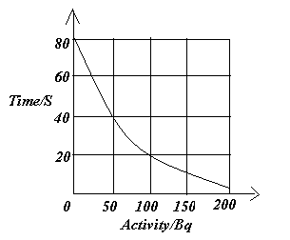
14.The side graph shows how the activity of a radioactive
material changes with time. Using the graph, determine
(a) Half-life of the material and
(b) decay constant.

15.In a Young’s double-slit experiment, the slit are separated by 0.28mm and the screen is placed 1.4m away.
The distance between the central bright fringe and the fourth bright fringe is measured to be 1.2cm.
Determine the wavelength of light used in this experiment.
OR
How do optical fibers transmit light without significant absorption? Mention one practical application
of optical fibres.
- Following figure shows a cylindrical Gaussian surface for an infinitely long thin straight wire of
uniform linear positive charge density along their axis. E
(a) For which surface is the electric flux is zero?
(b) Over which surface is E is zero? r

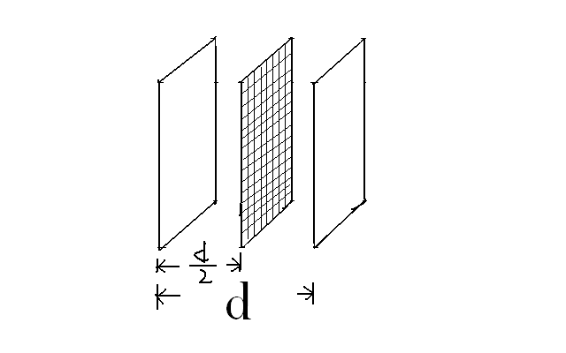

- A capacitor has a capacitance given by C_{O} when distance Between its
plates is d. A conducting wire mesh is placed as shown in figure what is
the effect on capacitance and calculate the new capacitance?

- A hydrogen atom initially in the ground level absorbs a photon, which excites
it to the n =4 energy state. Determine the wave length of the photon absorbed?

Three Marks Question
- An electric dipole of moment p is placed in a uniform electric field E. derive the expression for the potential energy of the dipole and show diagrammatically the orientation of the dipole in the field for which the potential energy is (i) maximum (ii) minimum
Or
Two capacitors C₁ and C₂ are charged to potential V₁ and V₂ respectively and then connected in parallel. Calculate : (i) common potential, (ii) charge on each capacitor,
(iii) electrostatic energy in the system after connection.

- With the help of ray diagram obtain the nature of the image in a compound microscope when the image is formed at least distance of distinct vision. What change in the magnification of compound microscope when the light used to see the specimen under it changes to red?
- Light from a point source in air falls on a convex spherical glass surface having refractive index is 1.5 and radius of curvature is 20 cm. If the distance of light source from glass surface is 100 cm then at what position image is formed?
- Define power in an a.c. circuit. Show that the average power transferred to an a.c. circuit is, in general given by, P_{avg} = ξ_{rms} I_{rms} CosØ = ξ_{rms} I_{rms} R/Z, Where the symbol has their usual meanings. Obtain the maximum power dissipation at resonance in LCR-circuit.
- The work function of cesium metal is 2.14eV. When light of frequency 6x10¹⁴Hz is incident on the metal surface, photoemission of electrons occurs Then what is the;
(a) maximum kinetic energy of the emitted electron,
(b) stopping potential, and
(c) maximum speed of the emitted photo electron?
- Draw a plot showing the variation of binding energy per nucleon with mass number A. Explain with the help of this plot, the release in energy in the process of nuclear fusion and nuclear fission?
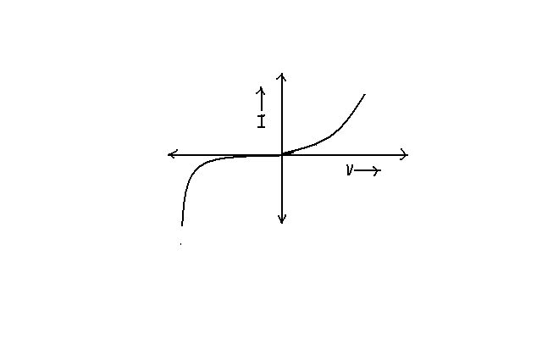
- The figure on right side shows the V-I characteristic of a semiconductor device.
(a) Identify the semiconductor device used here.
(b) Draw the circuit diagram to obtain the given characteristics of this diode.
(c) Briefly, explain how this device is used as a voltage regulator.

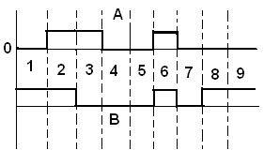
- The signals A and B are shown in the right side are used as
two inputs of NOR gate. Sketch the output wave form.
Draw its logic symbol.

- Is it necessary for the transmitting antenna and the receiving antenna to be of the same height for the Line of sight communication? Find the expression for the maximum line of sight distance d_{m} between these two antenna of height h_{T} and h_{R}.

Five marks Question
- (a) Show how a moving coil galvanometer can be converted into an ammeter?
(b) A galvanometer has a resistance 30Ω and gives a full scale deflection for a current of 2mA.
How much resistance in what way must be connected toconvert into?
(i) An ammeter of range 0.3A
(ii) A voltammeter of range 0.2V.
Or
(a) State Biot savart’s law.
(b) Using Biot Savart’s law derive an expression for magnetic field intensity on the axis
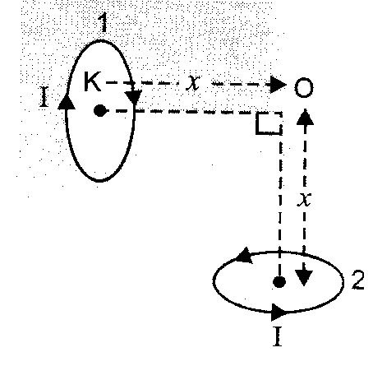
of a circular coil carrying current.
(c) To small circular loops marked 1 and 2 carrying equal
currents are placed with the geometrical axis perpen-
dicular to each other as shown in fig. find the magnitude
and direction of the net magnetic field produced at the
point O.

- (a) State the working principal of potentiometer. Explain, with the help of circuit diagram, how the
emf of two primary cells are compared by using a potentiometer.

(b) In a potentiometer arrangement, a cell of emf 1.2 V gives a balance point at 30 cm length of the
wire. This cell is now replaced by another cell of unknown emf. If the ratio of the emfs of two
cells is 1.5 calculate the difference in the balancing length of the potentiometer wire in two cases
Or
State Kirchhoff’s laws of an electrical network. Using Kirchhoff’s laws calculate the potential difference across the 8 Ω resistor.

A 4 V 2 Ω B

8 Ω 6 Ω

D C
4 Ω

6 V 1 Ω
- (a) A plane wave front approaches a plane surface separating two media. If the medium one is
(optically) denser and medium two is (optically) rarer, construct the refracted wave front using
Huygen’s principle.
(b) Draw the shape of the refracted / reflected wave front when a plane wave front is incident on
(i) Prism
(ii) convex mirror
(iii) convex lens
Or
(a) State the essential condition for the diffraction of light take place. A parallel beam of monochromatic light falls normally on a narrow slit and light coming out of the slit is obtain on the screen. Derive an expression for angular width of the central bright maxima obtained on the screen.

(b) ‘Diffraction defines the limit of the ray optics’. Give a brief explanation of this statement.

For solution contact:- S.P.Sharma ; phone no. +919466392969, E.mail;shashisir01@yahoo.com

