Sample Paper – 2012
Class – XII
Subject – Physics
Time:3hrs MM:70
------------------------------------------------------------------------------------------------------------------------------------------------------------------------------
Marking :
Questions 1-8 are of 1 marks each.
Questions 9-18 are of 2 marks each.
Questions 19-27 are of 3 marks each.
Questions 28-30 are of 5 marks each.

Q.1. The magnetic field lines form closed curves. Why?
Q.2. Light is incident at 60⁰ on glass slab. If reflected & refracted rays are perpendicular to each other then what is the refractive index of glass.
Q.3. What is band pass filter?
Q.4. How does magnifying power of a microscope change on decreasing the aperture of its objective?
Q.5. Name the part of electromagnetic spectrum which is suitable for
(a) Physical therapy (b) TV Communication
Q.6. Why is energy distribution of β-ray continuous?
Q.7. A point source of light is at the focus of a convex lens. What is the type of refracted wave front?
Q.8. Draw a graph showing variation of de Broglie wavelength of an electron with the variation of its momentum.
Q.9. All the cells are identical each of emf E & internal resistance r. what is the current passing through R.
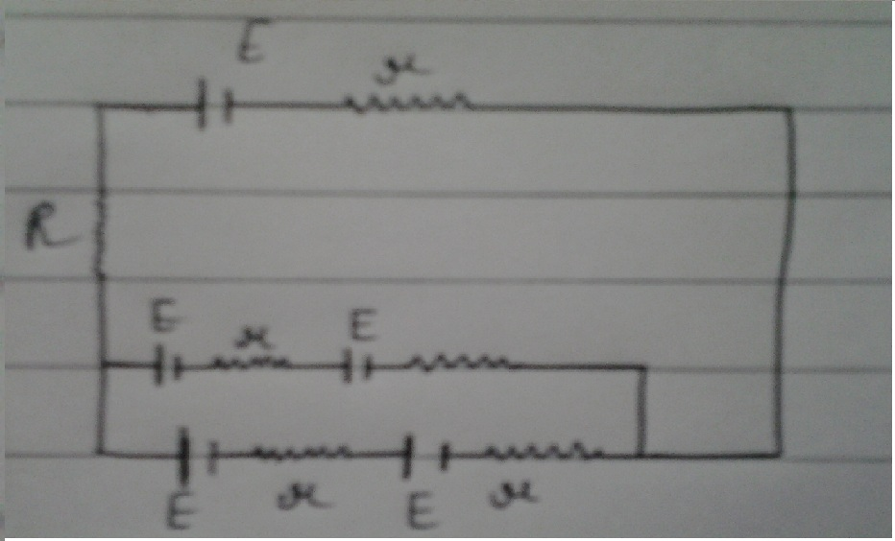
Q.10. What is a repeater? Explain with the help of a diagram. How does it increase the common range.
Q.11. In a wire connected across a source, drift speed & electric field are V & E respectively. The wire is stretched uniformly of double the length, what will be new drift speed & electric field.
Q.12. Sketch the output wave from an or gate. The input A & B are shown in the figure. If the output of above or gate is fed to a NOT gate, name the gate so formed.
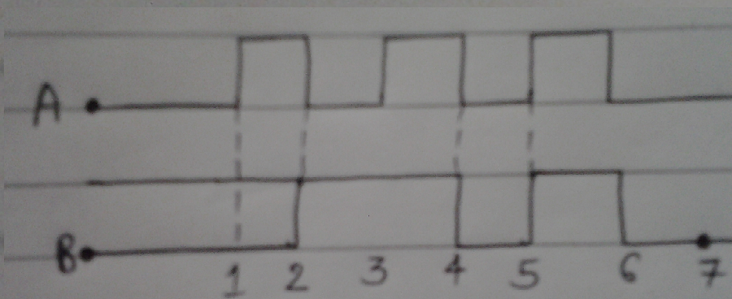
Q.13. A circular coil of radius r is carrying current I. At what distance from the centre of loop on the axis magnetic field is one light the magnetic field at the centre.
Q.14. P and Q are long straight conductors r distance a part N is a point in the place of wires r/4 distance away from P carrying current I. What is the magnitude & direction of current in the wire Q, so that net magnetic field at N is zero.
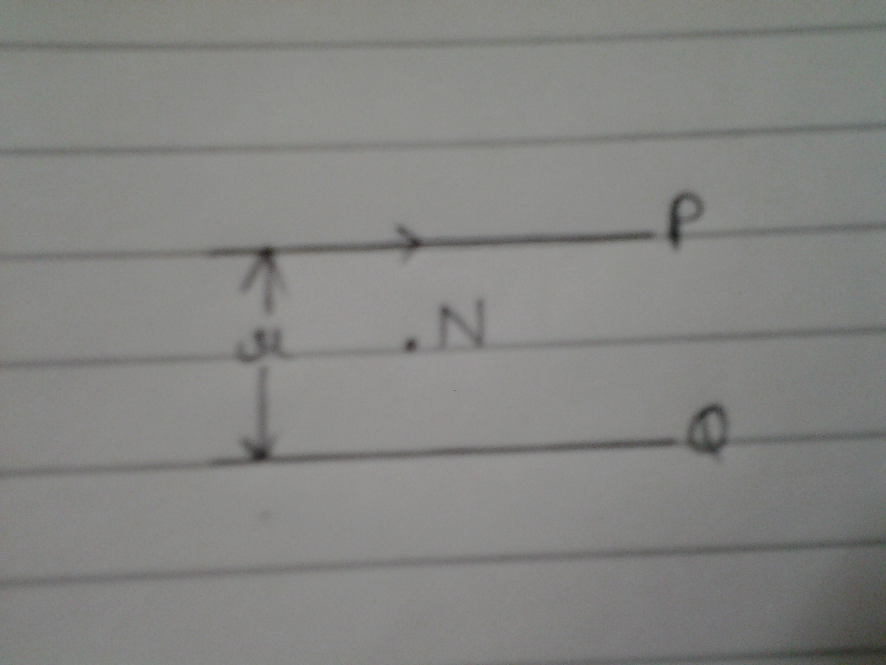
Q.15. In an electromagnetic wave propagating along +x-axis electric field vector is Ey=4x10³ Cos (3x10⁸t-1.5x) v/m. what is
(i) the frequency of em wave (ii) amplitude of magnetic field
Q.16. A and B are two concentric metallic spherical shell of radii a & b having charge q & Q respectively. How much work will be done in moving a test charge q0 from A to B (a<b).
Q.17. What is the SI unit of radio activity. Express curie in SI unit. The mean life of radio active substance is 2400yrs. What is its half life.
Q.18. What is meant by modulation? Draw a block diagram of a simple modulator for obtaining an AM signal.
Q.19. In interference pattern obtained in young’s double slit experiment, explain how will the angular width of fringe be affected if
(a) Slits separation is increased
(b) Screen is moved away
(c) Experiment is performed in a denser medium
Q.20. State Gauss’s law in electrostatics. Find (i) net electric flux (ii) charge enclosed by the cube of side ‘a’. Give E=E0xt⁻¹
Q.21. In an atom energy of electron in n^{th} orbit is En = -13.6z²/n²ev, where zis atomic number.
What is the shortest & longest wave length of emitted radiation n in singly ionized He+.
Q.22. With the help of a schematic diagram explain the principle & working of a cyclotron.
A bar magnet of magnetic moment Nv held in magnetic field of strength B what is
(a) Maximum torque on the magnet
(b) Work done in turning it from stable equilibrium to unstable equilibrium.
Q.23. A parallel plate capacitor of capacitance 4.8u F has been charged by a battery of 6V. After disconnecting the battery dielectric medium of dielectric constant 5 in introduced between its plates.
(i) Find new capacitance
(ii) What is the ratio of electrostatic energy stored before & after
(iii) Calculate new potential difference across the plates.
Q.24. Define the decay constant of a radioactive substance. Half life of radioactive substance is T, initial concentration. No and at instants t₁ & t₂ concentrations are N₁ and N₂ respectively. Find concentration at time (t₁+t₂).
Q.25. What is meant by detection? Draw the block diagram of a detector for AM Signal.
Q.26. State Huygen’s postulates. Draw diagrams to show the refracted wave front from a convex lens if paint source is (i) at 2F (b) at F.
Q.27. Photons of certain frequency and intensity are incident on a surface of work function W⁰. Kinetic energy of emitted electrons & photo electric current are Ek and I respectively. For photons of 50% higher frequency, find (i) Kinetic energy of, emitted electrons (ii) photo electric current.
Q.28. State the principle of a potentiometer. In the following figure find the length. P√ where √ is null deflection position. Given PQ =400cm, Resistance of PQ is 20Ω, driver cell emf E =4v & E¹=40mv.
Q.29. Derive the relationship b/w the peak & rims value of current in an ac circuit. For circuits used for transmission of electric power a law power factor implies large power lass in the transmission explain.
Q.30. With the help of a labeled diagram show image formed by a compound microscope. Derive expression for its magnifying power when final images is at near point. How is magnifying power changed on increasing
(a) Diameter of objective lens
(b) The focal length of the objective lens?

Paper Submitted By:
Name Geeta Jain
Email sagarverma1650@gmail.com
Phone No. 9045869919

