SAMPLE PAPER MATHEMATICS
CLASS - X

Max. Marks- 80 Time – 3 1/4 hours

General Instruction
- All the question are compulsory.
- This question paper consists of 25 question divided into three sections A, B, and C.
Section A contains 7 questions of 2 marks each,
Section B contains 12 questions of 3 marks each,
Section C contains 6 questions of 5 marks each.
- Internal choices have been provided for some question .you have to attempt only one of the choices in such question
- Write correct serial number of the question before attempting it.
- In the question on construction, the drawing should be neat and exactly as per given measurements.
- Use of Calculators is not permissible. However you may ask for mathematical tables

- Solve for x and y
x/a – y/b=0 and ax+by=a²+b²
OR
The sum of two numbers is 2. And the difference between its digits is 20. Find the numbers.
- find the HCF of
2(x-7)(x+7)², 4(x-7)²(x=8) and 8(x²-49)
- if A= (x+1)/(x-1) and B= (x-1)/(x+1) , find the value of (A-B)/(A+B)
- solve for x
4√3x²+5x-2√3=0
- A laptop is available for Rs 59300 cash or for Rs 22820 cash down payment and three equal half yearly installments .If the dealer charges interest at the rate of 22% per annum compounded semi annually , Calculate each installment
- What is the probability of selecting the red king in the set of cards if one card is chosen at random?
OR
If the probability of INDIA losing the match is one third the India winning the match. What is the probability of winning it.

- in the following triangle DE is parallel to BC. If AD=8 cm, DB=12 cm and AE= 10 cm find AC.
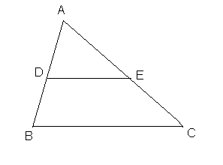
- The area of two similar triangles is in ratio of 7:8. If the median of first triangle is 10 cm. what is the length of corresponding median of other.
OR
In the figure below find the length of the altitude AD of an isosceles triangle
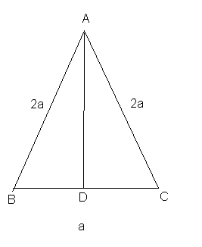

- If two chords of circles bisect each other, prove that these are diameters of the circle.
- Draw an equilateral triangle of side 5 cm and also draw its circumcircle.
- Find the sum of all two digit numbers.
OR
In an AP 2+5+8+11……………… how many terms make the sum of 155?
- Determine K so that K+2, 4K-6 and 3K-2 are consecutive terms of an AP.
- Find the centroid of the triangle whose vertices are (2,-5), (3,9) and (-8,11).
the mid point of the line joining the (a,2) and (3,6) is (2,b). Find the value of a
and b.
- Rs. 9000were divided equally among a certain number of persons. Had there been20 more persons, each would have got Rs. 160 less. Find the original number of persons.
- Simplify: 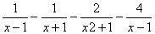
- A loan was returned in three equal quarterly installments of Rs.17576 each. If the rate of interest is 16% p.a. compounded quarterly find the loan and the total interest charged.
- evaluate.:- tan 5⁰ tan 25⁰ tan 30⁰ tan 65⁰ tan 85⁰
- The circumference of the base of a 16 m high solid cone is 3m. Find the volume of the cone.
- The following data relates to the cost of construction of a house in Delhi represent the data in the form of a pie-chart.
Items | Cement | Pricks | Labour | Timber | Misc.
Expence (in %) | 25 | 10 | 20 | 20 | 25

- A spherical shell of lead, whose external diameter is 18cm, is melted and recast into a right circular cylinder, whose height is 8cm and diameter 12cm. Determine the internal diameter of the shell.
OR
A petrol tank is a cylinder of base diameter 21cm and 18cm fitted with conical ends each of axis length 9cm. determine the capacity of the tank.
- A tower is 50m high. Its shadow is x m shorter when the sun’s altitude is 45⁰ than when it is 300. Find x.
OR
- An aeroplane, when 3000m high, pass vertically above another aeroplane at an instance when the angles of elevation of the two aeroplanes from the same point on the ground are 60⁰ and 45⁰ respectively. Find the vertical distance between the two aeroplans
- . If the angles of one triangles are respectively equal to the angles of another tranles. Prove that the ratio of their corresponding sides of the same as the ratio of their corresponding.
(i) medians (ii) altitudes (iii) anlgle bisectors.
- (a) In the given figure, ABCD is a cyclic quadrilateral. A circle passing through A and B meets AD and B in the points E and F, Respectively. Prove that EF || DC.
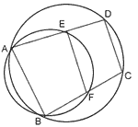

(b) In the given figure, AB is a diameter of the circle with centre O and Chord CD is equal to radius OC. AC and BD produced to meet at P. prove that .
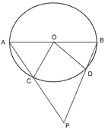

- The annual income of Kapil (excluding HRA) is Rs. 1, 95,000. He contributes Rs. 4,000 per month in providend fund. How much should he pay annually towards LIC premium to get the maximum rebate? Find the income tax to be paid by Kapil in the last month of the year if he paid Rs. 1000 per month as income tax for the first eleven months.
INCOME TAX SLAB

- Women (below 65 years)
Taxable income | Rate
Up to Rs. 1,35,000 | Nil
Rs 1,35,001-Rs 1,50,000 | 10% of the amount exceeding Rs 1,35,000
Rs 1,50,001-Rs 2,50,000 | Rs 1,500+20% of them amount exceeding Rs 1,50,000
Exceeding Rs 2,50,000 | Rs 21,500+30% of the amount exceeding Rs 2,50,000

- (C) For senior citizens (65 years or more)
Taxable income | Rate
Up to Rs 1,85,000 | Nil
Rs 1,85,001-2,50,000 | 20% of the amount exceeding Rs 1,85,000
Above Rs 2,50,000 | Rs 13,000+30% of amount exceeding Rs 2,50,000

- Surcharge: 10% of the amount of tax payable if the taxable income exceeds rs 10,00,000

- Educational cess: 2% of the amount of tax payable.

- Concession for saving: notified savings (PF, LIC, PPF, mutual fund etc) up to a maximum of rs 1, 00,000 are exempted from payment of income tax.

