Sample Paper – 2012
Class – XII
Subject – Biology
Time:- 3 h Max Marks :- 70
General Instructions:-
1. This question paper consists of four sections A, B, C and D. Section A consists of 8 questions of one mark each .Section B consists of 10 questions of 2 marks each. Section C consists of 9 questions of 3 marks each .Section D consists of 3 questions of 5 marks each
2. Draw diagram wherever required, with Pencil only
Section A

1. In the following figure of a fruit, label the part which is protective in function and that which is responsible for producing new plants. 
2. What is Brood Parasitism?
3. In the whiptail lizards only females are born generation after generation. There are no males How is this possible?
4. What would be the impact on the environment around a thermal power plant if its electrostatic precipitator stops functioning? Give a reason.
5. Which is the first diploid cell which begins life ?
6. A tourist at Mansarovar ,in China occupied Tibet ,feels nausea, fatigue and Heart palpitations. Name the disorder by which he is suffering?
7. What is the other name of pollen sac ?
8. What is the percentage of Photosynthetically active radiation in the incident solar radiation ?
Section B
9. Mention the number of cells in the following Embryonic stages:-
(a) Zygote (b) Morula (c ) Blastocyst (d) Blastomeres
10. How BOD is related to water pollution ?
11. Mention any two probable reasons for rapid rise of population in our country from about 350 million at the time of independence to about 1 billion by the year 2000.
12. The figure given below shows relative contributions of various green-house gases to the total global warming.
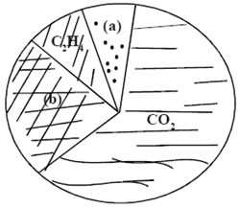
(i) Name the gases (a) and (b)
(ii) Explain how increase in green-house gases in the atmosphere leads to melting of ice caps.
13. Draw neat and labeled diagram of 7-celled, 8-nucleate Female Gametophyte.
14. Why is thermoregulation more effectively achieved in larger animals than in smaller ones? .
15. If the chromosome number of a plant species is 16, what would be the chromosome number and the ploidy level of the (i) microspore mother cell and (ii) the endosperm cells?
16. Describe the structure of a human sperm.
17. Even though each pollen grain has two male gametes, why are at least 10 pollen grains and not 5 pollen grains required to fertilise 10 ovules present in a particular carpel?
18. What is meant by “Hot Spots” in bio-diversity? Name any two hot spots of India?
OR
Explain Slash and Burn Agriculture.
Section C
19. In the adjacent population growth curve,
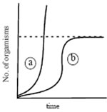
(i) What is the status of food and space in the curves (a) and (b)?
(ii) In the absence of the predators, which curve (a) or (b) would appropriately depict the prey population?
20. Expand MTP. Why are MTPs carried out?
21. State the function of each of the labelled part.
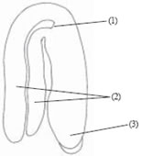
22. Explain why ecological succession will be faster in a forest devastated by fire than on a bare rock? Also compare succession in case of an abandoned land after floods with that on a bare rock?
23. What is Eutrophication? How does it take place?
24. Differentiate between:
    - Sexual and Asexual Reproduction.
    - Epicotyl and Hypocotyl.
    - Apomixis and Polyembryony.
25. Discuss the cause and effects of Global Warming? What measures need to be taken to control it?
26 What do you know about FOAM ?
OR
What remedy for plastic waste is used by Mr Ahmed Khan of Bangalore?
27. The events of the menstrual cycle are represented below. Answer the questions following the diagram.
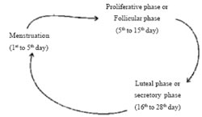
(i) State the levels of FSH, LH and Progesterone simply by mentioning high or low, around 13th and 14th day and 21st to 23 rd day
(ii) In which of the above mentioned phases does the egg travel to the fallopian tube?

Section D

28. Study the 3 representative figures of age pyramid relating to human population given below and answer the following question:
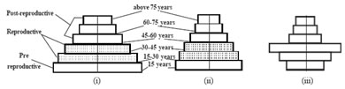
(a) Mention the names given to the 3 kinds of age profiles (i), (ii), and (iii).
(b) Which one of them is ideal for a population and why?
(c) How do such age-profile studies help policy makers get concerned about our growing population and prepare for future planning.(say for example : for the year 2022.)
OR
(a) Write an equation for Verhulst Pearl logistic Growth WhereN = Population density at a time t r = Intrinsic rate of natural increaseAnd K = Carrying Capacity
(b) Draw a graph for a population whose population density has reached the carrying capacity.
(c) Why is this logistic growth model considered a more realistic one for most animal populations?
(d) Draw a growth curve where resources are not limiting to growth of a population.

29. (a) What is Spermatogenesis and where does spermatogenesis in a human male begin to take place?
(b) Name the hormones involved in regulation of Spermatogenesis.
(c ) Differentiate Between Spermiogenesis and Spermiation
OR
Describe the functions of the followinmg
(a) Corpus Luteum (b) Endometrium (c) Acrosome (d) Sperm Tail (e)Fimbriae

30. Define the terms and give one example for each.
(a) Commensalism (b) Parasitism (c) Camouflage (d) Mutualism (e) Inter-specific Competition
OR
(a) Why is there no menstruation upon fertilisation?
(b) Give two advantages of Saheli. What is sterilisation?
( c) Expand ZIFT , GIFT.

Paper Submitted By:

Manjit Singh Rathore
manjitsinghrathore@gmail.com

