=================================================================
Guess Paper – 2012
Class – XII
Subject –Chemistry
=================================================================
SELECTED QUESTIONS OF CHAPTER :ALDEHYDE, KETONE, CARBOXYLIC ACID AND ORGANIC COMPOUND CONTAINING NITROGEN
=================================================================
Q. 1. Suggest a reason for the large difference in the boiling points of butanol and butanal, although they have same solubility in water.
Ans. The b. pt. of butanol is higher than that of butanal because butanol has strong intermolecular H-bonding while butanal has weak dipole-dipole interaction. However both of them form H-bonds with water and hence are soluble.
Q. 2. Why HCOOH does not give HVZ (Hell Volhand Zelinsky) reaction but CH3COOH does ?
Ans. CH3COOH contains  hydrogens and hence give HVZ reaction but HCOOH does not contain -hydrogen and hence does not give HVZ reaction.
Q. 3. What makes acetic acid a stronger acid than phenol ?
Ans. Greater resonance stabilization of acetate ion over phenoxide ion.
Q.4. How will you distinguish between methanol and ethanol ?
Ans. By Iodoform test :
Ethanol having -methyl gp will give yellow ppt. of iodoform whereas methanol does not have -methyl gp will not give ppt. of iodoform.
Q. 5. Distinguish between :
(i) Acetaldehyde and acetone
(ii) Methanoic acid and Ethanoic acid.
Ans. (i) Acetaldehyde will give positive tests with Tollen’s reagent and Fehling Solns. whereas acetone will not give these test.
(ii) Methanoic acid gives Tollen’s reagent test whereas ethanoic acid does not due to difference in their boiling points.
Q. 6. Arrange the following in order of increasing boiling points :
CH3CH2CH2OH, CH3CH2CH2CH3, CH3CH2 — OCH2CH3, CH3CH2CH2CHO
Ans. CH3CH2CH2CH3 < C2H5OC2H5 < CH3CH2CH2CHO < CH3 (CH2)2 OH
(hydrogen) (ether) (aldehyde) (alcohol)
——————————————————
increase in bond polarity.
Q. 7. Although phenoxide ion has more no. of resonating structures than carboxylate ion, carboxylic acid is a stronger acid. Why ?
Ans. Conjugate base of phenol — phenoxide ion has non equivalent resonance structures in which –ve charge is at less electronegative C-atom and +ve charge is at more electronegative O-atom.
 Resonance is not so effective.
In carboxylate ion, – ve charge is delocalised on two electronegative O-atoms hence resonance is more effective
.

Q. 8. An organic compound with the molecular formula C9H10O forms 2, 4-DNP derivative, reduces Tollen’s reagent and undergoes Cannizaro reaction. On vigorous oxidation, it gives 1, 2-benzenedicarboxylic acid. Identify the compound.
Ans. (i) Since the given compound with M. F. C9H10O forms a 2, 4-DNP derivative and reduces Tollen’s reagent, it must be an aldehyde.
(ii) Since it undergoes Cannizaro reaction, therefore CHO gp. is directly attached to the benzene ring.
(iii) Since on vigorous oxidation, it gives 1, 2-benzene dicarboxylic acid, therefore it must be an ortho substituted benzaldehyde. The only o-substituted aromatic aldehyde having M. F. C9H10O is 2-ethyl benzaldehyde. All the reactions can now be explained on the basis of this structure

[Ag (NH3)2]+ OH– [O]
Ag  + ——————— ————
Tollen’s reagent

Silver
mirror 2-ethyl benzoate 2-ethyl benzaldehyde 1, 2-benzene dicarboxylic acid
(M. F. C9H10O)

2, 4-dinitrophenyl hydrozene

2, 4-DNP derivative
Q9 Give simple chemical test to distinguish between the following pair of compounds:-
- Propanal & propanone
- Benzaldehyde and Acetophenone
- Ethanal & Propanal
- Acetophenone & Benzophenone

Ans:-
(i) Propanal & propanone
(ii) Benzaldehyde and Acetophenone Tollen’s reagent Test

(i) Ethanal & Propanal
(ii) Acetophenone & Benzophenone By Iodoform Test.

Q10. How will you distinguish?

- Phenol & Benzoic Acid
- Benzoic Acid & Ethyl benzoate.

Ans:- By Sodiumbicarbonate test, Benzoic acid gives effervescence.

COOH COONa
|

+ NaHCO₃ + CO₂ + H₂O

Phenol and ethyl benzoate do not give this Test.

Q11 How will you distinguish the following pairs:-

(i) Pentan- 2-one and Pentan- 3-one
(ii) Propanol & Propanal
(iii) Methanal & Ethanal
O O
|| ||
Ans:- CH₃-CH₂-CH₂-C-CH₃, CH₃-CH₂- C-CH₂-CH₂

Will Give +ve Iodoform test Do not give +ve Iodoform test

- Propanol will give sodium metal test.

Propanol will give +ve Fehling’s Solution Test

Question 12
An organic compound contains 69.77% carbon, 11.63% hydrogen and rest oxygen. The molecular mass of the compound is 86. It does not reduce Tollens’ reagent but forms an addition compound with sodium hydrogensulphite and give positive iodoform test. On vigorous oxidation it gives ethanoic and propanoic acid. Write the possible structure of the compound.
ANS: % of carbon = 69.77 %
% of hydrogen = 11.63 %
% of oxygen = {100 − (69.77 + 11.63)}%
= 18.6 %
Thus, the ratio of the number of carbon, hydrogen, and oxygen atoms in the organic compound can be given as:
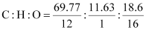
Therefore, the empirical formula of the compound is C₅H₁₀O. Now, the empirical formula mass of the compound can be given as:
5 × 12 + 10 ×1 + 1 × 16
= 86
Molecular mass of the compound = 86
Therefore, the molecular formula of the compound is given by C₅H₁₀O.
Since the given compound does not reduce Tollen’s reagent, it is not an aldehyde. Again, the compound forms sodium hydrogen sulphate addition products and gives a positive iodoform test. Since the compound is not an aldehyde, it must be a methyl ketone.
The given compound also gives a mixture of ethanoic acid and propanoic acid.
Hence, the given compound is pentan−2−ol.
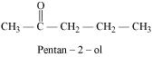
The given reactions can be explained by the following equations:
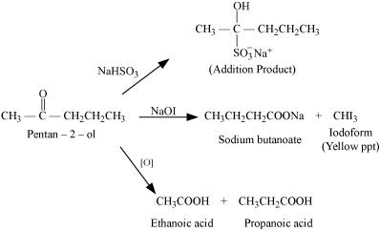
Q.13
How will you prepare the following compounds from benzene? You may use any inorganic reagent and any organic reagent having not more than one carbon atom
(i) Methyl benzoate (ii) m-Nitrobenzoic acid
(iii) p-Nitrobenzoic acid (iv) Phenylacetic acid
(v) p-Nitrobenzaldehyde.

ANS:(i)
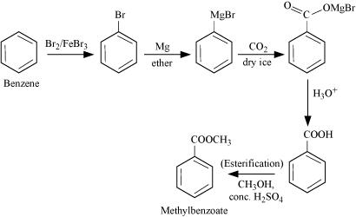
(ii)
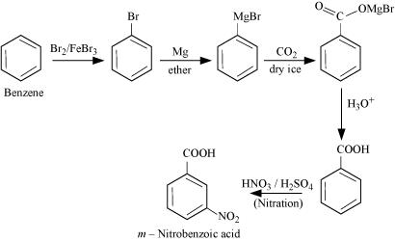

(iii)
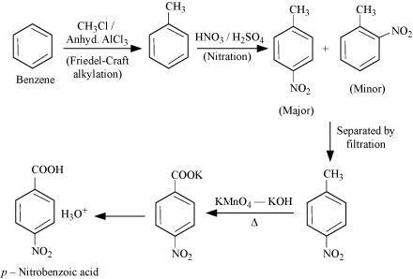
(iv)
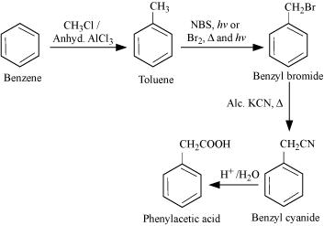
(v)
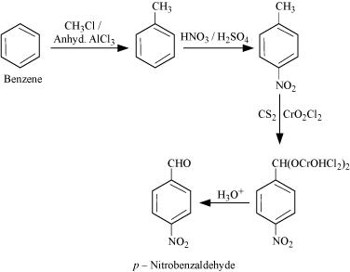
Q14 An organic compound ‘A’ with molecular formula C₈H₈O forms an orang e red precipitate with 2-4 DNP reagent & with yellow precipitate with on heating with iodine in the presence of sodium hydroxide. It neither reduce Tollens or fehling reagent nor does it decolorize bromine water. On drastic oxidation with chromic acid, it gives a carboxylic acid (B) having molecular formula n C₇H₆O₂. Identify the compound “A” and “B” and explain th e reaction involved.

Q. 15 Although — NH2 gp is an ortho and para directing gp, nitration of aniline gives along with ortho and para, meta derivatives also.
Ans. Nitration is carried out with a mixture of Conc. NO3 + Conc. H2SO4 (nitrating mix). In the presence of these acids, most of aniline gets protonated to form anilinium ion. Therefore, in the presence of acids, the reaction mixture consists of aniline and anilinium ion. Now – NH2 gp in aniline is O, p-directing and activating while –N+H3 gp in anilinium ion is m-directing and deactivating hence a mixture of all three–ortho, para and meta derivatives is formed.
Q. 16. Pkb of aniline is more than that of methyl amine.
Ans. In aniline, the lone pair of electrons on the N-atom are delocalized over the benzene ring. As a result electron density on the nitrogen decreases. In contrast in CH2NH2, + I effect of CH3 increase the electron density on the N-atom. Therefore, aniline is a weaker base than methylamine and hence its Pkb value is higher than that of methylamine.
Q. 17 Accomplish the following conversions :
(i) Nitrobenzene to benzoic acid
(ii) Benzyl Chloride to 2-phenylethanamine
Ans. (i) NaNO2 + HCl
(i) Fe/HCl 273 – 278 K CuCN/HCN
————— ————— —————
(ii) NaOH Diazotization Benzene
Diazanium
Aniline Chloride Benzonitrile
H3+O
—————
Hydrolysis

Benzoic acid
(ii)
KCN (aq)  LaAlH4
————— —————
– KCl Redue

Benzyl Chloride Phenyl ethanenitrite 2-phenylethanamine

Q. 18 Why are aliphatic amines more basic than aromatic amines ?
Ans. In Aromatic amines, due to resonance, N-atom acquries +ve charge and  lone pair of N-atom is less available.
In aliphatic amines, due to e– releasing nature of alkyl groups lone pair of e– on N-atom is more available.
 More basic.

Q. 19. How can you distinguish between 1° and 2° amine ?
Ans. (i) Carbylamine test :
R — NH2 + CHCl3 + 3 KOH ——— R — NC + 3 KCl + H2O

(pungent smelling)
2° amines do not give this test.

(ii) Aryl sulphonyl chloride test :
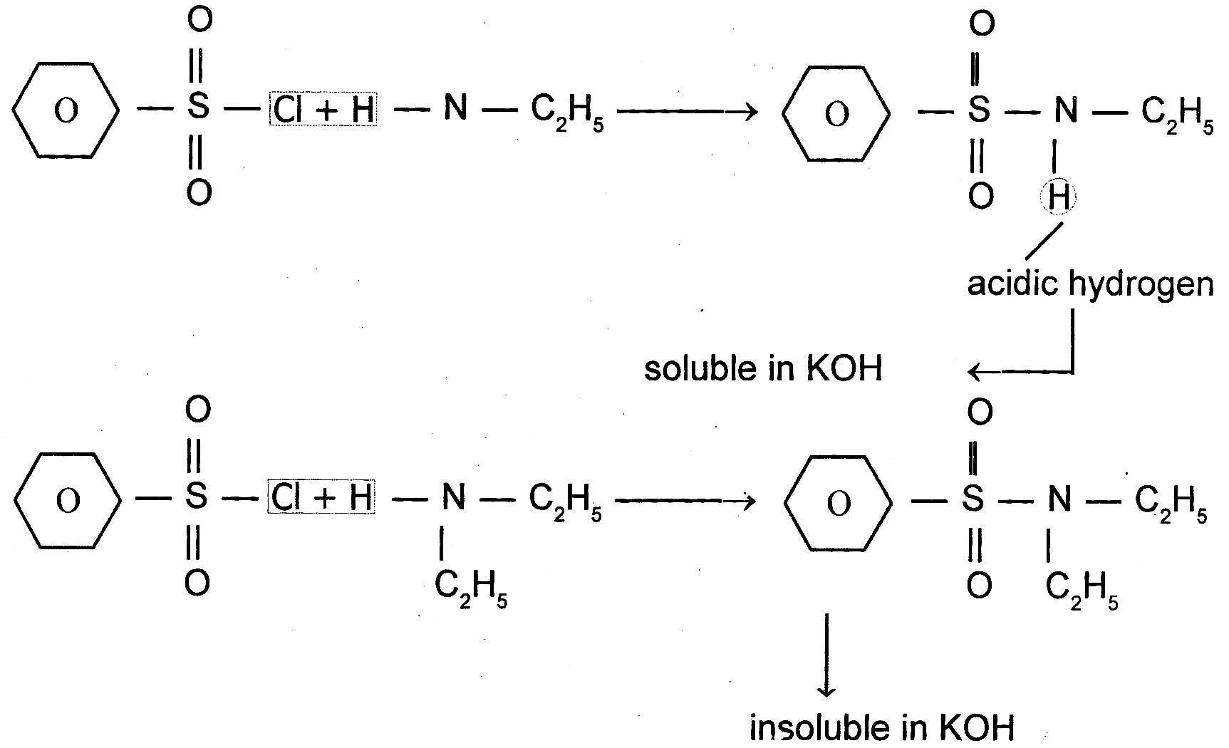

|
H

Q. 20. Explain the order of basicity of the following compounds in (i) Gaseous phase and (ii) inaqueous soln. :
(CH3)3N, (CH3)2NH, CH3NH2, NH3
Ans. Due to + I effect of alkyl gps, the electron density on the N-atom of 1°, 2° and 3° amines is higher than that on the N-atom in NH3. Therefore, all amines are more basic than NH3.
(i) In gaseous phase, solvation effects are absent and hence the relative basicity of amines depends only on + I effect of the alkyl gps. Now since + I effect increases in going from 1° to 2° to 3° amine, so the basicity of amines decreases in the order :

3° amine > 2° amine > 1° amine
(CH3)3N > (CH3)2NH > CH3NH2 > NH3
(ii) In aq. soln, the basicity depends upon two factors :
(a) + I effect of CH3 gp and
(b) Solvation effect.
Stabilization of the conjugate acid (formed addition of a proton to amine) by H-bonding explained above on the basis of + I effect, the order will be :
(CH3)3N > (CH3)2NH > CH3NH2
On the basis of Stabilisation of conjugate acids by H-bonding alone as explained below :
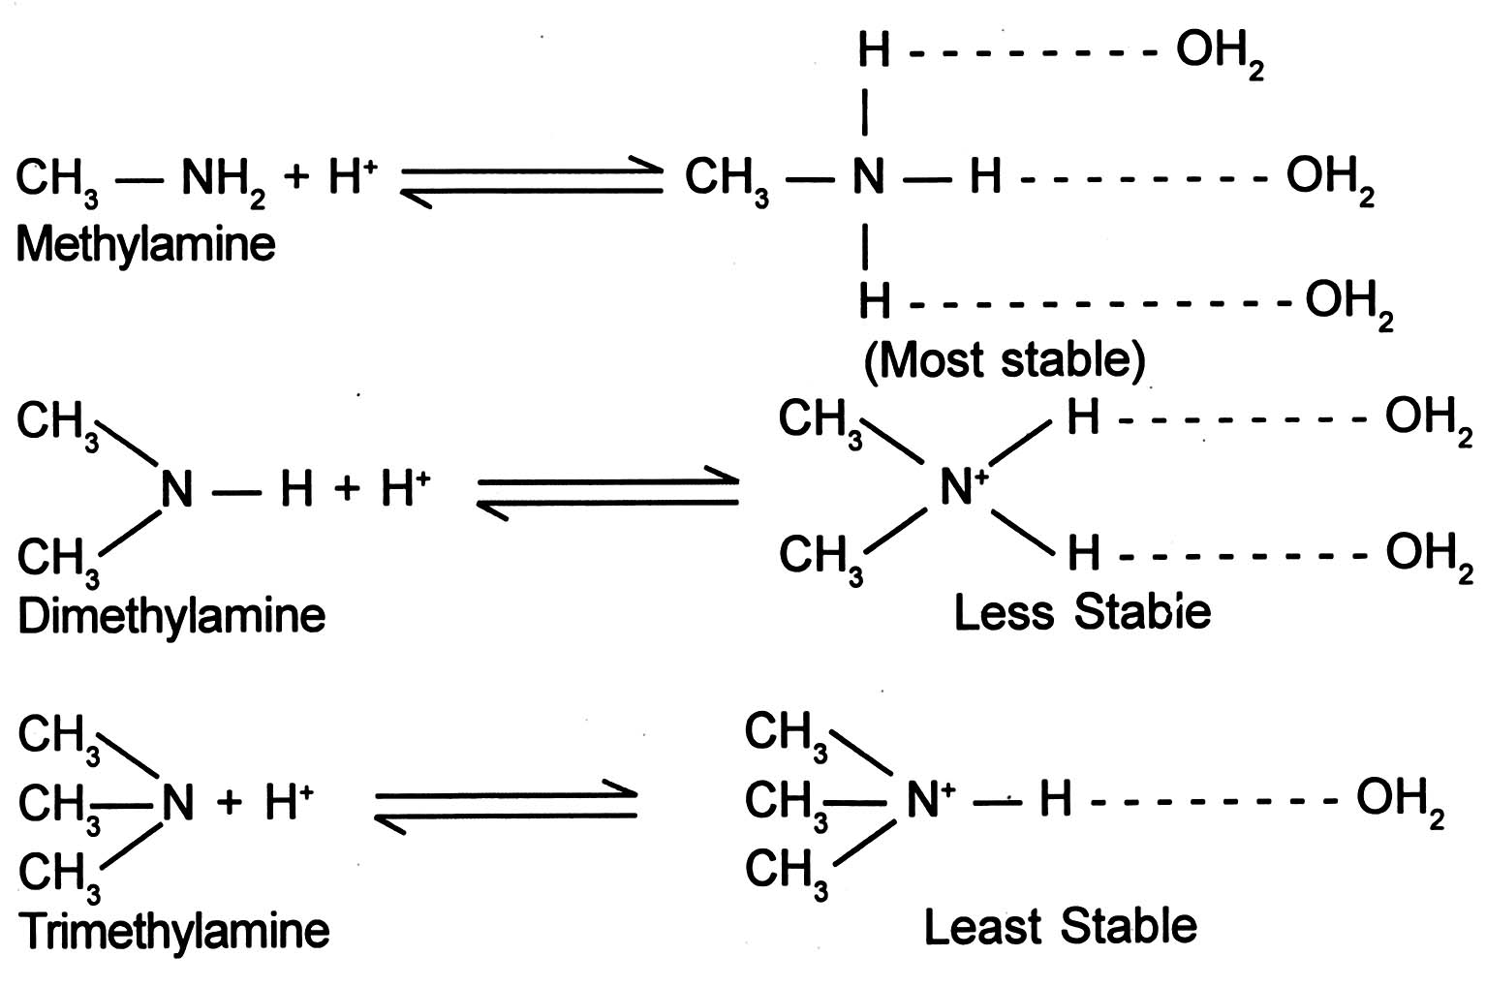

The order will be :
CH3NH2 > (CH3)2NH > (CH3)3N
The combined effect of these two opposing factors is that (CH3)2 NH is the strongest base. In case of CH3NH2 and (CH3)3 NH, the stability due to H-bonding predeminates over stability due to + I effect of CH3 gp, thereby making CH3NH2 stronger than (CH3)3 NH. So the overall order in aq. soln will be :
(CH3)2 NH > CH3NH2 > (CH3)3N > NH3
Q21 Comment on the following-
a. Hoffmann’s bromamide reaction.
b. Carbylamine reaction
c. Diazotization reaction (NCERT TEXT BOOK)

Q22. Write the chemical reactions -
- Hinsberg’s test for all amines.
- Test to distinguish aliphatic amines & aromatic amines.
Q23 An aromatic compound A on treatment with aqueous ammonia and heating form compound B which on heating with Br ₂and KOH form a compound C of molecular formula C₆H₇N. Write the structure and IUPAC name of compound A,B,C (NCERT TEXT BOOK)
Q 24Write short notes on
(1)Gabriel phthalimide synthesis
(2)H.V.Z reaction
(3)Aldol condensation
(4)cannizaro reaction
Q 25Which acid of each pair is stonger
(a)CH₃COOH Or CH₂FCOO
(b) CH₂FCH₂CH₂COOH Or CH₃CHFCH₂COOH (FOR answer see in text of ncert aldehyde ketone carboxylic acid

=================================================================
JAWAHAR NAVODAYA VIDYALAYA
DANTIWADA (GUJRAT)
=================================================================
SELECTED QUESTIONS OF CHAPTER :HALOALKANE AND HALOARENE,ALCOHOL,PHENOL AND ETHER
=================================================================
Q. 1. Write the mechanism of hydration of ethene to yield ethanol.
Ans. H2O + H+ ——— H3O+
Step (i) : — Protonation of alkene to form carbocation by electrophilic attack :

Step (ii) : — Nucleophilic attack of water on carbocation :
Step (iii) : — Deprotonation to form an alcohol :

Q. 2. Alcohols acts as weak bases. Explain.
Ans. The oxygen atom of the hydroxyl group has two lone pairs of electrons. Therefore alcohols accept a proton from strong mineral acid to form oxonium ions. Hence act as weak bases.
Q3. An Organic compound ‘A’ having molecular formula C4H8 on treatment with dil H2SO4 gives ‘B’ – ‘B’ on treatment with ione Hcl and anhydrous Zncl2 gives ‘C’ and on treatment with sodium ethoxide gives back ‘A’ . Identify the compound ‘A’ , ‘B’ and ‘C’ and write equation involved.
Ans:
A CH₃ − C = CH₂
|
CH₃

B CH₃ − C(OH) − CH₃
|
CH₃

C CH₃ − C(Cl) − CH₃
|
CH₃

Q.4. Explain why: -
(a) H₂SO₄ cannot be used along with KI in the conversion of an
alcohol to an alkyl halide.
(b) Alkyl halide though polar are immiscible with water.

Ans: -
- H₂SO₄ converts KI to corresponding HI and then oxidise it into iodine.
- When halo alkane interacts with water molecule , less amount of energy is released which is not sufficient to break the original H- bond between water molecule and to form new H-bond with halo alkane and water.

Q.5.Which one of the following has the highest dipole moment, and
why?
(a) CH₂Cl₂
(b) CHCl₃
( c) CCl₄
Ans:- CH₂Cl₂ has the highest dipole moment since both the Cl- atoms are present on one side (on the head) of c – atom and therefore cause a maximum dipole moment. In CHCl₃ and CCl_{4,} two Cl – atoms and four Cl – atoms cancel out their dipole moments.
Q.6. What happens when
- Methyl Chloride is treated with KCN
- ChloroBenzene is subjected to hydrolysis
- Propene is treated with Cl₂ in the presence of U.V. light OR is heated.
- Chlorobenzene is treated with acetyl chloride in presence
- of anhyd. AlCl₃
- Chloroform is slowly oxidized by air in presence of light.
Ans:-
a) CH₃ – Cl + KCN CH₃ – CN + Kcl
Methyl cyanide

b)
Cl + HOH H⁺ OH + HCL Phenol

U.V. Light or
( c) CH₃ – CH = CH₂ + Cl₂ CH₂ – CH= CH₂ + HCL
Heat
Cl
Allyl Chloride
O Cl Cl
(d) anhyd. COCH₃
Cl + CH3-C-Cl +
AlCl₃
COCH₃
Air
(e) CHCl₃ + $\frac{1}{2}$ O2 COCl₂ + HCl
Q.7. Arrange the compounds in increasing order of their boiling pts.
(a) CH₃CH₂CH₂CH₂Br, CH₃CH₂CHBrCH₃ , (CH₃)₃C Br
(b) CH₃Br, CH₂Br_{2,} CHBr₃
Ans:
(a) (CH₃)₃C-Br< CH₃CH₂CHBrCH₃< CH₃CH₂CH₂CH₂Br

Boiling point increases.

Boiling point decreasing on increasing the branching

(b) CH₃Br< CH₂Br₂< CHBr₃

Boiling point increases
Boiling point increases due increasing molecular mass.
Q.8. Write down the IUPAC name of the following organic compounds: -
(a) CH₃CHCl₂
(b) CH₃CH₂CH₂CH(C(CH₃)₃)CH(I)CH₂CH₃
(c)
H₅C₂ Cl

Ans: - (a) 1,1- Dichloroethane
(b) 3-Iodo – 4 – (1,1 – dimethyl ethyl ) heptane
(c) 1- Chloro – 4 – ethyl cyclo hexane

Q.9. Write down the structures of the following organic compounds
(a) 1- Bromo – 4 – sec. butyl – 2 – methyl benzene
(b) 2 – Chloro – 3 – methyl pentane
(c ) Vinyl chloride
Ans:- (a)
C₂H₅
CH Br

CH₃ CH₃
(b) CH₃CH₂CH(CH₃)CH(Cl)CH₃
( c) CH₂= CHCl
Q.10. How can the following interconversions are carried out
(a) Ethanol to but-1-yne
(b) Benzene to 4-bromo nitro benzene
( c) Toluene to benzyl alcohol

Ans:- Conc. H₂SO₄ 1. Br₂
a) CH₃CH₂OH CH₂=CH₂ CH= CH
160-170⁰C 2.Alc.KOH
NaNH₂
C₂H₅Cl
CH₃CH₂C= CH CH= CNa

NO₂ NO₂
b) Conc.HNO₃ Br₂/ CCl₄

Br

CH3 CH₂Cl
c) U.V.Light

Q11. Explain the following .
- Allyl chloride is hydrolysed more readily than n-propyl chloride.
- Vinyl chloride is hyolrolysed more slowly than ethyl chloride

Ans:- (a) Allyl chloride readily undergoes ionization tpo produce sesonance stabilized allye
carbocation. Science carbocation are rective species, therefore allyle cotion reading combines with OH ions to form allyl alcohol. In contrast n-propyl chloride does not undergo ionization to produce n- propyl chloride.
  - Vinyl chloride get reacting stabilization Carbon-chlorine bond acquires some double bond character. In contrast in ethyl chloride, the carbon-chlorine bond is a pure single bond. This Vinyl chloride under goes hydrolysis more slowly than ethyl chloride.
Q12What happened when
(1)propene is treated with HBr in the presence of peroxide.
(2)methyl chloride is treated with KCN. (ANS SEE NCERT TEXT BOOK)
Q 13Explain why Grignard reagent should be prepare under anhydrous condiction?
Ncert text book
Q14.Predict the order of reactivity of the following compound in SN¹ and SN² reaction.
- The four isomeric bromobutone
- C₆H₅CH₂Br, C₆H₅CH(C₆H₅)Br, C₆H₅CH(CH₃)Br, C₆H₅C(CH₃)C₆H₅Br

Ans:- CH₃CH₂CH₂CH₂Br<(CH₃)₂CH CH₂Br<CH₃ CH₂ CH(Br)CH₃<(CH₃)₃C-Br

Reactivity towards SN¹ Reaction

CH₃CH₂CH₂CH₂Br>(CH₃)₂CH CH₂Br>CH₃ CH₂ CH(Br)CH₃>(CH₃)₃C-Br

Reactivity towards SN² Reaction

(b) Reactivity towards SN1 Reaction

C₆H₅C(CH₃)(C₆H₅)Br>C₆H₅(CH(C₆H₅)Br>C₆H₅CH(CH₃)Br>C₆H₅CH₂Br
Reactivity towards SN² Reaction

C₆H₅C(CH₃)(C₆H₅)Br<C₆H₅(CH(C₆H₅)Br<C₆H₅CH(CH₃)Br<C₆H₅CH₂Br

Q 15In the following pair of halogen compound which is faster undergoing S_{N}2 REACTION

Q. 16. Alcohols are easily protonated than phenols. Justify.
Ans. In phenols lone pair of electrons on the oxygen atom are delocalised over the benzene ring due to resonance and hence are not easily available for protonation. In contrast in alcohols, the lone pairs of electrons on the oxygen atom are localized due to absence of resonance and hence are easily available for protonation

Q17 Why phenol is acidic compare it with ethanol ?

Ans: In phenol dissociation takes place as follows.
OH O⁻

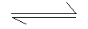 +H⁺

(Phenol) ( Phenoxideion )

The conjugate base of phenol ie. Phenoxide ion is resonance stabilized. This is why the negative charge on oxygen atom is delocalized through out the ring. So, the oxygen present in phenoxide ion has less tendency to form undissociated phenol molecule and equilibrium lies towards right direction.
Q.18. Give the IUPAC name of CH₃O – CH – CH₃

CH3
Ans:- 2- Methoxypropane
Q.19. Convert the following : -
- Aniline to Phenol
- Phenol to picric acid
Q.20. Explain the following with an example: -
- Kolbe’s reaction
- Williamson’s ether synthesis
Q.21. Write chemical reaction for the preparation of phenol from cumen
Q.22.
Distinguish Primary, Secondary and tertiary alcohols with the help of Lucastest.
Q.23Write the equation of the following reactions : -
(i) Friedel Craft reaction
(ii) Nitration of anisole
Q.24Explain the following with an example :
- Kolbe reaction
- Reimer Tiemann’s reaction
Q. 25Convert the following: -
(i) Phenol to bezene
(ii) Phenol to benzoquinone
Q.26Explain Williiamson’s synthesis with one example
Q.27
- Explain why is ortho - nitro phenol more acidic than o- methoxy phenol?
- Write the mechanism of the reaction of HI with methoxy methane.
Q.28Name the reagents used in the following reactions:

- Benzyl alcohol and Benzoic Acid
- Butan- 2- one to Butan – 2- ol
- Bromination of phenol to 2,4,6, tribromophenol (text book)

Q29 Write mechanism of the reaction of HI with methoxymethane (text book)

OCH₃

OCH₃
Q 30What is Luca reagents? Text book
Q31How phenol is obtained from aniline?

=================================================================
JAWAHAR NAVODAYA VIDYALAYA
DANTIWADA (GUJRAT)
=================================================================
SELECTED QUESTIONS OF CHAPTER : P-BLOCK ELEMENTS
=================================================================

Q1. Why Nitrogen is a gas whereas Phosphorous is a solid?
Ans: Nitrogen molecules have less Vander Waal’s forces of attraction whereas molecular phosphorous has more Vander Waal’s forces of attraction.

Q2. Complete the following reactions :-
i) XeF₆ + H₂O → --- + ---- ( partial hydrolysis)
ii) XeF₆ + H₂O → --- + ---- ( Complete hydrolysis )
iii) Cl₂ + H₂O→ --- + ----
Ans: i) XeOF₄ + HF
ii) XeO₃ + HF
iii) HOCl + HCl
Q3. Arrange the following in decreasing order :-
  - NaF, NaI, NaCl,NaBr( Ionic nature)
  - PH₃, NH₃, ,AsH₃,SbH₃ ( Basic Strength)
  - HF,HBr,HCl,HI ( Acid Strength)
Ans i) NaF> NaCl > NaBr> NaI
ii) NH₃> PH₃> AsH₃> SbH₃
iii) HI> HBr> HCl> HI
Q4 Find hybridization and shape i) XeF₂ ii) XeO₃ iii) XeF₄
Ans: i) sp3d, Linear
ii) sp3, Pyramidal
iii) sp3d², Square planar
Q5 Give reasons
i) H₂O is a liquid but H₂S a gas.
ii) Ammonia has higher boiling point than phosphine
ii) Krypton & xenon make compounds.
Ans: i) Hydrogen bond is found in H₂O but not in H₂S.
ii) Hydrogen bond is found in NH₃ but not in PH₃.
iii) Because they have low ionization energy.

Q6 Write down the chemical reactions that take place in the manufacture of sulphuric acid by contact’s process.
Ans: i) S + O₂ → SO₂
V₂O₅
ii) SO₂ + O₂ SO₃
iii) SO₃ + H₂SO₄ → H₂S₂O₇
iv) H₂S₂O₇ + H₂O → 2H₂SO₄
Q.7. Which forms of Sulphur show paramagnetic behaviour ?
Ans : In Vapour State sulphurPartly exists as S₂ molecule which has two unpaired electrons in the *
Orbitals hence exhibit paramagnetic
Q.8. Why does O₃ act as powerful Oxidising agent ?
Ans: Due to ease with Which it liberates atoms of nascent oxygen (O₃→ O₂ +0)
2Pbs (S) + 4O₃ (g) → PbSO₄(S) + 4O₂ (g)

Q.9. How is the presence of SO₂ detected ?
Ans : 1. It has pungent characteristic smell .
2. It decolourises KMn O₄ solution
3. It turns acidified K₂ Cr₂ O₇ green

Q.10. Are all the five bonds in PCl₅ molecule equivalent ?
Ans – PCl₅ has a trigonal bipyramidal structure and the three equatorial p-cl bonds are equivalent . while trhe
two axial bonds are different and longer than equatorial bonds
Q.11 Why is helium used in diving apparatus ?
Ans: Because heliun is very low solubility in blood

Q.12 Give reason for bleaching action of Cl₂
Ans Due to oxidation
Cl₂+H₂O→ 2HCl+ O
Coloured substance +O →colourless substance
Q.13 Why H₃ PO₃ is dibasic and H₃PO₄ is tribasic ?
Ans In H₃PO₃ only two replacable hydrogen but inH₃PO₄ , three hydrogens are replacable

Q14 Arrange the following as mentioned:

1. M-F, M-Cl, M-Br, M-I. (Decreasing order of ionic nature)
2. F₂, Cl₂, Br₂, I₂. (Increasing order of bond energy)
3. H₂O, H₂S, H₂Se, H₂Te. (Decreasing order of boiling points)
4. NH₃, PH₃, AsH₃, SbH₃. (Increasing order of basic nature)
5. HI, HBr, HCl, HF. (Increasing order of thermal stability)
6. HI, HBr, HCl, HF. (Increasing order of reducing power)
7. HOCl, HOClO, HOClO₂, HOClO₃. (Increasing order of acid strength)
8. H₂O, H₂S, H₂Se, H₂Te. (Increasing order of acid strength)
Q15 HClO₄, HBrO₄, HIO₄. (Decreasing order of acid strength
- Explain the process and necessary conditions involved in the preparation of NH₃, H₂SO₄ or HNO₃.
- What are interhalogen compounds? How are they classified?

- Why do noble gases have comparatively larger atomic size? Give the reasons which prompted Bartlett to prepare first noble gas compound.

Q16 Complete the following reactions:-

- XeF2 + H2O →
- XeF2 +PF5 →
- XeF4 +H2O →
- XeF6 +H2O →
- XeF4 +SbF5 →
- I₂+H2O+Cl2 →
Q17
- CaF2+H2SO4 →
- NaOH +Cl2 →
- F2 + H2O →
- PCl3 + H2O →
- PCl5 + H2O →
- C + H2SO4 →
- Ca(OCl)Cl+HCl →

SELECTED QUESTIONS OF :
- POLYMERS

Q. 1 Define the term polymerisation?
Sol. Polymerisation is a process of formation of a high molecular mass polymer from one or more monomers by linking together of repeating structural unit with covalent bond.

Q. 2 In which classes, the polymer are classified on the basis of molecular forces?
Sol. On the basis of molecular forces present between the chain of various polymers, the classification of polymer is given as follows,
- Elastomers
- Fibres
- Thermoplastics
- Thermosetting plastics

Q. 3 How you can differentiate between addition and condensation polymerisation?
Sol. In addition polymerisation, the molecule of same or different monomers add together to form a large polymers molecule. Condensation polymerisation is process in which two or more bifunctional molecules undergo a series of condensation reactions with the elimination of some simple molecule and leading the formation of polymers.

Q.4 Write the free radical mechanism for polymerisation of an alkene?
Sol. The mode of free radical polymerisation consist of three steps :
- Chain initiation step
O O O
|| || ||
C₆H₅ –C–O––O–C–C₆H₅ ----------→ 2C₆H₅ –C–Ò
| .
2C₆H₅
Phenyl radical

. .
C₆H₅ + CH₂ = CH₂ ----→ C₆H₅ –CH₂ –CH₂

(ii) Chain propagating step :

.
C₆H₅ – CH₂ – CH₂ + CH₂ = CH₂
| .
C₆H₅ – CH₂ – CH₂ – CH₂ – CH₂
|
CH₂ = CH₂ |
| .
C₆H₅ – (-CH₂CH₂-) – CH₂CH₂

(iii) Chain terminating step :

. .
C₆H₅–(-CH₂–CH₂-)– CH₂–CH₂ + C₆H₅

|
C₆H₅–(-CH₂–CH₂-)–CH₂–CH₂–CH₂–CH₂–(-CH₂–CH₂-)–C₆H₅

Polythene

Q.5 Define the thermoplastics and thermosetting polymers with two example of each.
Sol. A thermoplastic polymers can be repeatedaly soft ended o heating and hareden on cooling hence it can be use again and again. The example are polythene and polypropylene etc. A thermosetting polymers is a permanent setting polymer as it get harden and set during molding process and can not be soften again. The example are bakerlight and melamine – formaldehyde polymers.
Q. 6 Write structures of monomers used for getting the following polymers?
(A) PVC
(B) Teflon
(C) PMMA
Sol. (A) PVC : Is stands for polyvinyl chloride. Monomers used : Vinyl chloride structure of monomer is CH₂ = CH – Cl
(B) Teflon : It is also called polyteraflouro ethylene, PTFE. Monomers used : Teraflouro ethylene CF₂ = CF₂
(C) PMMA : Its stands for polumethylmethacrylate. It is also known as ‘Plexi glass’. Monomers used : Metyl meth acrylate, CH ₂ = C – COOCH₃
|
CH₃

Q. 7 Write the name and structure of one of the common initiators used in free radical addition polymerisation.
Sol. A commonly used reagent used for initiating of free radical change reaction is tertiary butylparoxide (CH₃)₃ CO – OC (CH₃)₃ it is decomposes under mild condition to form two turtbutoxide radical.

(CH₃)₃C–O––O–C(CH₃)₃
tert. butylperoxide
|
heat, light etc 370 – 420 K
split up
2(CH₃)₃ C –Ò(let it represent it by )

Q. 8 Write the name and structures of the monomers of the following polymers? (1) Buna – S
(2) Buna – N
(3) Dacron
(4) Neoprene
Sol. The names and the structures of monomers are

Name | Monomeric unit | Structure of monomer
(i) Buna – S | 1, 3 – Butadiene styrene | CH₂ = CH – CH = CH₂  C₆H₅CH = CH₂
(ii) Buna – N | 1, 3 – Butadiene  acrylonitrile | CH₂ = CH – CH = CH₂  CH₂ = CH – CN
(iii) Neoprene | Chloroprene | Cl  |  CH₂ = C – CH = CH₂
(iv) Dacron | Ethylene glycol  Terephthalic acid | OHCH₂ – CH₂OH

CHEMISTRY IN EVERY DAY LIFE
============================================================

Q.1 List two major classes of antibiotics with an example of each class?
Sol. See the NCERT text book.

Q.2 What are antacid? List some of the compound which are used as antacids?
Sol. See the NCERT text book.
Q.3 Define the term chemotherapy.
Sol. See the NCERT text book.

Q.4 What is mean by the term ‘broad spectrum antibiotics’ ?
Sol. The total range of microorganism which can be killed by a particular antibiotic is refered to its spectrum. Antibiotics which are effective agains several different type of harmful microorganism and thus capable of curing several infections are called broad spectrum antibiotic. Chloranphenical is such type of antibiotic.

Q.5 Why are cimetidine and ranitidine better antacid than sodium bicarbonate or magnesium or aluminium hydroxide?
Sol. Over production of hydrochloric acid in the stomach cause acidity. So, sodium bicarbonate or magnesium or aluminium hudroxide are used as treatment of acidity. However excessive bicarbonate can make the stomach alkaline and trigger the production of even more acid. But the drugs cimetidine and rentidine work in different way. They prevent the interaction of histamine with the receptor present in the stomach wall and this results in release a lesser amount of acid.

Q.6 Name the substance which can be used as an antiseptics as well as disinfectant.
Sol. Phenol can be used as antisepics as well as disinfectant. 0.2 % solution of phenol is used as an antiseptic and 1 % solution of phenol is disinfectant.

Q.7 What are main constituents of dettol?
Sol. Chloroxylenol and terpineol are the main constituent of dettol.

Q.8 What is tincture of iodine? What its used?
Sol. A 2-3 % of solution of iodine in alcohol water mixture is called tincture of iodine. It is used as an antiseptic.

Q. 9 What are food preservative?
Sol. Chemical substance which when added to food material inhibit the growth of microorganism and thus prevent the spoilage of food are known as food preservative for example sodium benzoate.

Q.10 Why is use of aspartame limited to cold food and drinks?
Sol. Aspartame is unstable to heat and therefore it can be used as sugar substitute in cold drinks and cold food only.
Q.11 what are artificial sweetening agents? Give two examples?
Sol. Substance which are used as sweetening agents in place of sugar but have no nutritive value are called artificial sweetening agent. Saccharine and aspartame are example of artificial sweetening agent.

Q.12 Explain the following term with suitable example?
(A) Cationic detergents
(B) Anionic detergent
(C) Neutral detergent
Sol. See the NCERT text book.

Q.12 What are biodegradable and non- biodegradable detergents? Give one example of each?
Sol. The detergents which are decomposed by microorganisms like bacteria are called biodegradable and detergents are not decomposed by microorganism are called non-biodegradable detergents containing unbranched hydrocarbon chain are biodegradable while the deterents containing branched hydrocarbon chain are non-biodegradable.
For example n-lauryl sulphonate is biodegradable. On the other hand, a detergent such as shown below is non-biodegradable.

Q.12 Give structural formula of aspirin, what is its chemical name?

Q.13 Give the name one broad spectrum antibiotic?

Q.14 What type of drug is chloramphenicol?

Q.15 Define the following and give one example of each :
(i) Antipyretics
(ii) Antibiotics

Q.16 Account of the following :
(A) Aspirin drug helps in the prevention of heart attack.
(B) Diabetic patients are advise to take artificial sweeteners instead of natural sweeteners.

ANIL KR SHARMA (P.G.T. CHEMISTRY)
JAWAHAR NAVODAYA VIDYALAYA , DANTIWADA,GUJRAT
Email maddy0408@gmail.com
Phone No. 80005899

