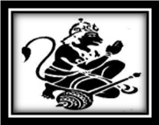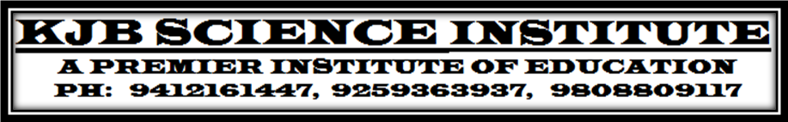
TEST SERIES - {CHEMISTRY: XII (CBSE)} TEST---7 CHAPTER: ORGANIC CHEMISTRY[set-A]

Q.1 Write the IUPAC name of the following compound: [1]
H₃C – CH – CH₂ – CH – CH – CH₂OH
| | |
CH₃ OH CH₃
Q.2 How do you account for the miscibility of ethoxyethane with water. [1]
Q.3 Explain why:
(i)The dipole moment of chlorobenzene is lower than that of cyclohexyl chlorides
(ii)Grignard reagents should be prepared under anhydrous conditions?
(iii)Alkyl halides, through polar are immiscible in water. [3]
Q.4 Suggest a possible mechanism for the following reaction: [2]
EtOH, H₂O
n – BuBr + KCN ------------------→ n – BuCN
Q.5 Give an example for each describe the following reactions:
(i) Gatterman reaction (ii) Coupling reaction. (iii)Riemer timann reaction [3]
Q.6 Explain as to why haloarenes are much less reactive than haloalkanes towards nucleophilic substitution reactions. [2]
Q.7 Which compound in each of the following pairs will react faster in SN² reaction with – OH? Why? [3]
(i) CH₃Br or CH₃I
(ii)
(iii)
Q.8 Alcohols react both as nucleophiles & electrophiles. Write one reaction of each type and describe its mechanism. [2]
Q.9 What products would you expect from the elimination of the following alkyl halides, which
product will be major in each case? (i) 2- Bromo – 2 methyl butane (ii)3 – bromo- 2 , 3 , 5 - trimethylhexane [2]
Q.10 Complete the following reactions. [2]
-----------→D
H₂o/ Hg²⁺
Q.11 Explain the following observations:
(i) The boiling point of ethanol is higher than that of methoxymethane.
(ii) Phenol is more acidic than ethanol (iii) o – and p – nitrophenols are more acidic than phenol. [3]
Q.12 Name the reagent which are used in the following conversions: Write chemical reaction also. [3]
(i) A primary alcohol to an aldehyde (ii)Butane – 2 – one to butane – 2 – ol. (iii)Phenol to 2, 4, 6-tribromophemnol.
Q.13 Explain the mechanism of the following reactions:
(i) Addition of Grignard’s reagent to the carbonyl group of a compound forming an adduct followed by hydrolysis.
(ii) Acid catalysed dehydration of an alcohol forming an alkene. [4]
Q.14 Give one chemical test each to distinguish between the following pairs of compounds:[4]
(i) Phenol & benzoic acid (ii) 1 – Propanol & 2 – propanol (iii) Ethanol & phenol (iv)Phenol & benzyl alcohol
Q.15 How would you carry out the following conversions?
(i) Ethyl magnesium chloride to propan -1 – ol (ii)Benzyl chloride to benzyl alcohol.
(iii)An alkyl halide to a quaternary ammonium salt. (iv) Propene to Propan – 1 – ol
(v) Phenol to salicylaldehyde. (vi) Methanol to ethanol
(vii) Anisole to 4-methoxyacetophenone [7]
Q.16 Write the formula of main product in the following chemical reactions.
(i) Na/ dry ether (ii) CH₃Br + AgF -----------→
(CH₃)₂ CH – Cl -----------------→
(iii) CH₃CH₂Br + NaI -----------------→ (iv) C₆H₅N₂Cl + KI -------------------------------→ [4]
Q.17. An organic compound (A) having molecular formula C6H6O gives a characteristic colour with aqueous FeCl₃
solution (A) on treatment with CO₂ and NaOH at 400 K under high pressure gives (B) which on acidification gives a
compound (C). C reacts with acetyl chloride to give (D), which is a popular Pain Killer. Deduce the structures of
(A), (B), (C) and (D). [4] Or
Compound (A) reacts with SOCl₂ to give compound (B). B reacts with Mg to form Grignard reagent which is treated
with acetone & product is hydrolyzed to give 2-methylbutan-2-ol. What are A & B compounds?Write all reactions.

