SAMPLE QUESTION MATHEMATICS
Class: X

Time : 3 1/4 hrs Marks :80

General Instructions

1. All questions are compulsory
2. The question paper consists of 25 questions divided in to three sections A, B and C .Section A
contains 7 questions of 2 marks each .Section B is of 12 Questions of 3 marks each and section
C of 6 Questions of 5 marks each
3. There is no overall choice .However ,internal choice has been provided in two questions of two marks each, two questions of three marks each, two questions of five marks each
4. In question on construction ,drawing should be neat exactly as per the given measurements.
5. Use of calculators is not permitted.

- What is probability of choosing the red ball from a box containing 20 balls if it is having equal number of yellow, red, blue and green balls?
- Find the frequency if ∑f x = 3100 and ∑ x = 124?
- Determine the sum of first 25 terms of an AP if the second term is 2 and seventh term is -7?
- Write the first 5 terms of an AP whose nth term is given by (2n+1)/3.
- Determine k so that the terms 4k+8, 2k²+3k+6 and 3k²+4k+4 are three terms of an AP?
- solve for y : y²-6y+2=0
OR
Find two consecutive terms, whose squares has sum 85.
- if -4 is root of quadratic equation x²+px-4=0 and the quadratic equation
x²+px+k=0 has equal roots, find the value of k.
OR
One root of the equation 2x²-8x-m=0 is 5/2. Find the value of m and other root.
- Find the length of DE if AE = 15 cm, DB=4 cm and CD= 9 cm.

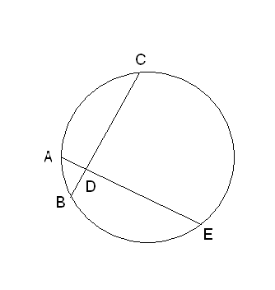
- Prove that the angle formed by a chord in a major segment is acute?
OR
State and prove the basic proportanality theorem.
- An electric pole is 10 m high. If its shadow is 10√3 m in length. Find the elevation of the sun.
- The diameter CD of a circle is perpendicular to chord AB. If AB= 12 cm and CM=2 cm, find the radius of circle.

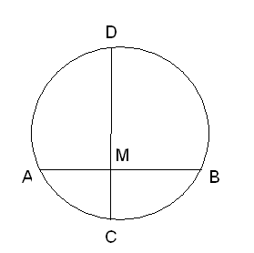
- draw pie chart of follwing data

Items | wheat | rice | Grams | maize | barley
% | 125/3 | 125/6 | 25/2 | 50/3 | 25/3

- In a isosceles triangle with AB=AC then prove that the tangent at A to. the circum circle of triangle ABC is parallel to BC.

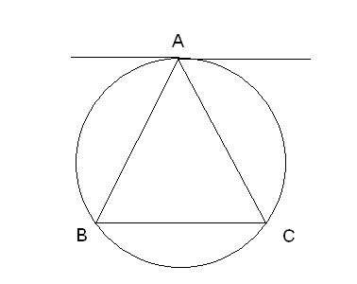
- Construct a circumcircle of an equilateral triangle with side 6 cm. write steps of construction.
- find the probability of having 53 Sundays in a leap year and non leap year.
- the height of a cylinder is 15 cm. the curved surface area is 660 cm². find the radius .
OR
The circumference of the edge f a hemispherical bowl is 132 cm. find the capacity of the bowl.
- The mid point of the line segment joining (2a, 4) and (2, 3b) is (1, 2a +1). Find the values of a and b.
- A is a point on the y axis whose ordinate is 5 and B is the point ( 3, 1). Calculate the length of AB.

- ABCD is a trapezium in which AB!! DC. the diagonals AC and BD intersect at o. prove that
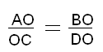

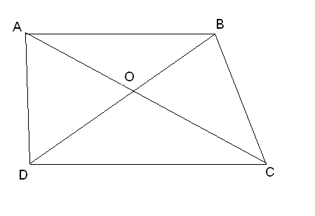

- A toy is in the form of a cone mounted on a hemisphere of radius 7cm. The total height of the toy is 19.5cm. Find the total surface area and the volume of the toy.
OR
A spherical shell of lead, whose external diameter is 18cm, is melted and recast into a right circular cylinder, whose height is 8cm and diameter 12cm. Determine the internal diameter of the shell. By-VIKRANT AGGARWAL LUDHAINA 09915089502

- a) . If Show that
  - If find the value of 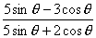
- . If the numerator of a traction in multiplied by 2 and its denominator is increased by 2, it becomes 6/7. If instead we multiply the denominator by 2 and increase the numerator by 2 it reduces to 1/2. What is the fraction?
OR
The area of a rectangle gets reduced by 80 sq. units if its length is reduced by units and the breadth in increased by 2 units. If we increase the length by 10 units and decrease the breadth by 5 units, the area in creased by 50 square units. Find the length and breadth of the rectangle.

- a) . Determine the value of k such that x + 3 is a factor of the polynomial
f(x) = kx³ + x² - 22x - 21
b) . Find the GCD and LCM of the polynomials P(x) and Q(x), where
P(x) = (x³ - 27) (x² - 3x + 2) and
Q(x) =( x² + 3x + 9) (x² - 5x + 6)

- A housing society charges for a flat Rs. 26, 00,000 or Rs. 9,85,999 cash down payment and five equal half yearly installments. If the society charged 16% p.a. compounded half yearly, calculate the value of each installment and the total interest charged.

- The annual income of Kavita is Rs. 3, 32,000 (exclusive of HRA) she contributes Rs. 5,000 per month towards her provident fund and pays an annual premium of Rs. 15,000 for her LIC policy. If she pays Rs. 4,000 per month towards income tax for the first eleven months of the year, find her income tax liability for the last month of the year.

Use the following for calculating income tax
i) Savings upto 1,00,000 are exempted from income tax
ii) Rates of income tax
Slab Rate
a)Taxable income up to 1,35,000 No tax

b)Taxable income from Rs 1,35,001 to 10% of the amount exceeding
1,50,000 Rs 1,35,000

c) Taxable income from Rs 1,50,001 Rs 1,500+20% of the amount
2,50,000 exceeding Rs 1,50,000

d) Taxable income above Rs 2,50,000 Rs 21,500+30% of the amount

