Sample Paper – 2012
Class – XII
Subject –Informatics Practices
Time- 3hrs Max^{m} Marks- 70
Do Not Write any thing on Question Paper

Answer all the questions:-

Q1 A. Cosmic Industries has set up its new center at Anand Nagar for its office and web based
activities. The company compound has 4 buildings as shown in the diagram below:

R Building
T Building

S Building
x Building

Center to center distances between various building is as follows:

X building to R Building | 50m
R Building to T Building | 60m
T Building to S Building | 25m
S Building to X Building | 170m
X Building to T Building | 125m
R Building to S Building | 90m
- Suggest a cable layout of connections between the building. 1
X Building | 15
R building | 150
T Building | 15
S Building | 25
- Suggest the most suitable place to house the server of this organization with a suitable 1
reason.

- Suggest the placement of the following devices with justification: 1
  - Internet connecting device/Modem.
  - Switch
- The organization is planning to link its sale counter situated in various parts of the 1
same city which type of network out of LAN, MAN or WAN will be formed?
Justify your answer.
- What are the various physical media used for the data transmission in a network system? 2
Arrange them according to their data transmission speed.
C. Write the names of different topologies? 1
D. Write short note on 3
      - GNU & FSF
      - Proprietary & Shareware Software
      - Unicode

2 a. Predict an output of the following code fragments: 2
int i = 1, j = 0, n = 0;
while(i<4) {
for(j=1;j<= i ; j++)
{ n+= 1;
i = i+1;
}
System.out.println(n);
}
b. What will be an output of the following code: 2

int i,j,n;

n=0; i=1;

do

{

n++; i++;

System.out.println(n+” “+i);

}while(i<=5);

c. (i)What is the difference between Constructor and a method? 1
(ii) What is the difference between Extends and an implements? 1
d Write the sample code to display current date and time in the text field 2
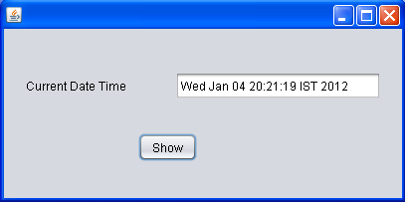
3 a i. Write the sample code to add cities from list box to combo box: 2

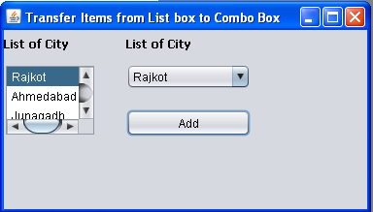
ii. Write code so that user cannot type into textfield RevStrTF. 1
b. Identify and Rectify errors in following code fragment. Explain it: 2
public abstract class Eatable{
private string name;
public string getName(){
return name;
};
}
public void setName(String nm) {
name = nm;
}
public abstract void Cook();
}
public class cake extends Eatable {
public Cake (String n){
name = n;
}
public void cook(int qty) {
int time = qty/4;
System.out.println(“Bake for “+time + minutes);
}
}
c. What is an use of Final and this keyword? 1
4 a Write the code snippet to display a message “HELLO HOW ARE YOU”? 2
Which package is required to be imported in a class to create table in java?
b Write code to calculate discount and insert the record in MySql table Item 4
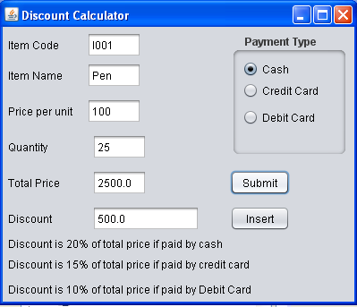
c What do you mean by DefaultTableModel? Write any two methods of this. 2

5 a. Write the name of the package used for using methods of table model. 1
b. For what rowspan and colspan attributes are used? 1
c. What is the difference between radio button and a checkbox? 1
d. Write HTML code to produce a text box a pop up box to choose class from it. 2
e. What is an use of the following in xml? 3
    - version
    - encoding
    - standalone.

6 Given the following tables for a database Library: 6
Table BOOKS
Book_id | Book_name | Author_name | Publishers | Price | Type | Qty
F001 | The tears | William Hopkins | First Publ | 750 | Fiction | 10
F002 | Thunderbolts | Anna Roberts | First Publ | 700 | Fiction | 5
T001 | My First c++ | Brain & Brooke | EPB | 250 | Text | 10
T002 | C++ Brain works | A.W.Rossaine | TDH | 325 | Text | 5
C001 | Fast Cook | Lata Kapoor | EPB | 350 | Cookery | 8
Write SQL queries for (a) to (f):
- To show book name, author name and price of books of epb publishers and price
Less than 700.
- To list the sum of price and average of quantity type wise.
- To display the names and price of the books in descending order of their price.
- To increase the price of all books of first publ by 50.
- To insert a new row in the books table.
- Add a column in the above table serial no which is a primary key and not null.

B. Write a query to display the number of employees with same job. 1
C. What is an use of COMMIT, ROLLBACK and SAVEPOINT in SQL? 3

7 a. Which Keyword is used to eliminate redundant data from a query result? 1
i. What will be an output of the following SQL queries: 4
      - SELECT DAYOFMONTH(CURDATE());
      - SELECT ROUND(453.345,2);
      - SELECT LENGTH(INSTR(SUBSTRING(‘CORPORATE WORLD’, 11,5),LD));
      - SELECT MOD(657,9);
      - SELECT CHAR(66,67.3,’69.3);
      - SELECT SUBSTR(“INTERNATIONAL”,LENGTH(CONCAT(“MARKET”,”ING”)),3);

    - What do you mean by Begin Commit and Rollback? 2
    - What is the difference between Primary key and unique Key? 2
    - What do you mean by derived table and base table? 2
    - What is the difference between Natural Join and Self Join? 1
    - What is the difference between table level constraint and column level 2
Constraints?Give Example
    - Why we use truncate command? 1

8 a. State define the different stages of Database Development Life cycle? 2
b. What are the benefits of e-Commerce and e-Learning? 2
c. What do you mean by Normalization and De Normalization? 1
Paper Submitted By:

Name Sanjay Kumar
Email sanjunt@gmail.com
Phone No. 9714228839

