Sample Paper – 2012
Class – XII
Subject – Informatics Practices
MM : 70 TIME : 3HRS.
SUBJECT : IP
INSTRUCTION :
- Read question carefully
- Put example where ever necessary
- Section A is 30 marks and B & C sections of 20 ,20 marks.
- Each question carries equal marks.

Q1. Answer the following questions.
(a) Differentiate Ring topology vs. star topology (2)
(b) What is a communication channel? (2)
(c) Name two encodings used for Indian Language computing? (1)
(d) Define the following terms: (2)
(i)LAN (ii) WAN
- What is the use of following software’s a) PHP b) MYSQL. (2)
- Give abbreviation for JPEG & ODF (1)

Q2. Answer the following questions.
(a) Give steps of connectivity ? (1)
(b) What does getpassword() on a password field return ? (1)
- a String (ii) an integer (iii) a character array
(c) Write the names of tag <table>‘s attributes along with an example (2)
(d) What is a markup language? Define XML as compare to HTML (2)
(e) What is a Combo Box? When would you prefer a combo box over a list? (2)
(f) What is a Class and its constructor? (2)

Q3. Answer the following questions.
(a) Define the ACID Property in MYSQL? (2)
(b) Write brief notes on any four table Constraints in MySQL? (2)
(c) Differentiate between CHAR and VARCHAR datatypes? (2)
(d) How you can add /remove constraints from table with an example? (2)
(e)Differentiate Primary key and foreign key (2)

SECTION B
Q4. (a)Read the following case study and answer the questions that follow:

The shop a save store has developed the following data entry screen for its operations. The store offers three different types of membership discount schemes for its regular customers. Platinum members get a discount of 10% on all their purchases, gold members get 5% and Silver members get 3% discount.

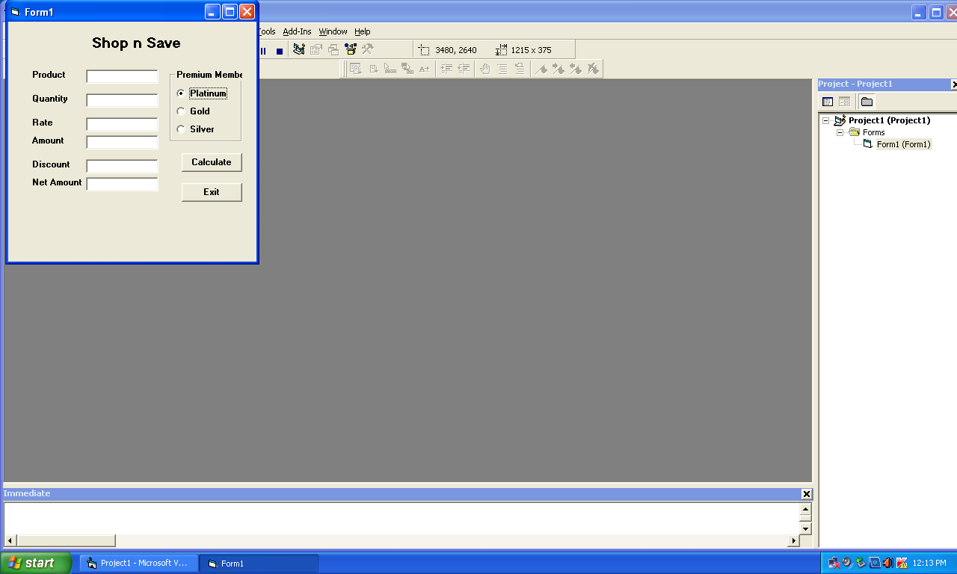

Object Type | Object Name
jText Field | ProductTF
jText Field | QtyTF
jText Field | RateTF
jText Field | AmountTF
jText Field | DiscountTF
jText Field | NetTF
jRadio Buttons | PlatinumRB
jRadio Buttons | GoldRB
jRadio Buttons | SilverRB
jButton | CalcBTN
jButton | ExitBTN

- Write the Code to disable the text fields AmountTF, DiscountTF And NetTF. (1)
- Write the code for CalcBTN to calculate the amount, discount and net amount as per the given description and conditions (3)
- Write the code to remove the decimal part from the text field NetTF so that the net amount contains only the integer portion in rupees. Where (in which event handler) would you place this code to have its impact? (2)
- Write the code for ExitBTN to close the application, but before the application in closed it should check the net amount and if the net amount >10000 the membership of the customer should be upgraded and displayed. For example if the customer already has silver membership it should be upgraded to gold and he should be informed of the same using a message box. (2)
(b) Write the java code to find table of given no. only using DO-WHILE loop. (2)

Q5 ANSWER THE FOLLOWING QUESTIONS

(a). Given the following code fragment : (2)
If(a==0)
System.out.println(“zero”);
If(a==1)
System.out.println(“one”);
If(a==2)
System.out.println(“two”);
If(a==3)
System.out.println(“three”);

Write an alternative code using switch case.
(b). What will be the output produced by following code fragment? (1)

x=1 ; y=1;

if(n>0) {

x=x+1 ;
y=y-1 ;
}
What will be the value of x and y, if n=1 & n=0

(c).Find out errors if any: (2)
int i; sum= 0;
i=1 ;
while (i<=10)
{
Sum =sum +i
i+=3
} System.out.println(sum) ;

(d). Predict the output of the following code fragments: (1)
int val1 =5; val2=10;
for(int i=1;i<=3;i++)
system.out.println(“ “ +val1++ + “,” + --val2);
system.out.println(“ “ +val2-- + “,” +++va12);

- Write HTML TAGS to define the following (1)
- A check Box
- A password Box

(f) (i) Distinguish between a unary, a binary and a ternary operator, Give examples of Java operators for each one of them? (2)
(ii) Explain term function overloading along with an example (1)

SECTION C
Q6. (a) What is a datatype? Name some datatypes used in MYSQL? (2)
(b) What are three transaction control statements n MySQL? Give example (2)
(c) Consider the table HOSPITAL given below. Write command in SQL for following questions- (4)
(i) To show all information about the patients of cardiology department.
(ii) To list the names of female patients who are in orthopedic department.
- To display Patient’s name, charges ,age for only male patients
- To count the number of patients with age>30.
NO. | NAME | Age | Department | Dateofadm | Charges | Sex
1 | Tarun | 12 | Surgery | 01/01/98 | 300 | M
2 | Zubin | 36 | Orthopedic | 12/01/98 | 250 | F
3 | Ankita | 16 | Orthopedic | 24/02/98 | 300 | F
d) What is a join? Explain with a suitable query? (2)

Q7.(a) Write an SQL command for creating a table student who structure given below (1)
Field Name | Data type | Size | Constraint
Rno | Number | 3 | Primary key
Class | Varchar | 5 | Not Null
Percentage | Number | 5,2 | Not Null

- Given the following teacher relation: Write SQL commands for question.
Teacher Table
No. | Name | Department | DateofJoining | Salary | Sex
1 | Raja | Computer | 21/5/98 | 8000 | M
2 | Sangeeta | History | 21/5/97 | 9000 | F
3 | Ritu | Sociology | 29/8/98 | 8000 | F
Question c.d,e based on teacher table
(b) Show the list of Computer and history department. (1)
(c) To list the name of female in History department. (1)
(d) To list all names of teacher with date of admission in ascending order. (1)
(e) To display Teachers name, department and salary of female teachers. (1)

(F)How is a back- end linked to a database and a server? (1)
(G) How has e-governance benefited the common man? (2)
(h) Explain One to Many or Many to One Relationships with an example in reference of
ER –Model (2)

Paper Submitted By:
Name Sangeeta asnani a
Email panjwani_sangeeta@rediffmail.com
Phone No. 9406929327

