Sample Paper – 2012
Class – XII
Subject – INFORMATICS PRACTICES
Time: 3 Hrs. M.M. 70

Q1.
(a) Which protocol is used for the transfer of hyper text document on the internet. (½)
(b) Which transmission medium should be used to transfer data across two continents at very high speed.
(½)
(c) Two neighbourhood school, at a distance of 120 metres from each other, decide to join their LANs using UTP cables so that they can share their e – learning resources. But after joining their LANs they are not able to share resources due to loss of signal in between. Which device should they use to that signal is amplified in between? (½)
(d) Which of the following software is an Open Source: (½)
Linux, MS Window7, Photoshop.
(e) Distinguish between Open Sources software and Proprietory software with reference to customizability of the software. (2)
(f) Name any two Indian scripts included in Unicode. (1)
(g) Sujata says that the following numbers indicate an address (1)
208.77.188.166
What is the above address called? To which object/device is it assigned?
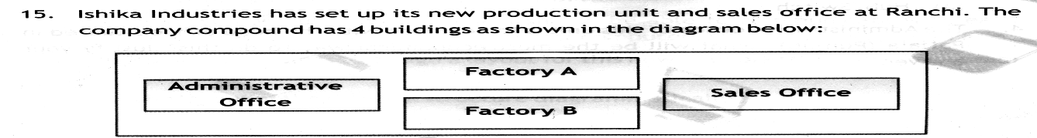
(h)

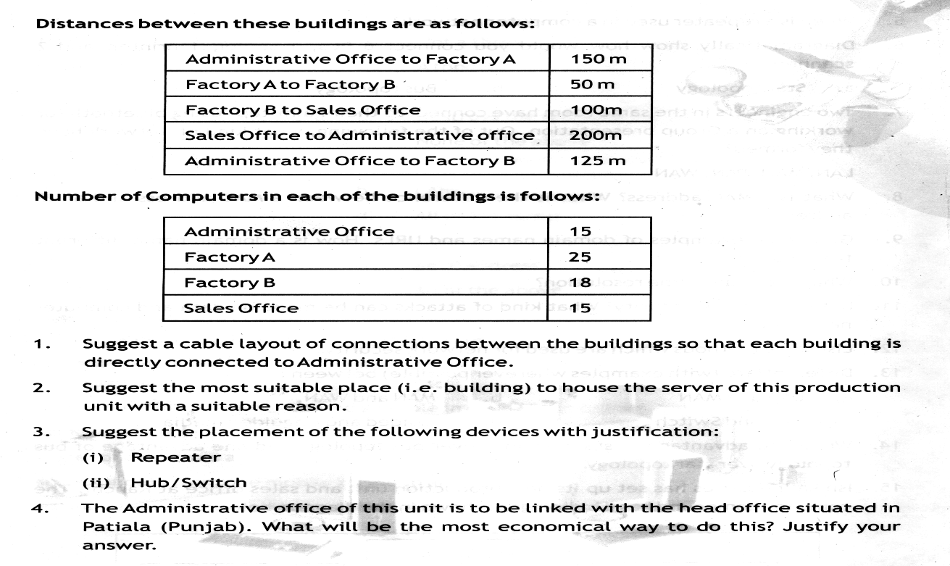

(4)

Q2. (a) While working in Netbeans, Ms. Kavita wants to display ‘Pass’ or ‘Needs to Reappear’ message depending on the marks entered in jTextField. Help her to choose the more appropriate statement out of ‘If statement’ and ‘Switch statement’. (1)
(b) Write one property and one method of jListBox. (1)
(c) Which HTML tags are used for making a table and adding rows in a HTML document? (1)
(d) How is <OL> tag different from <UL> tag of HTML? (1)

(e) What will be the value of P and Q after execution of the following code? (2)
int P,Q = 100
for (P=10; P<12; P++)
{
Q+ = P;
}
JOptionPane. showMessageDialog(this, “p + “+P+” Q;”+Q+” );
(f) Differentiate between XML and HTML. (2)
(g) Write Java code that takes a number from jTextField1 and displayed its table in jTextArea1. (2)
(e.g 6*1=6
6*2=12
…………..
6*10=60)
(h) Name the property of jPassword which sets the character that will be displayed instead of Text. (1)
Q3. (a) If a database “Employee” exists, which MySql command helps you to start working in that database? (½)
(b) Sahil created a table in MySql. Later on he found that there should have been another column in the table. Which command should he use to add another column to the table? (½)
(c) Rama is not able to change a value in a column to NULL. What constraint did she specify when she created the table? (½)
(d) The LastName column of a table “Directory” is given below:
LastName
Batra
Sehgal
Bhatia
Sharma
Mehta
Based on this information, find the output of the following queries: (½)
- SELECT LastName FROM Directory WHERE LastName like “_a%”;
(e) Write SQL statement to set Autocommit to off. (1)
(f) Distinguish between a Primary key and Candidate key with the help of suitable example of each. (2)
(g) Distinguish between Commit and Rollback. (2)
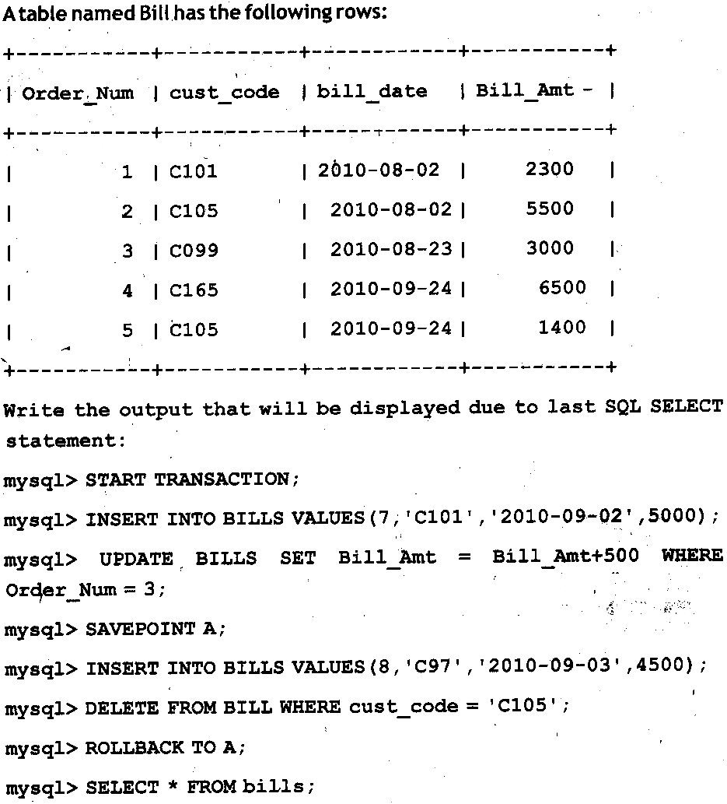
(h) (1)

Q4. (a) Define Inheritance, Class, Polymorphism with reference to object oriented programming. (3)
(b) A phone number, consisting of 10 digits, is stored in a string variable strPhone. Now it is required to store this phone number in a Long type variable lngPhone. Write Java statement to do this. (½)
(c) Write the result stored in jTextField1 by the following statement: (½)
jTextField1.setText(“Informatics”.substring(3));
(d) Rewrite the following program code using a for loop: (2)
int i=1, sum=0;
while (i<10)
{ sum+=i;
i+=2;
}
(e) Write different methods of JOptionPane Class. (1½)
(f) The following code has some error(s). Rewrite the correct code underlining all the corrections made:
Int i, j=5;
i==j+5;
if(i=j)
{ jTextField1.setText(“i and j are unequal”);
jTextField2.setText(“they are not equal”); break;
}
else jTextField1.setText(“i and j are equal”) (2)
(g) I) What will be the constants of jTextField1 and jTextField2 after executing the following code:
i) jTextField1.setText(Math.round(25.7)+ “ ”); (½)
ii) jTextField2.setText(Math.pow(2,3)+ “ ”); (½)
II) What will be the contents of F1 and F2 after the following code is executed? (1)
String F1=”hello”, F2=”Friend”;
F1=F1.concat(F2);
(h) Glamour Garments has developed a GUI application for their company as shown below :

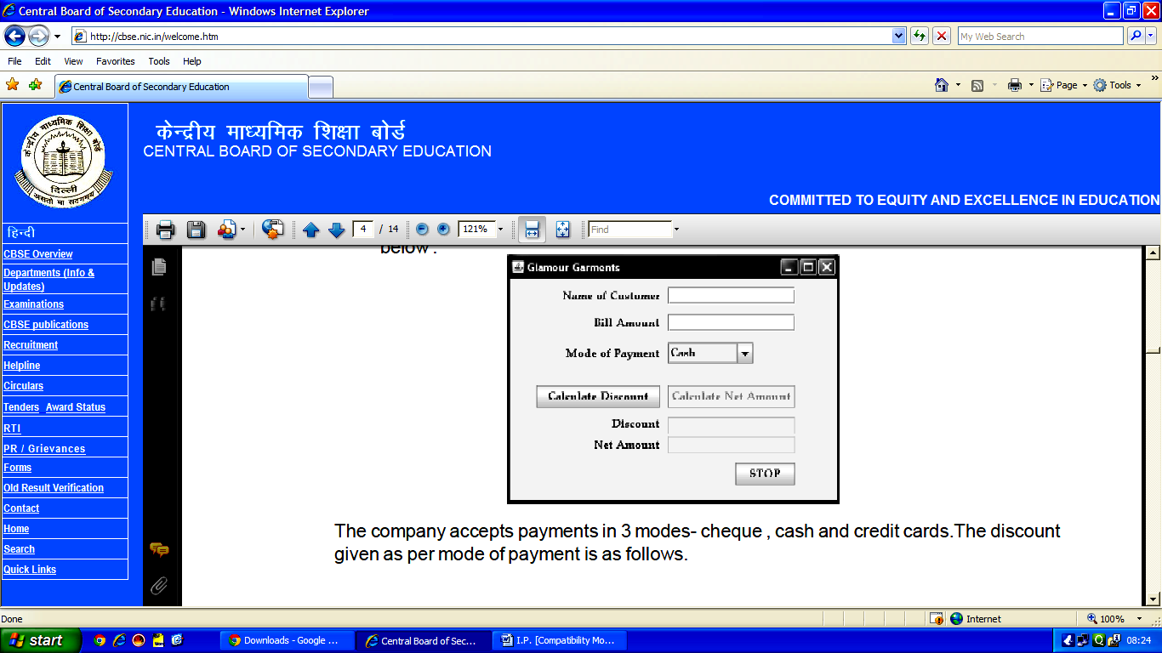
The company accepts payments in 3 modes- cheque , cash and credit cards.The discount given as per mode of payment is as follows.

Mode of Payment | Discount
Cash | 8%
Cheque | 7%
Credit Card | NIL

If the Bill Amount is more than 15000 then the customer gets an additional discount of 10% on Bill Amount.
(i) Write the code to make the textfields for Discount (named txtDisc) and Net Amount (named txtNetAmt) uneditable. (1)

(ii) Write code to do the following:
a)When "Calculate Discount" button is clicked the discount should be calculated as per the given
criteria and it should be displayed in the discount textfield. (1½)
"Calculate Net Amount" button (named btnCalcNetAmt) should also be enabled. (½)

b) When "Calculate Net Amount" button is clicked the net amount should be calculated and it should be displayed in the net amount textfield. (1½)
Convert txtName (jTextField1) value into uppercase. (½)

Q5. (a) What is the purpose of ALTER TABLE command in MySql? How is it different from UPDATE command?
(2)
(b) Table Employee has 4 records and table Dept has 3 records in it. Mr. Jain wants to display all information stored in both of these related tables. He forgot to specify equi–join condition in the query. How many rows will get displayed on execution of this query? (1)
(c) Consider the table EXAM given below. Write commands in MySql for (i) to (iv) and output for (v) to (viii).
Table: EXAM
No. | Name | Stipend | Subject | Average | Division
1 | Karan | 400 | English | 15 | FIRST
2 | Aman | 680 | Maths | 24 | FIRST
3 | Javed | 500 | Accounts | NULL | FIRST
4 | Bishakh | 200 | IP | 20 | SECOND
5 | Sugandha | 400 | History | 10 | THIRD
6 | Suparna | 550 | Geo | 5 | THIRD
7 | Ankit | 400 | NULL | 10 | THIRD

- To list the names of those students, who have obtained Division as FIRST in the ascending order of NAME.
- To display a report listing NAME, SUBJECT and Annual stipend received assuming that the stipend column has monthly stipend.
- To count the number of students, who have either Accounts or Informatics as Subject.
- To insert a new row in the table EXAM:
6, “Mohan”, 500, “English”, 73, “SECOND”;
- SELECT AVG(Stipend) FROM EXAM WHERE DIVISION=“THIRD”;
- SELECT COUNT (DISTINCT Subject) FROM EXAM;
- SELECT MIN (Average) FROM EXAM WHERE Subject=“English”;
- To count the number of students according to their Division wise. (8)
Q6. (a) Write a MySql command for creating a table “PAYMENT” whose structure is given below: (1)
Table : PAYMENT
Field Name | DateType | Size | Constraint
Loan_number | Integer | 4 | Primary key
Payment_number | Varchar | 3
Payment_date | Date
Payment_amount | Integer | 8 | Not NULL

(b) Write a MySQL command to change the constraint of field name Payment_amount to accept NULL values.
(1)
(c) Write a MySQL command to set the combination of Payment_number & Payment_date as the Primary key instead of Loan_number. (1)
Q7. (a)
In a database there are two tables “Product” and “Client” as shown below:
Table : PRODUCT
P_ID | ProductName | Manufacture | Price
P001 | Moisturiser | XYZ | 40
P002 | Sanitizer | LAC | 35
P003 | Bath Soap | COP | 25
P004 | Shampoo | TAP | 95
P005 | Lens Solution | COP | 350

Table : Client
C_ID | ClientName | City | P_ID
01 | Dreamz Disney | New Delhi | P002
05 | Life Line Inc | Mumbai | P005
12 | Harry Ltd. | New Delhi | P001
15 | Appolo | Banglore | P003
Write the command in MySql queries for the following:
- Write MySql command to show the Cartesian product of above mentioned tables. (1)
- To display the ClientName, City from table Client and ProductName and Price from table Product, with their corresponding matching P_ID. (1)
- To increase the Price of all the Products by 20. (1)

(b) In a Database school there are two tables Member and Division as show below.
Table : Member
Empld | Name | Pay | Divno
1001 | Shankhya | 34000 | 10
1003 | Ridhima | 32000 | 50
1002 | Sunish | 45000 | 20

Table : Division
Divno | Divname | Location
10 | Media | TF02
20 | Dance | FF02
30 | Production | SF01

- Identify the foreign key in the table Member. Justify your choices. (1½ )
- Write a MySql Query to display the NAME from Member Table corresponding their Divname from Division table? (1)

Q8. (a) What is impact of e – Learning sites on students learning process? (1)
(b) Write two advantages of e – Business sites. (1)
(c) Write one important feature of e – Governance? Give URL of one of the commonly used e – Governace portal. (1)
(d) What is the impact of ICT on Society? (1)
(e) Define Infomania? (1)

LILAWATI VIDYA MANDIR
SENIOR SECONDARY SCHOOL
Paper Submitted By:

Name Damanjeet Kaur Chowdhary
Email daman_romy2000@yahoo.com
PhoneNo. 9540389837

