Full Question Paper
Maths, IX Class
Time: 3 hrs Marks: 80
General Instructions:
- All questions are compulsory.
- The question paper is of 34 questions divided into four sections –A, B, C and D. Section A contains 8 questions of 1 marks each. Section B is of 6 questions of 2 marks each , section C is of 10 questions of 3 marks each and Section D is of 10 questions of 4 marks.
- There is no overall choice. However ,internal choice has been provided in 1 question of two marks each, 4 questions of three marks each and 2 questions of four marks each.
- Question numbers 1 to 10 in section A are multiple choice questions where you are to select one correct option out of given four.
Section- A

- Which of the following is a solution of 3x+2y=7 ? (a) (1,1) (b) (-1,-1) (c) (-1,2) (d) (1,2).

- The graph of the equation ax + c=0 may be of the form : 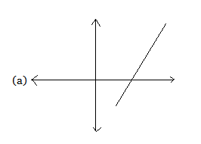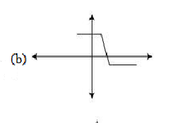
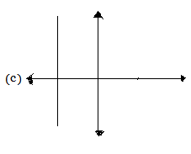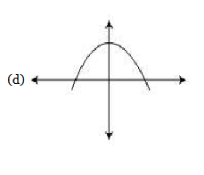
- The difference between maximum and minimum observation is called: (a) frequency (b) range (c) class interval (d) class size.

- The volume of a sphere of diameter r is : (a) (b) (c) (d).

- A circle centered at O, has diameter 10cm. If Q is a point in the plane of the circle such that OQ=4cm then Q lies : (a) Outside the circle (b) inside the circle (c) on the circle (d) At the centre of the circle.
myguru@coolguru.net www.coolGuru.net
- In the given figure ∠BCD is equal to : (a) 120⁰ (b) 60⁰ (c) 100⁰ (d) 80⁰. 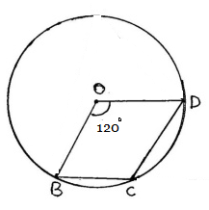
- Opposite angles of a parallelogram are (a) supplementary (b) equal (c) complementary (d) right angles.

- M and N are mid points of sides AB and AC. If the length of BC is 15 cm, then length of MN is: (a) 15/4 cm (b) 7.5 cm (c) 15/3 cm (d) 5.0 cm.

Section-B

- Find the point where the line represented by the equation 4x+3y-12=0 cuts the y-axis. Or Write equation x=3y+1 in standard form. Also find the values of a,b,c if ax+by+c=0.

- Find the radius of circle if its area is equal to its circumference.
- In the given fig. ABCD is a parallelogram, then find area ΔAFB. 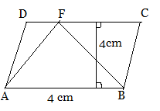
- Form less than cumulative frequency table.
Classes | 0-20 | 20-40 | 40-60 | 60-80 | 80-100
Frequency | 4 | 10 | 15 | 8 | 3
Or Find the median of the following data : 18,37,24,59,41,56,63,45,57,29. If 37 is
replaced by 73, then find new median.
- In the given fig. ABCD is a parallelogram. BP and DQ are angle bisectors of ∠B and ∠D. Show that line BP is ∕ ∕ to line DQ. 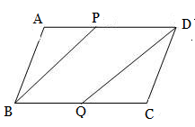

- In the figure AB and AC are two equal chords of the circle whose centre is ‘O’. If OD ⊥ AB and OE ⊥ AC, prove that AD = AE.

Section-C

- Draw the graph of the linear equation2(x-1)+3y=4.

- Determine the point on the graph of the equation 2x+5y=20, whose x-coordinate is 5/2 times its ordinate. Or Find three solutions of 5x-y+6=0 and then draw the graph.

- In the given fig. DE and BF are perpendiculars to the diagonals AC of a parallelogram ABCD. Prove that DE =BF. 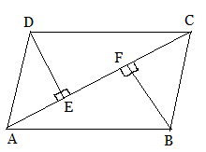 Or Prove that the quadrilateral formed by the bisectors of the angles of a parallelogram is a rectangle.

- In a ΔABC ; D,E and F are the mid points of the sides BC, CA and AB respectively. Prove that (i) BDEF is a parallelogram (ii) ar(ΔDEF) =1/4 (ar ΔABC).

- In a circle of radius 5cm, AB and AC are two chords such that AB = AC = 6 cm. Find the length of the chord BC. Or D is a point on the circumference of a circum circle of ABC in which AB = AC such that B and D are on opposite sides of AC. If CD is produced to point E such that CE =BD, prove that AD=AE.

- The diameter of the moon is one third of the earth. Find out the ratio of the surface area of the moon and earth.

- A lead pencil consists of a cylinder of wood with a solid cylinder of graphite filled in the interior. The diameter of the pencil is 7 mm and the diameter of the graphite is 1 mm. If the length of the pencil is 14 cm, find the volume of the wood and that of the graphite.

- A cylindrical bowl of internal radius 9cm and height 15cm is filled with water. The whole of the water is to be filled in small cylindrical bottles of diameter 3cm each and height 4cm. If each bottle is sold for Rs.5, then find the amount earned.

- A die is rolled 100 times such that an even number occurred 56 times and an even number less than 5 occurred 32 times. What is the probability of getting the number 6 on the die?

- Draw the frequency polygon for the following data:
Class | 100-120 | 120-140 | 140-160 | 160-180 | 180-200
frequency | 5 | 10 | 20 | 9 | 6

Or
The following table shows the weights of 12 workers in a factory :
Weight(in kg) | 60 | 63 | 66 | 69 | 72
No. of workers | 4 | 3 | 2 | 2 | 1
Find the mean weight of the workers.

Section-D
- If the number of hours for which a person works is x and his wages (in rupees ) and y=2x-1, draw the graph of work – wages equation . From the graph, find the wages of the person if he works for 5 hours.
- Show that the line segments joining the mid points of the opposite sides of a quadrilateral bisect each other. Or In a quadrilateral ABCD, the line segments bisecting C and D meet at E. Prove that A + B = 2 CED.

- D and E are points on sides AB and AC respectively of ΔABC such that ar( ΔDBC)= ar( ΔEBC). Prove that DE ∕ ∕ BC.

- In fig. ABCDE is a pentagon . A line through B parallel to AC meets DC produced at F . Show that ar(AEDF)= AR(ABCDE) 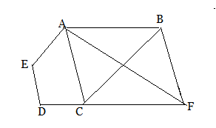
- Prove that angle subtended by an arc at the centre is twice the angle subtended by the same arc on the remaining part of the circle.

- Prove that the circle drawn on any one of the equal sides of an isosceles triangle as diameter bisects the base.

- Construct a triangle ABC in which BC=8cm, ∠B=45º and AC-AB=3.5cm.

- A soft drink is available in two packs a tin can with a rectangular base of : (i) length 5cm and width 4cm, having height of 15cm and (ii) a plastic cylinder with circular base of diameter 7cm and height 10cm. Which container has greater capacity and by how much. ( π=22/7) Or A joker’s cap is in the form of a right circular cone of base radius 7cm and height 24cm. Find the area of the sheet required to make 10 such caps.

- The mean weight of 40 students is 50 kg. One of the student leave and is replaced by another student which reduces the mean weight of the class by 0.5 kg. If the weight of the student who left is 65kg, what is the weight of the student who joined the class.

- Three coins are tossed 250 times and we get:
3 heads : 2 heads : 1 head : 0 head :
46 times 56 times 70 times 78 times
When three coins are tossed at random, what is the probability of getting :
(i) 3 heads ? (ii) 2 heads? (iii) atleast 2 heads? (iv) atmost 2 heads?
==============================================

