Sample Paper – 2012
Class – IX
Subject – Mathematics

General Instructions:
- All questions are compulsory.

- The question paper is of 34 questions divided into four sections –A, B, C and D. Section A contains8 questions of 1 marks each. Section B is of 6 questions of 2 marks each , section C is of 10 questions of 3 marks each and Section D is of 10 questions of 4 marks.

- There is no overall choice. However ,internal choice has been provided in 1 question of two marks each, 4 questions of three marks each and 2 questions of four marks each.

- Question numbers 1 to 8 in section A are multiple choice questions where you are to select one correct option out of given four .

Section- A
- The graph of y=a is a straight line parallel to : (a) x axis (b) y axis (c) line y=x (d) line x+y=0

- What is the value of m for which (−4, −1) a solution of the equation, −x + my = 1? (a) 5 (b) 3 (c) −3 (d) −5.
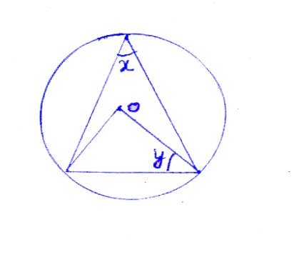
- In the fig. the value of is. (a) 50⁰ (b) 80⁰ (c) 100⁰ (d) 90⁰

- OC is drawn perpendicular the centre O of the circle to the chord AB. If OB=5cm
and OC=3cm, the length of the chord AB is (a)3cm (b) 4cm (c) 6cm (d)8cm
- The circumference of the base of a right circular cone is 44cm and its slant height is 10cm. Its curved surface area is : (a) 220/7 cm² (b) 200/7 cm² (c) 200 cm² (d) 220 cm².

- A conical tent is 10m high and the radius of its base is 24m. The slant height of the tent is : (a) 26m (b) 27m (c) 25m (d) none of these.

- In any triangle medians are concurrent and their point of intersection is called : (a) circumcentre (b) centroid (c) incentre (d) orthocentre.

- The mean of 16 numbers is 8. If 2 is multiply to every number, what will be the new mean.
(a) 16 (b) 12 (c) 10 (d) 8

Section-B
- Find four solutions for x=-2. Or Find k if (2,3) is a solution of 2x-y=k.

- If the diagonals of quadrilateral bisect each other then prove that quad. is parallelogram.

- Show that the diagonal of a parallelogram divide it into two triangles of equal area.

- In the given fig., O is the centre of the circle . The angle subtended by arc ABC at the centre is 140°. AB is produced to P. Determine ∠ ADC and ∠CBP.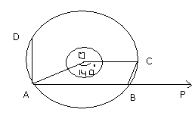
- Find x if O is the centre of the circle. 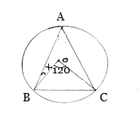

- Find median of :18,16,3,24,29,32,46. If 3 is replaced by 13 what will be the new median ?
myguru@coolguru.net www.coolGuru.net

Section-C

- Draw the graph of the linear equation :y=3x. Or Solve 7y+15=2y +5 and represent on (a) Number line (b) in the Cartesian plane.

- Find the points where the line represented by the equation 5x-4y+20=0 cuts x-axis and y-axis.

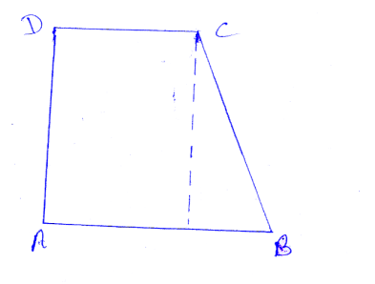
- In trapezium ABCD if , BC=17 cm AB=16, DC=8cm, then find area of trapezium.

- Prove that parallelogram on the same base and between same parallel are equal in area. Or ABCD is a rectangle .Diagonals AC and BD intersect at O . If ∠OAB = 35° , find the measure of ∠ DOC.

- If two equal chords of a circle intersect within the circle, prove that the line joining the point, of intersection to the centre makes equal angles with the chords.

- A river 3m deep and 40m wide is flowing at the rate of 2km per hour. How much water will fall into the sea in a minute.

- A cylindrical bowl of internal radius 9 cm and height 15 cm is full of liquid. The whole of the liquid is to be filled in small cylindrical bottles of diameter 3 cm each and height 4cm. each bottle is sold for Rs. 5, then find the amount earned.

- The slant height and diameter of a conical tomb are 25m and 14m. Find the cost of constructing it at Rs.2 per cubic metre. (take π=22/7) Or A hemispherical bowl has inner diameter 10.5cm. Find the cost of tin plating it on the inside at the rate of Rs. 16 per 100cm².
- Find the mean of the following data by using shortcut method.
Marks | 20 | 22 | 25 | 30 | 35 | 39 | 45 | 50 | Total
Frequency | 4 | 6 | 8 | 10 | 8 | 7 | 5 | 2 | 50
Or If the mean of the following distribution is 21, find the value of x
x: 10 15 20 25 30
f: 6 10 x 10 8

- The weekly pocket expenses of students are given in the following table :
Pocket expenses (in Rs.) | No. of students
145 | 7
140 | 4
159 | 10
171 | 6
158 | 3
147 | 8
165 | 12
Find the probability that the weekly pocket money of a student is : (a) Rs.159 (b) more than Rs. 159 (c) less than Rs. 159
SECTION-D
- Construct a triangle ABC whose perimeter is 10.5cm and its base angles are 60⁰ and 45⁰.
- 4 years before , age of a mother was 3 times the age of her daughter . Write a linear equation to represent this situation and draw its graph.
- In a given fig. AB=BC and l//m//n. Is DE=EF ? if yes Justify it and state the theorem which is used to justify it. 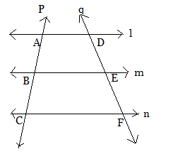

- The mid points of the sides BC, CA and AB of ABC are X, Y and Z respectively .Prove that AYXZ is a parallelogram.

- Prove that the angle subtended by an arc at the centre is double the angle subtended by it at any point on the remaining part of the circle. Or If two equal chords of a circle intersect within the circle . Prove that the segment of one chord are equal to corresponding segments of the other chord.

- In the given figure, AB Is a diameter of a circle With centre O and CD||BA. If $∠$BAC=20⁰, find (i)$∠$BOC iii)$∠\text{CAD}$ iv) $∠\text{ADC}$ 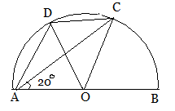
- ABCD is a trapezium with AB||CD. P and Q are the mid points of diagonals AC and BD respectively. Prove that PQ= ½(AB-CD).

- The mean of the numbers 21, 30, 16, x, and 9 is 18. The median of the numbers 23, 30, 31,3x, 3x + y, 60, 67, and 69 is 47.5. What is the value of y?

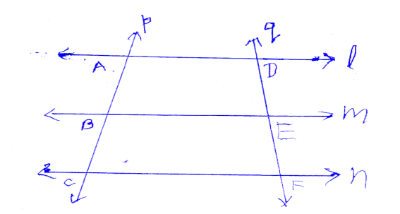

- If V is the volume of a cuboid of dimensions a,b,c and s is its surface area then prove that: 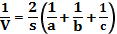. Or It costs Rs.2200 to paint the inner curved surface of a cylindrical vessel 10m deep. If the cost of painting is at the rate or Rs. 20 per m2,find the
(i) Inner curved surface area of the vessel.
(ii) Radius of the base.
(iii) Capacity of the vessel.

- What is the probability of 53 Sundays in (i) a leap year (ii) a non leap year.

