Sample Paper – 2012
Class – XII
Subject –Physics
- What is the radius of first Bohr’s orbit?
- Draw an equilateral surface for a system containing charges Q, -2 separated by a distance r in air.
- There is a potential barrier of 0.7 V at the junction in an unbiased p-n junction. Can you measure it directly by a multimeter?
- What is the source of production of electromagnetic waves?
- Sketch the path of light rays in air bubble formed in water.
- On what conservation law is Lenz’s law based ?
- A metal has work function 4 eV. Calculate the threshold wavelength.
- What is the geometrical shape of a wavefront when a plane wave passes through a concave lens?
- Name the place where vertical component of earth’s magnetic field is zero. What is the value of angle of dip where horizontal and vertical components are equal?
- He magnifying power of an astronomical telescope in normal adjustment is 9 and the length of tube is 20 cm. What are the focal lengths of the objective and eye-piece?
- Show that the power consumed in a pure inductor connected in ac circuit is zero.
OR
Show that the power consumed in a pure capacitance connected in ac circuit is zero.
- A plane electromagnetic wave of frequency 25 MHz travels in free space along the X-direction. At a particular point in space and time its electric field vector E is 6.3 j V/m. Calculate the magnetic field vector B at this point. Write its expressions for E and B.
- Why we need a carrier wave of very high frequency in the modulation of signals? A carrier wave of peak voltage 20 V is used to transmit a message signal. What should be the peak voltage of modulating signal for achieving modulation index?
- X and Y are two parallel plate capacitors having same area of plates and same separation between the plates as shown in the figure. X has air between the plates and Y has a dielectric of dielectric constant k=4.
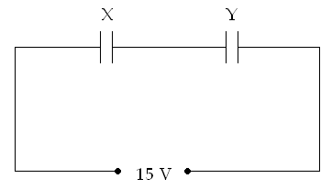
- Calculate the potential difference between the plates of X and Y.
- What is the ratio of electrostatic energy stored in X and Y ?
- Find the equivalent resistance between terminals X and Y of network shown in figure.
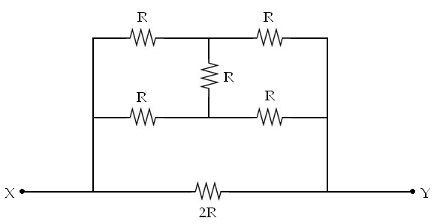
- Write nuclear equations for
- ⁻ -decay of P (b) ⁺-decay of C
- A convex lens (of refractive index n_{g}) has focal length f in air. Write an expression for its focal length when immersed in a liquid of refractive index n_{l}. Use the expression to find the focal length of glass lens (n_{l} =1.5) when immersed in water (n_{w}= ). (The focal length of lens in air is 25 cm.)
- Use Kirchhoff’s laws to find the currents I₁, I₂ and I_{g} in Wheatstone bridge shown in figure.
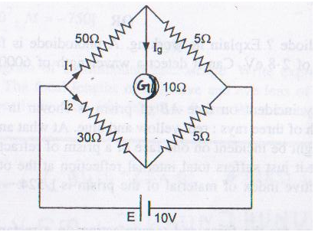

- Draw hysteresis loops for soft iron and steel. Hence, explain why soft iron is used for preparing electromagnets while steel is used for preparing permanent magnets.
- Drive a relation between decay constant and average life.
- Draw circuit diagram of a common emitter transistor amplifier using npn transistor. Why the voltage gain of his amplifier is more than that of common base transistor amplifier?
- Find the expression of amplitude modulated wave.
- Explain how will you combine cells to obtain maximum current if
- Internal resistance of cells are low.
- Internal resistance of cells are high.
- What do you mean by an ideal junction diode? Draw characteristic curve of forward and reverse biasing of a practical p-n junction diode. Explain the terms threshold voltage and reverse saturation current.

OR
What is a photodiode? Explain its working. A photodiode is fabricated from a semiconductor with a band gap of 2.8 eV. Can it detect a wavelength of 6000 nm?
- A white light ray incident on face AB of prism is shown in fig. Complete the path of three rays: red, yellow and blue. At what angle should a ray of light be incident on one face of a prism of refracting angle 60 so that it just suffers total internal reflection at the other face ? The refractive index of material of the prism is 1.524.
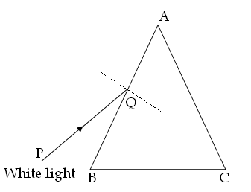
- Find an expression for the force and torque acting on a rectangular current carrying coil in a uniform magnetic field. Use it to find the linear relation between deflection and current of a moving coil galvanometer. Hence, explain why and how the magnetic field in galvanometer is made radial.
- Draw energy level diagram of atomic hydrogen. Name and show all he five series found in emission spectrum of hydrogen on his diagram. Also name the regions of spectrum to which these series lie.
- Write Faraday’s laws of electromagnetic induction. How will you find the direction of induced emf ? find an expression for induced emf in a rod of length l moving with velocity V perpendicular to a magnetic field of induction B.

OR
With the help of a labeled diagram explain the construction and working of an a.c. generator. Deduce the expression for emf induced. What is average and root mean square value of emf induced ?
- What do you mean by coherent sources of light ? Can two 100 W bulbs placed at a small separation be coherent ? Explain.
Find an expression for fringe width in Young’s double slit experiment. Sketch the intensity distribution of this interference pattern.
OR
What do you mean by diffraction of light? State the basic condition for diffraction of light to take place.
Derive an expression for the width of central maximum in the diffraction pattern of a single slit. Sketch the intensity distribution of this diffraction pattern.
- Draw a labeled diagram of an astronomical telescope. Write expressions for its resolving power and magnifying power.
An astronomical telescope uses an objective lens of focal length 15 m and eye lens of focal lengths 2 cm. the diameter of objective lens is 10 m. What is resolving power and magnifying power.
[Take mean wavelength 6x10 ⁻⁷ m.]
OR
Draw a labeled diagram of a compound microscope. Write expressions for its resolving and magnifying powers. The focal lengths of objective and eye lens of a compound microscope are 2 cm and 5 cm respectively. The tube length is 8 cm. What is its magnifying power?

Ajay Sharma
(Mob :- 9414368091, Email :- aks.672@refiffmail.com)
JIVEM JHUJHUNU (RAJ.)

