Guess Paper – 2012
Class – IX
Subject – Mathematics

SECTION – A [1 mark each]
- The diameter and height of a right circular cone are 7 cm and 12 cm respectively. The volume of the cone (in cm³) is :
(a) 88 (b) 112 (c) 154 (d) 616
- The condition that the equation ax + by + c = 0 represents a linear equation is two variables is
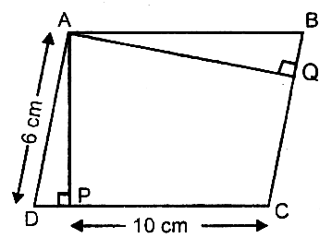
(a) a ≠ 0,b = 0 (b) b ≠ 0, a = 0 (c) a = 0, b = 0 (d) a ≠ 0, b ≠ 0
- In fig. if the area of a parallelogram ABCD is 30 cm², then the length of altitude AQ is :
(a) 5 cm
(c) 3.5 cm
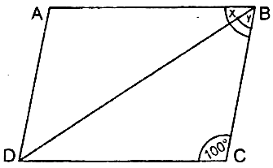
(b) 4 cm (d) 6 cm
- In fig. ABCD is a rhombus in which ∠BCD = 100°. Then (x + y) equals:
(a) 40° (b) 60°
(c) 80° (d) 70°
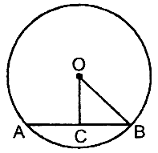
- In fig., OC is drawn perpendicular from the centre O of the circle to the chord AB. If OB = 5 cm and OC = 3 cm, then the length of the chord AB is:
(a) 3 cm (b) 4 cm
(c) 6 cm (d) 8 cm
- Number of lines passing through the point (2, 5) are:
(a) 2 (b) 3 (c) 4 (d) infinite many
- If one angle of a parallelogram is two-third of its adjacent angle, the smaller angle is:
(a) 108° (b) 90° (c) 72° (d) 60°
- The length of longest rod that can be fitted in a cubical box of edge 10 cm long is:
(a) 20 cm (b) 10 cm (c) 10$\sqrt{2}$ cm (d) 10$\sqrt{3}$ cm
- In a single throw of dice, the probability of not getting 3 or 6 is:
- If the point (2, — 7) lies on the line: 4x + my = 22, then value of m is:
(a) —2 (b) 2 (c) 3 (d) —7

SECTION – B [2 mark each]
- A three-wheeler scooter charges Rs 10 for the first kilometre and Rs 4. 50 each for every subsequent kilometre. For a distance of x km , an amount of Rs y is paid. Write the linear equation representing the above information and hence the graph.
- ABCD is a quadrilateral in which P,Q,R and S are the mid-points of the sides AB, BC, CD and DA respectively. Show that PQRS is a parallelogram.
- A hemispherical bowl is made of steel 0.25 cm thick. The inner radius of the bowl is 5 cm. Find the outer curved surface area of the bowl.
- Find the mean of first ten prime numbers.
(ii) The following observations have been arranged in ascending order, if the median of the data is 63,
find the value of x.
29, 32, 48, 50, x, x + 2, 72, 78, 84, 95

SECTION – C [3 marks each]
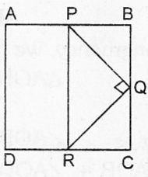
- Draw the graph of two lines, whose equations are 3x — 2y + 6 = 0 and x + 2y — 6 = 0 on the same graph paper. Find the area of triangle formed by the two lines and x-axis.
- In fig ABCD is a square. If ∠PQR = 90° and PB = QC = DR, prove that ∠QPR = 45°

- The ratio of the curved surface area to the total surface area of a right circular cylinder is 1 : 3. Find the volume of the cylinder if its total surface area is 1848 cm².
(ii) 500 persons took dip in a rectangular tank which is 80 m long and 50 m broad. What is the rise in the level of water in the tank, if the average displacement of water by a person is 4 m³?
- (i) On a page of a telephone directory, there are 200 telephone numbers. The frequency distribution of the digits at their unit’s place is given below.
Without looking at the page, a number is chosen at random from the page. What is the probability that the digit at the unit’s place of the number chosen is greater than 6?
(ii) Three coins are tossed simultaneously 200 times with the following frequencies of different outcomes.
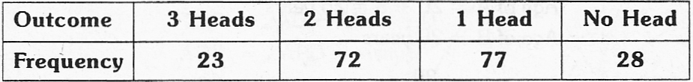
Find the experimental probability of getting: (i) 2 Heads (ii) at least 2 Heads
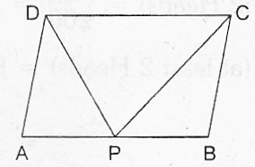
- (i) Prove that parallelograms on the same base and between the same parallels are equal in area.
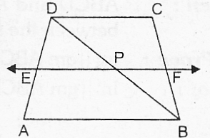
(ii) In fig., ABCD is a parallelogram. If AB = 2AD and P is the mid-point of AB, then find ∠CPD.
- In fig., ABCD is a trapezium in which AB ⎜⎜ DC. BD is a diagonal and E is the mid-point of AD. A line is drawn through E, parallel to AB, intersecting BC at F. Show that F is the mid-point of BC.Also prove the theorem used in this ques.
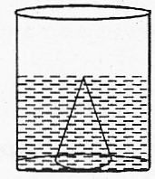
- In fig., a right circular cone of diameter r cm and height 12 cm rests on the base of a right circular cylinder of radius r cm. Their bases are in the same plane and the cylinder is filled with water upto a height of 12 cm. If the cone is then removed, find the height to which water level will fall.
- Draw a histogram for the following data:
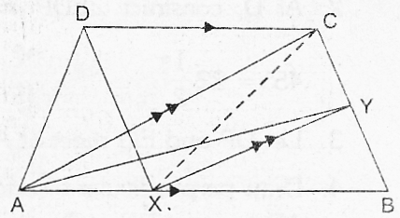
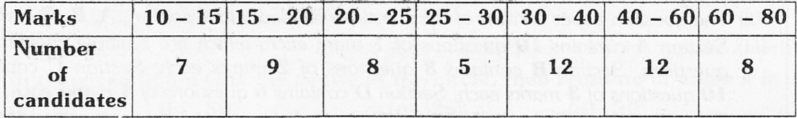
- ABCD is a trapezium with AB ⎜⎜ DC, a line parallel to AC intersects AB at X and BC in Y. Prove that ar(ΔADX = ar(ΔACY)

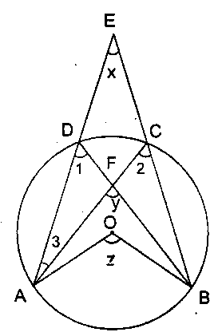
- (i) Construct a triangle with perimeter 11.8 cm and base angles 60⁰ and 45°. Write Steps of construction.
(ii) State and prove mid-point theorem
SECTION – D [4 marks each]
- In the given figure, O is the centre of a circle. Prove that ∠x + ∠y = ∠z.
(ii) PQ and RS are two parallel chords of a circle whose centre is O and radius is 10 cm. If PQ =
16 cm and RS = 12 cm find the distance between PQ and RS, if they lie: (a) on the same side of
the centre O (b) on opposite side of the centre O.
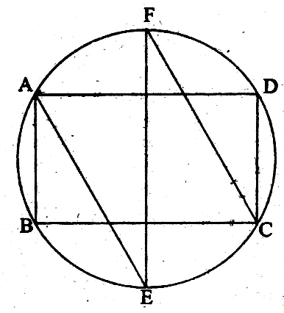
- BC is a chord of a circle with centre O. A is a point on an arc BC. Prove that
- ∠BAC + ∠OBC =90°, if A is the point on the major arc.
- ∠BAC - ∠OBC = 90°, if A is the point on the minor arc.
- The bisectors of the opposite angles A and C of a cyclic quadrilateral ABCD intersect the circle at the points E and F, respectively (Fig.). Prove that EF is a diameter of the circle.
(ii) Prove that sum of opposite angles of a cyclic quadrilateral is 180⁰
- Bisectors of angles A, B and C of a triangle ABC intersect its circumcircle at D, E, F respectively. Prove that the angles of $Δ$DEF are 90-$\frac{1}{2}$∠A, 90-$\frac{1}{2}$∠B, 90-$\frac{1}{2}$∠C respectively.
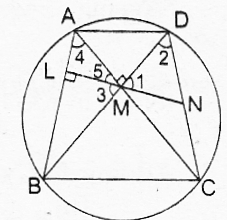
- Diagonals AC and BD of a cyclic quadrilateral ABCD intersect at right angles at M. Prove that a line drawn through M to bisect any side of the quadrilateral is perpendicular to the opposite side.
(ii) AB is the chord of a circle with centre O and AB is produced to C such that BO = BC. CO
produced meets the circle at D. If ∠ACD = y and ∠AOD = x prove that x = 3y.
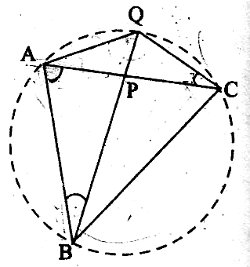

- In Fig. , ABC is a triangle in which AB = AC and P is a point on AC. Through C, a line is drawn to intersect BP produced at Q such that ∠ABQ = ∠ACQ. Prove that ∠AQC = 90° + $\frac{1}{2}$∠BAC
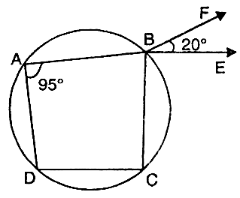
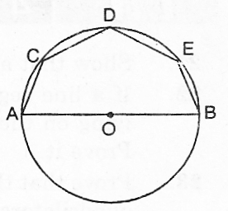
- In fig. ABCD is a cyclic quadrilateral in which AB produced to F and BE ⎜⎜CD. If ∠FBE = 20° and ∠DAB = 95° then find ∠ADC.
(ii)In Fig., AOB is a diameter of the circle and C, D, E are any three points on the semicircle. Find the value of ∠ACD + ∠BED.

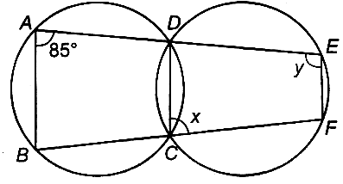
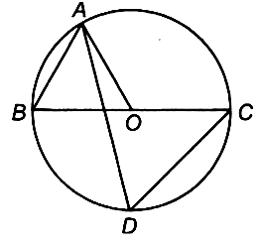
- In the given figure, the respective values of angles x and y are

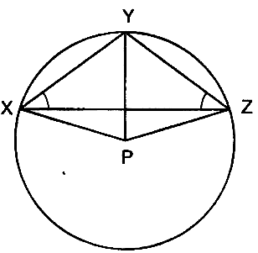
(ii)In the given figure, BC is a diameter of the circle and ∠BAO = 60°. Then find ∠ADC .
- In the Fig. , P is the centre of the circle. Prove that: ∠XPZ = 2(∠XZY + 2(∠XZY+ ∠YXZ).
(ii) In a circle of radius 5cm, AB and AC are two chords such that AB =AC =6cm. Find the
length of the chord BC.

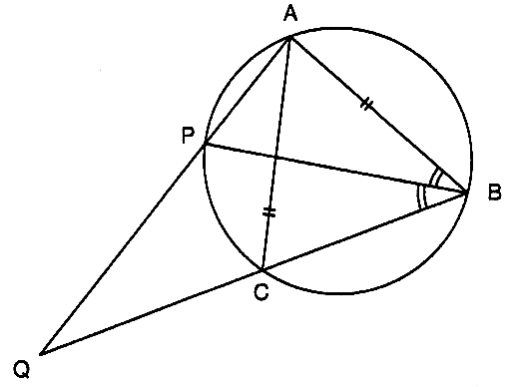
- The bisector of ∠B of an isosceles triangle ABC with AB = AC meets the circumcircle ABC at P as shown in Fig. If AP and BC produced meet at Q, prove that CQ=CA.
(ii) Two circles whose centres are O and O’ intersect at P. Through P, a line l parallel
to OO’ intersecting the circles at C and D is drawn. Prove that CD = 2 OO’.

MATHEMAGICS
VANDANA BANSAL M : 9855188797
VANDANA BANSAL # 3149, (T.F.), SECTOR 23−D, CHANDIGARH

