Sample Paper – 2012
Class – XII
Subject – Chemistry
POLYMER & BIOMOLECULES
Single Option
1. Which of the following pairs represents anomers?
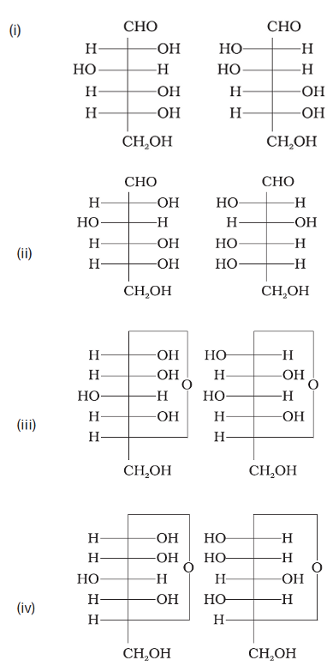
2. Compound which is added to soap to impart antiseptic properties is
(A) sodium laurylsulphate (B) sodium dodecylbenzenesulphonate
(C) rosin (D) bithional

3. Glycogen is a branched chain polymer of α-D-glucose units in which chain is formed by C1—C4 glycosidic linkage whereas branching occurs by the formation of C1-C6 glycosidic linkage. Structure of glycogen is similar to
(A) Amylose (B) Amylopectin
(C) Cellulose (D) Glucose

4. Which of the following polymer is biodegradable?

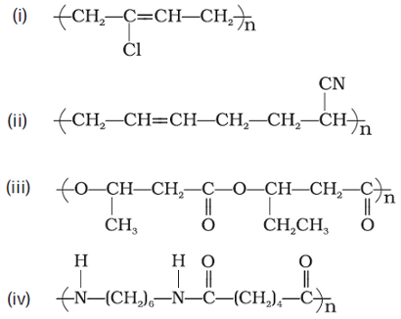
5. Sucrose (cane sugar) is a disaccharide. One molecule of sucrose on hydrolysis gives
(A) 2 molecules of glucose
(B) 2 molecules of glucose + 1 molecule of fructose
(C) 1 molecule of glucose + 1 molecule of fructose
(D) 2 molecules of fructose

6. In which of the following polymers ethylene glycol is one of the monomer units?
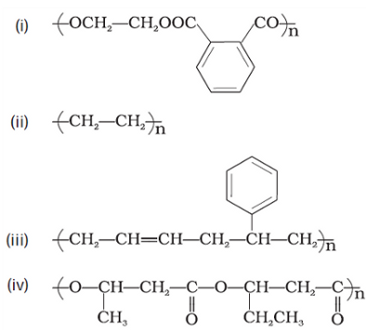

7. Glycerol is added to soap. Its function
(A) as a filler. (B) to increase leathering.
(C) to prevent rapid drying. (D) to make soap granules.

8. Proteins are found to have two different types of secondary structures viz. α-helix and β-pleated sheet structure. α-helix structure of protein is stabilised by
(A) Peptide bonds
(B) van der Waals forces
(C) Hydrogen bonds
(D) Dipole-dipole interactions
9. In disaccharides, if the reducing groups of monosaccharides i.e. aldehydic or ketonic groups are bonded, these are non-reducing sugars. Which of the following disaccharide is a non-reducing sugar?
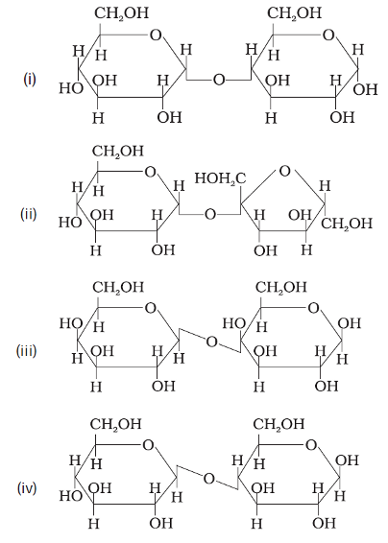
10.
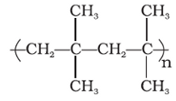is a polymer having monomer units ____________.
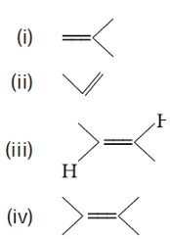
11. Which of the following statements is not true about enzyme inhibitors?
(A) Inhibit the catalytic activity of the enzyme.
(B) Prevent the binding of substrate.
(C) Generally a strong covalent bond is formed between an inhibitor and an enzyme.
(D) Inhibitors can be competitive or non-competitive.
12. Which of the following polymer can be formed by using the following monomer unit?
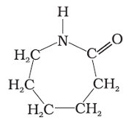
(A) Nylon 6, 6 (B) Nylon 2–nylon 6
(C) Melamine (D) Nylon-6
13. Each polypeptide in a protein has aminoacids linked with each other in a specific sequence. This sequence of amino acids is said to be
(A) primary structure of proteins.
(B) secondary structure of proteins.
(C) tertiary structure of proteins.
(D) quaternary structure of proteins.
14. DNA and RNA contain four bases each. Which of the following bases is not present in RNA?

(A) Adenine (B) Uracil
(C) Thymine (D) Cytosine

15. Three cyclic structures of monosaccharides are given below which of these are anomers.
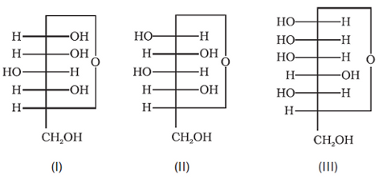
(A) I and II (B) II and III
(C) I and III (D) III is anomer of I and II
Multiple Option
16. Which of the following are addition polymers?
(A) Nylon (B) Melamine formaldehyde resin
(C) Orlon (D) Polystyrene

17. Which of the following polymers are used as fibre?
(A) Polytetrafluoroethane (B) Polychloroprene
(C) Nylon (D) Terylene

18. Which of the following polymers have vinylic monomer units?
(A) Acrilan (B) Polystyrene
(C) Nylon (D) Teflon

19. In fibrous proteins, polypeptide chains are held together by
(A) van der Waals forces (B) disulphide linkage
(C) electrostatic forces of attraction (D) hydrogen bonds

20. Lysine, 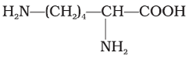is
(A) α-Amino acid (B) Basic amino acid
(C) Amino acid synthesised in body (D) β-Amino acid

Assertion & Reason:

For Question No. 21 - 25
(A) Assertion and reason both are correct statements and reason explains the assertion.
(B) Both assertion and reason are wrong statements.
(C) Assertion is correct statement and reason is wrong statement.
(D) Assertion is wrong statement and reason is correct statement.
21. Assertion : β-glycosidic linkage is present in maltose,
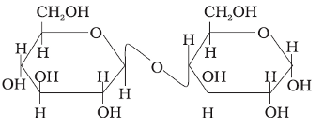
Reason : Maltose is composed of two glucose units in which C–1 of one glucose unit is linked to C–4 of another glucose unit.
22. Assertion : Olefinic monomers undergo addition polymerisation.
Reason : Polymerisation of vinylchloride is initiated by peroxides/persulphates.
23. Assertion : Polytetrafluoroethene is used in making non-stick cookwares.
Reason : Fluorine has highest electronegativity.
24. Assertion : Polyamides are best used as fibres because of high tensile strength.
Reason : Strong intermolecular forces lead to close packing of chains and

increase the crystalline character, hence, provide high tensile strength to polymers.
25.Assertion : All naturally occurring α-aminoacids except glycine are optically active.
Reason : Most naturally occurring amino acids have L-configuration.
Matrix – Match:
26. Match the following enzyms given in Column I with the reactions they catalyse given in Column II.
 | Column I (Enzymes) |  | Column II (Reactions)
(i) | Invertase | (a) | Decomposition of urea into NH₃ and CO₂
(ii) | Maltase | (b) | Conversion of glucose into ethyl alcohol
(iii) | Pepsin | (c) | Hydrolysis of maltose into glucose
(iv) | Urease | (d) | Hydrolysis of cane sugar
(v) | Zymase | (e) | Hydrolysis of proteins into peptides
27. Match materials given in Column I with the polymers given in Column II.
 | Column I |  | Column II
(i) | Natural rubber latex | (a) | Nylon
(ii) | Wood laminates | (b) | Neoprene
(iii) | Ropes and fibres | (c) | Dacron
(iv) | Polyester fabric | (d) | Melamine formaldehyde resins
(v) | Synthetic rubber | (e) | Urea-formaldehyde resins
(vi) | Unbreakable crockery | (f) | cis-polyisoprene
28. Match the polymers given in Column I with their commercial names given in Column II.
 | Column I |  | Column II
(i) | Polyester of glycol and phthalic acid | (a) | Novolac
(ii) | Copolymer of 1, 3-butadiene and styrene | (b) | Glyptal
(iii) | Phenol and formaldehyde resin | (c) | Buna-S
(iv) | Polyester of glycol and terephthalic acid | (d) | Buna-N
(v) | Copolymer of 1, 3-butadiene and acrylonitrile | (e) | Dacron

CHEMISTRY BY: MOHIT
House No – 10, Anand Vihar, Peer Baba Road, Baltana, Zirakpur
Contact : 9872905686 & mohitinorganic@gmail.com

