Sample Paper – 2012
Class – XII
Subject -PHYSICS (Theory)

VCBE/PO2/A/11
Time allowed: 3 hours Maximum Marks: 70
General Instructions:
(i) All questions are compulsory..
(iii) Q.No. 1 to 8 are very short answer type questions, carrying one mark each.
(iv) Q.No numbers 9 to 18 are short answer type questions, carrying two marks each.
(v) Q.No. 19 to 27 are also short answer type questions, carrying three marks each.
(vi) Q.No. 28 to 30 are long answer type questions, carrying five marks each.
(viii) You may use the following values of physical constants wherever necessary
c=3x10⁸ m/s h=6.6 x 10⁻³⁴ Js e=1.6 x 10⁻¹⁹ C N_{A} = 6.023 x 10²³ /mole m_{n} = 1.67 x 10⁻²⁷ kg µ₀ =4π x 10⁻⁷ T-m/A me = 9 x 10⁻³¹ kg

- Charges of magnitudes 2Q and –Q are located at points (a,0,0) and (4a,0,0).Find the ratio of the flux of electric field ,due to these charges, through concentric spheres of radii 2a and 8a centered at the origin.
- A plane wave front of width X is incident on air –water interface and the corresponding refracted wave front has a width Z as shown. Express the refractive index of air with respect to water, in terms of the dimension shown.
- A carbon resistor is marked in coloured bands of yellow, blue, orange and silver. What is the resistance of the resistor?
- Show, on a graph, the nature of variation, of the associated de –Broglie wavelength with the accelerating potential, for an electron initially at rest.
- 5000 lines of force enter a certain volume of space and 3000 lines emerge from it .Find the charge within this volume.
- Find the shortest wavelength of the Lyman series.
- Because this defect of an eye a person can focus either in vertical OR horizontal plane at a time. This arises due to distortion in the shape of cornea. Name the defect and suggest the correction for it.
- Draw symbolic diagrams for p-n-p and n-p-n transistor.
- Two wires X ,Y have same resistivity ,but their cross-sectional areas are in the ratio 2:3 and lengths in the ratio 1:2 ,They are first connected in series and then in parallel to a d c source. Find out the ratio of the drift speeds of the electrons in the two wires for the two cases.
- “The oscillations in copper disc in a magnetic field are highly damped.” Why? Where does the vibrational kinetic energy of the copper disc disappear?
OR
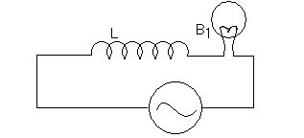
An inductor L of reactance X_{L} is connected in series with a bulb B to an A.C. source as shown in the figure. Briefly explain how the brightness of the bulb changes when
- Number of turns of the inductor is reduced and
- A capacitor of reactance X_{C} =X_{L} is included in series in the same circuit.

VECTOR ClASSES The classes with a direction Ph.No. 9910826233, 9213122859

- Block diagram of receiver is given. (a) Identify X and Y (b) State their functions.

- How will the focal length of convex lens change, when (1) monochromatic light is used in place of white light (2) lens is immersed in water?
- How long can an electric lamp of 100W be kept glowing by fusion of 2Kg of deuterium? Take fusion reaction is ₁H² + ₁H² = ₂He⁴ + n+ 3.27MeV
- Draw a circuit diagram of full wave rectifier. Explain the role of filter circuits in rectification.
- In an potentiometer experiment the null point is obtained at the centre of one meter long wire. State with reason, where the balance point will be shifted when
(1) the resistance placed in series with the driver cell is increased, keeping all parameters unchanged (2) Driver cell is replaced by another cell whose emf is lower than the primary cell.

- A wire of resistance 3Ω is cut into three pieces and then each piece is stretched to three times of length. These pieces are connected in parallel and connected across a battery of emf 3 V. Find the current through each resistance.

- Two students A and B prepare the following table about the electromagnetic waves. Rewrite this table in its corrected form.
- A student performs an experiment with prism and he gives following statements. Justify his observations.(1) The colour at position 5 observes less refractive index of the material than the colour at position 3.(2) The colour at position 5 is same as that of light emitted from sodium lamp.
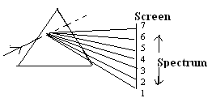
- Sketch the graphs, showing the variation of stopping potential with frequency of incident radiations for two photosensitive materials A and B having threshold frequencies ƒ₁ > ƒ₂ respectively. (1) Which of the two metals A Or B has higher work function? (2) Will the slope of both curves be same? Justify your answer.
- Three concentric metallic shells of radii a, b and c (a<b<c) have surface charge densities +σ, -σ and + σ (i) Find the potential of three shells a, b and c (ii) If shells a and c are at the same potential obtain relation between radii a, b and c.

VECTOR CLASSES The classes with a direction. Ph.No. 9910826233, 9213122859

- S₁ and S₂ are two hollow concentric spheres enclosing charges Q and 2Q respectively as shown in figure: (a) what is the ratio of the electric flux through S₁ and S₂? (b) How will the electric flux through the sphere S₁ change, if the medium of dielectric constant 5 is introduced in the space inside S₁ in place of air?
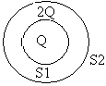
- State Lenz’s law. Two identical metallic rods one of copper and another of aluminum are rotated with same angular speed w in presence of same magnetic field. In which case (1) the induced emf (2) the induced current, will be more and why?
- Derive the expression for the combined focal length of two closed lens . A lens forms a real image of an object. The graph given below shows the variation of ‘V’ w.r.t. ‘U’. (i) What is the nature of lens? (ii) using graph calculate the focal length of this lens.

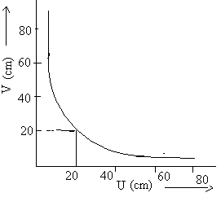
- Two parallel conductors are carrying current I₁ and I₂ are kept ‘r’ distance apart. Deduce an expression for force unit length acting between them. Define one ampere using this relation.
- In L-R series circuit, the potential difference across the inductor ‘L’ and the resistor ‘R’ are 120 V and 90 V respectively and rms value of current is 3 A (1) calculate r.m.s voltage across the circuit. (2) Is the algebraic sum of the voltage across two components more than the applied voltage? If yes, explain the reason (3) Calculate the phase angle between the voltage and current.
OR
A resistor of resistance 400Ω, and a capacitor of reactance 200Ω,are connected in series to a 220V,50Hz a.c. source .If the current in the circuit is 0.49 ampere find the (i) voltage across the resistor and capacitor(ii) value of inductance required so that voltage and current are in same phase.

- Define decay constant. Give the mass number and atomic number of elements on the right hand side of the decay process. ₈₆Ru²²⁰ → Po + He The graph shows how the activity of sample of radon-220 changes with time. Using this graph calculate (1) half life (2) decay constant

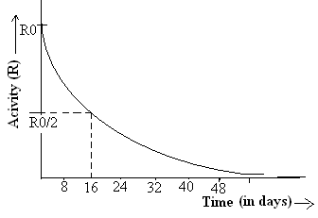

- What do you mean by term demodulation? How an amplitude modulated wave is demodulated? Explain with the help of block diagram and graphs.

VECTOR ClASSES The classes with a direction. Ph.No. 9910826233, 9213122859
- Name the physical quantity which has the unit J/Tesla. Derive the magnetic field intensity at a given point due to straight conductor or coil carrying current. Calculate the quantity at point ‘O’ in the following figure:
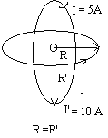
OR
State the principle of working of galvanometer. In galvanometer (i) concave shaped poles are used (ii) phosphor-bronze alloy is used for the suspension wire. Explain why? The current sensitivity of moving coil galvanometer is 5 divisions/mA and voltage sensitivity is 20 division/volt. Calculate the resistance of galvanometer.
- Draw the variation of intensity with angle in single slit diffraction experiment. Derive the expression for the central fringe width .How ray optics is a limiting case of wave optics. Determine angular separation between central maximum and first order maximum of the diffraction pattern due to a single slit of width 0.25mm when light of wavelength 5890 A⁰ is incident on it normally.
OR
What are coherent sources? Can two sodium lamps act as coherent sources? Justify. Write three differences between interference and diffraction pattern. A slit of width d is illuminated by white light .For what value of d is the first minimum, for red light of wavelength=650 nm, located at point P? For what value of the wavelength of light will the first diffraction maxima also fall at P

- Explain input and output characteristics of a common emitter transistor graphically. Draw the circuit diagram. In the given graph of a common emitter (a) Find the emitter current at V_{cc} =10V and
I_{b} = 60µA (b) find β at this point
OR
How a junction diode is formed. Explain the working when it is reverse and forward biased with circuital and graphical diagram. A given table is represented with voltage and current values calculate dynamic forward and reverse bias resistance resistance

Forward biasing | 2V  4V | 60mA  80mA
Reverse biasing | 0V  -2V | 0µA  -0.25µA

Shailendra Rawat, vectorclasses@gmail.com, Uttam nagar New Delhi, 9910826233

