Guess Paper – 2012
Class – XII
Subject – PHYSICS

Time: 3hrs M.M.-70

1 | What is the effect of heating of a conductor on the drift velocity of free electrons? | 1
2 | Which has a greater resistance ammeter or milli ammeter? | 1
3 | What is the angle of dip at a place where the horizontal and vertical components of earth’s magnetic field are equal? | 1
4 | What is the power dissipation in the circuit in which the applied voltage and current are given by V = 300 sin(ωt + π/2) and I = 5 sinωt | 1
5 | What physical quantity is same for X-rays (1Å),green light (5500Å)and radio waves (21cm)? | 1
6 | Two nuclei have their mass numbers in the ratio of 1:2.what will be the ratio of their nuclear density? | 1
7 | LOS communication is done by which type of wave propagation? | 1
8 | Can we use ground wave propagation for high frequency waves? give reason to support your answer | 1
9 | A 80µF capacitor is charged by a battery of 50V. The capacitor is disconnected and then connected to another uncharged capacitor of 320µF. Find the charge on second capacitor. | 2
10 | V-I graph for parallel and series combination of two metallic resistors is as shown below.  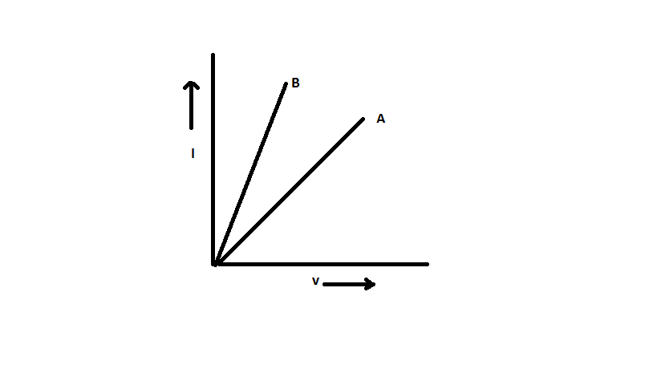  Which graph corresponds to parallel combination? Justify your answer. | 2
11 | Write the principle of a cyclotron. What is resonance condition in a cyclotron? | 2
12 | An ordinary moving coil ammeter used for measuring DC can’t measure AC even its frequency is low .why? | 2
13 | In a plane EM wave the electric field oscillates with a frequency 2x10¹¹ s⁻¹ and an amplitude of 40V/m then find (a) wavelength of wave (b) energy density due to electric field  OR  Give one use of each of the following :  (a)microwaves (b) infra-red waves (c) ultraviolet radiations (d) gamma rays | 2
14 | An alpha particle and a proton are accelerated through same potential difference calculate the ratio of their speeds. | 2
15 | Give two reasons to justify that wave theory fails to explain photoelectric effect. | 2
16 | Define mass defect and binding energy. What is the significance of binding energy per nucleon? | 2
17 | Draw the circuit diagram of a full wave rectifier using two diodes. How the frequency at its input and output are related? | 2
18 | The aperture of the objective lens of an astronomical telescope is doubled .How will this effect (a) resolving power (b) the intensity of the image | 2
19 | Find the expression for the potential at a point on axial line of dipole. | 3
20 | A potentiometer wire is 4m long and of resistance 5 ohm. It is connected to a battery of 6V and a series resistor of 20 ohms. A cell of 2V and internal resistance 0.8 ohm is connected in the secondary circuit. Where will be the null point if the cell is shunted by a resistor of 1.2ohm? Where will it shift if the shunt resistor is increased? | 3
21 | An electric heater and an electric bulb are rated 500W-220V and 100W-220V respectively. both are connected in series to a 220V ac mains calculate the power consumed by (a) heater (b) electric bulb | 3
22 | Explain the principle of a transformer. How can we minimize different types of losses in it .can it be used for DC supply. Explain | 3
23 | Three charges of 1µc 5µC and -4µC are placed at the vertices of an equilateral triangle of side 2m. How much work is needed to move the charge of 1µC to infinity? Do we need an external agent for this purpose? | 3
24 | Define TIR. calculate the refractive index of the material of the equilateral prism for which the angle of minimum deviation is 60⁰ | 3
25 | State Brewster’s law. show that the refracted and reflected light are at right angles if angle of incidence is same as angle of polarization | 3
26 | Write two limitations of Bohr’s atomic theory. Derive the formula for the velocity of an electron inside an atom.  OR  Define mean life and half life. How are they related to each other? Determine the energy released in the process ₉₂U²³⁸ ------- ₉₀Th ²³⁴ + ₂He⁴ if atomic mass of ₉₂ U²³⁸ is 238.05097u ,atomic mass of ₉₀Th²³⁴ is 234.04363u and atomic mass of ₂He⁴ is 4.00260u.also 1u= 931.5MeV/c² | 3
27 | Define amplitude modulation. Draw the circuit diagram for amplitude modulator and demodulator. | 3
28 | State Biot- savart’s law. Express it in vector form. Use it find the magnetic field at a point on the axis of a current carrying circular coil.  OR  A charge particle enters into a uniform magnetic field normally. Prove that it will move in a circle. Find the expression for the radius of its path. What will be the effect on KE of charged particle? If magnetic field is doubled. Explain. | 5
29 | Draw the circuit diagram to obtain the characteristics of a transistor in CE configuration.  Explain the working of a transistor as a CE amplifier.  OR  Write short notes on any two of the following(mention one use of each)  (a)Zener diode (b) photodiode (c) LED | 5
30 | Explain by a suitable diagram, diffraction due to a single slit. Why the intensity of maxima decreases with the order of maxima .write the conditions for maxima and minima in a diffraction pattern.  which is easier to diffract sound or light. Explain  OR  Define refraction. Complete the ray diagram given below and derive the necessary formula for refraction.  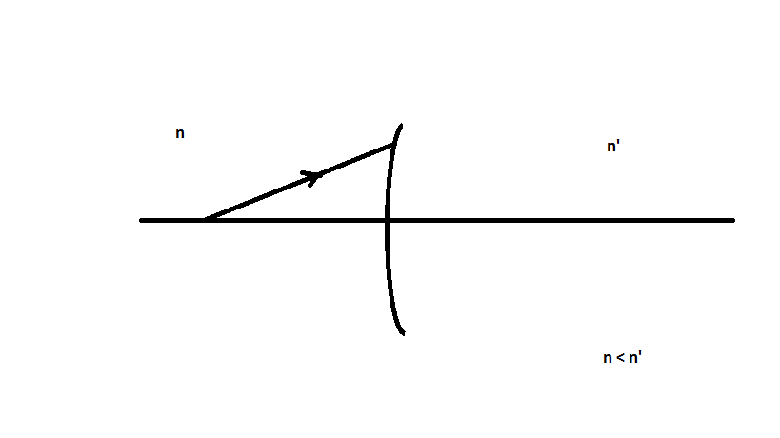  Find the position of image for the following figure  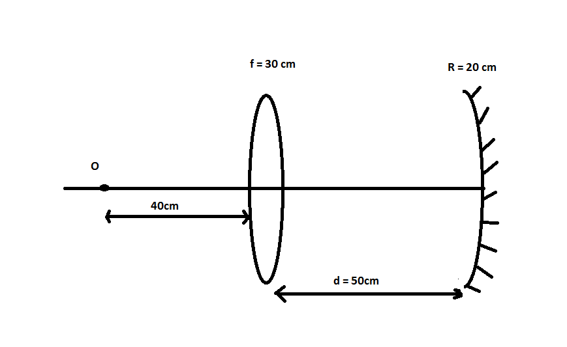 | 5

NOTE: crash course for AIEEE-2010 from 30th march 2010, for details contact in person Navin pant (9911625844)

