Guess Paper – 2012
Class – X
Subject – Mathematics

Time allowed: 3 hours 10/02/2012 Maximum Marks: 80

General Instruction:
- All questions are compulsory.
- The question paper consists of 34 questions divided into four sections A, B, C and D.
- Section A contains 10 questions of 1 mark each, which are multiple choice type questions. Section B contains 8 questions of 2 marks each. Section C contains 10 questions of 3 marks each, Section D contains 6 questions of 4 marks each.
- There is no overall choice in the paper. However, internal choice is provided in one question of 2 marks each. 3 questions of 3 marks each and two questions of 4 marks each.
- Use of calculators is not permitted.

SECTION ‘A’

- A sphere is diameter 18 cm is dropped into a cylindrical vessel of diameter 36 cm, partly filled with water. If the sphere is completely submerged, then the water level rises (in cm ) by
- 3 (B) 4 (C) 5 (D) 6

- Which of the following cannot be the probability of an even?
- 3/2 (B) 3/5 (C) 25% (D) 0.3

- The mid – point of segment AB is the point P(0, 4). If the coordinates of B are ( - 2, 3) then the coordinates of A are
- (-2, 11) (B) (-2, -5) (C) (2, 9) (D) (2, 5)

- The point P which divides the line-segment joining the points A ( 2, - 5) and B (5, 2) I the ratio of 2 : 3 lies in the quadrant
- I (B) II (C) III (D) IV

- The roots of the equation x² + x – p(p + 1) = 0, where p is a constant, are
- p, p + 1 (B) - p, p + 1 (C) p, - (p + 1) (D) - p, - (p + 1)

- In Fig, O is the centre of a circle, AB is a chord and AT is the tangent at A. If ∠AOB = 100º , then ∠BAT = ?
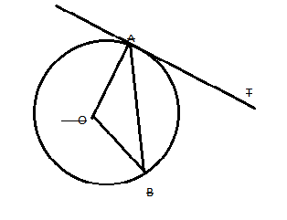
- 100º (B) 40º (C) 50º (D) 90º

- In an AP, if d = - 2, n = 5 and a_{n} =0, then the value of a is
- 10 (B) 5 (C) 8 (D) – 8

- The radii of two circles are 12 cm and 5 cm respectively. The diameter of the circle having area equal to the sum of the areas of the two circles (in cm) is:
- 15 (B) 14 (C) 26 (D) 13

- In Fig. PA and PB are tangents to the circles with centre O. If ∠APB = 60º then ∠OAB is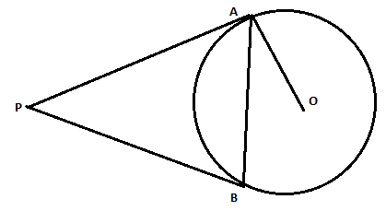
- 30º (B) 90º (C) 60º (D) 15º

- The angle of elevation of the top of a tower from a point on the ground, which is 30 m away from the foot of the tower is 45º. The height of the tower (in metres) is
- 15 (B) 30 (C) 30√3 (D) 10√3

SECTION ‘B’

- Draw a line – segment of length 6 cm. Using compasses and ruler, find a point P on it which divides it in the ratio of 3 : 4.

- Find whether – 150 is a term of the AP 17, 12, 7, 2,………………..?

- A coin is tossed two times. Find the probability of getting at least one head.

- Find that value(s) of x for which the distance between the points P (x, 4) and Q (9, 10) is 10 units.

- Two cubes, each of side 4 cm are joined end to end. Find the surface area of the resulting cuboid.

- Find the value of p so that the quadratic equation px(x – 3) + 9 = 0 has two equal roots.

- Two concentric circles are of radii 7 cm and r cm respectively, where r > 7. A chord of the larger circle, of length 48 cm, touches the smaller circle. Find the value of r.

- Find the area of a quadrant of a circle, where the circumference of circle is 44 cm. (use π = 22/7)
OR
In Fig. APB and CQD are semi –circles of diameter 7 cm each, While ARC and BSD are semi –circles of diameter 14 cm each. Find the perimeter of the shaded region. (use π = 22/7).
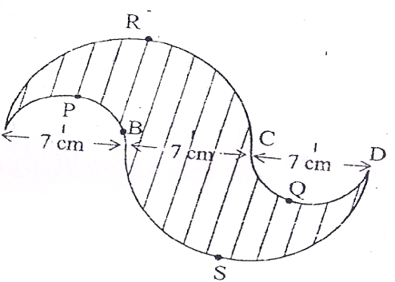

SECTION ‘C’

- Find the value of the middle term of the following AP:
- 6, - 2, 2,………………………………….., 58.
OR
Determine the AP whose fourth term is 18 and the difference of the ninth term from the fifteenth term is 30.

- Draw a triangle ABC in which AB = 5 cm, BC = 6 cm and ∠ABC = 60º. Then construct a triangle whose sides are 5/7 times the corresponding sides of Δ ABC.

- The radii of the circular ends of a bucket of height 15 cm and 14 cm and r cm (r < 14 cm). If the volume of bucket is 5390 cm³, then find the value of r. (use π = 22/7)

- Find the roots of the quadratic equation: 2√3 x² – 5x + √3 = 0.

- If (3, 3), (6, y), (x, 7) and (5, 6) are the vertices of a parallelogram taken in order, find the value of x and y.

- From the top of a tower 100 m high, a man observers two cars on the opposite sides of the tower with angles of depression 30º and 45º respectively. Find the distance between the cars. ( use √3 = 1.73)

- Find the value of k, if the points P(5, 4), Q (7, k) and R ( 9, - 2) are collinear.
OR
If two vertices of an equilateral triangle are (3. 0) and (6,0), find the third vertex.

- Two dice are rolled once. Find the probability of getting such numbers on two dice, whose product is a perfect square.
OR
A game consists of tossing a coin 3 times and noting its outcome each time. Hanif wins if he gets three heads or three tails and losses otherwise. Calculate the probability that Hanif will lose the game. Also write the sample space.

- Find the area of the major segment APB, in fig, of a circle of radius 35 cm and ∠ AOB = 90º. (use π = 22/7)
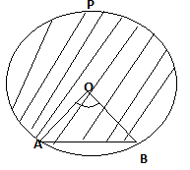

- In Fig. a triangle ABC is drawn to circumscribe a circle of radius 2 cm such the segments BD and DC into which BC is divided by the point of contact D of are lengths 4 cm and 3 cm respectively. If area of Δ ABC = 21 cm², then find the lengths of sides AB and AC.
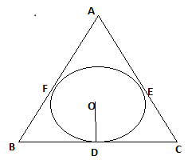

SECTION ‘D’
- In Fig. arcs are drawn by taking vertices A, B and C of an equilateral Δ ABC of side 14 cm as centers to intersects the sides BC, CA and AB at their respective mid –points D, E and F. Find the area of the shaded region. (use Δ= 22/7, √3 = 1.73)
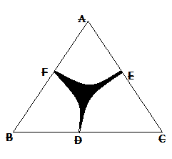
- Prove that the lengths of tangents drawn from an external point to a circle are equal.

- If the sum of first 4 terms of an AP is 40 and that of first 14 terms is 280. Find the sum of first n terms.
OR
Find the sum of the first 30 positive integers divisible by 6.

- A motor boat whose speed is 20 km/h in still water, takes 1 hour more to go 48 km upstream than to return downstream to the same spot. Find the speed of stream.
OR
Find the roots of the equation:- 1 __ 1 = 11 x ≠ -4, 7
x + 4 x – 7 30

- Two poles of equal heights are standing opposite to each other on either side of the road, which is 100 m wise. From a point between them on the road, the angles of elevation of the top of the poles are 60º and 30º respectively. Find the height of the poles and position of the point.

- From a solid cylinder whose height is 15 cm and diameter 16 cm, a conical cavity of the same height and same diameter is hollowed out. Find the total surface area of the reaming solid. (take π = 3.14)

“Success is never permanent, and failure is never final”
Prepared By: Trilochan Wadhwa
Email wadhwadost@indiatimes.com
Phone No. 8802551906
M.COM, B.ED

DEEPAK TUITION CENTRE FP I (SM II)
A – 98, NEW MOTI NAGAR
NEW DELHI – 110 015 Ph: - 25176448

