Sample Paper – 2012
Class – X
Subject – MATHEMATICS
Time allowed : 3 hours Maximum Marks : 80
General Instructions:
All questions are compulsory.
The question paper consists of 34 questions divided into four sections A, B, C and D. Section A comprises of 10 questions of 1 mark each, section B comprises of 8 questions of 2 marks each, section C comprises of 10 questions of 3 marks each and section D comprises 6 questions of 4 marks each.
- Question numbers 1 to 10 in section A are multiple choice questions where you are to select one correct option out of the given four.
- There is no overall choice. However, internal choice have been provided in 1 question of two marks, 3 questions of three marks each and 2 questions of four marks each. You have to attempt only one of the alternatives in all such questions.
- Use of calculator is not permitted.
Section - A
Question numbers 1 to 10 carry 1 mark each. For each question, four alternative choices have been provided of which only one is correct. You have to select the correct choice.
- Which of the following equations has 2 as a root?
  - 4x²-12x+9=0
  - 6x²+x-12=02
  - 9x²-22x+8 = 0
  - x² -18x+77 = 0
- If , a, 4 are in AP, the value of a is
  - 1
  - 13
- If two tangents inclined at an angle 60° are drawn to a circle of radius 3 cm, then length of each tangent is equal to
  - cm
  - 2.√3 cm
  - 3√3 cm
  - 6 cm
- To divide a line segment AB in the ratio 3 : 5, first a ray AX is drawn so that angle BAX is an acute angle and then at equal distances, points are marked on the ray AX such that the minimum number of these points is
  - 5
  - 6
  - 7
  - 8
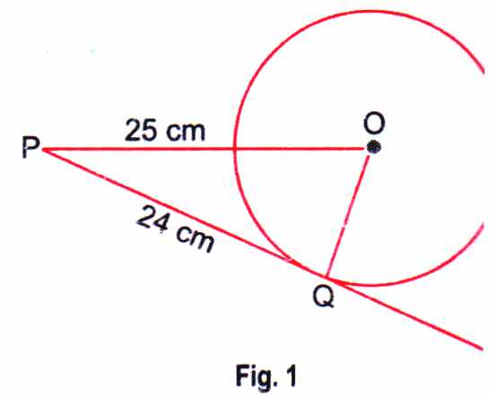
- In Fig. given, the length of a tangent to a circle is 24 cm from a point P and point P is at a distance of25 cm from Centre O, then radius is
  - 7cm
  - 6cm
  - 8cm
  - 5cm
- A circle touches all the four sides of a quadrilateral PQRS whose three sides are 6 cm, 8 cm and 9 cm respectively, fourth side is
  - 6cm
  - 7cm
  - 8cm
  - 4cm
- The areas of two circles are in the ratio 16 : 25. The ratio of their perimeter is
  - 16: 25
  - 25 : 16
  - 4 : 5
  - 5 : 4
- The area of a circle is 49 π. Its circumference is
- The angle formed by the line of sight with the horizontal when it is above the horizontal level is
  - vertical angle
  - angle of depression
  - angle of elevation
  - none of these
- If the event cannot occur
  - 1
  - 2/3
  - ½
  - 0
Section B
Question numbers 11 to 18 carry 2 marks each.
- Without finding the roots, comment on the nature of the roots of the quadratic equation px ² + 2 x+ q = 0.
- If the numbers 'A - 2, 4A -1 and 5A. + 2 are in AP, find the values of 'A.
OR
For the AP: - 3, -7, -11, can we find directly a₃₀ - a₂₀ without actually finding a₃₀ and a₂₀? Give reasons for your answer.
- Show that tangent lines at the end points of a diameter of a circle are parallel.
- Find the area of circle whose circumference is 66 cm.
- Two cubes have their volumes in the ratio 8: 125. What is the ratio of their surface areas?
- 'A' is a point all the y-axis whose ordinate is 5 and B is the point (- 3, 1). Calculate the length of AB.
- Find the ratio in which the line segment joining the points (6, 4) and (1, -7) is divided by x-axis.
- A card is drawn from a well-shuffled pack of 52 cards. Calculate the probability of getting
    - Neither a card of club nor a card of spade.
    - Neither a card of spade nor an ace.
Section C
Question numbers 19 to 28 carry 3 marks each.
- Find the roots of the equation 5x ² - 6x - 2 = 0 by the method of completing the square.
- Determine a so that 2a + 1, a² + a + 1 and 3a² - 3a + 3 are consecutive terms of an AP.
OR
If the first term of an AP is 2 and the sum of first five terms is equal to one-fourth of the sum of the next five terms, find the sum of the first 30 terms.
- Two tangents PQ and P R are drawn from an external point to a circle with centre O. Prove that QORP is a cyclic quadrilateral.
- Draw a ∆ABC with side BC = 7 cm, angle B = 45° and angle A = 105°. Then, construct a triangle whose sides are times the corresponding sides of ∆ABC.
- Area of a sector of a circle of radius 36 cm is 54 π cm². Find the length of the corresponding arc of the sector. ( Leave your answer in π. )
OR
Find the difference of the areas of sector of angle 120° and its corresponding major sector of a circle of radius 21 cm.
- A cone of radius 4 cm is divided into two parts by drawing a plane through the mid-point of its axis and parallel to its base. Compare the volumes of the two parts.
- A person, standing on the bank of a river, observes that the angle subtended by a tree on the opposite bank is 60⁰. When he retreats 20 m from the bank, he finds the angle to be 30°. Find the height of the tree. Give your answer correct to 2- decimal places.
- If D (), E (7, 3) and F () are the mid-points of sides of ∆ABC, find the area of the ∆ABC.
- Show that the points P (0, -2), Q (3, 1), R (0, 4) and S (-3, 1) are the vertices of a square.
OR
Find the coordinates of the point Q on the x-axis which lies on the perpendicular bisector of the line segment joining the points A (-5, - 2) and B (4, - 2). Name the type of triangle formed by the points Q, A and B.
- Two dice are thrown together. Find the probability that the product of the numbers on the top of the dice is
  - 6
  - 12
  - 7
Section - D
Question numbers 29 to 34 carry 4 marks each.
- A dealer sells a toy for Rs 31.25 and gains as much percent as the cost price of the toy .Find the cost price of the toy.
OR
In a class test, the sum of Kamal's marks in Mathematics and English is 40. Had he got 3 marks more in mathematics and 4 marks less in English, the product of the marks would have been 360. Find his marks in two subjects separately.
- K. Rajalingam Ramaswammy repays his total loan of Rs 1,18,000 by paying every month starting with the first installment of Rs1000. If he increases the installment by Rs100 every month, what amount will be paid by him in the 30th installment? What amount of loan does he still have to pay after the 30th installment?
R
Q
P
O
- Prove that the lengths of tangents drawn from an external point to a circle are equal.
- Find the area of the circle excluding the area of triangle PQR in Fig. given alongside, if PQ = 24 cm, PR = 7 cm and O is the Centre of the circle.
- A building is in the form of a cylinder surmounted by a hemispherical dome. The base diameter of the dome is equal to of the total height of the building. Find the height of the building, if it contains 67 m³ of air.
- A vertical tower stands on a horizontal plane and is surmounted by a vertical flagstaff of height h. At a point on the plane, the angle of elevation of the bottom and the top of the flagstaff are respectively. Prove that the height of the tower is 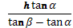.
OR
The angles of elevation of the top of a tower from two points at distances a and b from the base and on the same straight line with it are complementary. Prove that the height of the tower is..
Paper Submitted By:

Name Rahul Varshney
Email rahulpcm101@rediffmail.com
Phone No. 9759979695

