

Note : This booklet contains mathematics Important formulae on next page.

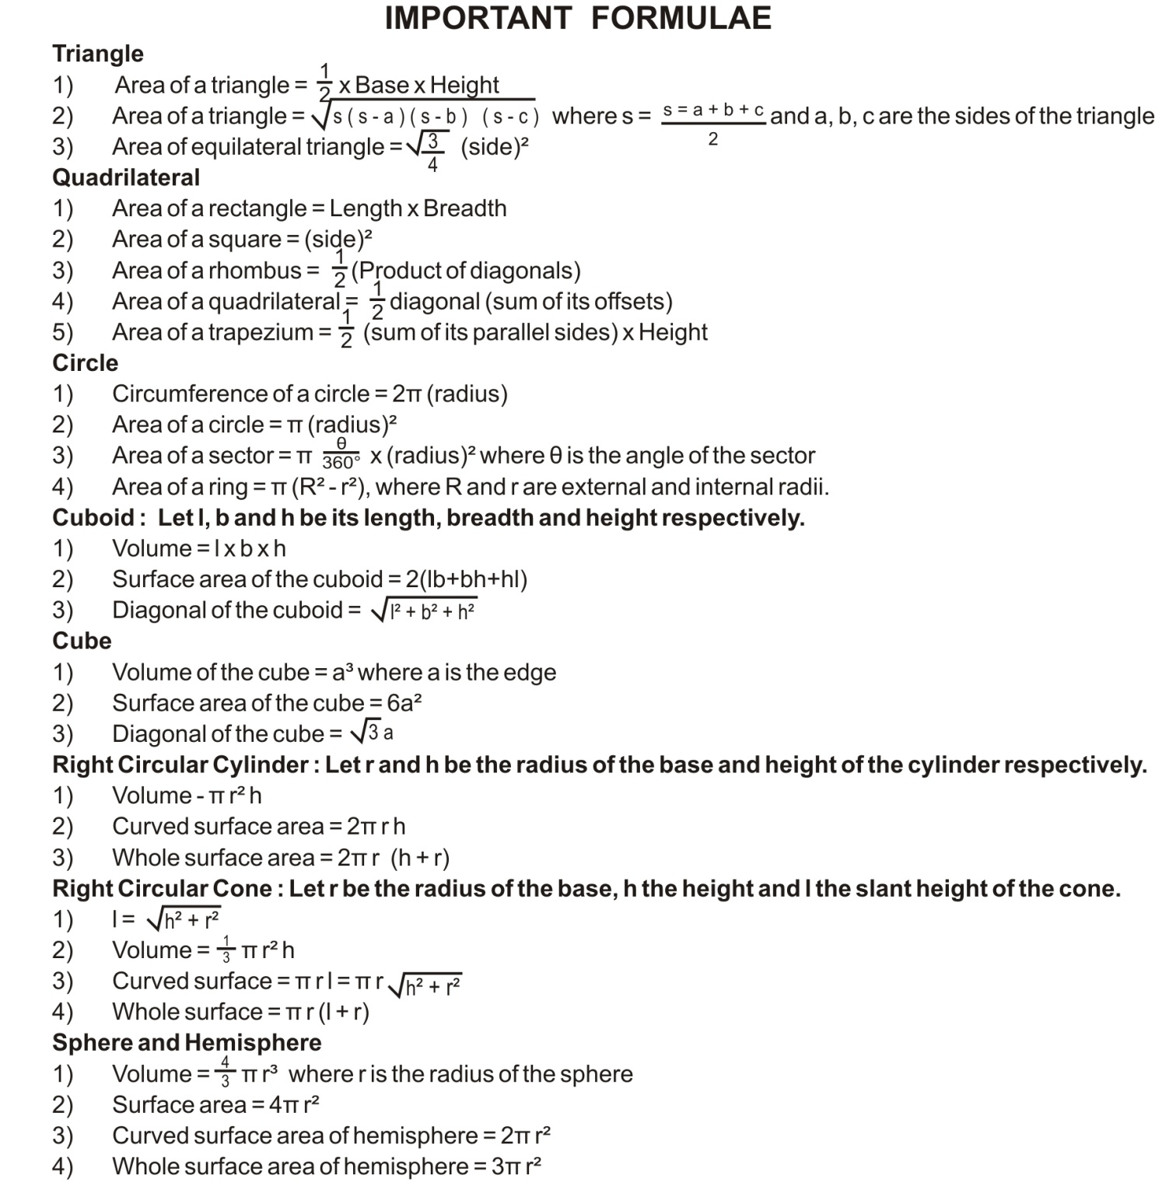
Sides )
Algebra
- (a + b)² = a² + 2ab + b²
- a² – b² = (a + b) (a – b)
- (a – b) ² = a² – 2ab + b²
- (a – b)³ = a³ – 3a²b + 3ab² – b³
- (a + b) ³ = a³ + 3a²b + 3ab² + b³
- a³ – b³ = (a – b) (a² + ab + b²)
- a³ + b³ = (a + b) (a² – ab + b²)
- x³ + y³ + z³ – 3xyz = (x + y + z) (x² + y² + y² – xy – yz – zx =
½ (x + y + z) [ (x – y) ² + (y – z) ² + (z – x) ²]
- a³ – b³ + c³ + 3abc = (a – b + c) (a² + b² + c² + ab + bc – ca)

Comparing Quantities :
- Profit = S.P. – C.P.
- Loss = C.P. – S.P.
- Profit % = (Profit / C.P.) x 100
- Loss % = (Loss / C.P.) x 100
- C.P. = S.P. / (1+P%)
- S.P. = C.P. – (Loss% x C.P.)
- Amount = Principal + Interest1
- S.I. = (P x R x T)/100, P = Principal, R = Rate, T = Time, S.I. = Simple intrest for yearly
- A = P (1 + R/100)^{n} A = Amount, R = Rate, n = Numbers of years
- Discount = Marked Price – Sale Price.
- Discount % = (Discount / Marked Price) x 100
- A = P (1 + R/200)^{2n} A = Amount, R = Rate, n = Number of years, for half yearly.

Mensuration :
- Perimeter of a regular Polygon = Number of sides x length of one side.
- Area of Parallelogram = base x height
- Area of trapezium = half of the sum of the length of parallel sides x perpendicular distance between them.
- Area of rhombus – half the product of its diagonal
- Volume of cube = (I)³
- 1 cm³ = 1ml
- 1 L = 1000 cm³
- 1 m³ = 1000000 cm³
- aº = 1
MATHEMATICS
Max Marks – 90 Time – 3 ½ hours.

General Instructions :
- All questions are compulsory.
- The question paper consists of 34 questions divided in to Four sections A, B, C and D. Section–A comprises of 8 questions of 1 mark each, Section–B comprises of 6 questions of 2 marks each, Section–C comprises of 10 questions of 3 marks each and Section–D comprises of 10 questions of 4 marks each.
- Question numbers 1 to 8 in Section – A are multiple choice questions where you are to select one correct option out of the given four.
- There is no overall choice. However, internal choice has been provided in 1 question of two marks, 3 questions of three marks each and 2 questions of four mark each. You have to attempt only one of the alternatives in all such questions.
- Use of calculator is not permitted.
- An additional 15 minutes time has been allotted to read this question paper only.
SECTION – A
Questions Number 1 to 8 carry 1 mark each. For each question Four alternate choices have been provided of which only one is correct. Choose the correct one.
- Any point on the line y=x is of the form :
(A) (a, a) (B) (0, a) (C) (a, 0) (D) (a, -a)
- Three angles of a quadrilateral are 75°, 90° and 75°. The fourth angle is :
(A) 95° (B) 90° (C) 105° (D) 120°
- The equation of x-axis is of the form :
(A) x = 0 (B) y = 0 (C) x = y (D) x + y = 0
- A quadrilateral having only one pair of opposite sides parallel is called a :
(A) square (B) parallelogram (C) rectangle (D) trapezium
- If each side of a cube is doubled, the total surface area becomes :
(A) 2 times (B) 12 times (C) 4 times (D) 6 times
- In fig, O is the centre for the circle. If reflex a ∟AOC=230º then x is equal to :
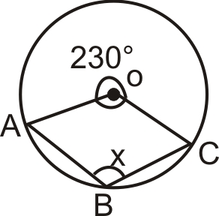

(A) 65° (B) 50°
(C) 130° (D) 115°

- Which of the following can not be the empirical probability of an event?
(A) 2/3 (B) 1 (C) 3/2 (D) 0
- The median of a triangle divides it into two :
(A) triangles of equal area (B) congruent triangles
(C) right triangles (D) Isosceles triangles
SECTION - B
Questions Number 9 to 14 carry 2 marks each.
- Find median and mode of the following data
7, 9, 12, 13, 7, 12, 7, 12, 15, 7, 18, 20, 7, 13
- The angles of a quadrilateral are in the ratio 1 : 2 : 3 : 4. Find all the angles of the quadrilateral.
- In fig, a circle with centre at O is given. If ∟ABO= 20° and ∟ACO = 35°, then find the value of x.
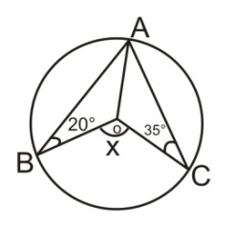
- Find the volume of a right circular cone with radius 6 cm and height 14 cm. (Take π = 22/7)
- The diameter of the moon is one fourth of the diameter of the earth. What fraction of the volume of the earth is the volume of the moon?
- The cost of a table is seven times the cost of a chair. Write a linear equation is two variables in the form ax + by + c = 0 to represent this statement. Write also the values of a, b and c.
OR
Write the linear equation such that each point on its graph has an ordinate 3 times its abscissa. Write one solution also.
SECTION – C
Questions Number 15 to 24 carry 3 marks each.
- In a circle of radius 5 cm, AB and CD are two parallel chords of lengths 8 cm and 6 cm respectively. Calculate the distance between the chords if they lie on the opposite sides of the centre.
OR
In a fig, PQ=QR are chords of a circle equidistant from the centre O. Prove that the diameter passing through Q bisects ∟PQR. Also, prove that PQ=PR.

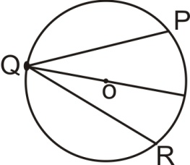
- 1.1 cm³ of gold is drawn into a wire of 0.1 mm in diameter. Find the length of the wire in metres.
- Show that if the diagonals of a quadrilateral bisect each other at right angles then it is a rhombus
- Find the mean of the following frequency distribution.
x : 4 6 9 10 13
f : 5 10 10 7 8
- A conical tent is 10 m high and the radius of its base is 24 m. Find
- Slant height of the cone
- Cost of the canvas required to make the tent, if the cost of 1 m² canvas is 70
OR
There metal cubes, whose edges measure 3 cm, 4 cm and 5 cm respectively, are melted to form a single cube. Find its edge. Also find the total surface area of the new cube formed.
- Solve the equation 4x – 3 = x + 21 and represent the solutions(s) on
- The number line
- The Cartesian plane.
- 1500 families with 2 children were selected randomly and the following data was recorded.
Number of girls in a family : 0 1 2
Number of families : 475 804 221
Compute the probability of a family, chosen at random having
i) 2 girls ii) 1 girl iii) No girl.
Also check whether the sum of these probabilities is 1.
- Express the following statement as linear equation in two variables :
‘The cost of 2 oranges and 3 apples is 45. From the equation find the cost of an apple if the cost of an orange is 7.50
OR
Find two solutions for each of the following equations.
i) 2x + y = 8 ii) x – 3y = 18
- In a parallelogram ABCD, P & Q are the mid points of sides DC & AB respectively. Show that the diagonal BD is trisected by line segments AP&CQ.
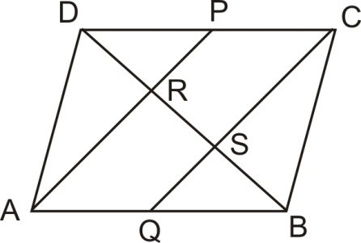
- The relative humidity (in %) of a certain city for a month of 30 days was as follows :
98.1 98.6 99.2 90.3 86.5 95.3 92.9 96.3 94.2 95.1
89.2 92.3 97.1 93.5 92.7 95.1 97.2 91.3 95.2 97.3
96.2 92.1 84.9 90.2 95.7 98.3 97.3 96.1 92.1 89
Construct a grouped frequency distribution table with classes 84–86, 86–88 etc.
SECTION – D
Questions Number 29 to 34 carry 4 marks each.
- P is any point on the chord BC of a circle such that AB=AP. Prove that CP=CQ.
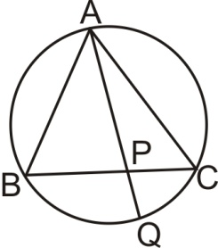

OR
In a circle with centre O, chord SR=chord SM. Radius OS intersects the chord RM at P. Prove that RP = PM.
- The following is the distribution of weights (in kg) of 50 persons :
Weight (in kg) : 55 – 55 55 – 60 60 – 65 65 – 70 70 – 75 75 – 85
Number of persons : 10 10 8 6 9 5
Draw a histogram for the above data.
- A closed cylindrical petro storage tank is made up of steel sheet, find
- the lateral or curved surface area of the tank that is 4.2 m in diameter and 4.5 m high.
- how much steel was actually used, if (1/12) of the steel actually used was wasted in making the tank.
- ABCD is a trapezium with AB║DC. If AD=BC then prove that ∟BCD=∟ADC.
OR
ABCD is a parallelogram and AP and CQ are perpendiculars from vertices A and C on diagonal BD. Show that
- ΔAPB ~ ΔCQD
- AP = CQ
- Draw the graph of the linear equation 2x – y = 4. From the graph, find the co-ordinates of the point where the line intersects y – axis.
- Prove that the parallelograms on the same base and between the same parallels are equal in area.
- Draw histogram and frequency polygon on the same graph for the following data :
Weight  (in kg) | 124–128 | 128–132 | 132–136 | 136–140 | 140–144 | 144–148
Number of Students | 5 | 8 | 17 | 24 | 16 | 12
- Two circles of radii 10 cm and 17 cm intersect at two points and distance between their centres is 21 cm. Find length of common chord.
- A hemispherical tank is made up of an iron sheet 1 cm thick. If the inner radius is 1 m, then find the volume of the iron used to make the tank.
- Solve for 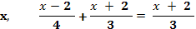

SCIENCE
Max Marks – 80 Time – 3 hours.
General Instructions :
- The question paper comprises of two sections, A and B. You are to attempt both the sections.
- All questions are compulsory.
- There is no overall choice. However, internal choice has been provided in all the five questions of five mark category. Only one option in such questions is to be attempted.
- All questions of section A and all questions of section B are to be attempted separately.
- Questions number 1 to 3 in section A are one mark questions. These are to be answered in one word or in one sentence.
- Questions number 4 to 7 in section A are two marks questions. These are to be answered in about 30 words each.
- Question number 8 to 19 in section A are three marks questions. These are to be answered in about 50 words each.
- Questions number 20 to 24 in section A are five marks questions. These are to be answered in about 70 words each.
- Questions number 25 to 42 in section B are multiple choice questions based on practical skills. Each questions is a one mark question. You are to select one most appropriate response out of the four provided to you.
SECTION – A
- A body does 50J of work in 5 seconds. What is its power?
- A standing man holding a suitcase in his hand. State if work is done or not done. Why?
- Name the major Green house gas responsible for causing global warming.
- A fish weighs less in water than air. Why?
- Define wavelength and amplitude.
- Differentiate Kinetic energy and Potential energy. (2 points)

Element | Atomic | Number of neutrons
X | 37 | 20
Y | 35 | 18
- Write atomic number and electronic configuration of X
- What is the relation between the two species X and Y
- A bat emits ultrasonic sound of frequency 100 KHz in air. If his sound meets Water surface, what is the wavelength of
- Reflected sound ii) transmitted sound
Given : speed of sound in air = 340 m/s and in water = 1486 m/s
- Derive the expression for kinetic energy, K. E = ½ m v² and the symbols have their usual meanings.
- a) State Archimedes’s principle of floatation.
b) Relative density of silver is 10.9. The density of water is 10³ kg m⁻³. What is the density of silver in S.I. unit.
- a) State the law of constant proportions
b) Two grams of hydrogen combine with 16 grams of oxygen to form water. How many grams of water will be formed? Write the name of law of chemical combination which you have used in the calculation.
- a. A flask contains 180 grams of water, Calculate
- The number of molecules present in water?
- How many moles does it contain?
b. Calculate the mass of 54.18 x 10²³ molecules of carbon dioxide.
- Pick the odd one out and justify your choice by giving reasons
- Crocodile, Pigeon, Rat, Toad
- Funaria, Marchantia, Riccia, Fern
- Distinguish between acute diseases and chronic diseases. Give an example for each.
- A person gets a disease like cholera
- Give the scientific term for the following
- A substance that is injected into the body to protect against a specific disease
- A chemical substance obtained from microbes to stop the growth of specific kinds of microbes
- The body part of the host where a pathogen attacks and manifests the symptoms of the diseases.
- State the major characteristic considered for classifying the organisms.
- What is nitrogen fixation? How is it carried in nature?
- Distinguish power from energy. Write their commercial units. An electric heater of 1000 W is used for 2 hours a day. What is the cost of using it, for a month of 28 days, if one unit costs 3?
- (a) What is SONAR? What is the basic principle of its working? Explain its use.
(b) Why do the stages of auditorium have curved background? Curtains, carpets and false ceilings? OR
- What is meant by positive work and negative work? Illustrate with an example for each.
- A horse and calf are running with same speed. Which of the two has more kinetic energy? Draw a graph to show relation between mass and K.E of a moving body.
- a) Explain Rutherford’s experiment with his observations and result
b) What is the valency of an element if it’s atomic number = 12?
What is the name of this element? OR
- Summarize the three rules for writing of distribution of electrons in various shells for the first elements?
- X contains 11 proton and 12 neutrons. Identify the element and write its electronic configuration
- a) With the help of diagram show Nitrogen cycle in nature
b) What is the importance of nitrogen fixing bacteria? OR
- With the help of a labeled diagram show the cycling of oxygen in nature.
- Name a harmful synthetic chemical which is mainly responsible for depletion of ozone layer.
- Does sound require a medium to pass? Explosion in stellar space is not audible on the surface of earth. Give reason.
- a) What are postulates of Bohr’s model of atom?
b) What are α-particles?
Questions 25 to 42 are multiple choice questions based on practical skills. Each question is a one mark question. You are to choose one most appropriate response out of the four a, b, c and d provided to you.
- Identify the correct diagram for the correct measurement of the level of water in a measuring cylinder.
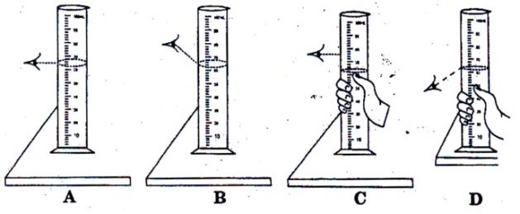
- When a pulse is formed on a slinky :
- the oscillations ‘stay-on’ for a long time.
- the slinky remains totally undisturbed.
- the whole of the slinky oscillates for a short while and then returns to its original undisturbed position.
- the pulse keeps on moving along the length of the slinky, and only a small part of it is disturbed at a given time.
- A student took solid bodies of different shapes, sizes and materials and noted down the apparent loss in weight on partially or fully immersing the bodies in different liquids., Based on the observations, he wrote the following conclusions. Which conclusion is wrong/
- Upthrust depends upon the volume of the body immersed.
- Upthrust increases as body goes deeper and deeper inside the liquid.
- Upthrust depends upon the density of the liquid.
- Upthrust does not depend upon the shape of the vessel in which liquid is filled.
- While determining the density of the material of metallic sphere using a spring balance and measuring cylinder, a student noted the following readings.
- Mass of the sphere = 81 g
- i) Reading of water level in the cylinder without sphere = 54 mL
ii) Reading of water level in the cylinder with sphere = 63 mL
On the of these observations the density of the material of the sphere is –
a) 1500 kg m⁻³ b) 6000 kg m⁻³ c) 7000 kg m⁻³ d) 9000 kg m⁻³
- The correct position of the ear of the observer is shown in
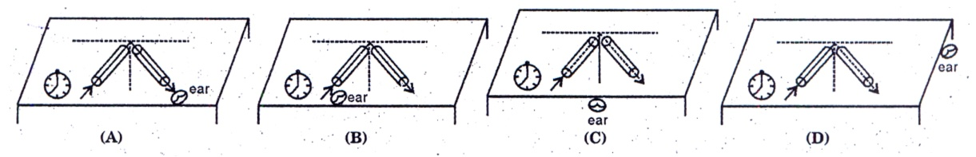
- The sound received in the ears while doing the experiment should be
- The direct sound from the clock
- The sound reflected from any reflecting surface
- The sound coming through the tube after reflection
- Any of these
- Two students A and B recording depth of depression of sand for two surfaces of area A₁ and A₂ of a block, record the pressures as P₁ and P₂ such that P₁ > P₂ Then.
- A₁ = A₂ b) A₁ >> A₂ c) A₁ < A₂ d) A₁ = 2A₂
- The length, breadth and height of a cuboidal of mass m kg are 5 cm, 3 cm, 2 cm. The pressure on the floor will be more for the surface area.
- 5 x 3 cm² b) 3 x 2 cm² c) 5 x 2 cm² d) same in all
- The weight W of a body felt in a liquid of density half the density of the bodyis.
- W b) W/2 c) 2W d) zero
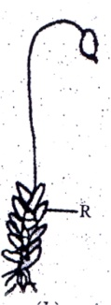
- The part marked R in the given diagram is
- Sporophyte c) oppositely arranged leaves
- Spirally arranged leaves d) branches
- Lichens generally reproduce by :
- Budding b) Vegetation c) Spores d) Fission
- A pollen grain of an angiosperm may be best defined as :
- A male sperm cell c) A spore mother cell
- A partially developed embryo d) A partially developed male gametophyte
- Earthworm has following characteristics of Annelida :
- Metameric segmentation c) Both (a) and (b)
- True coelom d) Open blood vascular system
- Observe the pictures of honey bee and cockroach. The common feature that assigns them to the same phylum is :
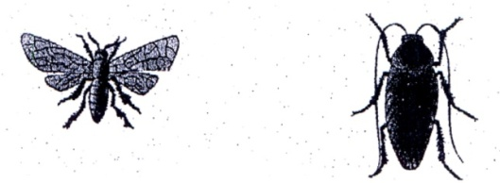
- Wings b) Three pair of legs c) Jointed appendages d) Antennae
- A Student while verifying the laws of reflection of sound measured the angle between the incident sound was and reflected sound wave as 110. The angle of reflection is:
- 110º b) 55 º c) 27 º d) none of these
- In a chemical reaction, 5.3 g of sodium carbonate reacted with 6 g of ethanoic acid. The products were 2.2 g of carbon dioxide, 0.9 g water and 8.2 g of sodium–ethanoate. Which
- Law of constant proportions c) Law of conservation of mass
- Law of multiple proportion d) Law of combining volume
- To find velocity of the pulse in a string, we need :
- Only a measuring scale b) only a stop watch
- Both (a) and (b) d) neither (a) nor (b)
- The spring balance shown is to measure the mass of a given solid. The mass of the solid is :
- 40g b) 75 g c) 51 g d) 35 g

   

