Sample Paper – 2013
Class – IX
Subject – SUMMATIVE ASSESSMENT-II
FOUNDATION OF INFORMATION TECHNOLOGY
Time allowed : 3 hours Maximum Marks : 90
SECTION A
Answer the following questions within one word only : [0.5X10=5]
- How many decimal digits can be used with the fixed or currency format ?
- With which character the formula will begin ?
- The cell A1 contains ‘Mon’. What will be the cell contents of B1,C1,D1 if you click and drag the fill handle of A1 towards right ?
- If the result of a formula can not be displayed completely in a cell , which symbol will display ?
- What are the options of speed at which transition effects can be set in a presentation ?
- What will be the cell address of the cell formed by the intersection of 16th column and eighth row ?
- Out of the following external file(s), which one(s) will help you include sound in your presentation ? JPEG, GIF, WAV, MP3, BMP
- If the formula in the cell A2 is =B2+C2 . On copying this formula to cell A3, the formula in cell A3 is ________
- Name the feature which will help one to create a professional presentation without devoting much time .
- In Spreadsheet software , what is the column immediately next to column ”Z” ?

Fill in the blanks with appropriate word : [0.5X10=5]
- Pictorial representation of worksheet information is called as ____________ .
- ___________ shortcut is used to print the worksheet .
- The default font size of text in MS Excel is ________
- The ___________ animation enhance used the flying effect on the text and character .
- If a user enter 78/4 in a cell , what would be displayed in the cell .________
- Heading of chart are called as _________ .
- Cheating of person’s email identity and address is not a privacy issue . Yes/No ______
- To insert a new slide click on ________ menu .
- _____________ key is used to start a slide show .
- The twisted pair cable consists of __________ identical wires .

Answer the following questions :- [2X10=20]
- What is Protocol ?
- Give a short note on Star Topology with diagram .
- What is Modem ?
- Name and explain the careers or jobs offered by IT industries . ( any 4)
- Identify and explain the following components :
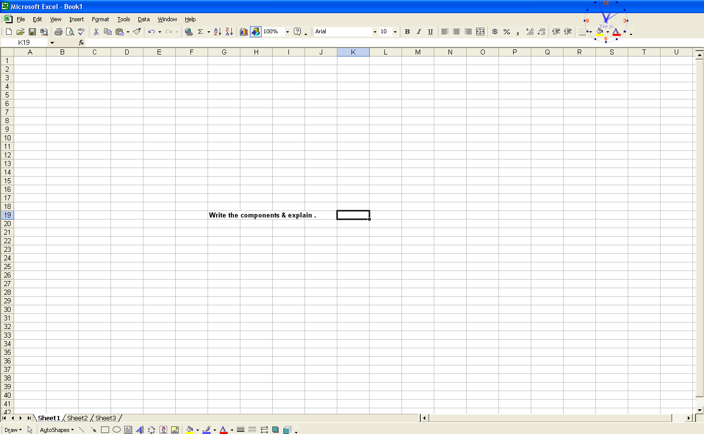

?

- Write the steps to find a particular text in a document .
- Explain the different panes under Normal view
- Define WWW .
- How do you make changes in your slide color scheme ?
- Expand the following :
SMTP , ARPANET, ISDN , NOS

Answer the following questions : [3X10=30]
- What is Computer Network ?
- What are the different protocols used for Communication ? Explain them .
- What do you mean by the following terms ?
  - Espionage
  - Plagiarism
  - Software Ethics
- What technologies are used to preserve the security and integrity of information ?
- What do you mean by Cell Referencing ? Define Relative and Absolute Referencing .
- Define : LAN, MAN & WAN .
- Explain the different forms of Piracy . (Software)
- Write the steps to generate a chart from data entered by the user using Chart Wizard .
- Write the shortcut keys for :
    - to select a word
    - to select a paragraph
    - to select all texts on a single slide in the outline pane
    - to select all texts in an object or an entire outline .
    - To move at the end of the presentation .
    - To edit a cell content in MS Excel
- Write the file extensions for saving presentations
    - A slide as a graphic
    - A slide as a graphic for use on Web pages
    - A presentation outline as an outline
    - A presentation as a template
    - A presentation that will open in a Web Browser
    - A presentation that will always open as a slide show

Read the Instruction carefully and answer the following :
- Give the following answers with respect to spreadsheet . [2]
- Cell A1 contains the number 20 and B1 contains 3. What will be the contents of cell C1, if the formula = A1+B1*2^3 id entered in cell C1 ?
- The contents of cell A1,B1, C1 and D1 are 10,-20,30, 6 &-30 respectively . What will be the value displayed in cell E1 which contains the formula = MIN(A1:D1)
- Cell D3 contains the formula =$B$3 + C3 and this formula is copied to cell E3, What will be the copied formula in cell E3 ?
- Cell D3 contains the formula = $B3 + C3 and this formula is copied to cell E3 . What will be the copied formula in cell E3 ?
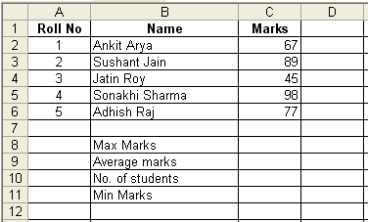
- Answer the following : [3]
  - Write a formula to calculate the maximum marks obtained in the test in cell C8.
  - Write a formula to calculate the average marks obtained by the students in the test in cell C9 .
  - Write a formula to count the number of students who appeared for the test in cell C10.
  - The examination roll number starts from 1001. Which feature helps to automate the typing of sequential numbers ?
  - How will you insert a row between the 6th and 7th rows ?
  - Write a formula to calculate the minimum marks of 1st three students obtained in the test in cell C11.
- Name the menu under which the following options are present in MS PowerPoint. [5]
Office on the Web , Cascade , Slide Transition , Spelling , Alignment , Text box
Header & footer , Duplicate , Search , Exit
- Write the complete steps to spell check a presentation files . [2]

SECTION B [1X18=18]
45. Which is an example of a mixed reference ?
a) B1 b) $B$1
c) $B1 d) AB1
46. What is the result of the formula =3+4*5^2
a) 403 b) 103
c) 1025 d) 100
47. Which device allows computers all over the world to communicate with each other over telephone lines .
a) ISP b) URL
c) Modem d) Website
48. What will be placed in the selected cell when you click the AutoSum button ?
a) The sum of values in the cell’s columns.
b) Nothing unless you select the range of cells .
c) The sum of the values in the cell’s row .
d) The sum of values in the cell’s column and cell’s row .
49. Which of the following can you do in Slide Sorter view ?
a) Insert slide b) Delete slide
c) Select more than one slide d) All the above
50. The CEO of the company wants to graphically analyze the financial budget of the company. Which of the following will be good for graphical report in the most effective manner with minimum effort .
a) Database b) Spreadsheet
c) Presentation d) Word Processor .
51. Which of the following external files will include sound in your presentation ?
a) . gif b) .bmp
c) .jpeg d) none
52. The formula in A3 is = B1+C2 . On copying this formula to cell A4, what will be the copied formula .
a) = B2 + C3 b) =B1 + C3
c) =B2 + C2 d) Error
53. Which of the following features is/are available in both presentation and spreadsheet software ?
a) Header & Footer b) Adding Background / Water mark
c) Spell check facility d) All of above .
54. They develop websites with security features.
a) Graphic designers b) Webmasters
c) Technical writers c) Consultants
55. Transmission lines are also called
a) Register, channels or trunks b) Circuits, channels or trunks
c) Memory, channels or trunks d) Circuits, channels or registers
56. The special machine, which allows different electronic networks to Internet that uses TCP/IP is called a
a) Repeater b) Bridges
c) Router d) Gateway
57. To avoid noise interference, wire pairs used in communication are
a) Kept parallel b) Twisted
c) Kept on Over d) None of the above .
58. Faster data communication is possible when using
a) Coaxial Cable b) Microwave transmission
c) Optical fiber d) None of the above
59. Internet uses generates
a) Large amount of personal information
b) Information theft
c) Information Technology piracy
d) All the above
60. Intellectual Property is an
a) Industrial property b) Copyright property
c) Both a and b c) None of the above .
61. Name the chart that does not have gridlines.
a) Pie b) Bar
c) Line d) Column
62. You can place the chart legend in the chart at
a) Bottom b) Corner
c) Top, right, and left d) All the above

*******All the Best *******

Paper Submitted By:

Name :Sujit Ku. Das (RKL)
St. Arnold’s School
Odisha
Email :sujrkl152003@yahoo.co.in
Phone No. 9437341570

