Sample Paper – 2013
Class – X
Subject – Mathematics

SECTION – A (1 mark each)
- Of the four numbers
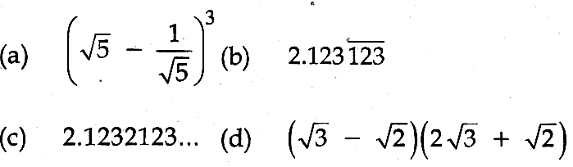
the rational number is
(A) (a) (B) (b) (C) (c) (D) (d)
- The pair of linear equations $\frac{4}{3}$+ 2y — 8 = 0 and 2x + py — 12 = 0 will have infinitely many solutions if:
(A) p=6 (B) p ≠ 6 (C) p = 3 (D) p ≠ 3
- If sinθ — cosθ =0, then the value of (sin⁴ θ+ cos⁴θ) is:
(A) 1 (B) ¾ (C) 1/2 (D) 1/4
- If the mode and median of a grouped data are 40 and 30 respectively, the mean value
(A) 35 (B)— 25 (C) 55 (D) 15

SECTION – B (2 marks each)

- (i) Prove that (sin A + sec A)² + (cos A + cosec A)² = (1 + sec A cosec A)².
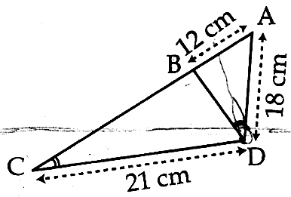
(ii) Find the divisor of x² +1 which gives the quotient as x +1 and leaves 2 as remainder.
- (i) In fig. Name the triangle similar to ∠ABD. Hence calculate BD.
(ii) Given-a, b, c are prime numbers, explain why abc + a is a composite number.
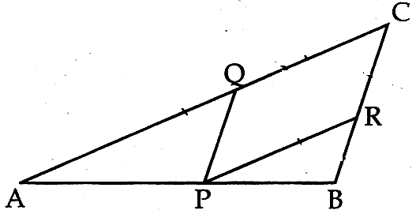
- (i) In the adjoining figure PQ||BC and $\frac{\text{AQ}}{\text{QC}}=\frac{\text{CR}}{\text{RB}}$. Prove that PR||AC
(i) ΔABC is right angled at B and BC = 2AB. If AM is the median, prove that AM² =$\frac{2}{5}$AC²

SECTION – C (3 marks each)
- (i) Prove that ($\sqrt{2}$ + 5)² is irrational.
(ii) The L.C.M of two numbers is thrice its H.C.F. The sum of L.C.M and H.C.F. is 64. If one of the numbers is 48, find the other number.
- (i) Two persons P and Q are 12.5 km part. If they travel towards each other they meet after 1/2 hr and if they travel in the same direction, they meet after 2 ½ hrs. P travels faster than Q. What is his speed?
(ii) The Mean of the following frequency distribution is 22. Find the value of k.
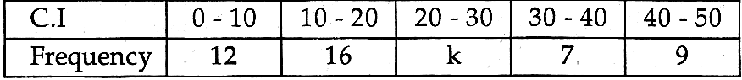
- (i) ΔABC is right angled at A and AD is drawn perpendicular to BC. Show that ar (BAD) : ar (ACD) = BA²: AC²
(ii)

- (i) The distribution below gives the weights of 30 students in a class. Find the mode.
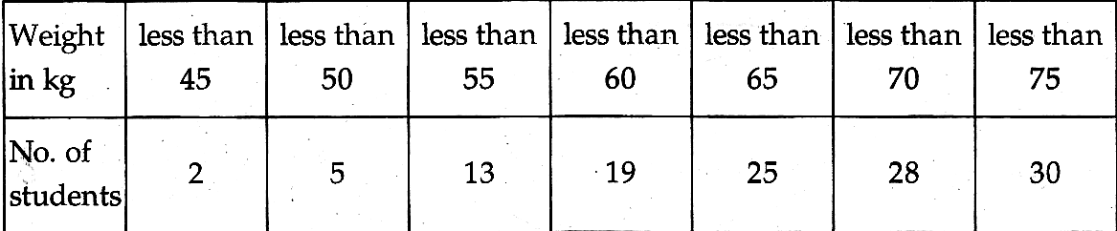
(ii) If 3sinθ + 5cosθ = 5, prove that 5sinθ — 3cosθ = ± 3 Hence find $\frac{3−5\text{tan}θ}{3+5\text{tan}θ}$

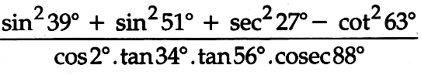
- (i) simplify

(ii) Draw the ‘less than’ ogive for the following distribution and find the median from the graph and verify it with help of formula.
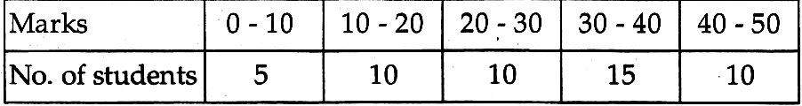

SECTION – D (4 marks each)
- (i) If tanA = n tanB and sinA = m sin B, Prove that cos²A= $\frac{m^{2}−1}{n^{2}−1}$
(ii) Draw the graph of the following equations 2x – y - 2= 0; 4x – y – 8 = 0
(a) Find the solution of the equation from the graph
(b) From the graph, find the points where the lines intersect x-axis and find the area.
- (i) Evaluate:

(ii) Prove that in a right triangle the square of the hypotenuse is equal to the sum of the squares of other two sides
- (i) A man travels 370 km partly by train and partly by car. If he travels 250km by train and rest by car, it takes him 4 hours. But, if he travels 130 km by train and the rest by car, he takes 18 minutes longer. Find the speed of the train and that of the car.
(ii) Find the median of the following data:
- (i)

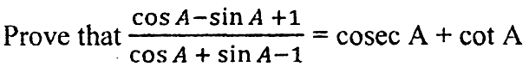
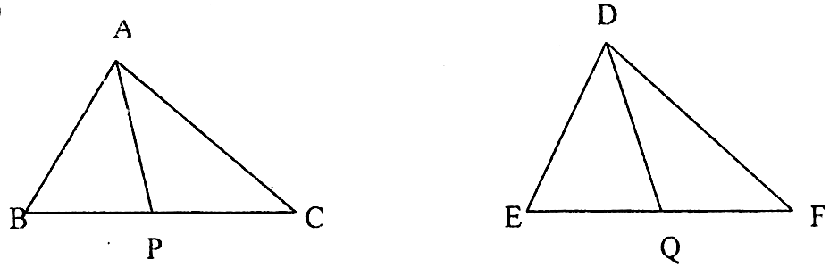
(ii)

- (i) Use Euclid’s division lemma to show that the square of any positive integer is either of the form 3m or 3m +1 for some positive integer m.
(ii) Using Euclid division algorithm find the HCF of 10224 and 9648.

Paper Submitted By:

Name Vandana bansal
Email vandanakukreja.bansal@gmail.com
Phone No. 09855188797

