Sample Paper – 2013
Class – IX
Subject –FOUNDATION OF INFORMATION TECHNOLOGY
Time allowed : 3 hours Maximum Marks : 90
SECTION A
- Name the appropriate button that has to be selected from the start menu to launch an application . 1
- Name the program design to govern the computer hardware system. 1
- What do you understand by the term Windows ? 1
- When Sheetal was typing a letter, she saw the placement of text going past the right margin to the next line . Guess the feature used in MS Word . 1
- Which option will Raju use to write the Math formula (a+b) ²=a²+b²+2ab in MS Word ? 1
- Amit wants to move the text “MY Great INDIA” from one place to another in MS Word and also make 10 copies of the same . Which shortcut will he use to do so ? 1
- To format text in a document which option will you select from the format menu ? 1
- A full system backup of 4 GB would be made using a ............. 1
- What is line spacing ? 1
- Ravi wants to listen to songs while doing work on computer. Is it possible for him to do so ? 1
- What do you mean by formatting ? 1
- Mr. P. Guha, a chemistry teacher is typing his Chemistry Assignment and he needs to type in chemical representation of Sulfuric Acid as H₂SO₄. But, when he is typing, it is appearing as H2SO4. Which formatting feature will help him to see the numbers 2 and 4 in the desired format. 1
- Which of the following is not a type of operating system ? 1
a. MS Windows
b. MS DOS
c. MS Word 1
- Kanan Gupta is a computer professional and has started writing a book titled “Learn Computer within 30 days”. He does not have a good command over English Language and cannot afford to hire an editor for the book. Which two features of Word Processor he should use for basic language corrections? 1
- Name the input device used to sense and read the following code shown below. 1

- Madhu wants to check the file size of her document. With which click of mouse she can go to properties option of file? 1
- Define the term ‘encryption’. 1
- Name the primary memory with the following features: 1
a) It is volatile in nature
b) Before a program can be run, the program is loaded into this memory, which allows the CPU direct access to the program.
- Name a disk utility Software . 1
- Name the device with following features : 1
a) Easy to use
b) Useful for programs like CAD
c) Expensive compared to alternate pointing device like mouse .
- Sumit has created a banner for his school Sports Day as shown. Write the name of the feature that he has used for marked features. 1

- Anshu was writing a story about Akbar and Birbal in Hindi. He created a document with an alignments. Identify it : 1
अकबर-बीरबल
एक दिन बाद्शाह अकबर ने कागज़ पर पैन्सिल् से एक लम्बी लकीर खीची और बीरबल को बुला कर कहा- बीरबल न तो यह लकीर घटाई जाए और न ही मिटाई जाए लेकिन छोटी हो जाए?

- Arrange the following in descending order . 1
Terabyte , Megabyte , Zettabyte , Nibble , Yottabyte
- The capacity of a 3.5 inch floppy disk is __________ . 1
- Which device would you prefer to carry data easily from one computer to another ? 1
- What do you mean by compiler? 1
- Identify which of the following can be categorized as Secondary Memory devices: 2
a) CD ROM b) Keyboard c) Printer
d) Hard Disk e) Pen Drive f) Mouse
g) Plotter h) DVD
- Define “Mail Merge” . 2
- a. Which feature will you use to type ¥ ? 2
b. Can you delete the left most column of the table ?
- In a document all the occurrences of word “is” have to be changed to “are”. Which option is suitable for this and what is the shortcut key for the same option? 2
- List the area where computers are being used efficiently (any four) . 2
- Name any two features that can be used to improve the presentation of a story in MS Word . 2
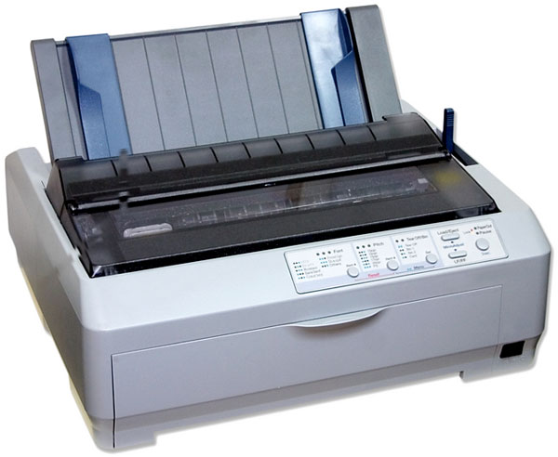
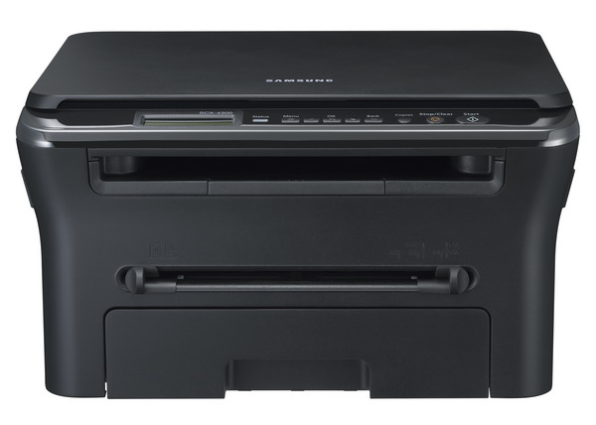
- Name the following printer with one line definition for each . 2

- What is the full form of OCR and MICR ? 2
- Raju Sribastav wants to design the poster as shown below : 5
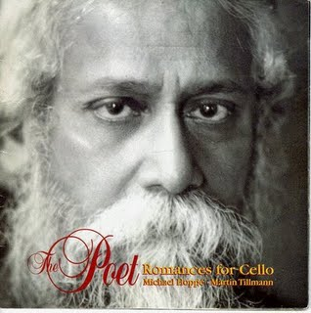
Words of Wisdom

- There’s no right way to do the wrong thing .
- When angry, count ten before u speak .
- By asking for the impossible we obtain the possible.

Identify any 5 features which should be used to design the poster.
- With reference to the following letter, written in a word processor, answer the questions that follow:
The Principal,
The ABC School,
New Delhi-11001.

Sub: Conduct of classes for Math Olympiad

Respected Sir/Madam,

We are a group of profesional teachers preparing studants for various competitive classes. Our track record has been excellent. We condct classes in various schools in and around Delhi. We shall eel obliged if we get a chance to conduct these classes in your school also. This will help your students improve basic mathematical skils also.
In this regard we shall like to have a meeting with you to doscuss the detailed plan. Please contact the undersigned to fix the meeting date and time.

Regards,

Raj Kumar Pal,
Marketing Manager,
Excellent Educational Group.
Phone: 5936365988
1) What changes will you make to the subject line so that it looks as follows: 2
Sub: Conduct of classes for Math Olympiad
2) How will you set the alignment of letter body to justify? 1
3) How will you change the line spacing of letter body to double line spacing . 1
4) Which tool of the word processor will you use to correct the spellings of all the misspelled words? 1
- Answer the following questions : 5
a) What is the shortcut key for warm booting ?
b) What is the full form of OLE ?
c) You have five different types of files . Which object will you use to store similar types of files so that they are stored together on the media and are easy to identify ?
d) Shortcut to move to the beginning of a document .
e) How will you change the location of an icon on the desktop ?
- A document with the name FIT is stored in the folder D:\FIT\IX. How will you:
a) Open this document in a word processor? 1
b) Make changes in it and save the changed document with the name NewFIT so that the original document remains unchanged? 1
c) Change the word device with the word devices at all the places in the document? 1
d) Put the word ‘Modified’ at the top of each page? 1
e) Draw a triangle at a specific location in the document? 1
- Ajay and Akshay, students of class IX, prepared their time table using a word processor as shown below: 10
Subject Teachers:
Class Teacher:
Mrs. S. Parashar
Mon | Hindi | Maths | Maths | Eng. | S.Sc. | Science | SUPW | SUPW
Tue | Science | Science | S.Sc. | Eng. | Maths | Maths | Hindi | S.Sc.
Wed | S.Sc. | Maths | Science | Eng. | Sc. (Pr.) | Sc.(Pr.) | Hindi | Games
Thu | FIT | FIT | Maths | Eng. | Hindi | Sc. | S.Sc. | Games
Fri | Maths | Maths | Science | Eng. | S.Sc. | Hindi | Maths(lab.) | CTP
Hindi – Mrs. S. Parashar English – Mrs. G. Gupta
Science – Mr. V. Bahl S.Sc. – Mrs. K. Walia
Maths – Mrs. J. Khanna FIT – Mr. Y. Rastogi
SUPW – Mr. G. Praksah
When they showed this time table to their class teacher, she recommended some changes so that the time table looks as follows:
Time Table: Class IX - D
Class Teacher: Mrs. S. Parashar
 | 1 | 2 | 3 | 4 |  | 5 | 6 | 7 | 8
Mon | Hindi | Maths |  | Eng. | B | S.Sc. | Science | SUPW
Tue | Science |  | S.Sc. | Eng. | R | Maths |  | Hindi | S.Sc.
Wed | S.Sc. | Maths | Science | Eng. |  | Sc. (Pr.) |  | Hindi | Games
Thu | FIT |  | Maths | Eng. | E | Hindi | Sc. | S.Sc. | Games
Fri | Maths |  | Science | Eng. | A | S.Sc. | Hindi | Maths(lab.) | CTP
Sat | Meditation | CTP | Activity |  | K | House Meeting |  | Bal Sabha

Subject Teachers:
• Hindi – Mrs. S. Parashar • English – Mrs. G. Gupta
• Science – Mr. V. Bahl • S.Sc. – Mrs. K. Walia
• Maths – Mrs. J. Khanna • FIT – Mr. Y. Rastogi
• SUPW – Mr. G. Praksah
Name the word processing features that Ajay and Akshay should use to make the changes. The changes recommended are listed below::
a) The headline should be centre aligned
b) The Class Teacher’s name should span along all the columns in the first row.
c) Add another row after the first row to indicate period number.
d) The day names should be in Italics.
e) At all the places in the table where a subject occurs twice for consecutive columns, it should be displayed only once spread over the two columns
f) There should be a column after 4th period to accommodate ‘BREAK’.
g) There should be a row for Saturday
h) The Subject-Teacher list should be a bulleted list.
i) Period numbers and ‘BR EAK’ should be in Bold.
j) The table should be centre aligned.
SECTION B
- Kamini has placed four objects in a document and she wants to ensure that these objects move together when she makes any changes in the document .Which feature will help her to achieve the desired effect. 1
a. Tab stops b. Grouping
c. Page Margin d. All of the above.
- At one place in a document Renu wants to type x3+8x-2, but she is not able to get 3 at its proper place. Which option should she use for this purpose: 1
a. Bold b. Superscript
c. Underline d. Subscript
- Which of the following is not a storage device: 1
a. Memory Card b. Random Access Memory
c. Pen Drive d. CD-ROM
- Saving an existing document with some other name using Save As option: 1
a. Replaces the curr document b. Leaves the curr document intact.
c. Is not possible d. Closes the document.
- After assembling a computer system, the very first software to be installed is: 1
a. Anti Virus Software b. Operating System
c. Application Software d. Utility Software
- Keyboard shortcut for right alignment is: 1
a. Ctrl+R b. Ctrl+A
c. Ctrl+E d. Ctrl+T
- A bulleted list: 1
a. Can be converted to a numbered list b. Can’t be converted to a num list
c. Is better than a numbered list d. Cannot be printed
- Disha has created a document and now in some parts of the document’s text he wants to apply the same type of format : bold,underline,font size 14 & color red. He can do it by:
a. Using format painter b. Using paint brush 1
c. Using cut copy paste d. Using Windows
- Replace option is available in 1
a. EDIT menu b. FILE menu
c. INSERT menu d. TOOLS menu
- The shortcut key for spell check is 1
a. F7 b. F8
c. F4 d. F9
- Arrange the properly 1
1 2 3 4 5
a. Disturb row-Disturb column- Insert Table-Merge-Split
b. Insert Table- Split-Disturb row- Merge-Disturb column
c. Insert Table-Merge-Split-Disturb row-Disturb column
d. Disturb row- Merge- Disturb column-Split- Insert Table
- Disk Cleanup helps to free up 1
a. data b. Recycle bin
c. space d. None of these
- Which of the following language is not suited for the computation ? 1
a. PASCAL b. FORTRAN
c. Machine d. All the above
- The language processor which convert HLL into machine language is 1
a. Assembler b. Compiler
c. Interpreter d. Both b & c
- Which memory is volatile in nature ? 1
a. Dynamic RAM b. Secondary memory
c. ROM d. Static RAM
- One zettabyte is approx. equivalent to 1
a. 10¹² bytes b. 10¹⁸ bytes
c. 10¹⁵ bytes d. 10²¹ bytes
- A laser printer uses 1
a. Raster scan b. Camera lens
c. both a & b d. hear sensitive paper
- 1 nibble is equal to ________ bits 1
a. 8 bits b. 4 bytes
c. 8 bytes d. 4 bits

Paper Submitted By:

Name S K Das
Email sujrkl152003@rediffmail.com
Phone No. 9437341570
S. Arnold’s School,
Odisha

